Lab 3 – Transmission Control Protocol (TCP)

Table of Contents
Task A: TCP Basics 1
Observations 2
Task B: TCP Congestion Control in Action 2
Observations 4
Task C: A Short Study of TCP Fairness 4
1. Case: Four clients, four downloads, same host, same server 4
2. Case: One client, one download, one host, different mirror servers 5

Task A: TCP Basics
The client computer makes a HTTP POST request to gaia.cs.umass.edu. To transmit the request, a TCP connection is setup between port 1161 of the client computer and port 80 of the server (gaia.cs.umass.edu). Since the HTTP request is too large to be transmitted as a single TCP segment, it is broken down into multiple chunks (122).
To set up the connection, a three way handshake is performed (shown in packets 1 to 4 in the Wireshark packet list) between the client (192.168.1.102:1161) and the server (128.119.245.12:80). After this the client keeps sending the TCP segments. The client also keeps an estimate of the RTT using the time elapsed between the sending of a segment and the receipt of acknowledgement for the same. This estimate of the RTT is used to determine packet drops. If the client doesn't receive any acknowledgement for a packet within a certain time (depending on the estimated RTT), the client interprets that the packet is lost and hence retransmits it.
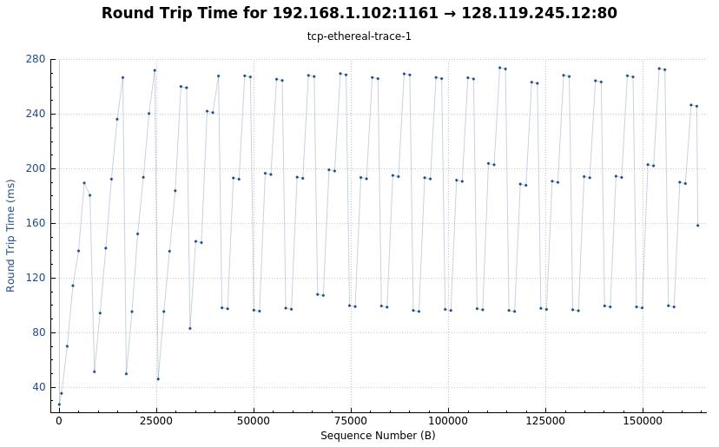
Illustration 1: The figure above shows an RTT vs. Sequence number plot of the whole file upload.

Observations
- In order to determine whether a packet is of SYN / SYN-ACK / ACK type, the field ‘Flags’ in the TCP packet header is updated accordingly, e.g., if the packet represents a SYN header, the corresponding SYN bit is enabled, and the rest of the flag-bits are set to 0.
- The length of the first TCP segment is 565 bytes, and the length of the following 5 is 1460 bytes, which is the recommended MSS for TCP.

Task B: TCP Congestion Control in Action
- The TCP’s slow start phase’s start and end are not possible to spot from the graphs. It seems that the data is coming from the host browser to the TCP layer at a lower rate than then network capacity, so the TCP layer does not have to aggressively increase its cwnd.
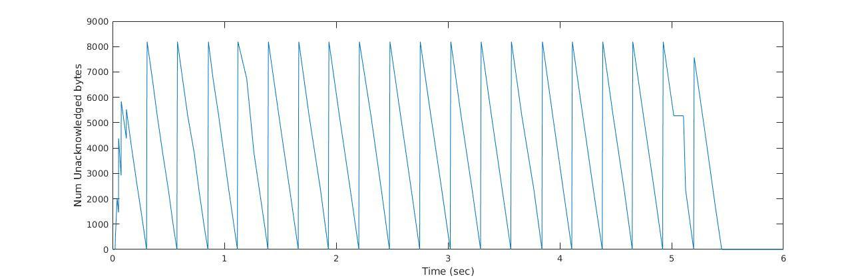
Illustration 2: Time vs. Number of Unacknowledged bytes. The reason for this is BLA BLABLA (But maybe that the client send about 8000 Bytes (which corresponds to approximately 5 TCP MSS, and then waits until those MSS have been acknowledged, that is why the value of the unacknowledged bytes falls to 0 in every period of the signal.) ??? Not sure about this
- The congestion window (cwnd) is maintained at the client, and denotes how many unacknowledged segments there can be in the network. This is maintained so as to not congest the network by sending too many bytes at once.
The receive window (rwnd) is sent by the receiver and denotes how much more data the receiver can buffer. This is done for flow control, i.e. to ensure that sender doesn’t send data at a higher rate than the receiver can handle.
The number of unacknowledged bytes is used by the sender for both flow control as well as congestion control. It should be lower than both cwnd and rwnd.
The effective window (EW) at the sender denotes how many unacknowledged bytes the sender can have in the network.
Formula 1: Effective window inequality

- If the host is sending the data at a high rate so that the network speed is the bottleneck, then it should be possible to find the cwnd from the trace by looking at how many unacknowledged bytes there are in the network, since that should be equal to cwnd when the TCP sender always has data to send. However if the sender is sending data at low rate, then its not possible.

Observations
- The reason why the 3-way handshake is done in the first 3 packets is because when the client sends the first SYN packet, the SYN-ACK response that the client expects from the server times out (it actually comes in packet number 6, marked in black as “Out-Of-Order”.), so the client retransmit the SYN packet.

Task C: A Short Study of TCP Fairness
The throughput for every connection has been calculated by simply dividing the number of transferred bytes (converted to bits) with the amount of time, i.e.,
Formula 2: Calculation for the throughput of a given TCP connection

1. Case: Four clients, four downloads, same host, same server
The following formula is well-known for estimating the steady-state throughput of a TCP connection:
Formula 3: Average throughput of a connection, depending on the MSS, RTT and L
, with MSS being the Maximum segment size, RTT the round-trip time and L the loss rate. Assuming an equal loss rate for the same connections sharing the same bottleneck link, we establish the simplified relationship as:
Formula 4: Simplification of Formula 2 for a scenario where all connections share the same link, thus having the same losses L
, meaning that the higher the RTT, the lower the average throughput of the connection, i.e., RTT and throughput are inversely proportional.
Since all clients (within the same host) are using the same link to retrieve the files, in this particular case RTT can be “ruled out” from the equation and the total bandwidth of the host can be obtained by adding up the individual bandwidths of every connection. This points out TCP’s fairness.
Connection | Total transferred bytes | Duration (s) | RTT (ms) | Throughput (bps)
1 | 165095720 | 521 | 12 | 2535059
2 | 165842766 | 521 | 12 | 2546529
3 | 165458792 | 514 | 12 | 2575234
4 | 163235772 | 512 | 12 | 2550558
Total: |  |  |  | 10207380

2. Case: One client, one download, one host, different mirror servers
As in Formula 2, the total bandwidth has been calculated by adding up the individual bandwidths of every connection made. Since every connection used a different link – all mirrors are different - , little can be commented on the TCP fairness. The only thing that can be pointed out from the results is that the lower the RTT, the higher the throughput.
Connection | Total transferred bytes | Duration (s) | RTT (ms) | Throughput (bps)
1 | 261319130 | 90 | 13 | 23228367
2 | 175995832 | 90 | 35 | 15644073
3 | 151894552 | 90 | 68 | 13501737
4 | 140388568 | 90 | 73 | 12478983
5 | 108610702 | 90 | 49 | 9654284
6 | 70644690 | 90 | 33 | 6279528
7 | 65744938 | 90 | 135 | 5843994
8 | 43212876 | 90 | 326 | 3841144
9 | 39222524 | 90 | 322 | 3486446
Total: |  |  |  | 93958556

3. Case: BitTorrent download from multiple peers
Once again, as in Formula 2, the total bandwidth has been calculated by adding up the individual bandwidths of every connection.
Connection | Total transferred bytes | Duration(s) | RTT(ms) | Throughput (bps)
1 | 108851134 | 58 | 40 | 15013949
2 | 90435681 | 58 | 36 | 12473887
3 | 57971584 | 53 | 100 | 8750427
4 | 32000012 | 29 | 68 | 8827589
5 | 32557334 | 35 | 31 | 7441676
6 | 27199361 | 31 | 33 | 7019189
7 | 26329578 | 31 | 122 | 6794729
8 | 38834490 | 56 | 146 | 5547784
9 | 23571761 | 35 | 74 | 5387831
10 | 36252962 | 55 | 66 | 5273158
Total: |  |  |  | 82530219

