the results of the position, velocity, acceleration of the right ankle x

set up: filtered by 4th zero lag Butterworth low pass (cut-off frequency = 6Hz)

set up events

1. Event 1 = touch down = the x velocity lower than 0.3 m / s
2. Event 2 = heel off = the x velocity more than 0.3 m / s after event 1

###

I am not sure if it makes sense if you want me to change the setup,

Please let me know

The report graphs I cut the first frame and the final frame (because vel and acc = nan)

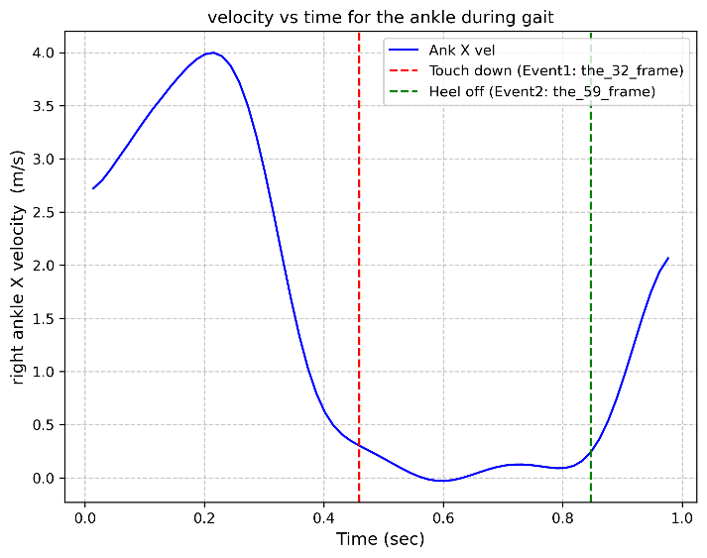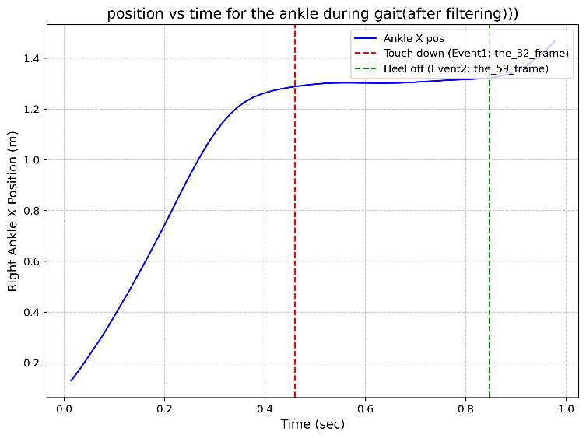

Description of the graph

|  |  |
| --- | --- |
| Interval | Description |
| Position (m) X direction (AP direction) (positive = forward ; negative = backward) | |
| Start to touch down | Value is increasing because the participant is moving forward  The slope is high in the first half of the phase because he needs to move forward.  The slope is getting smaller in the middle of the phase because he needs to slow down to prepare for the touching down. |
| Stance phase | Value doesn’t change a lot because it doesn’t move forward a lot. But it still go forward because he needs to move body cross the middle line of the body to prepare for the heel off |
| Heel off to the end | Value increase again in the swing phase for the next step (or next touch down) |
| Velocity (m / s) | |
| Start to touch down | Value increase to get the leg go forward in the first half phase.  Value decrease to slow down to prepare for the touch down |
| Stance phase | Value is around zero during the stance phase but it is a little bit above zero because he needs to move body forward to cross the middle line for the heel off |
| Heel off to the end | Value increase again in the swing phase |
| Acceleration (m / $S^{2}$) |  |
| Start to touch down | Value is positive and getting closer to zero in the first half of this phase to move forward  Value is negative and getting far away to acc the body of the negative direction of the second half of the phase to stop the body, but getting to close to the zero to prepare of touch down |
| Stance phase | It is almost zero during the stance phase because the ankle doesn’t change a lot of velocity. Around heel off, increase the acceleration again. |
| Heel off to the end | Increase and decrease again for the next touch down |

Filtered data VS raw data

Q1 What does the smoothing process remove from the data?

Ans: High frequency Noises; Small Artifacts or Sudden Spikes

Q2 Do your new graphs change your analysis of the movement?

Ans: yes

I have used three cutoff frequencies (cutoff = 6, 15, 30) for the walking data

RMS (cutoff = 6 Hz): 0.016300996251357218

RMS (cutoff = 15 Hz): 0.00564444531070542

RMS (cutoff = 30 Hz): 0.002649159503646743

Although the rms is getting lower, but it also means the data will be “distortion”.

Also, we need to set up a standard to decide the cutoff frequency (which I think the real situation is filter will affect the accuracy of the data because the researcher needs to decide how many “noises” pass or not pass to affect to the data [maybe I am wrong]).

The results of the Butterworth 4th zero lag low pass filter method

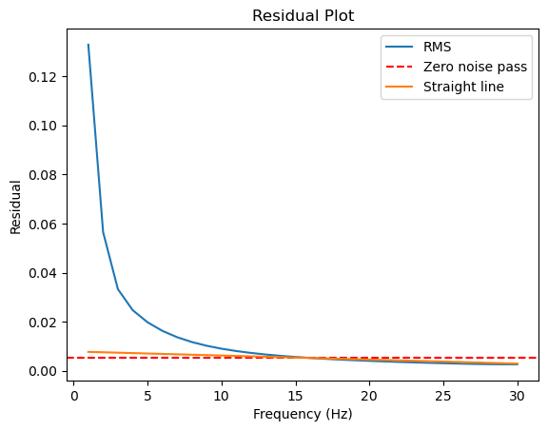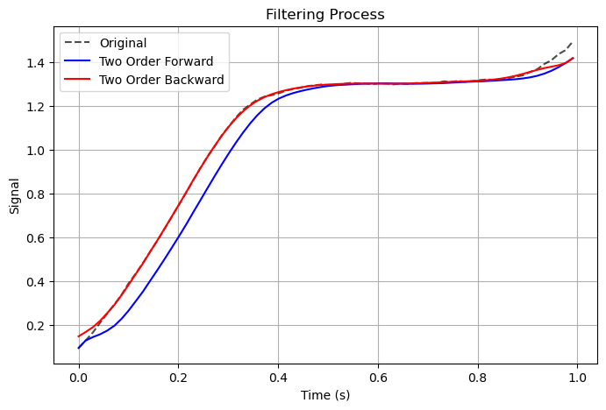

Rms from 1 to 30 Hz to decide the best cutoff frequency

(if the motion is fast, probability try to 40-50Hz, but try until 30Hz is usually enough)

The slopes (orange line) is calculated by 19Hz and 29Hz with (y = ax + b )

I will decide 15Hz (it is a little wired because for walking, I guess it should be around 6~8Hz)