class4.R

goose

2025-01-16

x <- 1:50  
plot(x, sin(x))

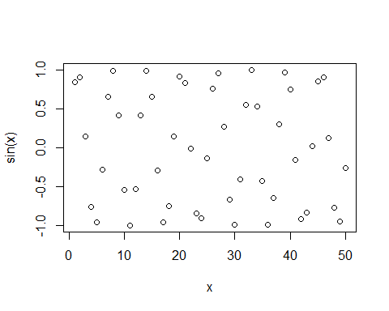

#Make this nicer  
plot(x, sin(x), col="purple",type="l",lwd=3)

