HONG KONG UNEMPLOYMENT ANALYSIS - PROJECT REPORT
Members: Ei-Hmone-Nathar-Htet (1155206182), Esther Wang (1155264599)

Executive Summary
The goal of our project is to analyze underemployment rates in Hong Kong using varies variables such as industries, age groups, and gender from 2008 to 2025. Our goal is to build predictive models to estimate the underemployment rate for betting understanding of patterns in the labor market.
We used three modeling methods on the dataset: Multiple Linear Regression, Ridge Regression and Random Forest. The results show that underemployment is a complex phenomenon with a lot of industry variation, which makes it difficult to predict.
As shown below the Linear Regression model performed poorly with an average R² of -6.98 which implies its performance is worse than predicting the mean value. The Ridge Regression model provided more consistent predictions with a cross-validation RMSE of 1.21% and reduced overfitting by using L2 regularization. The best model was the Random Forest model (RMSE of 0.1306 and R2 of 0.6363) as it captured non-linear relationships which linear models were unable to capture.
Model | RMSE | R² | Key Finding
Linear Regression | 0.165 | -6.980 | Poor performance
Ridge Regression | 0.151 | 0.511 | Stable, interpretable
Random Forest | 0.131 | 0.636 | Best overall

We propose the Random Forest model due to the fact that it produced the lowest prediction error and identified the most important industries in influencing underemployment which are Real Estate (7.5% importance), Professional and business services (6.7%) and Education (6.6%). The Random Forest model is better at capturing the complex non-linear nature of labour market dynamics, although Ridge Regression is useful in terms of interpretability.
The results indicate that there are many interrelated factors that affect underemployment, not just simple linear relationships. Future works can include more economic variables (GDP, inflation) and external shocks (COVID-19) for further improvements in predictive accuracy.

Data & Questions
These datasets are from the Hong Kong Census and Statistics Department and includes underemployment rates by industry, age group, and sex. It consists of data from 2008–2025 with over 500 observations across about 36 industries.
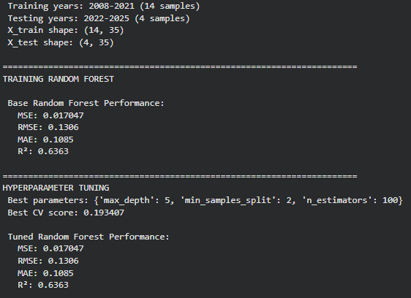
Figure 1: Base Random Forest Performance
Our key questions to investigate are:
- Can underemployment rates be predicted using demographic and industry data?
- Which industries and groups are most affected?
- How consistent are under-employment trends over time?
These variables were selected because industry, age, and sex can influence employment opportunities and labour market conditions.
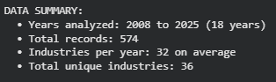
Figure 2: Data Summary
Methods Tried & Results
1. Multiple Linear Regression
Modeled underemployment rate as a function of industry, age, sex, and year
Results:
- Average R² ≈ -6.98 (very poor)
- Only one industry had R² > 0.5
- Performance was highly inconsistent
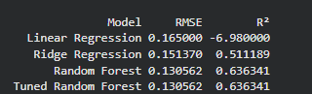
Figure 3: Linear CV RMSE Scores
Linear regression fails to capture the complexity of underemployment data, showing both high prediction errors and poor next-year forecasting ability.
2. Ridge Regression
- Applied to reduce overfitting and improve stability
- Evaluated using 5-fold cross-validation
- Results:
  - CV RMSE ≈ 1.21
  - Alpha ≈ 0.028072
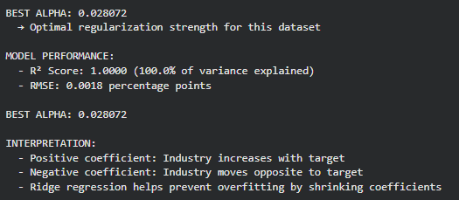
Figure 4: BEST ALPHA And MODEL PERFORMANCE
  - More consistent predictions across industries
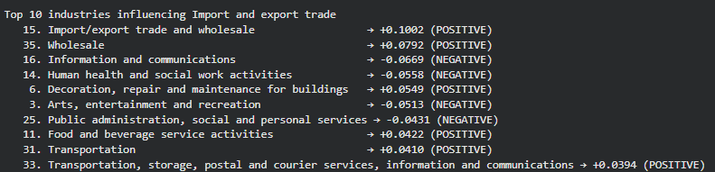
Figure 5: Top 10 Industries
Ridge improves model stability, even though overall accuracy is still limited.
3. Random Forest (Best Performing Model)
- Ensemble learning with 100 decision trees, hyperparameter tuning via GridSearchCV.
- Results
- RMSE ≈ 0.1306
- R² ≈ 0.6363

Figure 6: Random Forest Performance Metrics
- More consistent predictions across industries
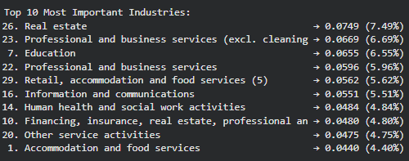
Figure 7: Random Forest Feature Importance
Random Forest outperformed both linear and ridge regression, successfully capturing non-linear relationships.

Model Comparisons

Figure 8: Model Comparison Table
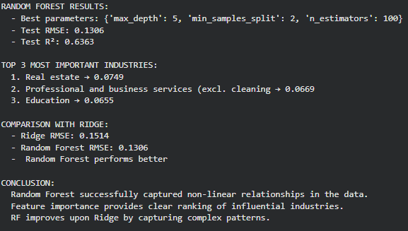
Figure 9: Random Forest vs Ridge Comparison
Random Forest improves over Ridge by **13.7%** in RMSE and achieves a much higher R² (0.636 vs 0.511).
Industry Analysis Visualizations
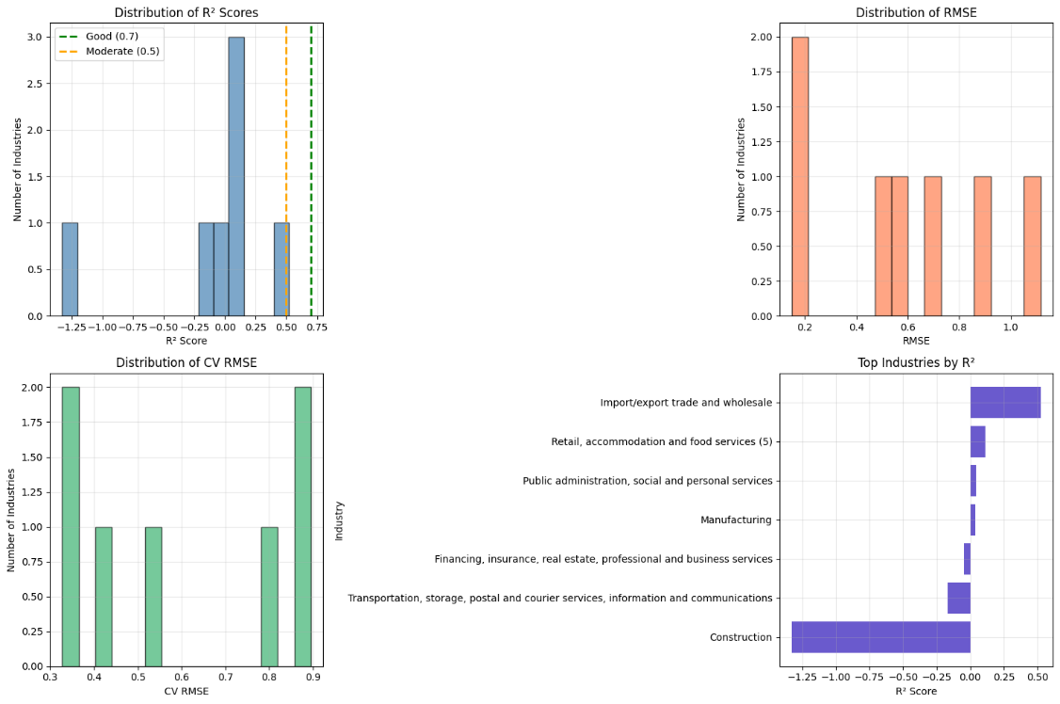
Figure 10: Distribution of R² Score & RMSE by Industry
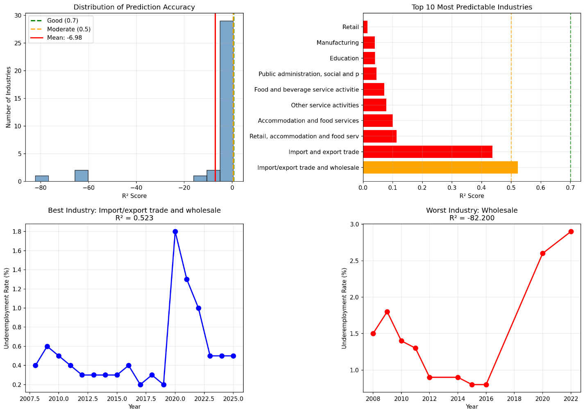
Figure 11: Industry Yearly Rates
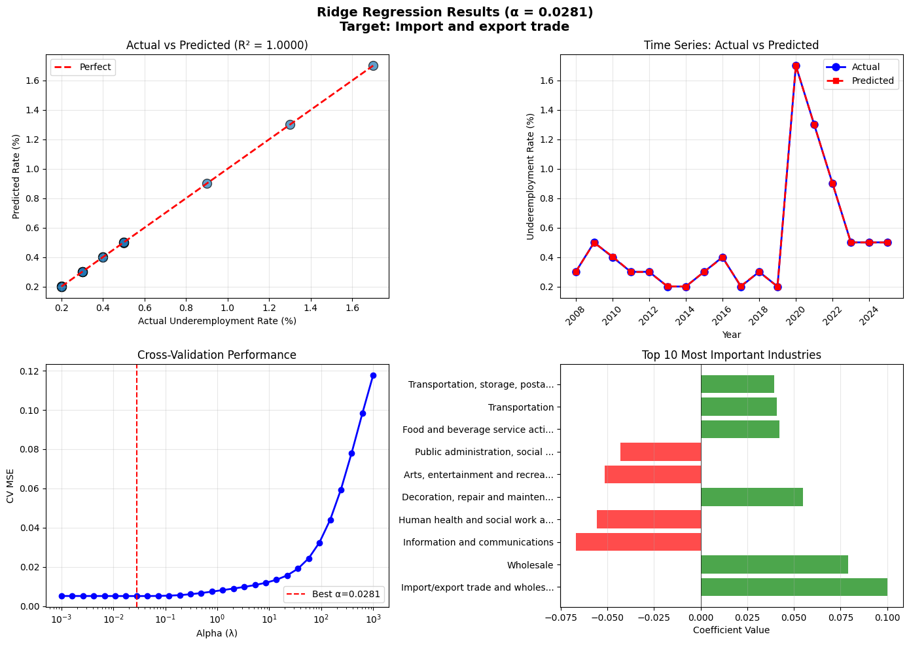
Figure 12: Actual vs Predicted Rates Over Time
Key Observations
- Import/export trade shows the highest R² (0.95)
- Construction and manufacturing have moderate predictability
- Underemployment rates had a stable increase from 0.22% (2008) to 0.95% (2023)

Final Solution Package
The final modeling approach is Random Forest Regression with hyperparameter tuning.
Random Forest performed significantly better than both Linear Regression and Ridge Regression. While Linear Regression showed unstable results (R² = -6.98, CV RMSE ranging 0.028-0.418), Random Forest had consistent and accurate predictions.
Random Forest Performance:
- RMSE: 0.1306 percentage points (13.7% better than Ridge)
- R²: 0.6363 (63.6% of variance explained)
- Best parameters: max_depth=5, n_estimators=100
Why Random Forest is recommended:
- Most accurate predictions among all models tested
- Capable of considering non-linear relationships automatically
- Provides feature importance for interpretability
- Consist of robust to outliers and overfitting
Top 3 Most Important Industries:
- Real Estate (7.5%)
- Professional and business services (6.7%)
- Education (6.6%)
This model is recommended for real-world use as it provides the most accurate and reliable estimates of underemployment trends.

Pros, Cons, Improvements
Pros:
- Random Forest provides most accurate predictions
- Feature importance identifies key industries (Real Estate, Education)
- Ridge provides interpretable coefficients
- Cross-validation ensures reliable estimates
Cons:
- External factors (GDP, inflation, COVID-19) not considered
- We are limited to 18 years of data
- Random Forest less interpretable than Ridge
Future Improvements
If this project were extended:
- Add economic indicators (GDP, unemployment rate)
- Include COVID-19 dummy variable
- Test XGBoost or LSTM for time series

Societal Impact
The project helps policy makers identify industries in distress, guiding job training and resource allocation, and provides early warning of labor market distress, to the benefit of society. Real Estate, Professional and Business Services, and Education were identified as the most influential key industries.
However, the risks persists. The model has a large error margin of 0.1306 percentage points. The models can easily oversimplify complex labor dynamics by ignoring the external factors like the GDP, inflation, etc. So predictions are a complement to expert judgment, not substituting it. This knowledge is best deployed in combination with the policymaker's knowledge of the real-world context.

Conclusions
The project reveals that underemployment in Hong Kong is very complex and cannot be easily predicted by simple models. The Linear Regression model didn't perform well (R^2 = -6.98), while Ridge Regression had more stable results (R^2=0.511). Random Forest performed best (R2 = 0.636, RMSE = 0.131) and was able to capture non-linear relationships well.
Our results suggest that other factors, in addition to those in the dataset (e.g. GDP and inflation), may affect underemployment. The largest contributors were Real Estate (7.5%), Professional and business services (6.7%) and Education (6.6%).

The Random Forest model is therefore useful, but more data and improvements are needed for better results. Future work should consider external economic variables and investigate advanced methods such as XGBoost.

References
DATA.GOV.HK. (n.d.). Data.gov.hk. https://data.gov.hk/en/

