|  |  |
| --- | --- |
| +  -  + | Movement: FORWARD  Using LEFT JOYSTICK,  Touching the joystick upward |
| -  -  -  +  + | Movement: BACKWARD  Using LEFT JOYSTICK,  Touching the joystick downward |
| +  +  +  - | Movement: RIGHT  Using LEFT JOYSTICK,  Touching the joystick to right |
| +  -  -  + | Movement: LEFT  Using LEFT JOYSTICK,  Touching the joystick to left |
| -  +  +  + | Movement: ROTATE TO LEFT  Pressing the button Y |
| -  -  - | Movement: ROTATE TO RIGHT  Pressing the button X |

-

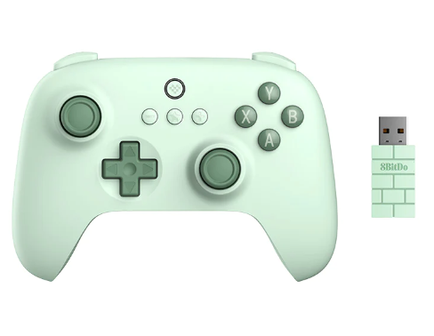**8BitDo Ultimate C 2.4G**

**MOTOR DRIVER: BTS7960**

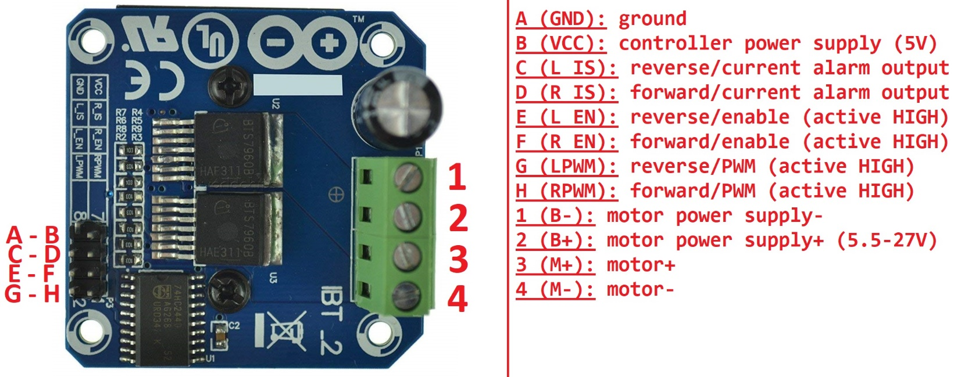

**GEAR DC MOTOR: SGM37-550 12V-120 RPM**

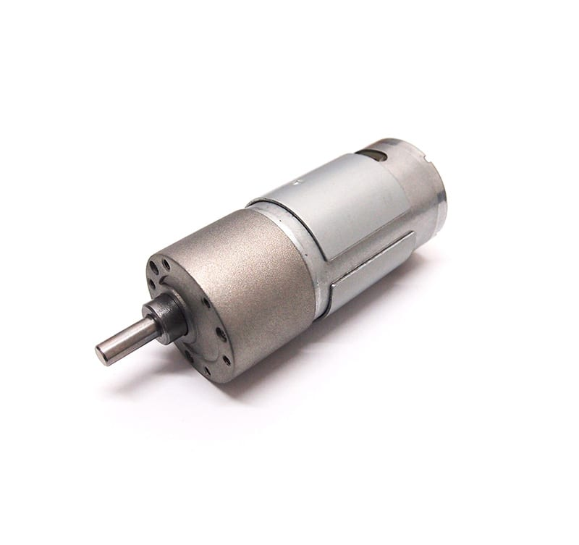 **YDKIDAR X4-PRO**

