﻿﻿**PROBLEM SET 4 WRITEUP(Problem 6)**

Eijiro Asada

December 9th, 2021

Problem 2 simulation:

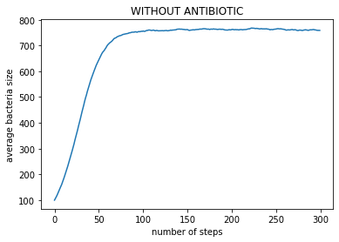

Problem 5 Simulation

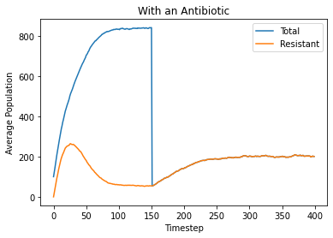

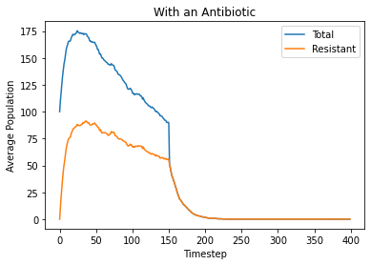

QUESTIONS:

1. What happens to the total population before introducing the antibiotic?

Before introducing the antibiotic, depending on the birth rate and death rate, the total population increases in the beginning but then after a certain threshold, it either decreases or flattens out.

1. What happens to the resistant bacteria population before introducing the antibiotic?

Before introducing the antibiotic, the resistant bacteria population increases in the beginning but after a certain threshold it decreases.

1. What happens to the total population after introducing the antibiotic?

The total population after introducing the antibiotic converges to the resistant antibiotic population.

1. What happens to the resistant bacteria population after introducing the antibiotic?

After introducing the antibiotic, the resistant bacteria population either increases or decreases depending on the birth rate and the death rate.