II Semester 2023-2024
CSE 2030 – Web Application Development
MySQL Exercise
---------------------------------------------------------------------------------------------------------------------
Write Query to get the following output.
- Create database with the name “university”.
- Create two tables in this database: name as “student” and “teacher”
- “student” table structure:
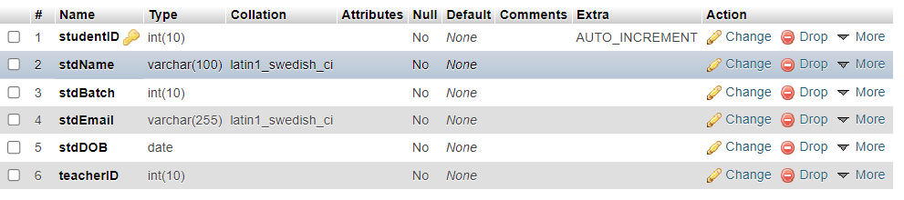
- “teacher: table structure:
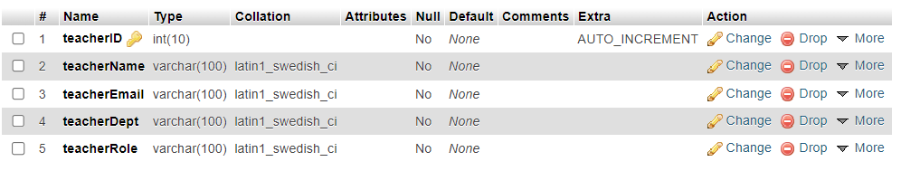
- “student” table is inserted data as following:
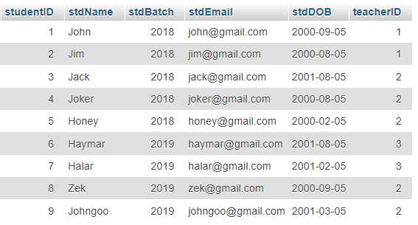
- “teacher” table is inserted data as following:
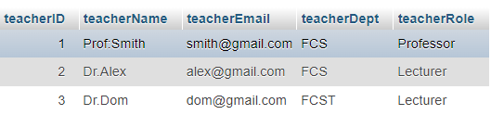
- Select the data to get the following output table:
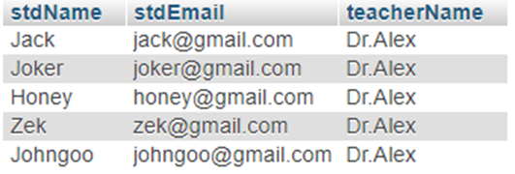
- Select the data to get the following output:
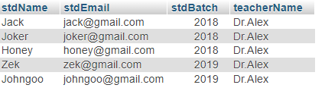
- Update and insert teacher table to get the following output:
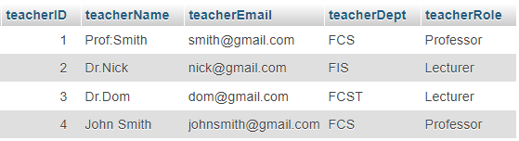
- Select the data to get the following output:
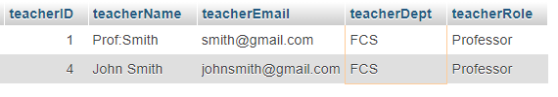

select studentID,stdName,teacherName from student join teacher where student.teacherId=teacher.teacherID and teacher.teacherID='2';

SELECT * FROM `student`
join student_course on student.id=student_course.student_id
join course on course.id=student_course.course_id;

SELECT first_name,last_name FROM `student`
join student_course on student.id=student_course.student_id
join course on course.id=student_course.course_id where course.id=2

