**IE 301 -OPERATIONS RESEARCH II**

**PROJECT REPORT**



**Elif İlayda GÜNTÜRK – 042003028**

**Hülya İkranur DİLTEMİZ – 042003081**

**Selin ERGÜL – 042003086**

**Table for The Queuing Model:**

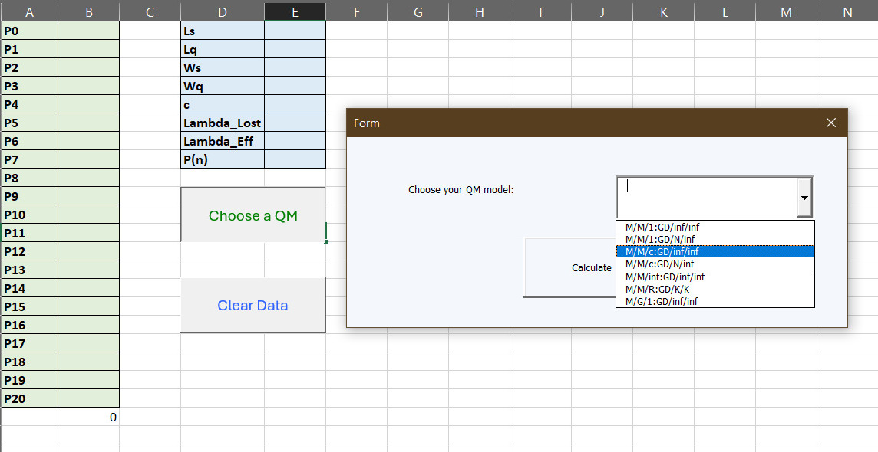

A table layout was created to print the probabilities. Each model has been added separately to the drop-down menu options. When a model is selected, the corresponding User Form appears and prompts users to provide specific inputs required for that model. Different and separate input parameters were created for each user form.

Another macro in our sheet is "Clear Data". It allows us to delete data in certain cells after each model selection and calculation.

**Warning Message:**

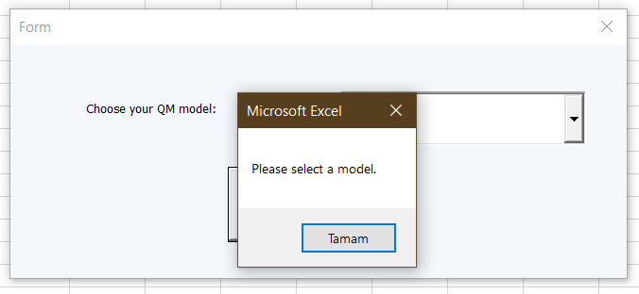

To inform users about incomplete selection or if they do not select the relevant QM Model, we receive an error code and a message box appears on our screen. In this message box "Please select a model." warning is encountered.

**Userforms and Results:**

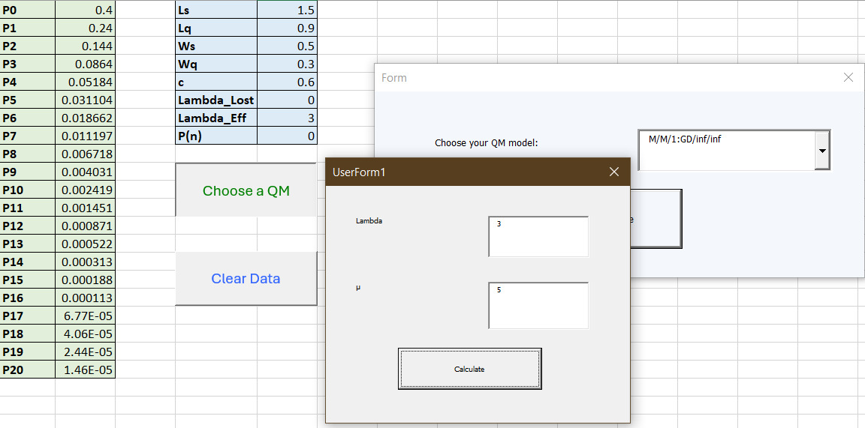

'Userforms' and 'Results' sections in Excel VBA are areas where users can enter data and see the results. There are different input parameters for each model in userforms. It allows users to enter the necessary data and specify the parameters to be processed. 'Results' shows the results of these operations and presents the output of the operations to the user. These areas allow users to manage data and instantly observe transaction results.

**Missing input warning:**

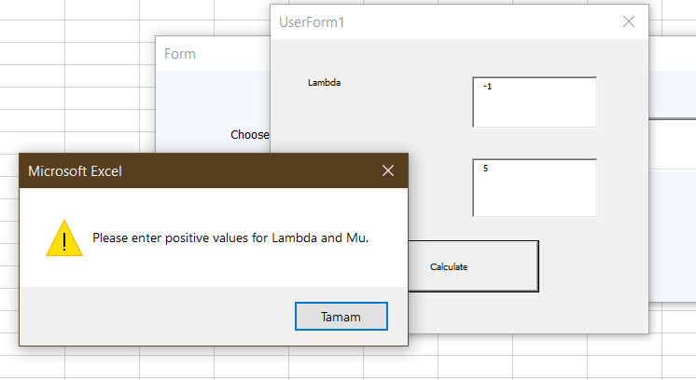

Finally, when we enter a negative value in our values, a warning message box appears on the screen. In this warning message box "Please enter positive values for Lambda and Mu." However, this message box varies from parameter to parameter.