CS189-hw6 Report

Eileen Li, Minyoon Jung

See README for more information.

Resources:

Relied heavily on the Caltech lectures as well as class notes. Probably read some articles online too, but none that really stood out.

Single-layered:

It was difficult for us to lower our error rate for the mean squared error. We played with the learning rate, with the weight initialization, with the preprocessing methods, and the best we could manage was around 30% error. Below is a graph of the accuracy. There are four lines, representing the test and training sets using mean squared or entropy.

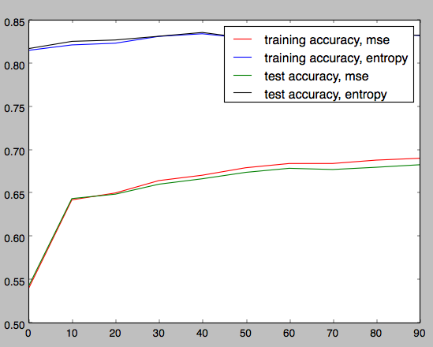

For cross-entropy loss function, we got the error rate down to around 7% error on the training data and 8% on the test data using a learning rate of 0.01, and decreasing this rate by a factor of 1/n^0.5 where n is the number of epochs. If we had more time, we could’ve ran more epochs and achieved lower error rates. The error rates for cross-entropy were still decreasing (very slowly) when we stopped at 200 epochs. The running time for 200 epochs was 2.4 hours. Below is a graph of the accuracy. Notice that the mean squared had really results using this learning rate. Please just ignore that and refer to the first graph for mean-squared.

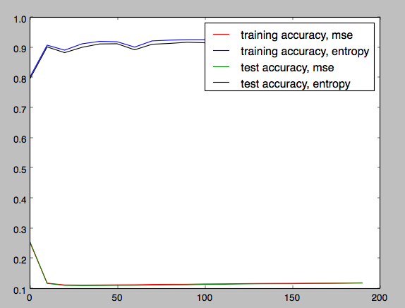

Double-layered: