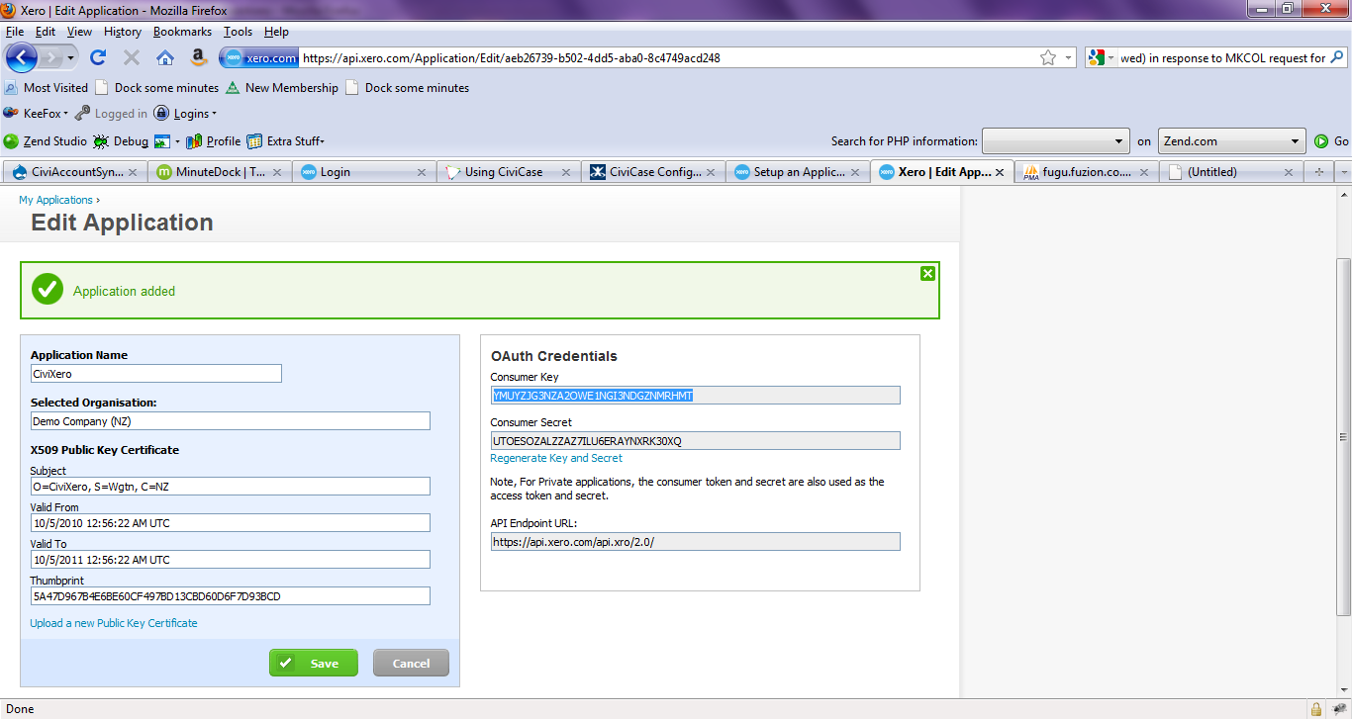
Log into https://api.xero.com/Application?redirectCount=0
Choose My Applications
http://blog.xero.com/developer/api-overview/setup-an-application/#private-apps

Choose Add

