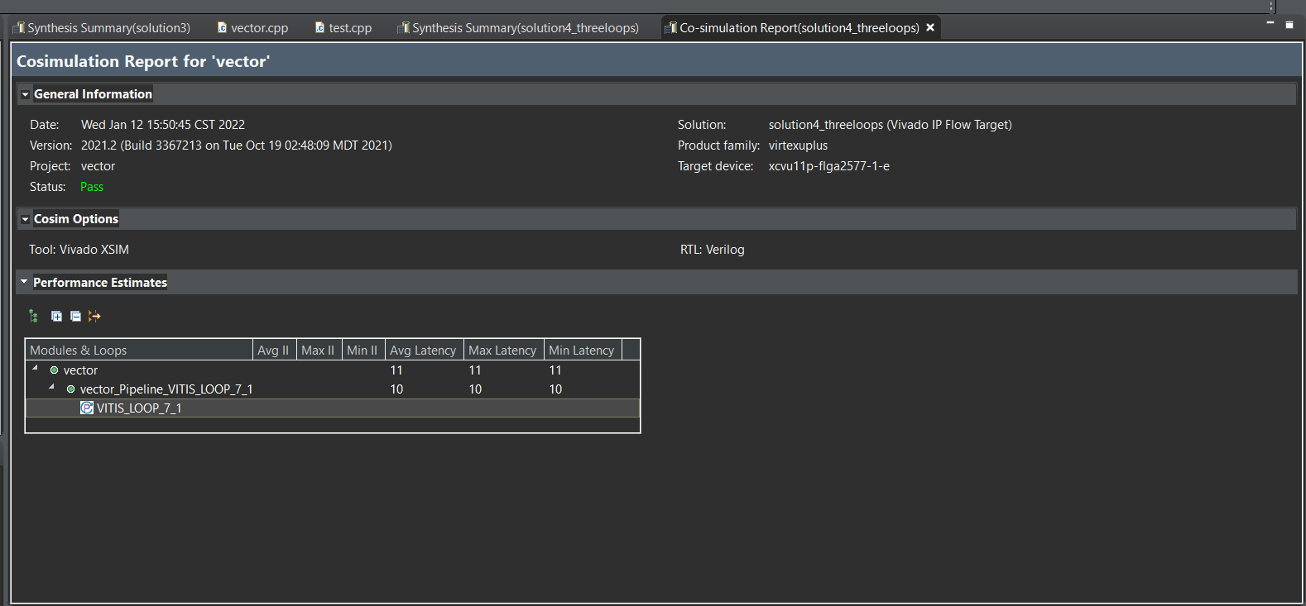

Co-simulation

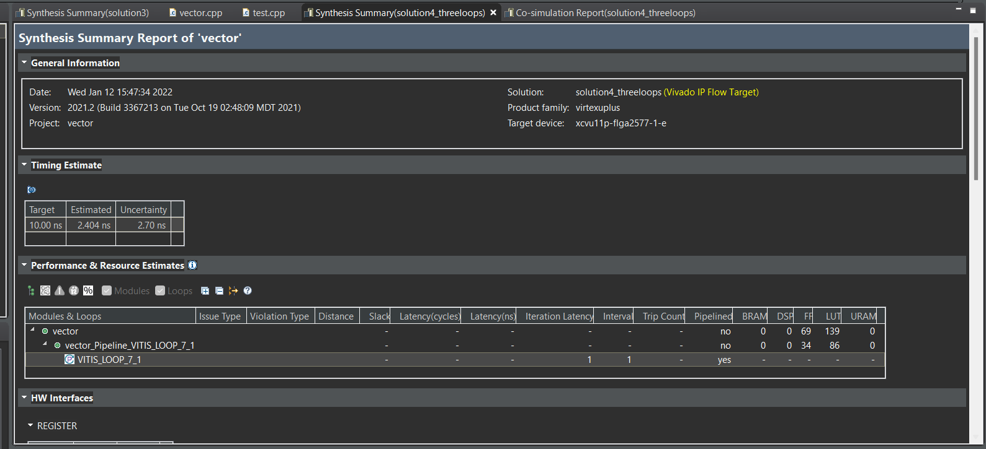

C synthesis

Vector addition: one loop each for A and B initiation and one loop for addition and no pregma

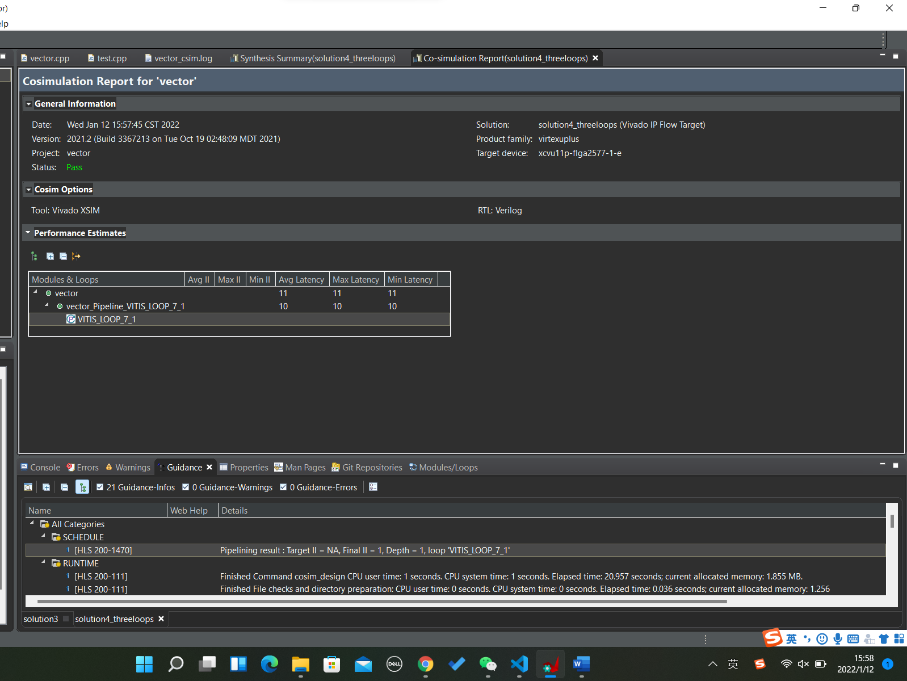

Adding one pragma: pipeline

Result: the same as the first one without any pragmas

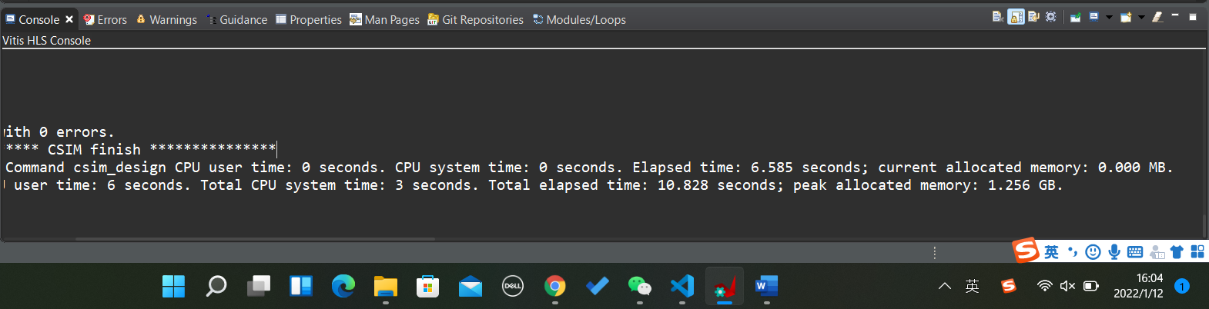

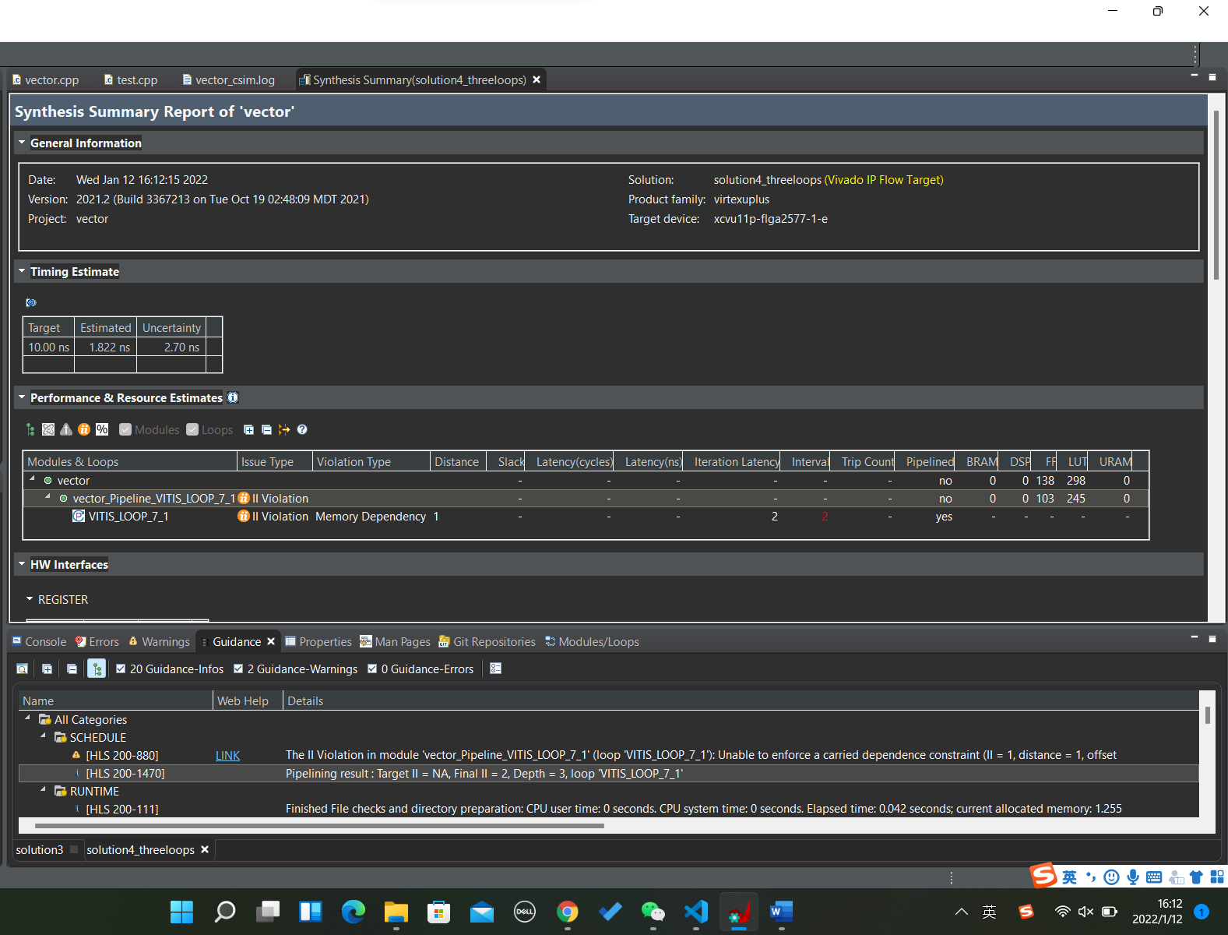

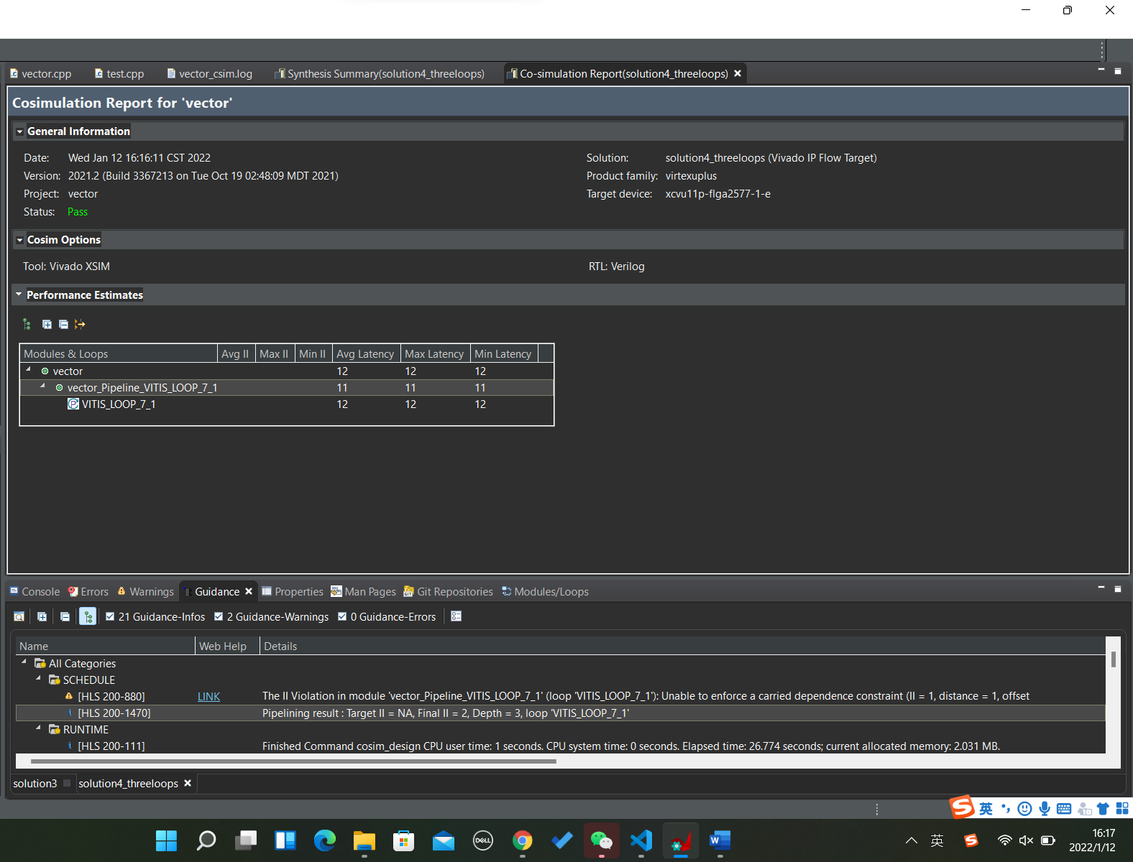

Adding 2 pragmas: pipeline & unrolling with factor of 2

Result: II violation

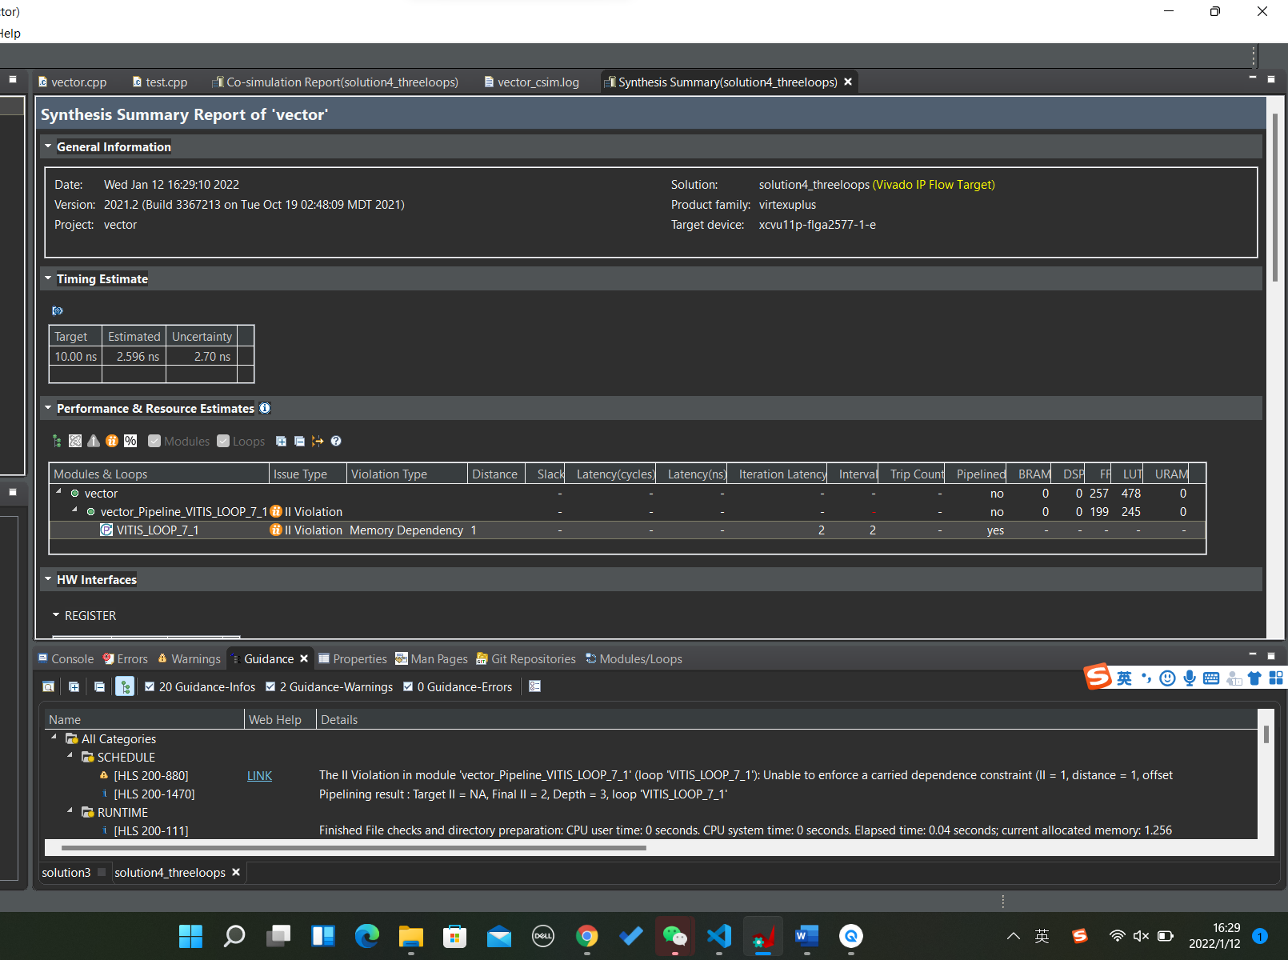

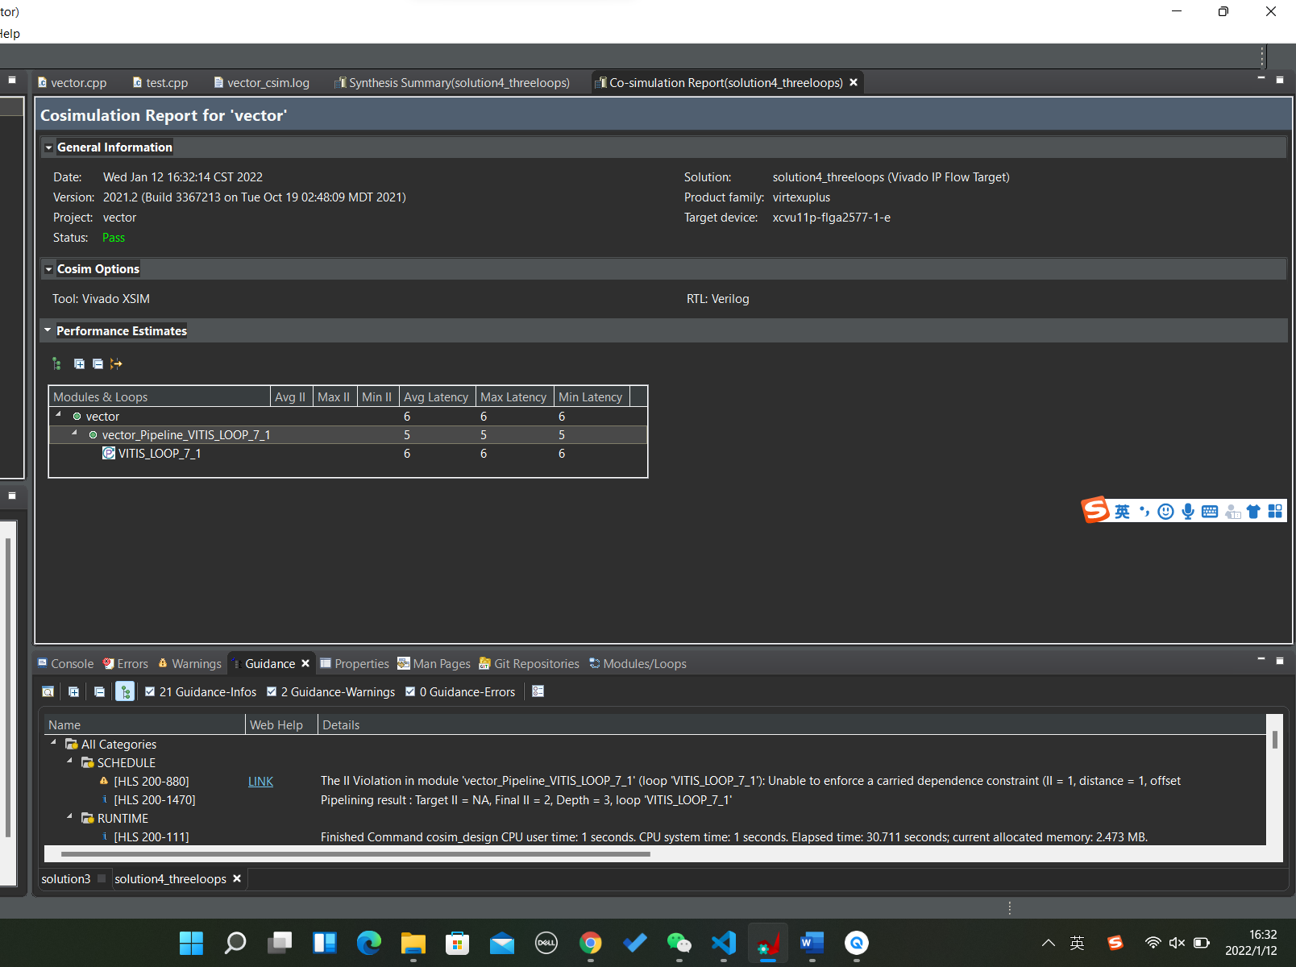

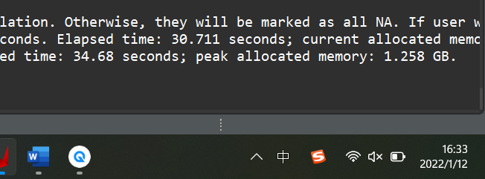

Total elapsed time: 12.649 seconds; peak allocated memory: 1.255 GB.

Total elapsed time: 14.893 seconds; peak allocated memory: 1.256 GB.

Total elapsed time: 35.107 seconds; peak allocated memory: 1.255 GB.

Adding 1 pregma: unrolling with factor of 2

Result: II violation

Total elapsed time: 7.815 seconds; peak allocated memory: 1.255 GB.

Total elapsed time: 15.277 seconds; peak allocated memory: 1.255 GB.

Total elapsed time: 32.48 seconds; peak allocated memory: 1.255 GB.

**Top is unrolling and down is no unrolling**

Decrease one loop when initializing A and B

Total elapsed time: 12.816 seconds; peak allocated memory: 1.255 GB.

Unrolling factor = 5

Total elapsed time: 8.56 seconds; peak allocated memory: 1.249 GB.

Vector addition

No pragma:

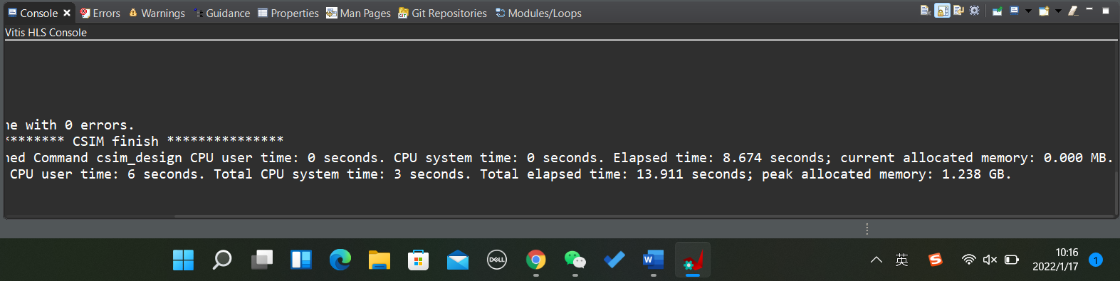

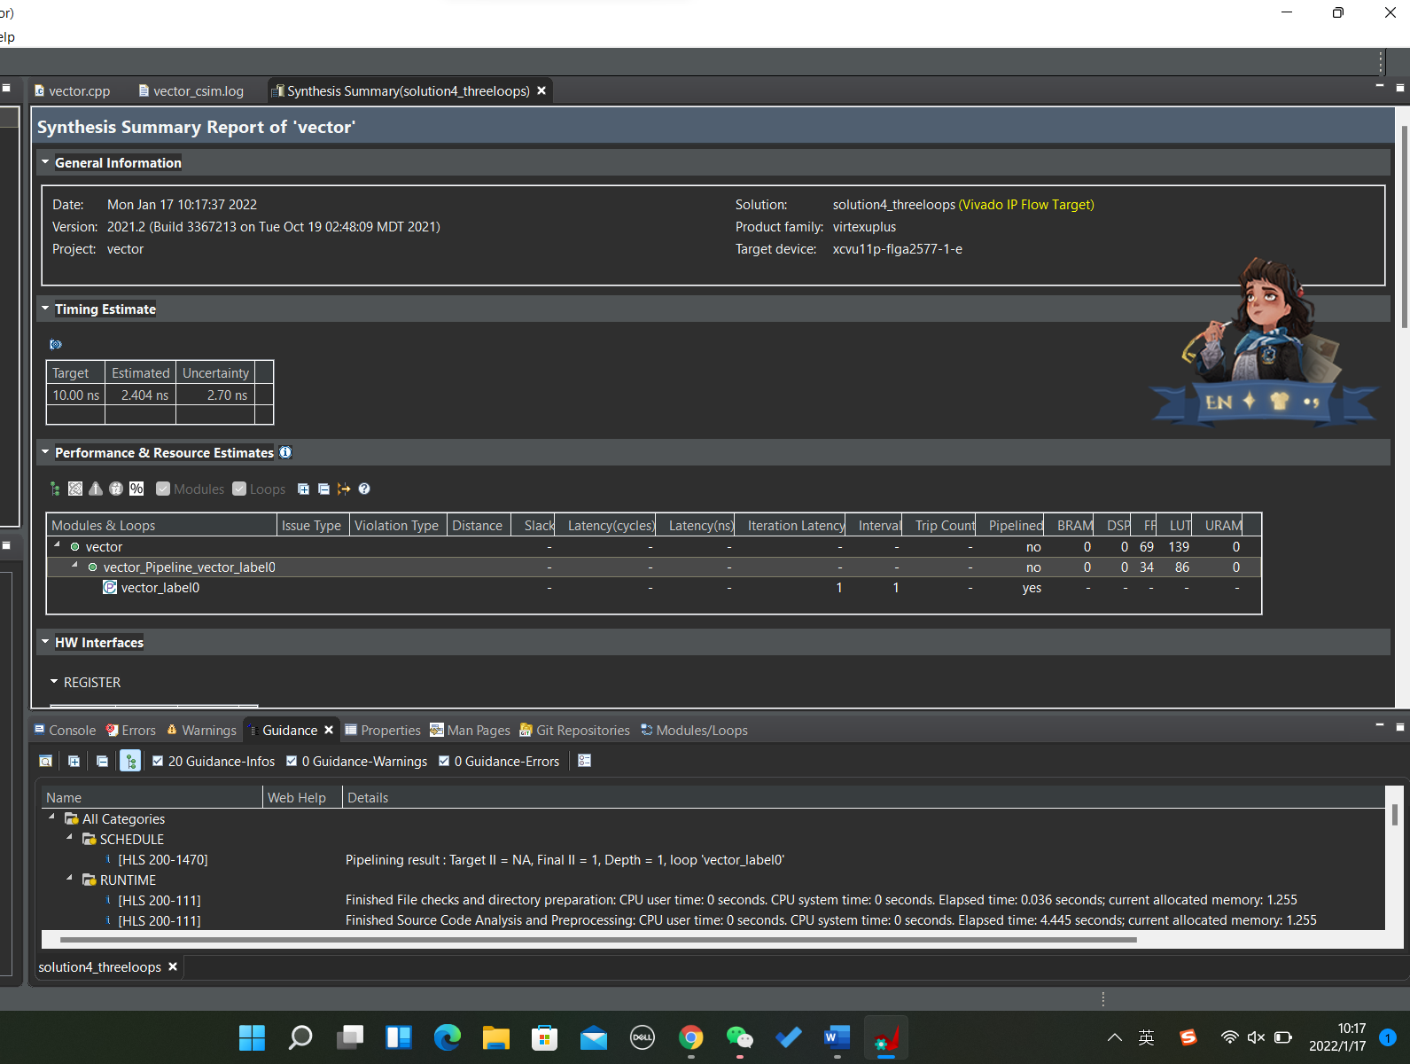

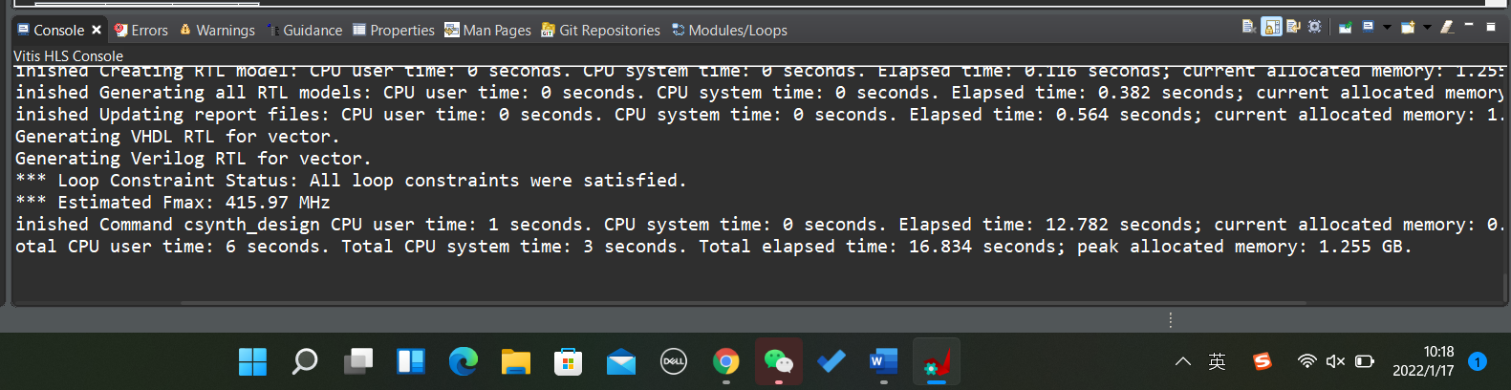

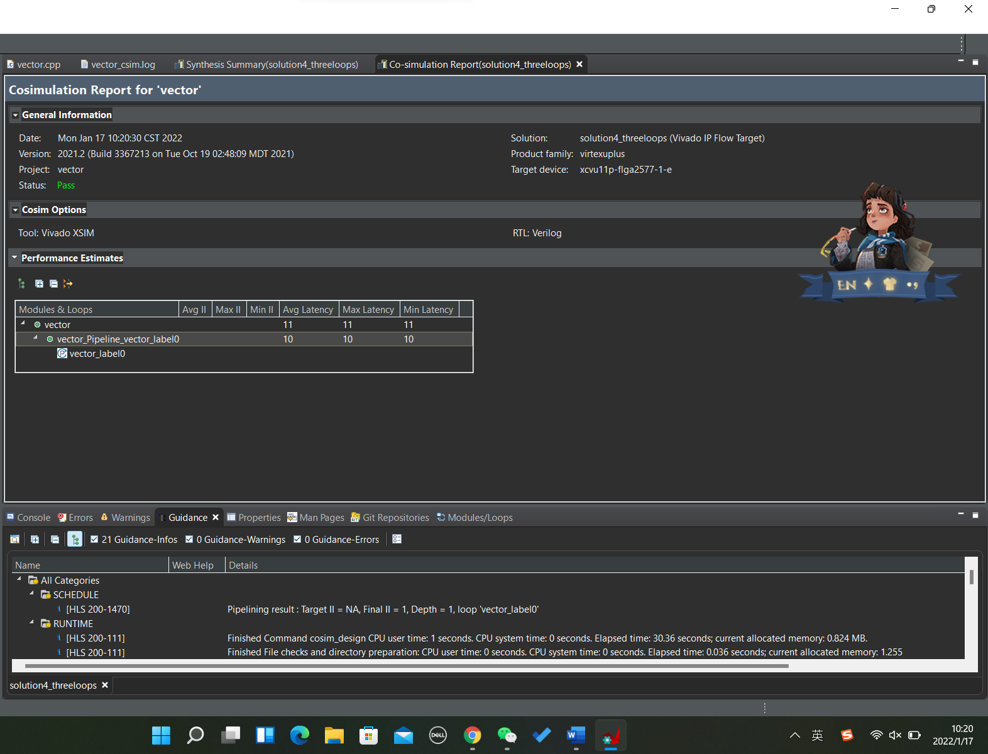

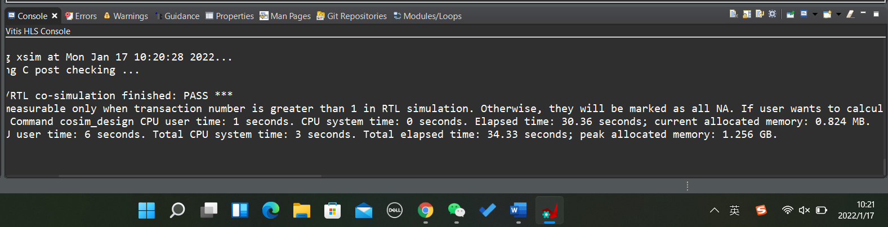

Vector addition

Pragma of unrolling with factor of 2:

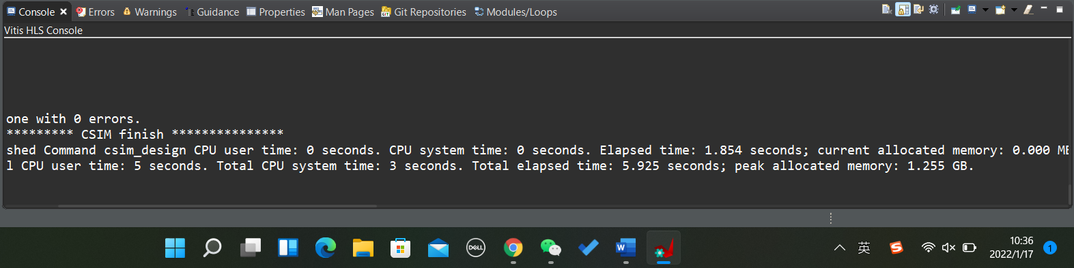

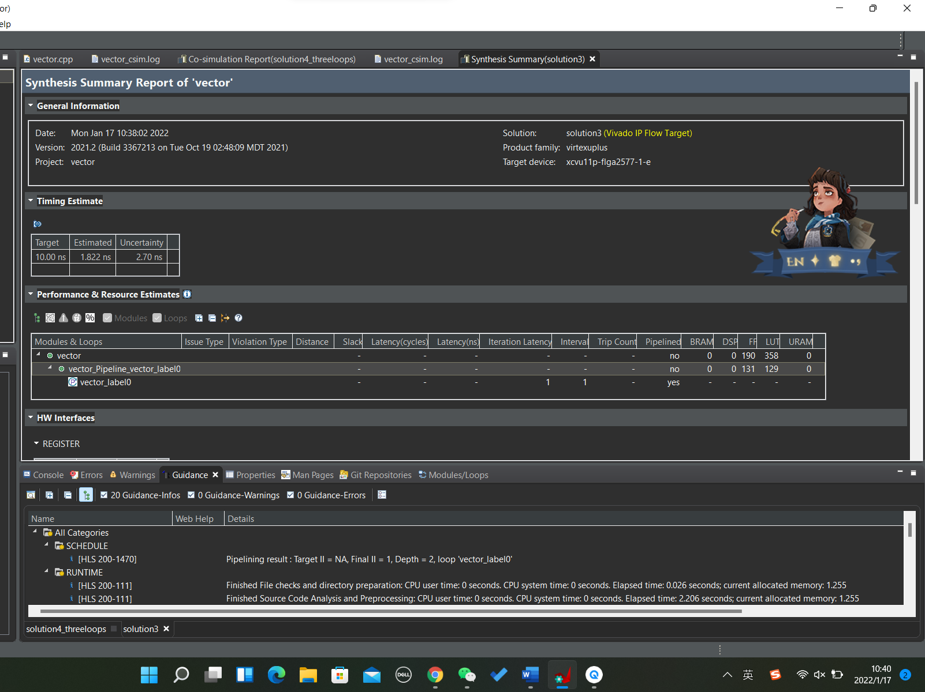

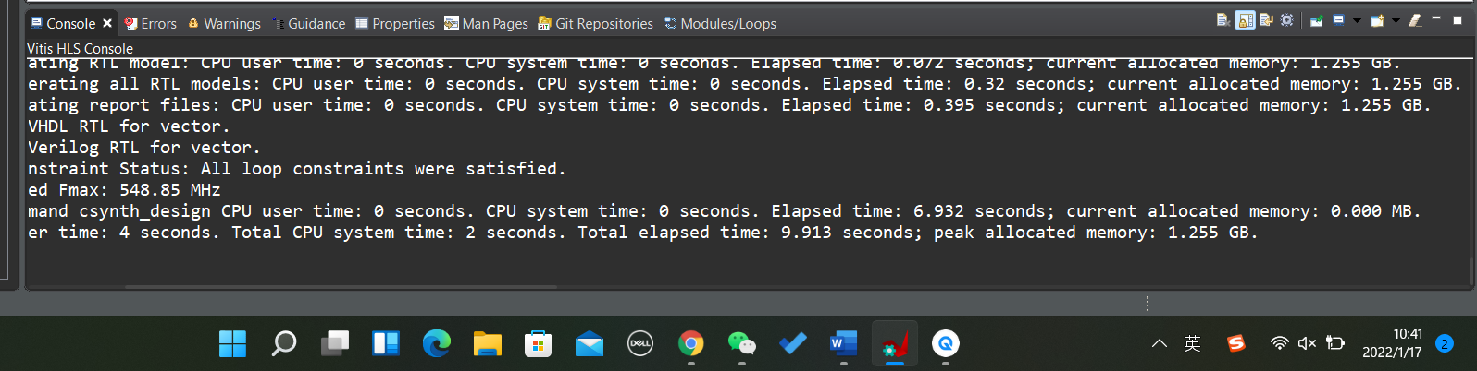

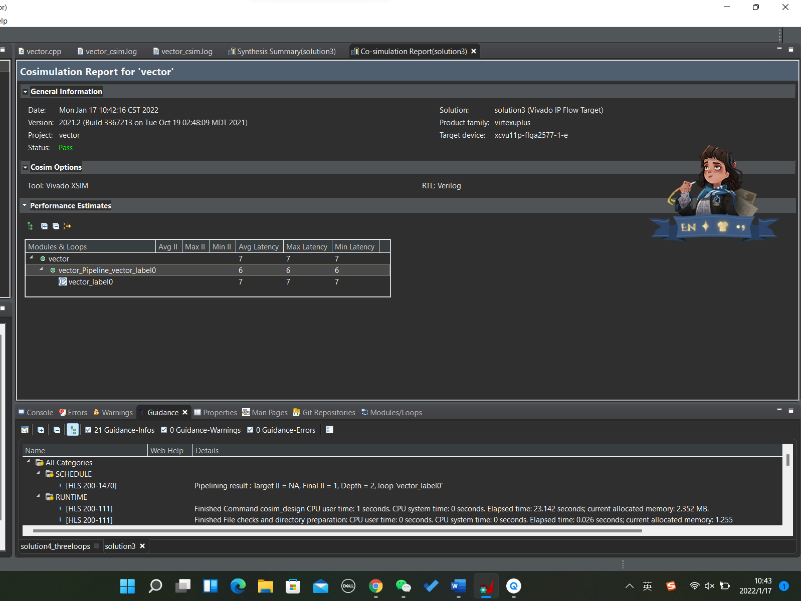

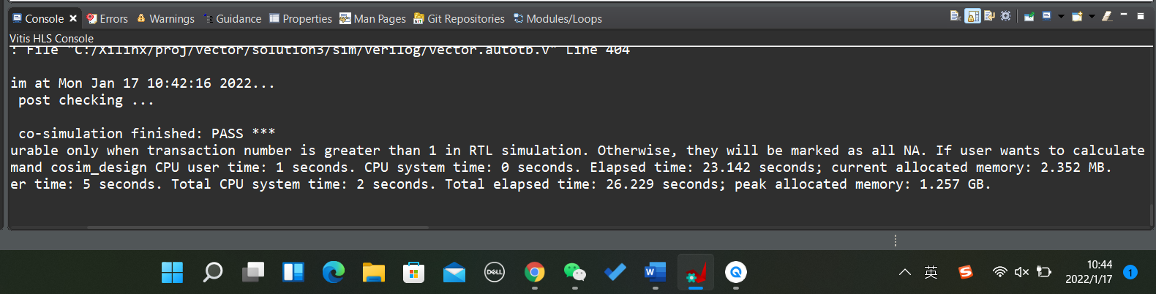

Unrolling will lift the runtime vastly.

Array partition in A, B and C

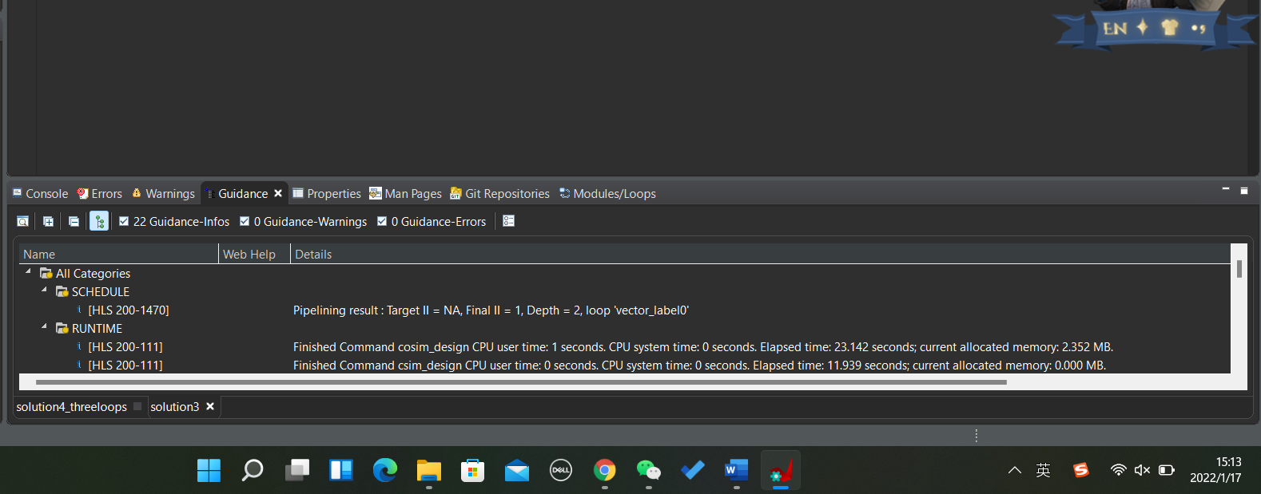

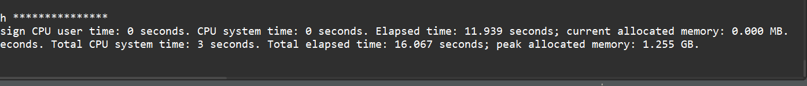

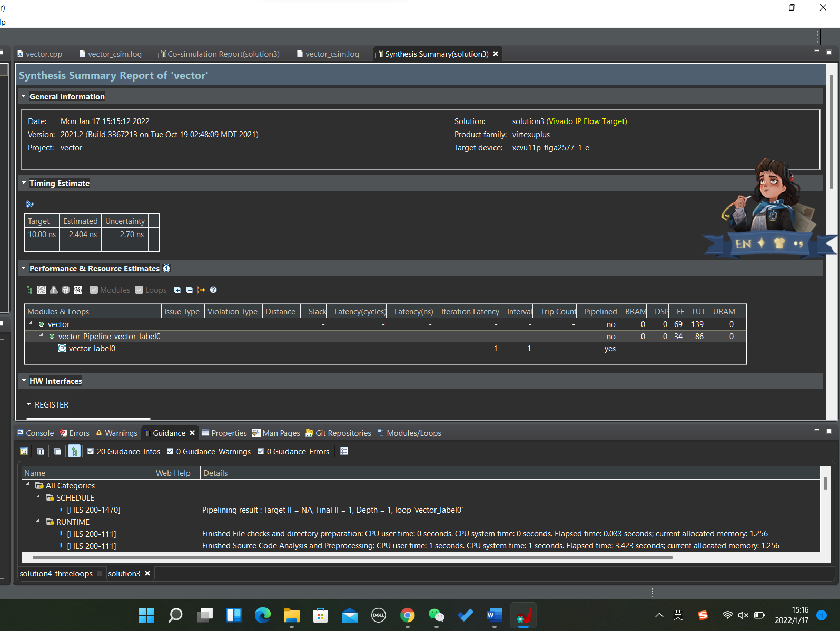

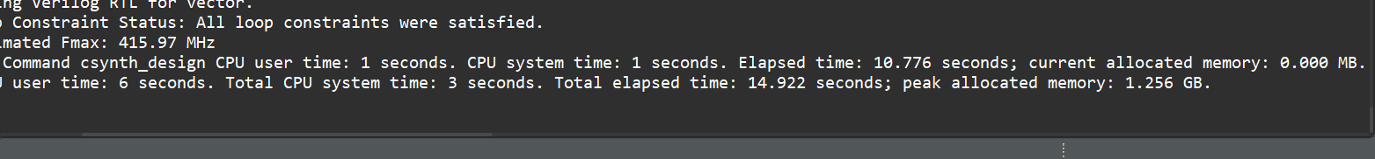

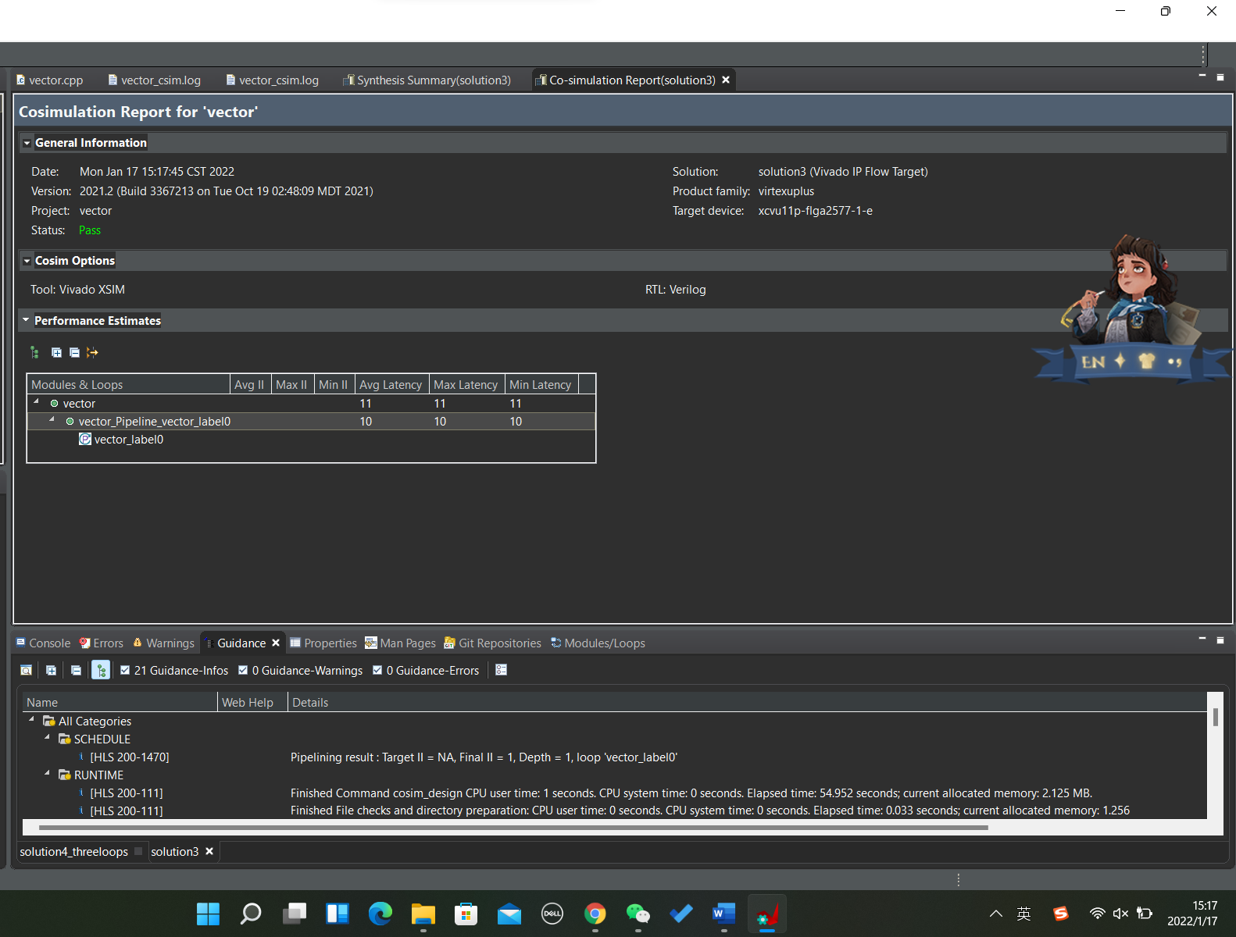

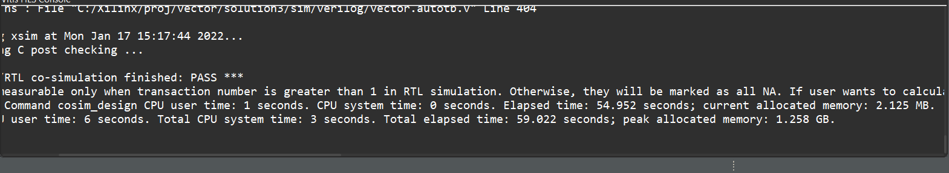

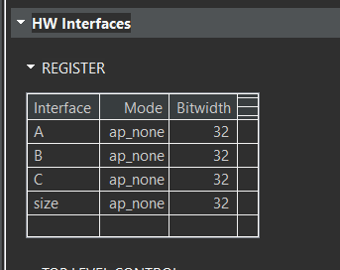

New solution:

C simulation

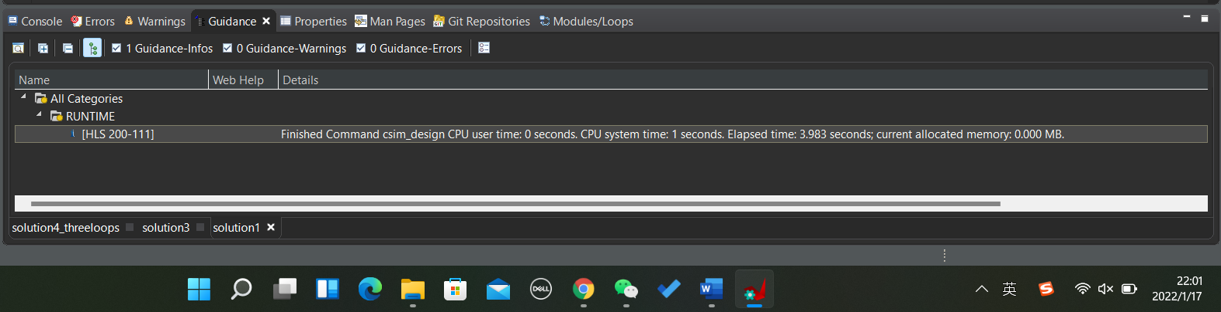

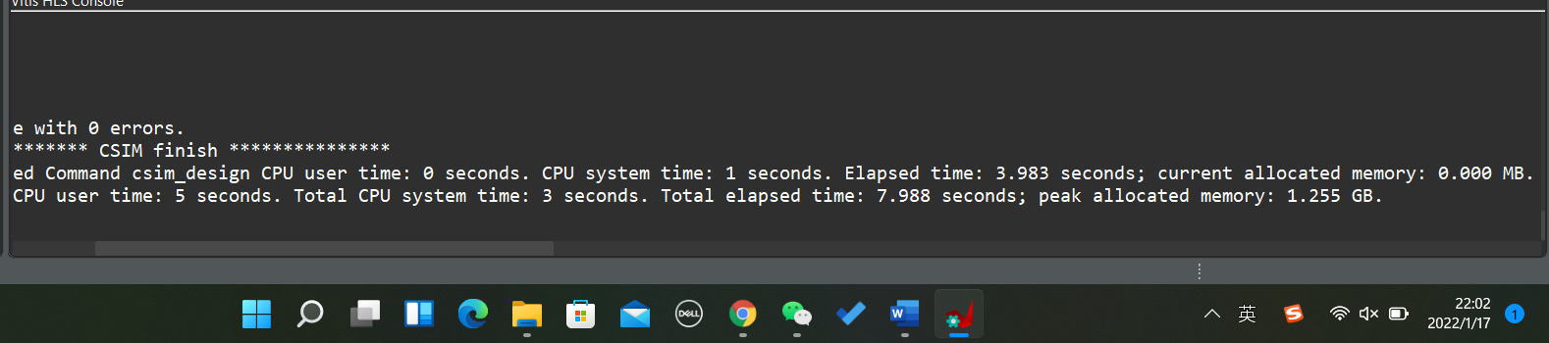

C synthesis

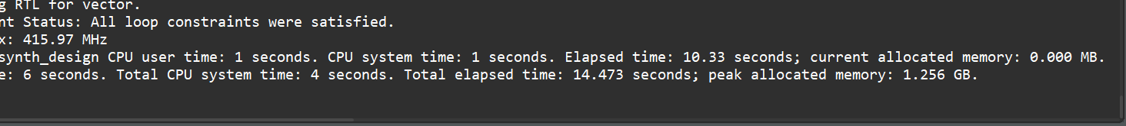

Co-simulation

