Problem b **Simple Hypotheses**

*Try running this program with no data at all (data = [ ]). What do you find? What are we displaying when we do this? Some numbers have a very low probability in this graph. What set do they belong to?*

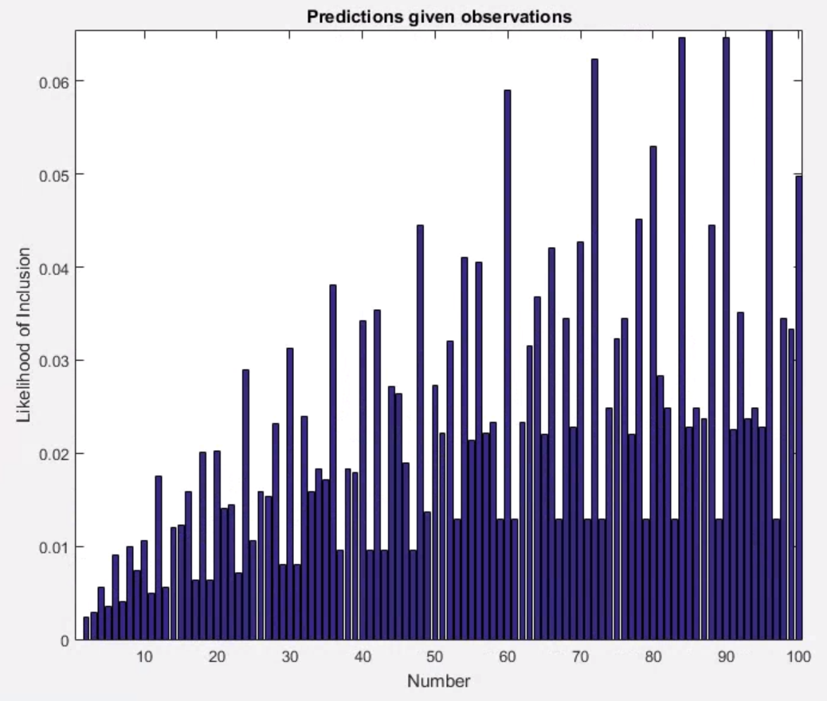 I find that some numbers appear more likely to be in the empty dataset. The numbers with the highest likelihood of inclusion are the numbers that have the most divisors, as the only hypothesis is “multiples of i,” while the numbers with the lowest likelihood of inclusion are prime numbers.

Problem c **Multiple Hypotheses**

*What does this program think about the number 37, now that is has "odd numbers" as a hypothesis? What does the program do when you remove this hypothesis?*

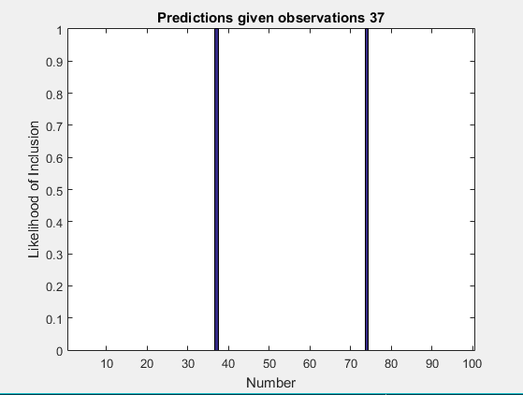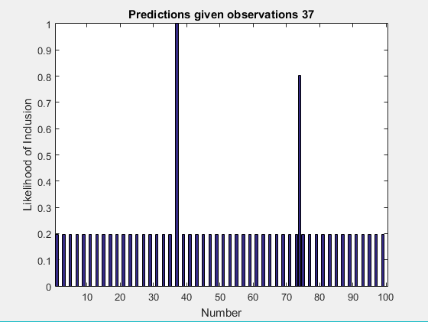Without this hypothesis, the only set that 37 can be included in is [37 74] or “multiples of 37, as the only hypothesis is “multiples of n,” and 37 doesn’t have any divisors. By adding “odd numbers,” you add one more set that 37 is part of. The likelihood of inclusion for “multiples of 37” is, however, much higher than that of “odd numbers” due to the size principle.

Problem d **Adding More Hypotheses**

*Describe the hypotheses you added. How, if at all, did changing the hypothesis space change the output of the program? What does this tell us about how learning new concepts can change our ability to make predictions about the real world? Can you give at least one example?*

List of hypotheses I added:

Problem e **Real Cognitive Science!**

*Give at least three friends the data sets from question 2 and ask them to list some candidate numbers that come quickly to mind as other members of the set. (You don't need to ask them for the probability of each and every number from 1 to 100). Compare your data to the output of your program. If you've modeled the data well, then the numbers that come to mind first should correspond to the numbers assigned high probability by your model. When (and if) there is a disparity, try to add concepts to your hypothesis space that attempt to bridge the gap. Describe the results of your survey and what changes you made. You don't need to model the data perfectly - just try to move in the right direction.*

Problem f **Experimental Results**

*After changing your hypothesis space, test the predictions of your new model. For instance, imagine people kept saying "80" when you gave them [24 72]. You might say that this is because there is a concept "years in the 20th century in which a Republican was elected president of the United States." You should now test your model on new predictions - for instance when you say [52 20], people should say "88," but not "48." (This prediction probably wouldn't hold up.) Come up with three new sets (hopefully better ones!) for your revised model and test them on three more friends. Report your results. It's okay if your results disconfirm your model. The process of testing is the important part. Compare your data to the output of your program. If you've modeled the data well, then the numbers that come to mind first should correspond to the numbers assigned high probability by your model. When (and if) there is a disparity, try to add concepts to your hypothesis space that attempt to bridge the gap. Describe the results of your survey and what changes you made. You don't need to model the data perfectly - just try to move in the right direction.*