Dear Dr. Peng and Associate Editor,

We thank you and the two anonymous reviewers again for constructive comments toward improving our manuscript “OBSrange: A new tool for the precise remote location of Ocean Bottom Seismometers”. Our response to each reviewer comment is in red below. Based on reviewers’ suggestions, we have added two new supplementary figures: S11 which compares model uncertainties estimated from the model covariance matrix with the bootstrap estimates and S12 which explores the effects of azimuthal gaps on model recovery. We have also added the OBSrange project to IRIS SeisCode and include there the full Young Pacific ORCA survey dataset. Finally, we prefer *not* to have the README file published alongside the paper but include it only as an aid for reviewers.

Regards,

J. Russell, Z. Eilon, & S. Mosher

**Reviewer #1:** This manuscript presents an algorithm to located OBS with transponder data. This is a useful contribution because at present the available algorithms are either proprietary or ad hoc. I suspect a lot of people will make use of this code.

I have read through the manuscript and I think the authors have responded well to my comments.

The only significant quibble concerns my comment

"Line 120-146. This error analysis is very sophisticated and probably totally unnecessary for most applications. The errors shown in the figures (e.g., Figure 2) look ellipsoidal so have the authors attempted to use the covariance matrix to get errors based on a travel time uncertainty calculated from the travel time misfits? How do these compare with the bootstrap method?"

The authors response to this is a little unsatisfactory. They argue that error estimates from the covariance matrix depend on an estimate of the data uncertainty and use this as a reason not to do the comparison I suggest. The data uncertainty for this problem can be estimated very simply from the RMS data misfit (with a small/negligible correction for the number of free parameters). I think it would be interesting to perform this comparison but I accept that it is not necessary

We thank the reviewer for their suggestion to explore simpler methods for quantifying model uncertainty. We have carried out the suggested comparison for 10,000 synthetic PACMAN realizations with varying data coverage, as summarized in a new supplemental figure S11 (shown below). We find that estimating model uncertainties directly from the model covariance matrix, while similar, is not strictly equivalent to estimating them from the bootstrap algorithm, as shown by the low correlation (R^2 << 1) between uncertainties for all four model parameters. In particular, the uncertainties estimated from the bootstrap method span a wider range than those estimated simply from the covariance matrix. This is likely due to the oversimplifying assumption in calculating the covariance matrix that all data uncertainties are uncorrelated and can be estimated from the RMS data misfit. We add a reference to Figure S11 in Section 2.3 of the main text.

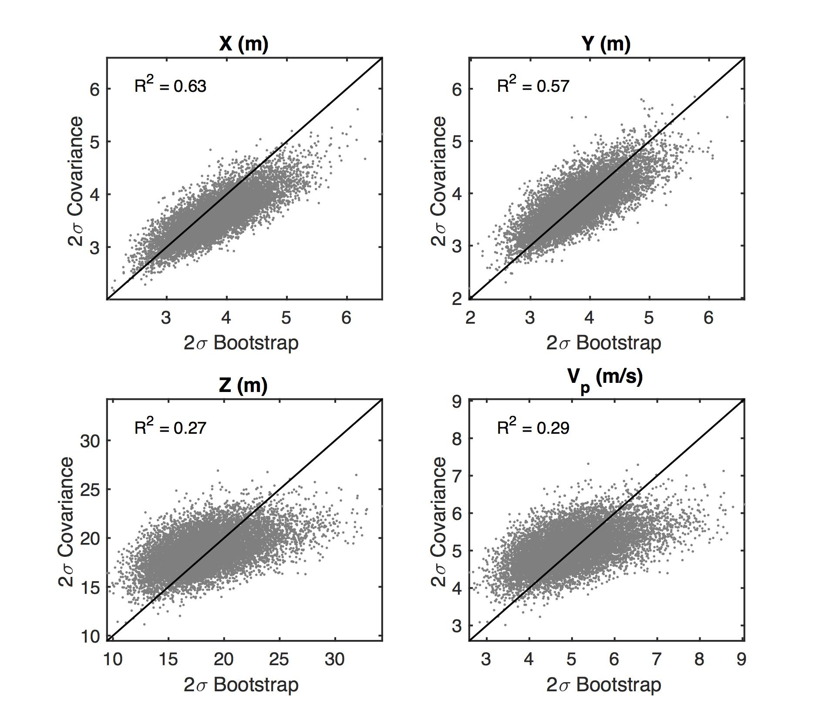

Figure S11.

Also, in the Data and Resources section it states

All 2018 Young Pacific ORCA survey data are available upon request by contacting the author J.B. Russell.

I have not looked to see if the authors algorithm is already available at IRIS but I would have thought that it would make sense to share an example data set and solutions with the algorithm since that is a good way for many users to understand how to use a new code.

We have included three example station files from Young Pacific ORCA as part of the OBSrange package, as now outlined in the README. The code is now listed on IRIS SeisCode at <https://seiscode.iris.washington.edu/projects/obsrange>. The complete Young Pacific ORCA survey data is available there as well. The Data and Resources section has been updated to reflect this.

**Reviewer #2:** The authors did or tested almost all of the modifications suggested by the reviewers: this makes the article much stronger. I only recommend "minor revisions" because I don't think that the authors adequately discussed/studied the effect of unequal azimuthal distribution. I would have preferred that they either investigate this case analytically (fairly simple for a PAC-MAN or diamond survey) or ran a bootstrapping test: the idea being for example to have all returns on one "side" of the instrument and only 1/X returns on the other side: a fairly common case and one that I still think could cause bias.

But this is a minor point and, if the authors don't investigate this themselves, some other groups soon will if the code is publicly released.

We thank the reviewer for this suggestion. The case with unequal azimuthal distribution is actually treated within the synthetic tests where, as described in Section 3.3, we omit random back-azimuthal swaths of data. The effects of this unequal distribution are currently tacitly included within the average location uncertainties we report from the bootstrap synthetic tests. To tease out the effect of azimuthal coverage more fully - per the reviewer’s suggestion - we have added a supplemental figure S12 (shown below) showing how the location error changes as the “gap” (defined as the maximum azimuthal difference between returns) increases. We do not find a significant bias in model uncertainties with increasing azimuthal gap up to ~60º. Note the relatively consistent (approximately 5º–6º) median of the azimuthal gaps between returns for all surveys. We have added a sentence to the Discussion on the robustness of the 1Nm PACMAN geometry to azimuthal gaps out to ~60º.

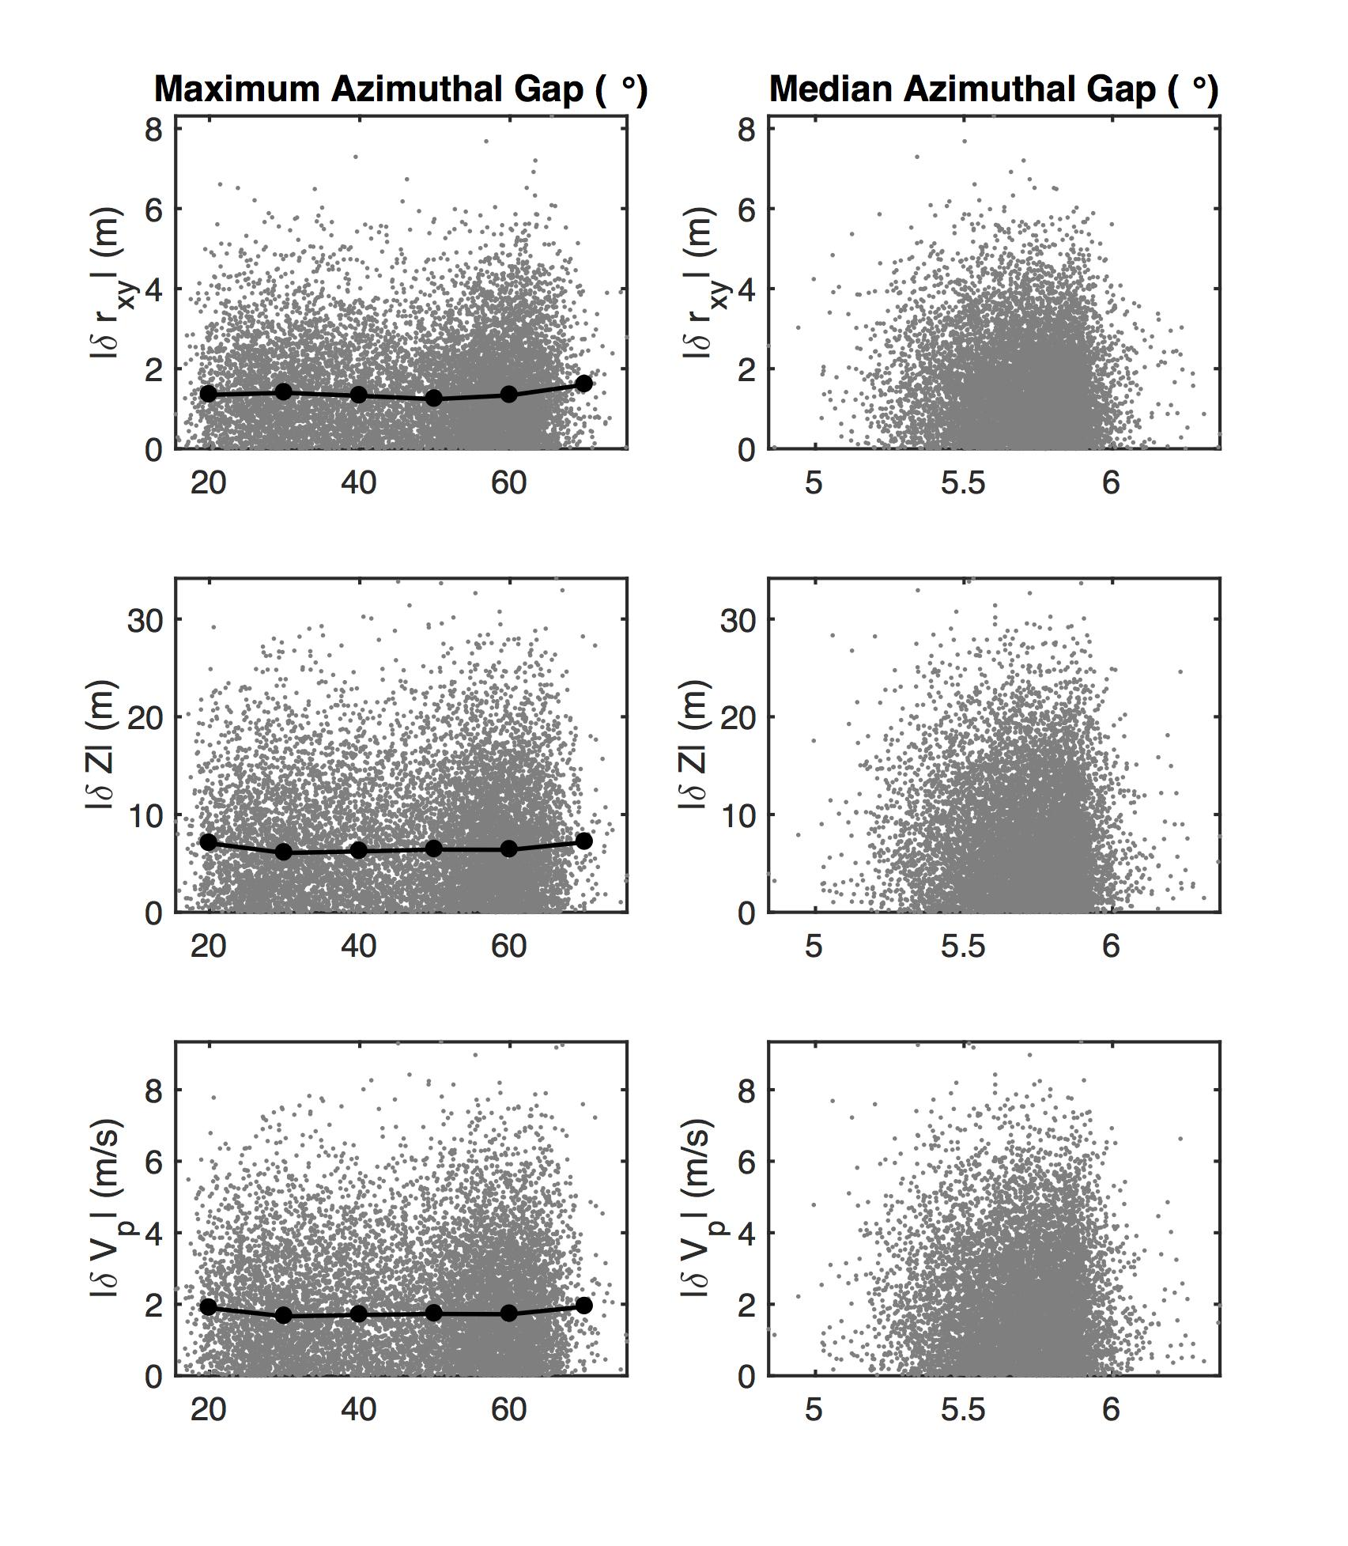

Figure S12. Effects of azimuthal survey gaps on model recovery for 10,000 synthetic PACMAN realizations at 1Nm radius and 5 km depth. As described in the main text, three sectors of data are systematically removed with random central azimuth and half-width standard deviation of 20º for each realization. (left) Horizontal location, depth, and water velocity misfit as a function of maximum azimuthal difference between returns and (right) median azimuthal difference between returns. The black circles denote 10º binned averages, showing no significant bias with increasing maximum azimuthal gap up to ~60º.

**Reviewer #3:** Review of esupp: Please use labels "Figure Sx' rather than 'Figure x'. Please revise the README file to include appropriate caption descriptions of the figures, add references (lots of places it says 'refs', add reference, 'our paper' etc). And when these references are added, please add a reference list in the README file.

Our electronic supplement already uses labels “Figure Sx” rather than “Figure x”, except when referring directly to figures from the main text. Perhaps we misunderstand the reviewer’s point and need further clarification.

We have updated the README as requested; however, it should be noted that we prefer *not* to have the README published as supplemental material alongside the paper. Rather, it will be included within the repository on IRIS, allowing for modifications/updates with future versions of the code, should they be necessary. We include it here only as an additional aid for the reviewers, but not for publication.