**Task:**

I want 4 line-charts in APA7 format. Right now these line-charts are in the form of jamovi outputs from my analysis (indicated as Figure 1- 4 below) that I want to reproduce in APA7 format. I have attached instructions under each figure as well as their simple effects & EMMS tables to reproduce these charts.

For Figures 1-4: Produce all figures in the same style, format, same axis ie for the X-axis use the same time point of 0,4,8,12 months

**Figure 1**

*Effect of Outcome Expectancy on BAI Scores at Post-Treatment and Follow-Up*

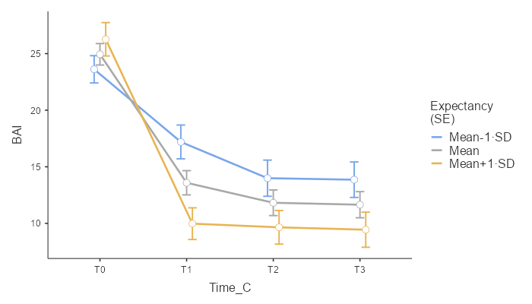

**Instructions for APA7 formatting**

Format Figure 1 & 2 to be the same as the following reference plot (from the parent study)

**Figure 1**

1. Use Figure title as provided
2. EMMS data provided in file “Mixed Model BAI Expectancy”
3. Use **SE bars** (please make them look small and not clutter the plot)
4. Prefer to have horizontal gridlines (as per reference plot) but not essential
5. Insert a vertical dotted gridline at 4-month (as per reference plot to signify post-treatment)
6. Change the legend to:

**Outcome expectancy levels**

**Low**

**Average**

**High**

1. Have the 3 levels of Expectancy in different colours or patterns
2. Change Y-axis to same as the reference plot (do not use T0 to T3):

**Time (months)**

**0**

**4**

**8**

**12**

1. Change X-axis to same as the reference plot:

**Estimated BAI (95% CI)**

**Figure 2**

*Effect of Treatment Credibility on BAI Scores at Post-Treatment and Follow-Up*

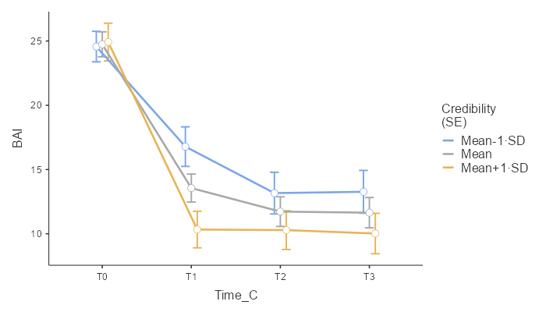

**Instructions for APA7 formatting**

**Figure 2**

1. Use Figure title as provided
2. EMMS data provided in file “Mixed Model BAI Credibility”
3. Use **SE bars** (please make them look small and not clutter the plot)
4. Prefer to have horizontal gridlines (as per reference plot) but not essential
5. Insert a vertical dotted gridline at 4-month (as per reference plot to signify post-treatment)
6. Change the legend to:

**Treatment credibility levels**

**Low**

**Average**

**High**

1. Have the 3 levels of Credibility in different colours or patterns
2. Change Y-axis to same as the reference plot (do not use T0 to T3):

**Time (months)**

**0**

**4**

**8**

**12**

1. Change X-axis to same as the reference plot:

**Estimated BAI (95% CI)**

**Figure 3**

*

**Instructions for APA7 formatting**

**Figure 3**

1. Use Figure title as provided
2. EMMS data provided in file “Mixed Model CSR Expectancy”
3. Use **SE bars** (please make them look small and not clutter the plot)
4. Prefer to have horizontal gridlines (as per reference plot) but not essential
5. Insert a vertical dotted gridline at 4-month (as per reference plot to signify post-treatment)
6. Change the legend to:

**Outcome expectancy levels**

**Low**

**Average**

**High**

1. Have the 3 levels of Expectancy in different colours or patterns
2. Change Y-axis to same as the reference plot (do not use T0 to T3). Please note that CSR didn’t collect any data for 8 months follow-up so visually show as per the reference plot (with no mark & SE bars at 8-months)

**Time (months)**

**0**

**4**

**8 (Note there is no mark or SE bar at this timepoint)**

**12**

1. Change X-axis: **Estimated CSR (95% CI)**

**Figure 4**

*

**Instructions for APA7 formatting**

**Figure 4**

1. Use Figure title as provided
2. EMMS data provided in file “Mixed Model CSR Credibility”
3. Use **SE bars** (please make them look small and not clutter the plot)
4. Prefer to have horizontal gridlines (as per reference plot) but not essential
5. Insert a vertical dotted gridline at 4-month (as per reference plot to signify post-treatment)
6. Change the legend to:

**Treatment credibility levels**

**Low**

**Average**

**High**

1. Have the 3 levels of Credibility in different colours or patterns
2. Change Y-axis to same as the reference plot (do not use T0 to T3). Please note that CSR didn’t collect any data for 8 months follow-up so visually show as per the reference plot (with no mark & SE bars at 8-months)

**Time (months)**

**0**

**4**

**8 (Note there is no mark or SE bar at this timepoint)**

**12**

1. Change X-axis: **Estimated CSR (95% CI)**