Abstract
A photo mosaic is an approximation of an image using a given set of images This problem was formulated from the work previously achieved on domino portraits by a team of Insight researchers. Photo mosaics have been generated most often using integer linear programming techniques that provide optimal solutions, but these can be slow and do not scale well to larger mosaics. In this paper we propose an approach that overcomes these limitations and efficiently provides high quality portraits.

1. Introduction
Our approach combines image processing using combinatorial optimization and constraint programming. Our problem was originally viewed as an assignment problem, however to provide a scalable model we accepted duplicate images giving a subsequent optimal solution and empirically, it can be shown the results were both a reduction in search time and a high quality photo mosaic.

2. Cost Matrix
A set of images can be simplified into a constrained palette of RGB values which we used to produce a photo mosaic. Similarly, we break down the photo we wish to make a mosaic of into a list of RGB values. In order to find the optimal solution, a combinated weighted Euclidean distance formula is used to calculate the colour cost or distances between two RGB values to create an optimal matching between images and tiles of the chosen photo.

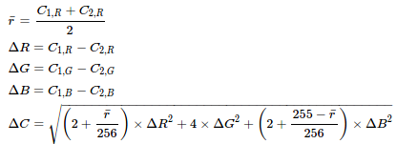
Figure 1: Combinated Weighted Euclidean Distance formula

The output of this function is a cost matrix which forms the input of our Numberjack model.

3. Constraints Model
Numberjack[1] is a modelling package written in Python for constraint programming. Our Numberjack model takes the cost matrix and calculates the cheapest cost using the solver SCIP. Originally the model was based on an assingment problem however as the size of the problem was increased, the search time grew exponetially. In order to overcome this limitation we allowed duplicates.
Our model produces a boolean matrix which is flattened into a list of co-ordinates for the program to slot a given image from the set of images to its best match given every other match in the tiles of the chosen photo.
4. Image Processing
Pillow[2], a fork of Python, is an imaging library that provided us with the image manipulation tools to produce a high quality mosaic image. After experimenting, we concluded that blending the original photo with the mosaic image at a chosen opacity and using edge-enhancement resulted in clearer definition and higher precision making of the photo mosaic.

5.Evaluation
This approach provides optimal solutions but higher quality solutions, for example, a mosaic made of 5,000 images, can only be produced if the user is willing to allow for a longer period of time. However it is moreover very robust to the increase of the size of the problem....

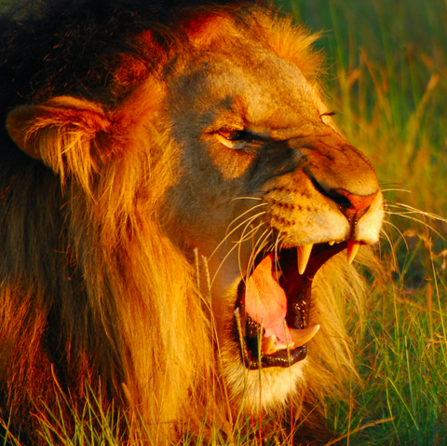

Figure 2: Original Photo
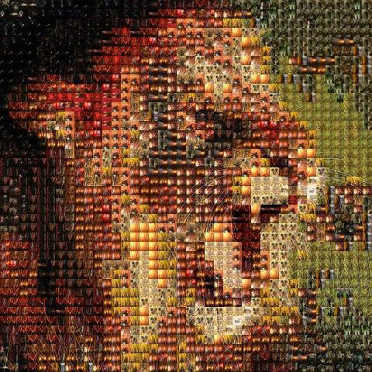

Figure 3: Photo Mosaic using 1600 images (40x40)

Acknowledgments
This publication has emanated from research conducted with the financial support of Science Foundation Ireland (SFI) under the SFI Scholarship Program.

8. References
[1]
[2]

