[UNIVERSITY NAME]
[College / Department Name]
CC-103 — DATA STRUCTURES AND ALGORITHMS
FINAL CASE STUDY DOCUMENTATION
Sari-Sari Store Inventory & Sales Management System
Business / Organization: [Name of the Sari-Sari Store Interviewed]
Section: [Section] Group No.: [Group No.]
Members: [Member 1, Member 2, Member 3, Member 4 — Group Leader marked]
Instructor: John Sebastian P. Mangilin
Date: [Date of Submission]

2. Background of the Business
[Business name] is a small neighborhood sari-sari store that sells everyday household items such as canned goods, snacks, drinks, and basic home supplies to residents in its immediate community. Like most sari-sari stores, it operates as a single-proprietor business run day-to-day by the owner, often with help from a family member during peak hours.
The store generates income primarily through small, frequent retail transactions rather than bulk sales, which makes accurate, up-to-date tracking of stock levels and daily sales especially important: a shortage in a fast-moving item (e.g. instant noodles, canned goods, soft drinks) directly costs the owner sales, while overstocking a slow-moving item ties up limited capital.
This section should be completed with the actual details gathered during the group's interview: the store's exact name and location, how long it has been operating, approximate daily transaction volume, and the number of people involved in running it.

3. Existing Business Process

3.1 Narrative Description
Before the proposed system, the store's inventory and sales process was entirely manual. When a customer requests an item, the owner checks the physical shelf by sight to judge whether it is in stock, then computes the price (and change, if needed) mentally or with a calculator. If a sale is recorded at all, it is jotted into a notebook, with no running computation of totals. To decide what to reorder, the owner periodically reviews the shelves and the notebook from memory, then makes a supplier trip — often without a precise quantity in mind.

3.2 Business Process Flow
The diagram below contrasts the current manual process with the process as supported by the proposed program. [To be replaced/refined with the actual flow observed during the group's interview.]
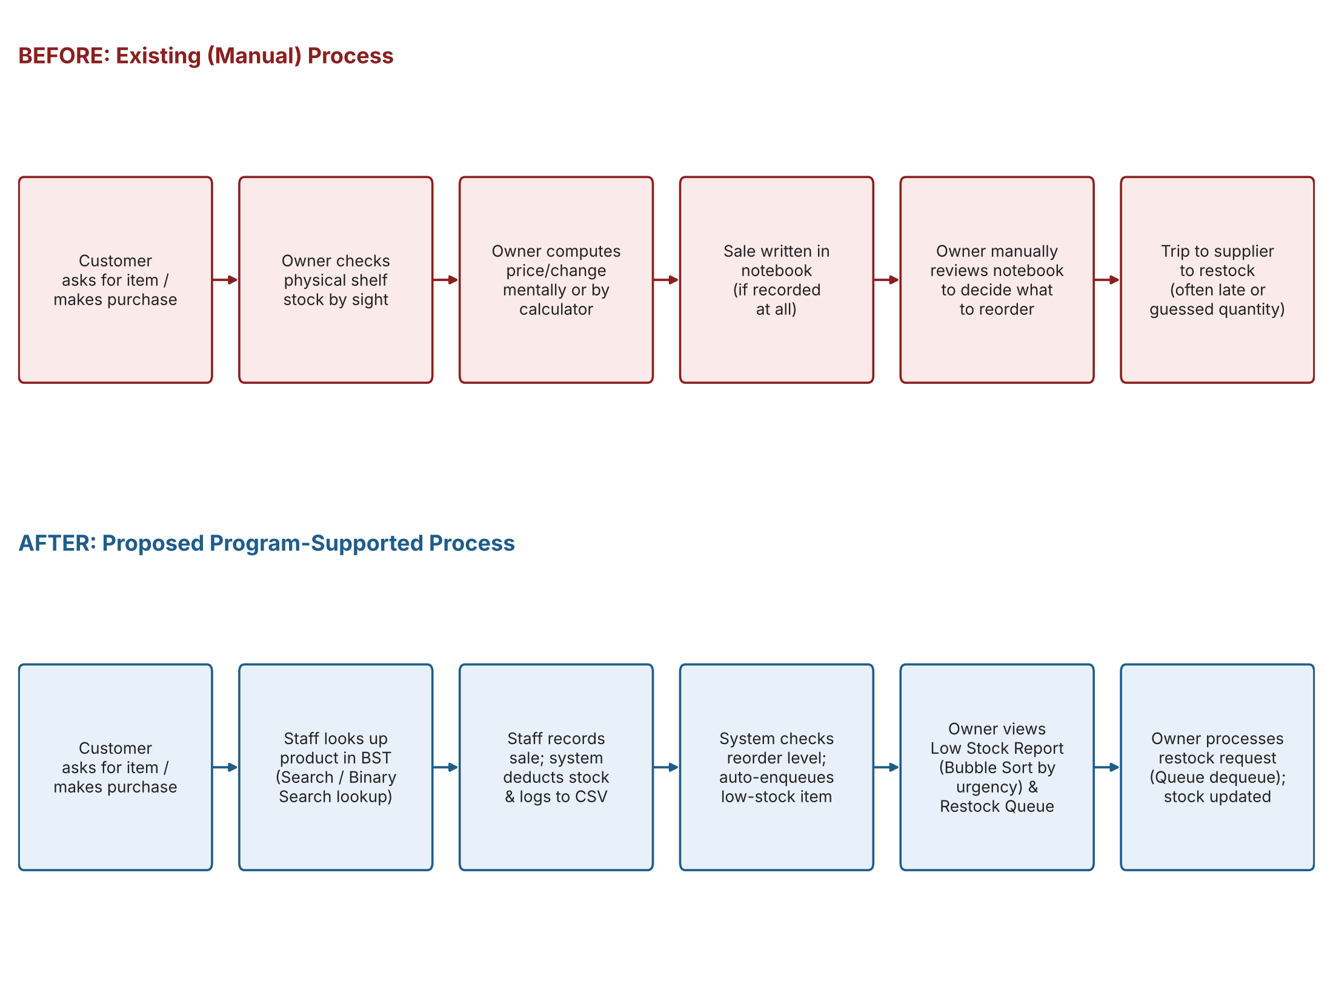

3.3 Persons Involved
- Store Owner — manages stock, sets prices, decides on restocking, and performs most sales transactions.
- Store Attendant / Family Helper (if any) — assists with sales during peak hours.
- Customers — request and purchase items.
- Suppliers — deliver stock upon the owner's reorder trip or call.

3.4 Inputs and Outputs
- Inputs: product names and quantities being sold, new stock deliveries, supplier prices, customer requests.
- Outputs (manual, before): notebook entries (if any), the owner's memory of what needs restocking.
- Outputs (system, after): inventory.csv and sales.csv records, low-stock reports, restock queue, sales rankings, and a printed receipt-style confirmation per sale.

4. Problems Identified
- No reliable, centralized record of current stock levels — the owner relies on visually checking the shelf, which is slow and error-prone as the catalog grows.
- Sales are inconsistently recorded, making it hard to know which products sell well or how much revenue was made on a given day.
- Restocking decisions are made from memory, which leads to some items running out (lost sales) while others are over-ordered (tied-up capital).
- There is no way to correct a mistaken sale entry without manually crossing out and rewriting notebook entries.
- No way to quickly search sales history for a specific product when questions come up (e.g. supplier reconciliation).

5. Proposed Program Solution

5.1 Purpose
The Sari-Sari Store Inventory & Sales Management System is a console-based C++ program that replaces the store's manual notebook process with structured, searchable, and sortable digital records — stored in plain CSV files so no database setup is required — while directly applying the data structures and algorithms required by this course to real operational needs of the store.

5.2 Intended Users
The store owner and any attendant who handles sales at the counter. The interface assumes a single operator at a time, matching how a small sari-sari store is actually staffed.

5.3 Major Functions
Full catalog management (add/search/list/edit/delete), stock updates, sale recording with automatic receipt and stock deduction, a low-stock report, a restock request queue, sale undo, sales history search, a quick product lookup, and a top-sales ranking. The complete function-by-function breakdown is given in Section 9.

5.4 Scope and Limitations
- Single-store, single-operator scope — no multi-branch or multi-user concurrency support.
- CSV-file storage only, per the case study's requirement — no external database.
- Console/terminal interface only, run locally on the store's computer.
- Assumes product names are unique identifiers within the BST; two products cannot share an identical name.

6. Data Structures Used
The program meaningfully integrates three required data structures, each chosen because the actual business process it supports has that structure's defining behavior — not merely to satisfy a minimum count.
Data Structure | Data Managed | Business Problem Addressed | Why Appropriate
Binary Search Tree (BST) | Product inventory records, keyed by product name (case-insensitive) | Owner cannot quickly find a product's price or stock level among dozens of items without flipping through a notebook | Products are naturally looked up by name; a BST keeps them in sorted order automatically and gives O(log n) search/insert/delete instead of scanning a flat list, while in-order traversal yields the catalog already alphabetized for reports.
Queue (custom linked-list, FIFO) | Restock requests — which products need reordering and when they were flagged | The owner forgets which items were already low on stock and which still need a supplier trip, especially when several run low around the same time | Restock requests must be handled in the order products actually ran low — first flagged, first restocked — which is exactly First-In-First-Out behavior, so a Queue is the natural fit rather than an arbitrary list.
Stack (custom array-based, LIFO) | History of recorded sales, for undo support | A wrong quantity or wrong item is occasionally rung up at the counter, and there was no way to reverse a mistaken entry without manually editing the notebook | Only the most recent sale is ever the one that needs correcting in day-to-day use, so Last-In-First-Out access is the right shape: push on every sale, pop to undo the latest one.

7. Searching Algorithm

7.1 Linear Search — O(n)
Used in Search Sales History (menu option 13). The sales log is stored chronologically (append-only, as sales happen), not sorted by product name, so there is no ordering to exploit — every record must be checked. Linear Search scans the log front to back and collects every matching sale (a product can be sold many times), then reports the count and total value sold, directly supporting the owner's need to reconcile how much of a given item has moved.

7.2 Binary Search — O(log n)
Used in Quick Product Lookup (menu option 14). The product catalog, via the BST's in-order traversal, is already guaranteed sorted by name. Binary Search exploits that order to locate a product in O(log n) comparisons instead of scanning the whole list — the same lookup the BST itself performs internally, offered here as an independent, explicitly-demonstrated implementation of the required algorithm.

8. Sorting Algorithm

8.1 Bubble Sort — O(n²)
Used in the Low Stock Report (menu option 4) to order at-risk products ascending by quantity, so the most urgently needed item appears first. The low-stock list is always small (a handful of items at most in a sari-sari store), so Bubble Sort's quadratic cost never becomes noticeable, while its simplicity makes the urgency ordering easy to verify by hand.

8.2 Merge Sort — O(n log n)
Used in Top Sales by Amount (menu option 15) to rank the full sales log descending by peso value. Unlike the low-stock list, the sales log grows continuously over the life of the store and can become large — exactly the situation where Merge Sort's O(n log n) guarantee matters over Bubble Sort's O(n²) worst case, which is why the two required sorts were deliberately paired with a small list and a growing list respectively.

9. Major Program Functions
Function / Module | Purpose | Data Structure / Algorithm Used | Business Requirement Addressed
Add new product | Register a new item in the catalog | BST insert | Owner cannot currently add new products without rewriting the notebook
Search product | Find one product by name | BST search | Replaces manually scanning the shelf/notebook for a price or stock check
List all products (sorted) | Display the full catalog alphabetically | BST in-order traversal | Gives an always-sorted catalog view for stocktaking
Low stock report | Show items at/below reorder level, most urgent first | Bubble Sort (by quantity) | Owner currently decides what to restock from memory/guesswork
Update stock (restock/deduct) | Adjust on-hand quantity | BST update + Queue enqueue/removal | Keeps stock counts accurate after deliveries or corrections
Edit product pricing | Change cost/selling price | BST update | Prices change often (supplier cost changes) and must stay accurate
Delete product | Remove a discontinued item | BST delete (incl. two-child case) | Clears discontinued items instead of leaving stale notebook entries
Record a sale | Log a counter sale and deduct stock | BST update, CSV log, Stack push, Queue enqueue (if now low) | Core transaction the whole system exists to capture — currently done in a paper notebook or not recorded at all
Sales report | Chronological list of all recorded sales | CSV read | Gives the owner a day-to-day sales trail that did not exist before
View restock queue | Show pending restock requests, oldest first | Queue traversal (non-destructive) | Lets the owner see everything still waiting to be reordered
Process next restock request | Dequeue and guide restocking of the oldest-flagged item | Queue dequeue + BST update | Processes restocking in the fair, first-flagged-first-served order
Undo last sale | Reverse the most recently recorded sale | Stack pop + BST update + CSV rewrite | Corrects counter mistakes without manual notebook edits
Search sales history (Linear Search) | Find every past sale of a given product | Linear Search over the unsorted chronological sales log | Sales are logged in time order, not by name, so every record must be checked
Quick product lookup (Binary Search) | Independently verify a product exists in the sorted catalog | Binary Search over the BST's sorted output | Demonstrates/benefits from O(log n) lookup once the catalog is already sorted
Top sales by amount (Merge Sort) | Rank all sales by peso value, highest first | Merge Sort (descending by total) | Shows the owner which transactions matter most as the sales log grows large

10. Complete Source Code
The complete, commented source code is included as an appendix of source files alongside this documentation (see the accompanying project folder / back-page digital access): Product.h, InventoryBST.h/.cpp, CSVHandler.h/.cpp, Console.h/.cpp, RestockQueue.h/.cpp, SaleHistoryStack.h/.cpp, Algorithms.h/.cpp, and main.cpp.
Build command: g++ -std=c++17 -o inventory_system main.cpp InventoryBST.cpp CSVHandler.cpp Console.cpp RestockQueue.cpp SaleHistoryStack.cpp Algorithms.cpp

11. Sample Outputs
The following are actual captured console outputs from a live run of the program (peso-sign rendering may vary by terminal font; shown here as 'P' for print compatibility).

11.1 Main Menu
SARI-SARI STORE INVENTORY & SALES SYSTEM
┌────┬──────────────────────────────────────┐
│ # │ ACTION │
├────┼──────────────────────────────────────┤
│ 1 │ Add new product │
│ 2 │ Search product │
│ 3 │ List all products (sorted) │
│ 4 │ Low stock report │
│ 5 │ Update stock (restock/deduct) │
│ 6 │ Edit product pricing │
│ 7 │ Delete product │
│ 8 │ Record a sale │
│ 9 │ Sales report │
│ 10 │ View restock queue │
│ 11 │ Process next restock request │
│ 12 │ Undo last sale │
│ 13 │ Search sales history (Linear Search) │
│ 14 │ Quick product lookup (Binary Search) │
│ 15 │ Top sales by amount (Merge Sort) │
│ 0 │ Save and exit │
└────┴──────────────────────────────────────┘

11.2 Recording a Sale
Record a sale at the counter
Product name: Coke 1.5L
In stock: 12 Unit price: P70.00
Quantity sold: 3
┌───────────┬─────┬────────────┬─────────┐
│ PRODUCT │ QTY │ UNIT PRICE │ TOTAL │
├───────────┼─────┼────────────┼─────────┤
│ Coke 1.5L │ 3 │ P70.00 │ P210.00 │
└───────────┴─────┴────────────┴─────────┘
Sale recorded. Remaining stock: 9

11.3 Top Sales by Amount — Merge Sort
All sales ranked by amount, highest first (Merge Sort)
┌──────┬───────────┬─────┬─────────┐
│ RANK │ PRODUCT │ QTY │ TOTAL │
├──────┼───────────┼─────┼─────────┤
│ 1 │ Coke 1.5L │ 3 │ P210.00 │
│ 2 │ Skyflakes │ 5 │ P50.00 │
└──────┴───────────┴─────┴─────────┘

11.4 Search Sales History — Linear Search
Search past sales by product name (Linear Search)
Product name: Coke 1.5L
┌─────────────────────┬───────────┬─────┬─────────┐
│ TIMESTAMP │ PRODUCT │ QTY │ TOTAL │
├─────────────────────┼───────────┼─────┼─────────┤
│ 2026-11-06 22:55:00 │ Coke 1.5L │ 3 │ P210.00 │
└─────────────────────┴───────────┴─────┴─────────┘
Matches: 1 Total sold: 3 Total value: P210.00

11.5 Quick Product Lookup — Binary Search
Quick lookup on the sorted catalog (Binary Search)
Product name: Skyflakes
┌──────┬───────────┬──────────┬──────┬───────┬────────┬────────┐
│ CODE │ NAME │ CATEGORY │ UNIT │ STOCK │ PRICE │ STATUS │
├──────┼───────────┼──────────┼──────┼───────┼────────┼────────┤
│ P002 │ Skyflakes │ Snacks │ pack │ 25 │ P10.00 │ OK │
└──────┴───────────┴──────────┴──────┴───────┴────────┴────────┘

11.6 Undo Last Sale — Stack (LIFO)
Undo the most recent sale (Stack - LIFO)
┌───────────┬─────┬────────┐
│ PRODUCT │ QTY │ TOTAL │
├───────────┼─────┼────────┤
│ Skyflakes │ 5 │ P50.00 │
└───────────┴─────┴────────┘
Sale undone. Stock restored and removed from the sales log.

12. Program Testing
Test Scenario | Input | Expected Result | Actual Result | Status
Add a product then search for it | Add 'Bear Brand 33g' (P009); search 'Bear Brand 33g' | Product is found with the exact values entered | Product found, values matched | PASS
Delete a node with two children from the BST | Delete a mid-alphabet product (e.g. 'Nescafe 3-in-1') | Remaining catalog stays complete, correctly sorted, no duplicates or data loss | In-order listing after deletion showed all other products intact and sorted | PASS
Record a sale that drops stock to/below reorder level | Sell enough 'Candles' to reach qty ≤ reorder level | Product is auto-enqueued into the Restock Queue | Product appeared in 'View restock queue' immediately after the sale | PASS
Process a restock request | Process next restock request, enter a restock quantity | Product is dequeued and stock is updated; item no longer in queue once above reorder level | Queue returned to 'Nothing pending'; stock increased correctly | PASS
Undo the last sale | Record a sale, then Undo last sale | Stock is restored to its pre-sale amount; sale line is removed from sales.csv | Stock matched exactly pre-sale quantity; sales.csv returned to header-only | PASS
Linear Search with multiple matches | Record 2 sales of the same product, then search sales history for it | Both matching sale records are returned, with correct totals | 2 matches returned; totals summed correctly | PASS
Binary Search for a non-existent product | Quick lookup a product name that was never added | System reports 'not found' rather than crashing or returning the wrong item | Correctly reported not found | PASS
Bubble Sort ordering on Low Stock Report | Create multiple low-stock items with different quantities | Items are listed ascending by quantity (most urgent first) | Lowest-quantity item listed first, as expected | PASS
Merge Sort ordering on Top Sales report | Record 3 sales of differing totals (e.g. ₱350, ₱100, ₱140) | Sales listed descending by total value | Order was ₱350 → ₱140 → ₱100, correct | PASS
Undo with an empty sale history | Choose Undo last sale with no sales recorded yet | System shows a clear 'nothing to undo' message instead of crashing | 'No sales recorded yet to undo' message displayed | PASS
Invalid / non-numeric menu input | Type a letter at the 'Choose an option' prompt | System re-prompts instead of crashing | 'Please enter a whole number.' shown; re-prompted correctly | PASS

13. Conclusion
The Sari-Sari Store Inventory & Sales Management System demonstrates how three required data structures — a Binary Search Tree, a Queue, and a Stack — and the four required algorithms — Linear Search, Binary Search, Bubble Sort, and Merge Sort — can each be matched to a genuine behavior of a real, small business process rather than added arbitrarily. The BST gives the store fast, always-sorted product lookup; the Queue enforces fair, first-flagged-first-served restocking; and the Stack gives the owner a safe way to undo counter mistakes. Together with the two searching and two sorting algorithms, the program directly addresses the inefficiencies identified during the business process analysis: untracked stock, unrecorded sales, memory-based restocking decisions, and no way to correct errors. [Expand this conclusion with the group's own reflections after the actual business interview and any refinements made to the system as a result.]

14. Back Page — Digital Access
QR Code:
[Insert QR code image linking to the source code / documentation repository here.]
Short Link: ____________________________________________________________
Complete source-code files and a PDF copy of this documentation should be made accessible via the link/QR code above, per the case study's submission requirements.

