**

**Docker Container :**

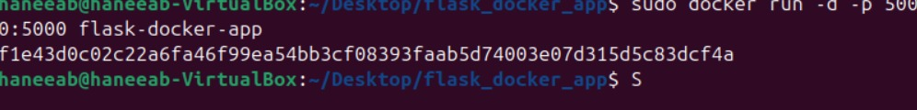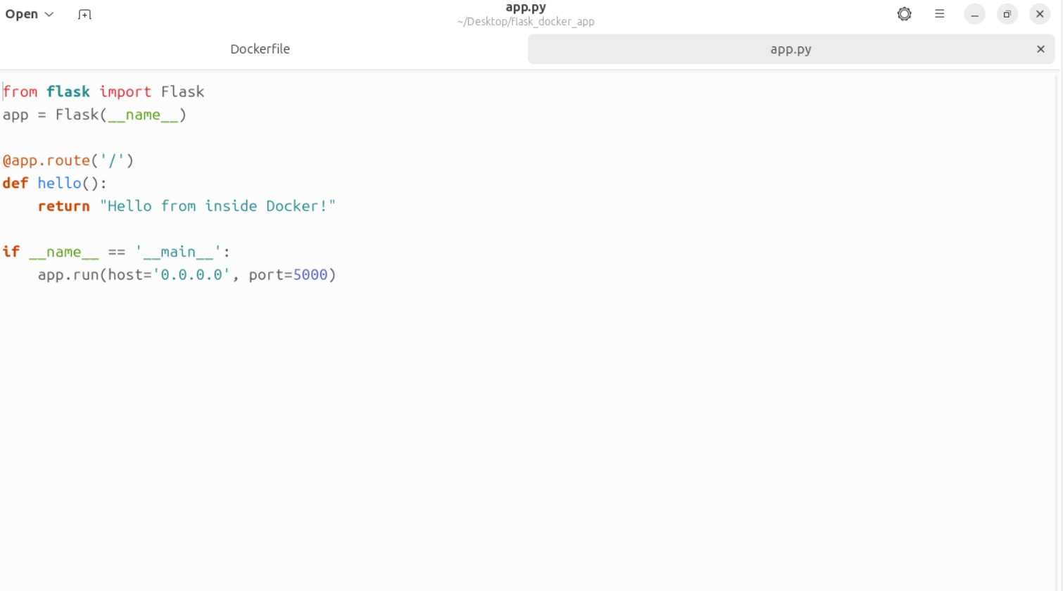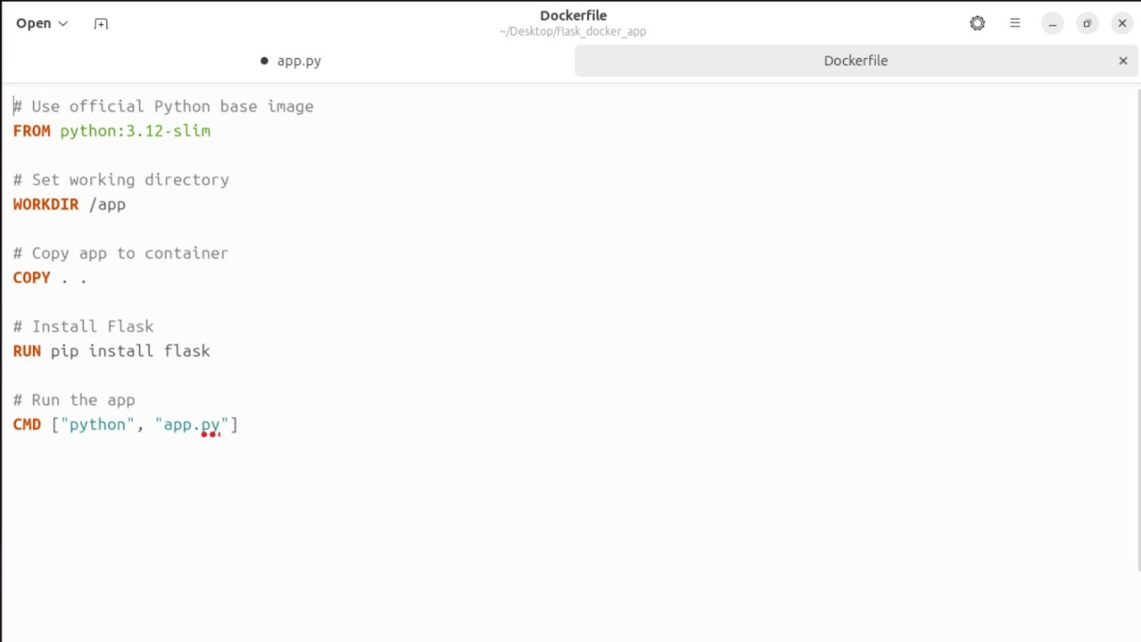

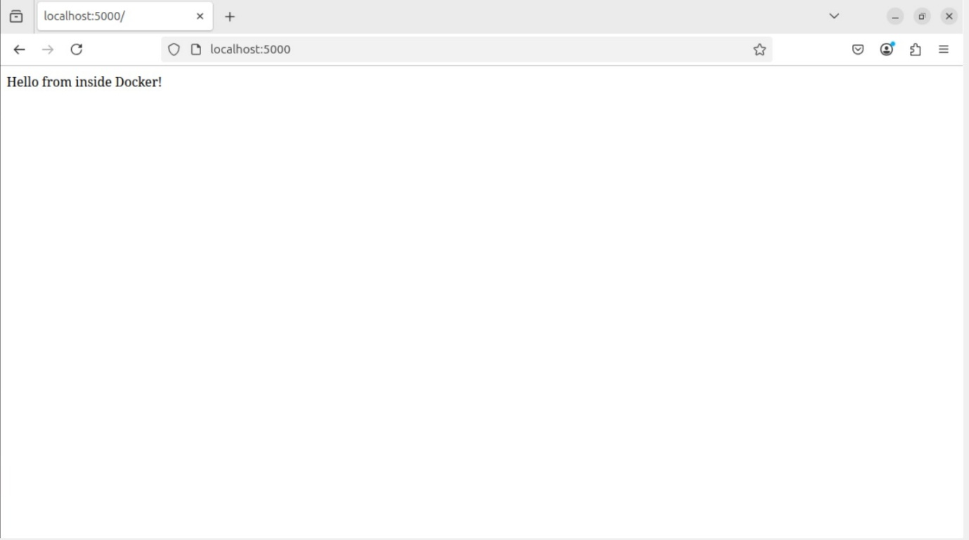

**AWS EC2 :**