Mr. President, Ladies and Gentlemen,
The Middle East is not exactly renowned for producing good news, and few expected this year to be any different. You know, the pandemic is ravaging our part of the world like everywhere else.
Promoted: ChaiFlicks – Streaming Jewish stories from around the WorldKeep Watching
But I am pleased to report to you that this year, I can tell you about good news from the Middle East. In fact, I can report two pieces of good news.
Earlier this month, at a White House ceremony hosted by President Trump, Israel signed historic agreements with the United Arab Emirates and the Kingdom of Bahrain.
This was the first peace treaty between Israel and an Arab country in over a quarter of a century. And it was the first time peace agreements between Israel and two Arab countries were signed on the same day.
These new agreements will bring our peoples the blessings of peace and the enormous benefits that come with more trade, more investment, more commerce, transportation, tourism, increased cooperation in so many other areas.
I also have no doubt that more Arab and Muslim countries will be joining the circle of peace, soon, very soon.
This good news about peace came about because of a clear break with the failed strategies of the past.
For far too long, the Palestinians effectively wielded a veto on peace between Israel and the broader Arab world.
For decades, all progress was halted and was held hostage to completely unrealistic Palestinian demands, such as the demand that Israel withdraw to the indefensible lines of 1967 and place its security in the hands of others; or the demand that Israel expel tens of thousands of Jews from their homes, effectively committing ethnic cleansing; or the demand that Israel absorb millions of Palestinians who are descendants of refugees from a war that was launched by the Palestinians against Israel more than half a century ago.
Of course, these demands, along with many others, are complete non-starters for any responsible Israeli government. Yet for years, many in the international community have tried to appease these absurd Palestinian demands, and as a result, they have wasted time to try to advance an illusion that won’t happen, instead of working for a realistic solution that could happen.
Thankfully, President Trump chose a different path to peace—a path anchored in reality.
He recognized Jerusalem as Israel’s capital; he recognized Israel’s sovereignty over the Golan Heights; and he put forward a realistic peace plan that recognizes Israel’s right, addresses Israel’s security needs and provides the Palestinians with a dignified realistic path forward if they make peace with Israel.
The critics argued that each of these steps by President Trump would kill the chances for peace.
Well, they were wrong. Dead wrong.
Those steps advanced peace.
Now two Arab states have decided to make peace with Israel, and more will follow.
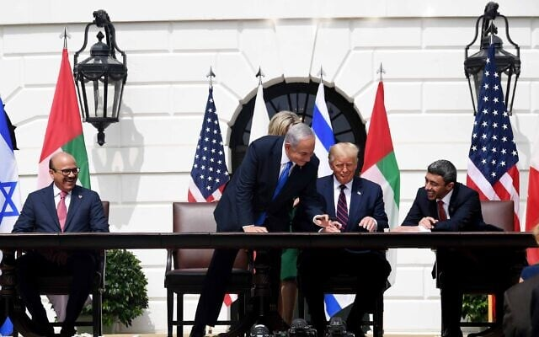
The expanding circle of peace will not make an agreement between Israel and the Palestinians less likely. It will make peace between Israelis and Palestinians more likely.
Palestinian leaders will increasingly realize that they no longer have a veto over peace and progress in our region, and hopefully, those leaders will ultimately decide to make peace with the Jewish state.
And when that happens, Israel will be ready.
I will be ready and I’d be willing to negotiate on the basis of the Trump plan to end our conflict with the Palestinians once and for all.
Ladies and Gentlemen,
Israel and states across the Arab world not only stand together in advancing peace. We stand together in confronting the greatest enemy of peace in the Middle East—Iran.
Iran wantonly and repeatedly attacks its neighbors, and it’s terror proxies are directly involved in violence throughout the Middle East, including in Iraq, Syria, Yemen, Gaza and of course, Lebanon.
We all saw the terrible explosion at Beirut port last month. The explosion happened here. This is the Beirut port.
Two hundred people died, thousands of people were injured, and a quarter of a million people were made homeless.
Now, here is where the next explosion could take place. Right here. This is the Beirut neighborhood of Janah. It’s right next to the international airport. And here, Hezbollah is keeping a secret arms depot. This secret arms depot, right here, is adjacent, a meter away, from a gas company. These are gas canisters. Right here. It’s a few meters away from a gas station. It’s fifty meters away from the gas company. Here are more gas trucks. And it’s embedded in civilian housing here, civilian housing here. For the Janah neighborhood residents this is the actual coordinates.
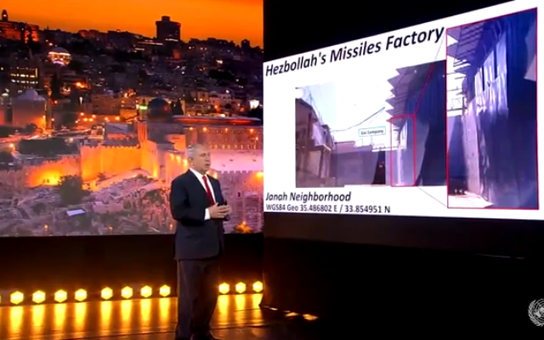
So I want to show you the entrance to Hezbollah’s missile factory. Because that’s what it is. It’s right here. This is the gas company, and this is the missile explosive depot.
I say to the people of Janah, you’ve got to act now. You’ve got to protest this. Because if this thing explodes, it’s another tragedy.
I say to the people of Lebanon, Israel means you no harm.
But Iran does.

Iran and Hezbollah have deliberately put you and your families in grave danger.
And what you should make clear is that what they have done is unacceptable. You should tell them, tear these depots down.
Just a few days ago, one of these depots exploded at Ain Qana in south Lebanon.
And that is why the international community must insist that Hezbollah stop using Lebanon and Lebanese civilians as human shields.
Ladies and Gentlemen,
We must all stand up to Iran, and President Trump deserves praise for doing exactly that.
First and foremost, I commend President Trump for withdrawing from the flawed nuclear deal with Iran.
In 2015, I stood alone among world leaders in opposing the shameful nuclear deal that was made with Iran. I opposed it because the nuclear deal did not block Iran’s path to the bomb, it actually paved its way to it. I opposed it because the deal’s restrictions on Iran’s nuclear program were only temporary and were no way tied to Iran’s change of behavior.
Now, Iran has violated even those temporary restrictions.
Because of these violations, Iran will have enough enriched uranium in a few months for two nuclear bombs.
And Iran has been working on a new generation of centrifuges, it’s called the IR9, which will multiply Iran’s enrichment capability fifty-fold.

Ladies and Gentlemen,
There is no question that Iran is seeking nuclear weapons.
The once-secret nuclear archive, Israel’s agents obtained from the heart of Tehran, proves that beyond a shadow of a doubt.
In the run-up to the nuclear deal, Israel was told—especially by our European friends—that any Iranian violation would be met with a quick and severe response.
But in the face of Iran’s brazen violations, in the face of the irrefutable evidence of the nuclear archive, the Security Council has done, well, absolutely nothing.
And wedded to the failed nuclear deal, the Security Council also still refuses to see what was obvious to anyone who understands anything about the Middle East.
Rather than curb Iran’s aggression, the nuclear deal fed and funded it.
Five years ago, in removing the sanctions on Iran, the leading powers of the world opened the door of a tiger’s cage, and then they simply hoped for the best.
But instead, exactly as I warned five years ago, we who live in the Middle East are suffering the consequences of that irresponsible deal. A richer and emboldened Iran used the billions that flowed into its coffers to fuel its campaign of carnage and conquest across the region.
Thankfully, President Trump recognized the disastrous nuclear deal for what it was and he acted.
He restored US sanctions, forced countries to choose between doing business with America or doing business with Iran, and took out the world’s most dangerous terrorist, Qassem Suleimani.
And last month, when the Security Council refused to extend an arms embargo on Iran, the United States snapped back the sanctions.
While the Security Council is divided, we in the region are united.
Both Arabs and Israelis are together urging tough action on Iran. And when Arabs and Israelis agree, others should pay attention.
Israel calls upon all members of the Security Council, stand with the United States against Iran’s aggression, stand with it in insisting that Iran end its nuclear weapons program once and for all, stand with the United States in confronting the greatest danger to peace in our region.
And if you do, I am confident that in the years ahead we will be able to celebrate more good news from the Middle East.
Good news for Israel.
Good news for our Arab neighbors.
And good news for the world for all those who seek peace, security and prosperity.

