**Peer Review Feedback Summary**

The **FIRST** peer review did not provide any actionable recommendations. The reviewer simply conducted the tests that I prepared for the testing site. No news is good news. The user’s review was quick: short and sweet- Indicating that my site was simple. This is good. Not much to look at, but the information is there and easy to find. That is the intention as established from the guerilla testing when my monster-in-law, excuse me, mother-in-law was confused and flustered just by the appearance of it.

**No Actionable** **items**.

The **SECOND** peer review took a little more time. The reviewer went through the objectives easily. Everything worked properly and he completed the review successfully. During the Panopto video review, the user did not have any recommendations but was kind enough to comment on the testing website so I could easily reference it. He insisted that I make the navigation menu more user friendly by adding a “Contact Us” option. I appreciate this input and I am going to code this after I get done typing this summary. He also suggested that I remove excess whitespace from the homepage. In this, he is referring to my little lorem ipsum paragraph below the splash image. The last thing I did with the code was cite the images I used. Somehow, someway it threw some of the content out of whack. This is my first time creating or trying to create a website prototype of any sort. I was just feeling my way through it, and it took me a VERY long time to get that far. I will fix it though. The recommendation is great, and I will correct it.

**Actionable:**

* Add “Contact Us” to navigation menu
* Reduce whitespace encompassing paragraph on the home page.

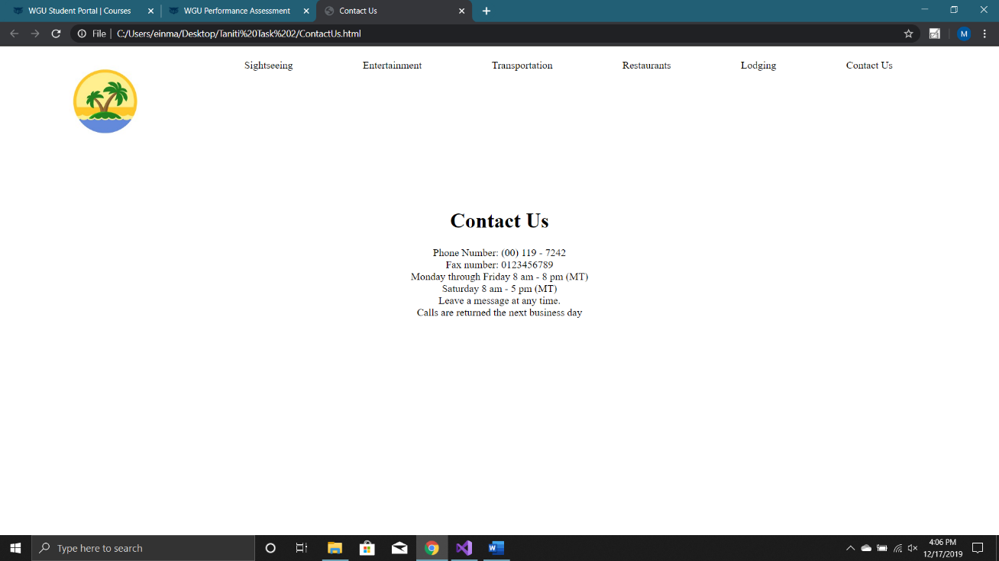

Pictured above is the new “Contact Us” page. I changed the navigation bar system for all the pages. So “Contact Us” is the same and fixed like the rest of them and accessible from every page.

*(I also fixed the whitespace cosmetic recommendation for the homepage. I don’t feel that its worthy to post an image of it. The result is noticeable but miniscule at the same time. Issue resolved though!)*

The **THIRD** peer review was very insightful. This guy sounded like he knew really knew what he was talking about- like he has experience in coding webpages. Though his suggestions were good and made total sense, I like it the way I have it better than what he suggested. I’ll include a picture below of what I am talking about.

Actionable:

* Apply percentages to navigation bar
* Position text and pictures in a more centered form

AGAIN, I choose to kindly reject his proposal because I prefer what I have going on…

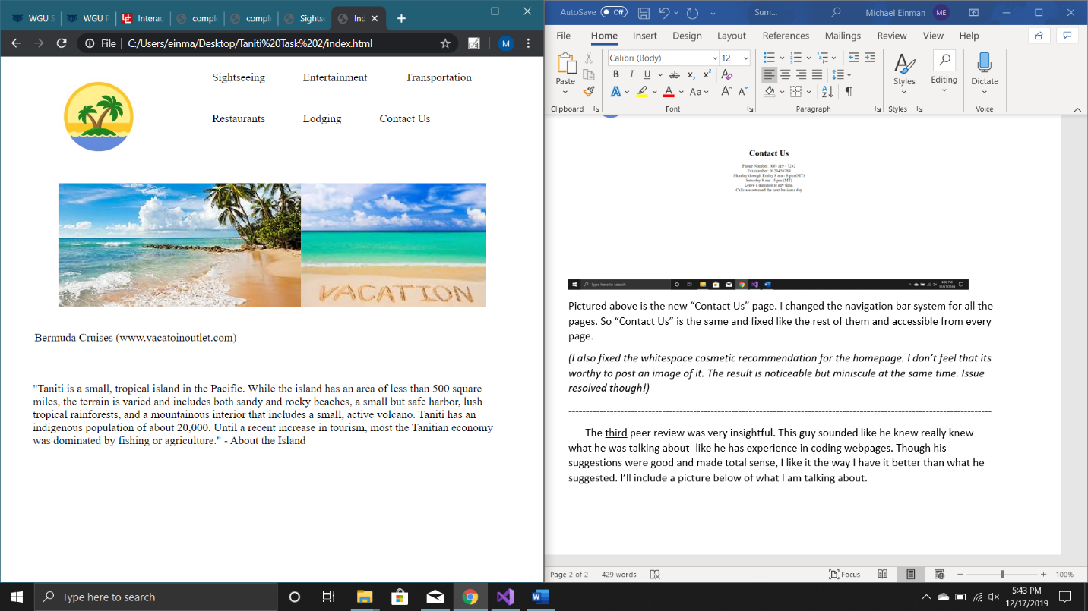

I made a split screen with the prototype and this document. The prototype resized itself and stacked the navigation links. I think that is super neat. It accommodates for users with vision problems because it doesn’t scale down the text to fit it on on the screen horizontally. User’s like my mother in law would appreciate this one.

**Design Changes Through UX Design Process**

I took a UI Design class before this UX Design class so I was fresh with a lot of the principles and key concepts to make a universally accessible website. It covered wireframes, mockups, user personas, etc., etc. all sorts of stuff that this class covered as well. So I had a strong idea going into it, which I made minor changes as the process developed.

**From the first round of gorilla testing:**

1. I use of whitespace to greatly to separate items (mother-in-law’s indirect suggestion)
2. I did incorporate more pictures into the structure (daughter’ suggestion) – I feel this gives the site more substance. Instead of putting more words that people may not want to read.

**Peer Review feedback testing:**

1. I added the ‘contact us’ link to my fixed navigation bar. I feel like this is an important part of the website. Essential. A good suggestion from a tentitive reviewer.

Again, I felt like I hit the mark pretty well from the beginning. I am very pleased with the resulting website. I feel this was great practice with coding and UX Design. I appreciate the testing and user feedback- very insightful. This has been a very fun class. Thank you!

**Citations** - (pictures from the prototype)

“8 Most Romantic Beach Hotels in Hawaii.” Coastal Living, [www.coastalliving.com/travel/top-10/most-romantic-beach-hotels-hawaii](http://www.coastalliving.com/travel/top-10/most-romantic-beach-hotels-hawaii).

“Bermuda Cruises.” Google Images, Google, 9 Dec. 2019, images.google.com/.

Chiland, Elijah. “Take a New Look at the Massive Entertainment Complex Set to Rise next to the Queen Mary.” Curbed LA, Curbed LA, 15 Aug. 2017, la.curbed.com/2017/8/14/16146576/queen-mary-island-activities-renderings-long-beach.

Cruises. “Princess Cruises: Experience Hilo, Hawaii, Volcanoes.” Www.princess.com, 31 July 2019, www.princess.com/learn/cruise-destinations/hawaii-cruises/hawaii-cruise-tips/learn-about-hawaii/experience-hilo-hawaii-volcanoes.html.

“Daily Shuttle Bus from Ninh Binh to Catba Island.” Book Daily Shuttle Bus from Ninh Binh to Catba Island from $18 in Hanoi 2020, www.viator.com/tours/Hanoi/Daily-Shuttle-Bus-from-Ninh-Binh-to-Catba-Island/d351-8638P47.

“FOOD & DRINK: 1.” Greg Powers : Photographer : Luxury Hotels-Restaurants-Celebrities : Washington DC : New York, www.gregpowers.us/FOOD%20&%20DRINK/Comfort%20Foods/.

inson, Tamara. “13 Of the Most Spectacular Footbridges around the World.” CNN, Cable News Network, 25 Mar. 2019, www.cnn.com/travel/article/spectacular-footbridges/index.html.

“How to Eat Hawaiian Food.” Hawaiian Airlines, www.hawaiianairlines.com/hawaii-stories/culture/how-to-eat-hawaiian-food.

“Island of Hawaii Accommodations.” Go Hawaii, 15 Oct. 2018, [www.gohawaii.com/islands/hawaii-big-island/accommodations](http://www.gohawaii.com/islands/hawaii-big-island/accommodations).

Lowin, Rebekah. “Pregnant Women Believe a Pizza Induces Labor-And They're Lining Up For It.” Food & Wine, 24 Apr. 2017, www.foodandwine.com/news/pregnant-women-believe-pizza-induces-laborand-theyre-lining-it.

Nelson, Dustin. “You Can Get 30% Off Hotels in Hawaii This Week in a Big Sale.” Thrillist, Thrillist, 6 Sept. 2018, www.thrillist.com/news/nation/hawaii-hotel-sale-wyndham-destinations-offer-30-off-stays-in-hawaii.

“Polin Creates New Water Play Structure at Tropical Islands Waterpark: Attractionsmanagement.com Products.” Http://Www.attractionsmanagement.com/, www.attractionsmanagement.com/index.cfm?pagetype=products&codeID=341203.

staff, Science X. “Easter Island's Society Might Not Have Collapsed.” Phys.org, Phys.org, 13 Aug. 2018, phys.org/news/2018-08-easter-island-society-collapsed.html.

“Vacation.” Https://Demolay.org, Google, images.google.com/.

Wolff, Josephine. “The Aviation Industry Is Starting to Grapple With Cybersecurity.” Slate Magazine, Slate, 3 May 2016, slate.com/technology/2016/05/the-aviation-industry-is-starting-to-grapple-with-cybersecurity.html.

“You Need to Add a Maui Snorkeling Adventure to Your Bucket List.” The Old Wailuku Inn at Ulupono, 24 July 2019, mauiinn.com/blog/maui-snorkeling/.