Works? | № | T1 | T2 | T3 | Screenshot
yes | 1 | + | + | + | 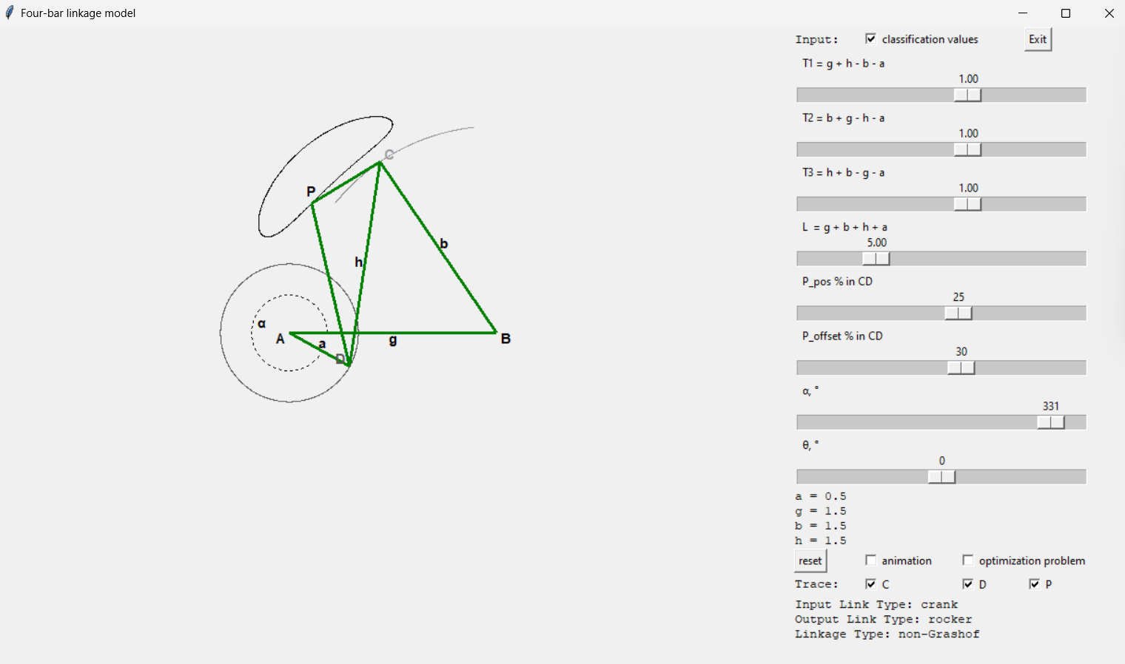
yes | 2 | 0 | + | + | 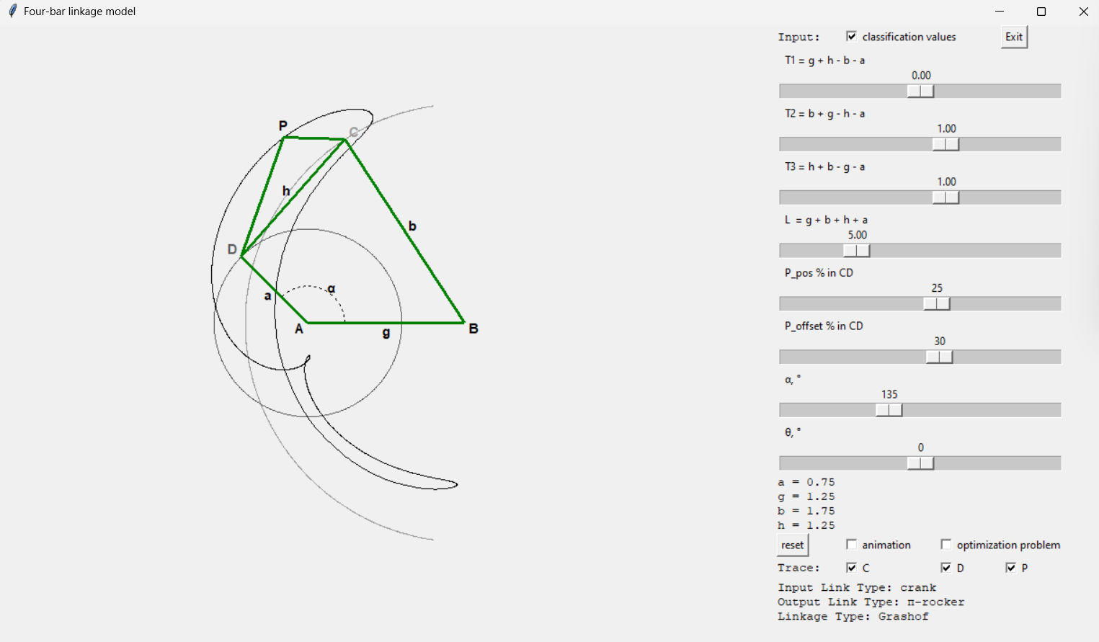
yes | 3 | - | + | + | 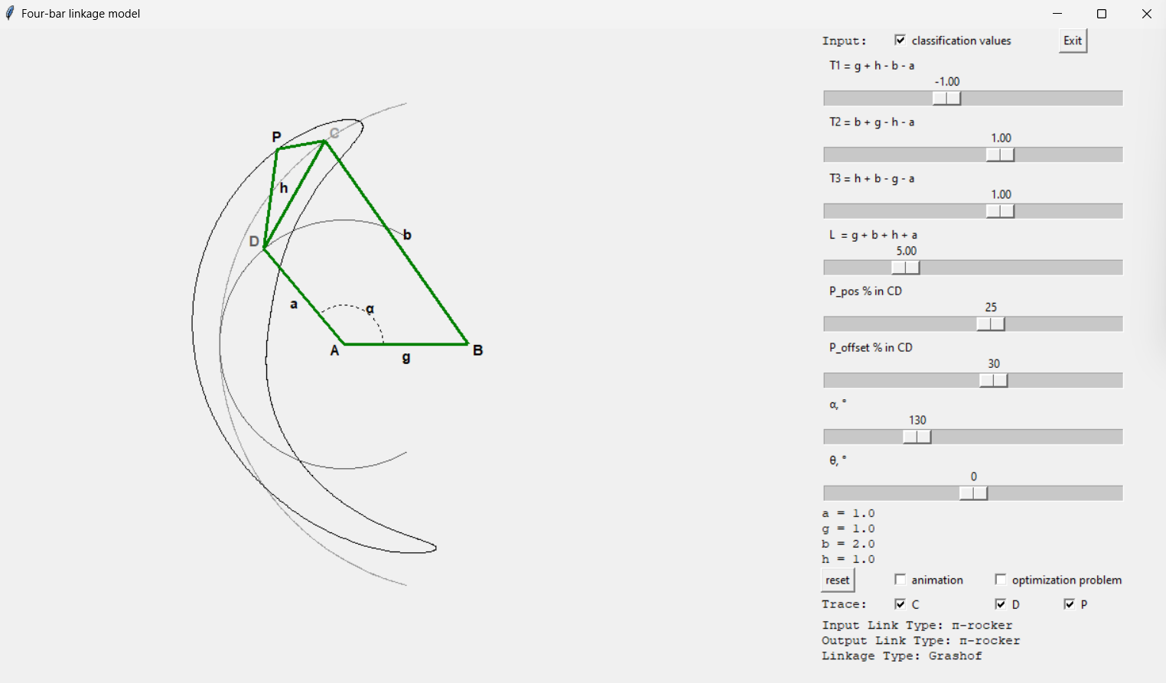
yes | 4 | + | 0 | + | 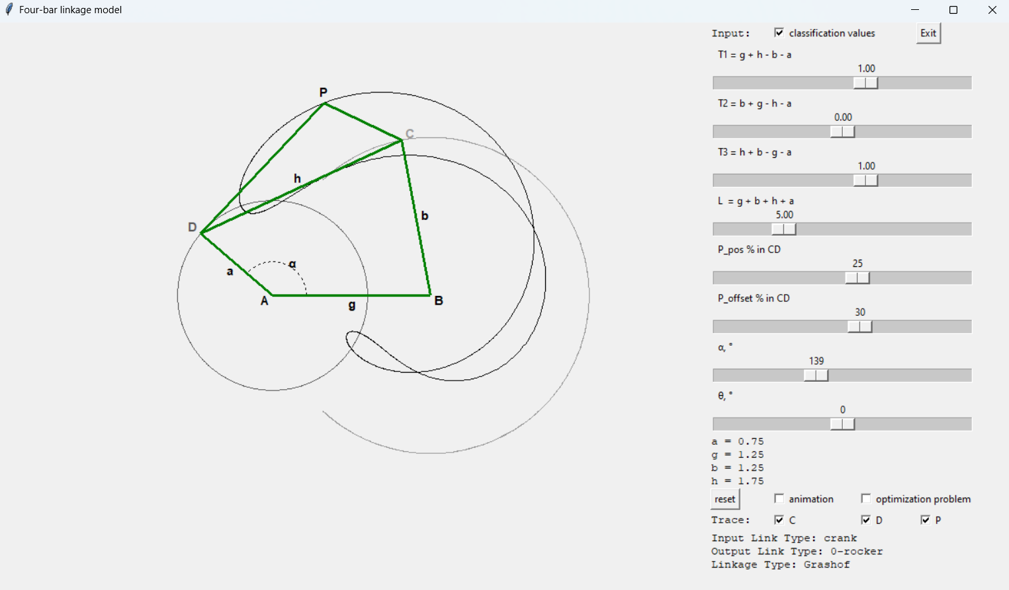
yes | 5 | 0 | 0 | + | 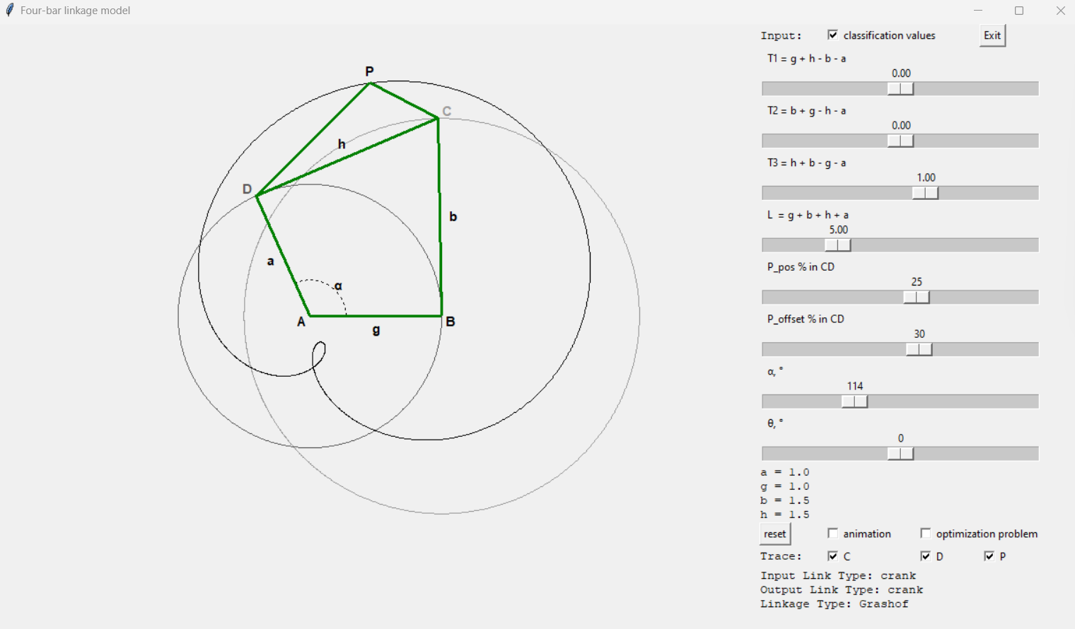
yes | 6 | - | 0 | + | 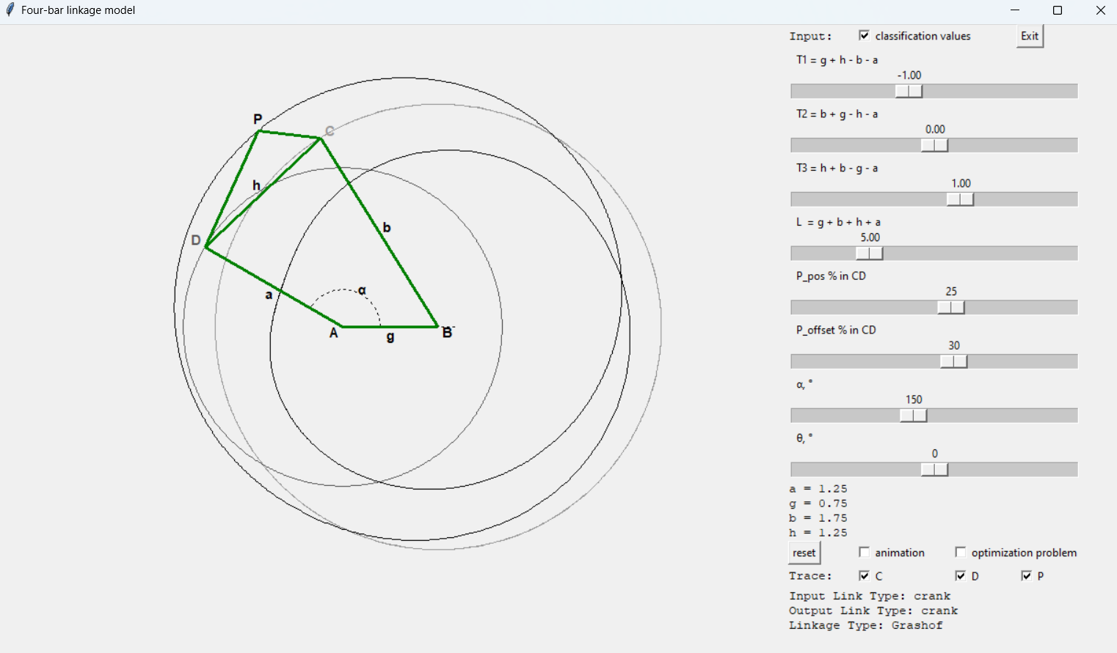
yes | 7 | + | - | + | 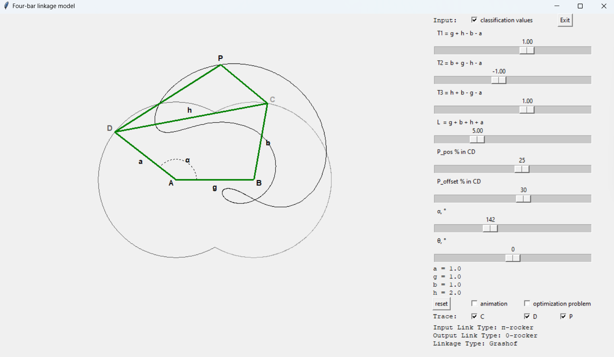
yes | 8 | 0 | - | + | 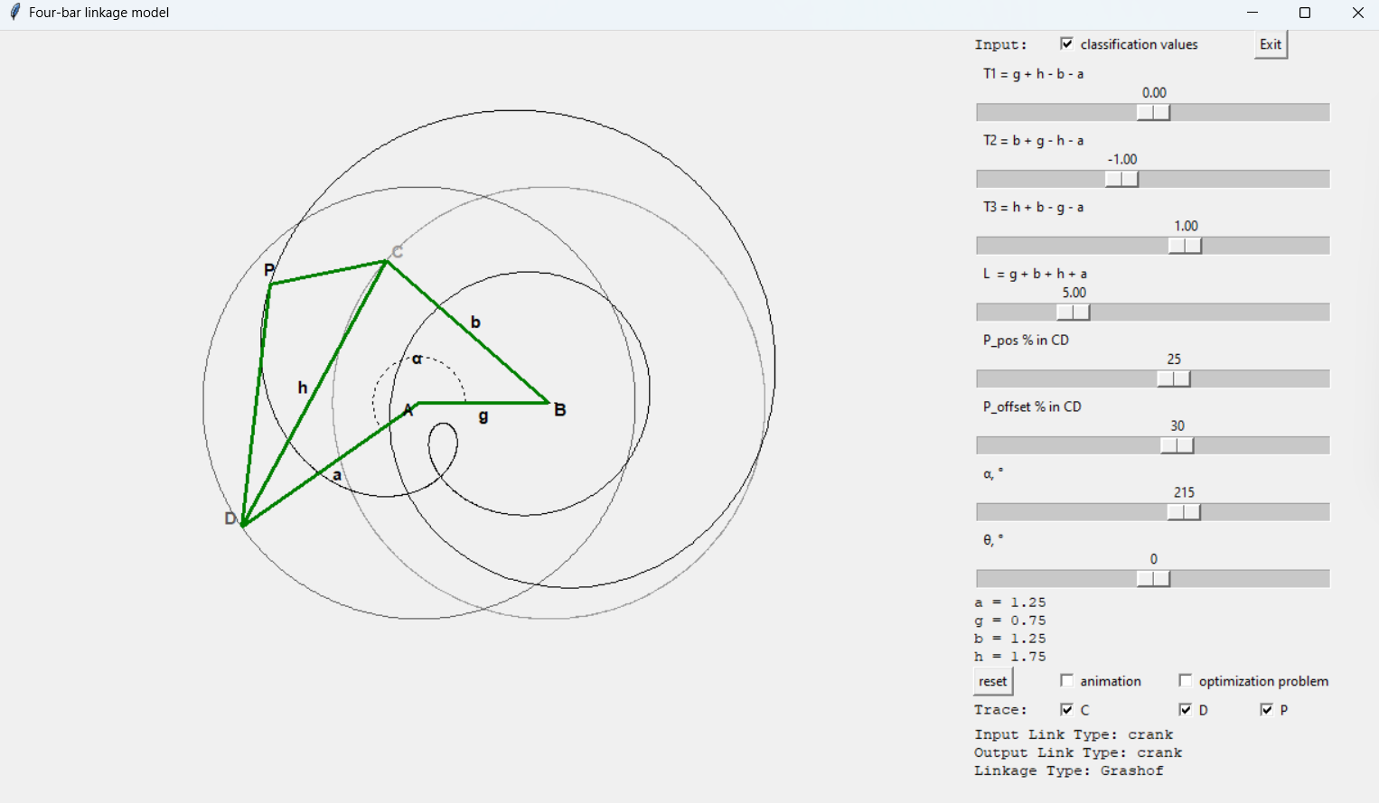
yes | 9 | - | - | + | 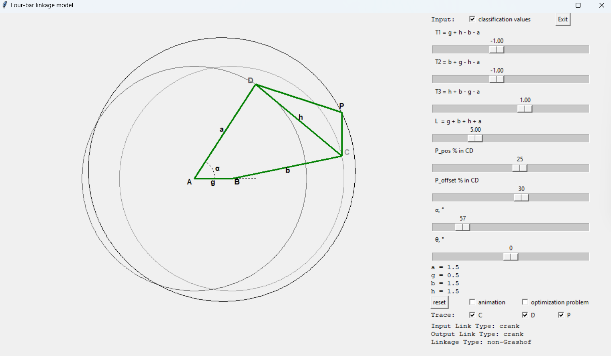
yes | 10 | + | + | 0 | 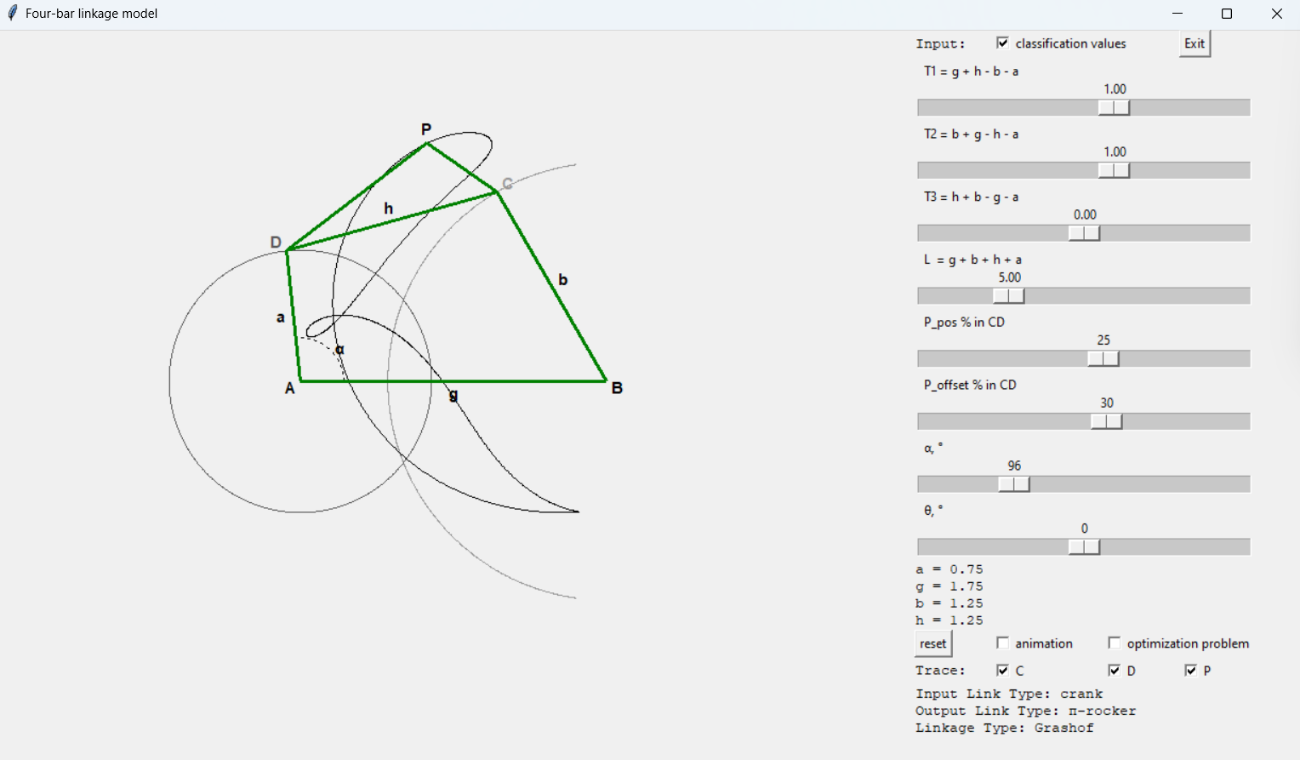
yes | 11 | 0 | + | 0 | 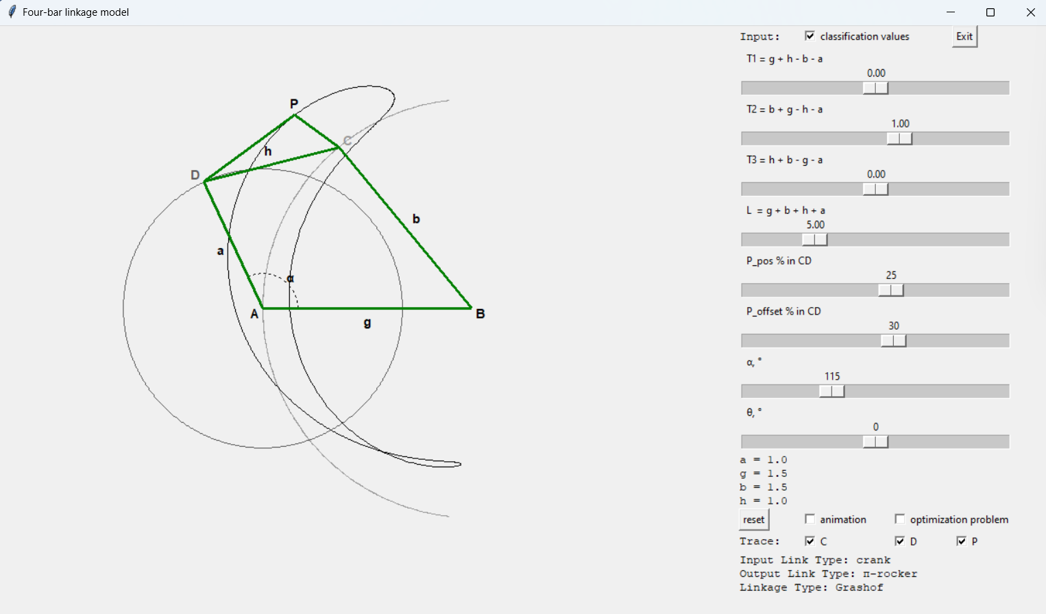
yes | 12 | - | + | 0 | 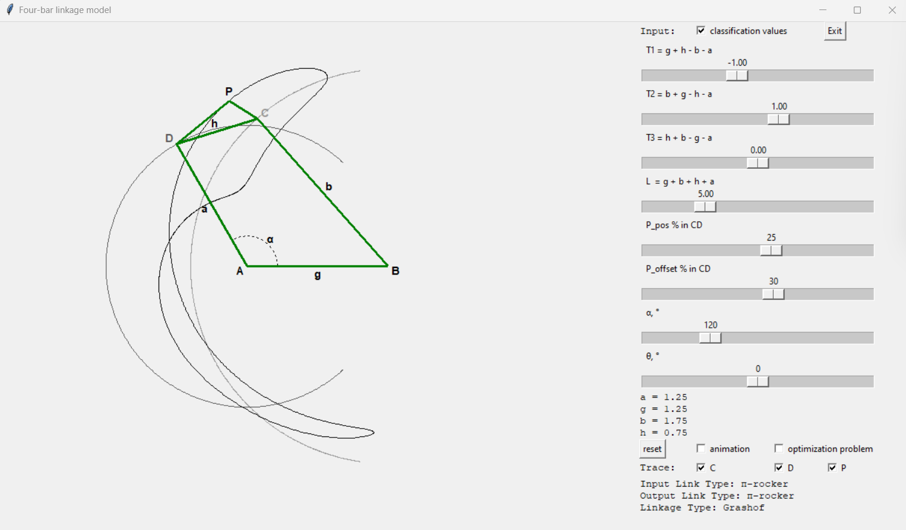
yes | 13 | + | 0 | 0 | 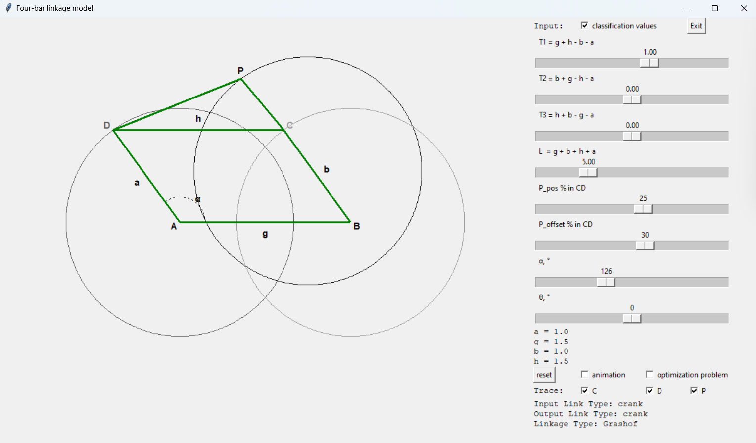
yes | 14 | 0 | 0 | 0 | 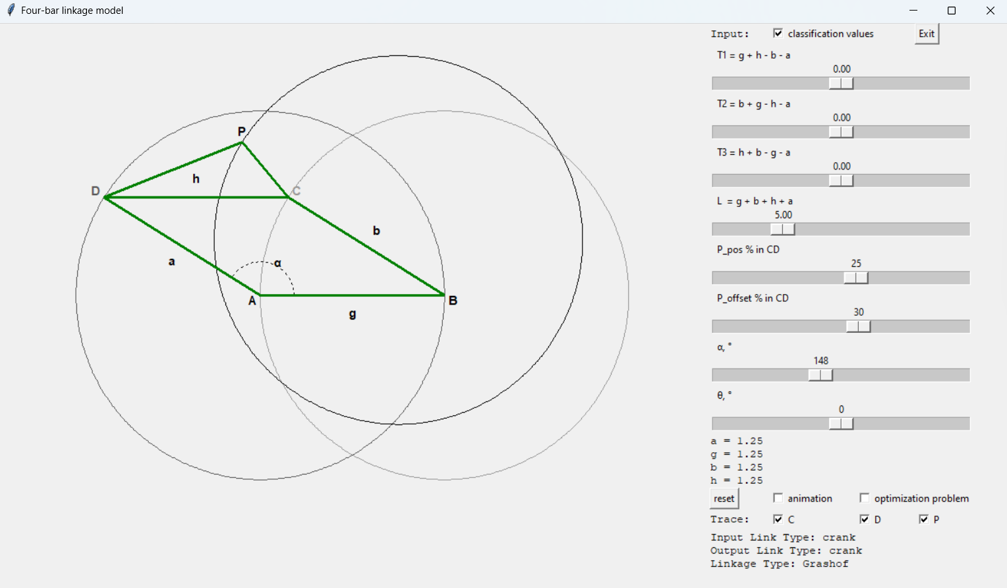
yes | 15 | - | 0 | 0 | 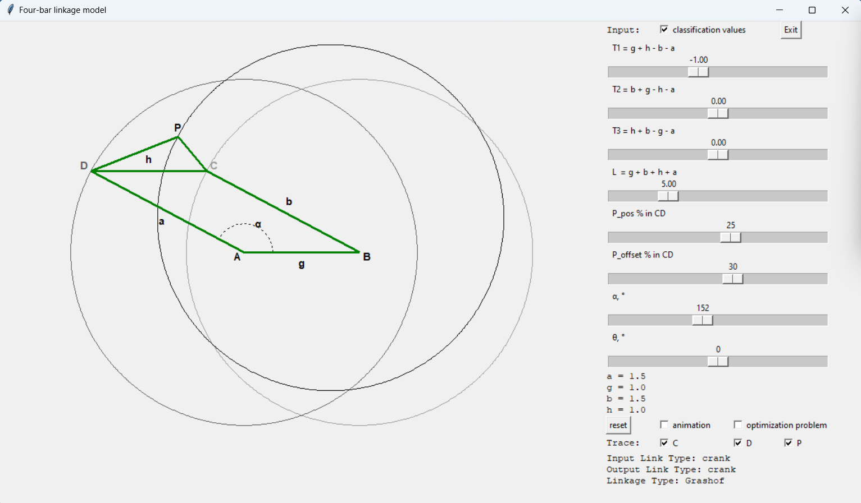
yes | 16 | + | - | 0 | 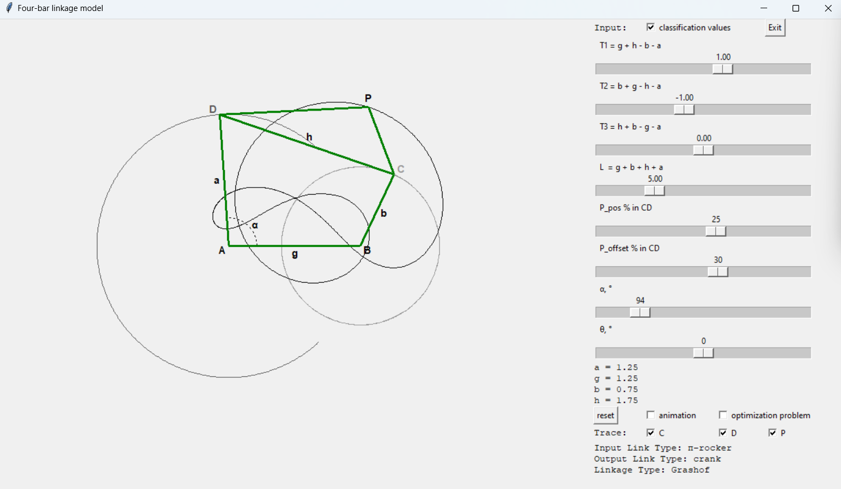
yes | 17 | 0 | - | 0 | 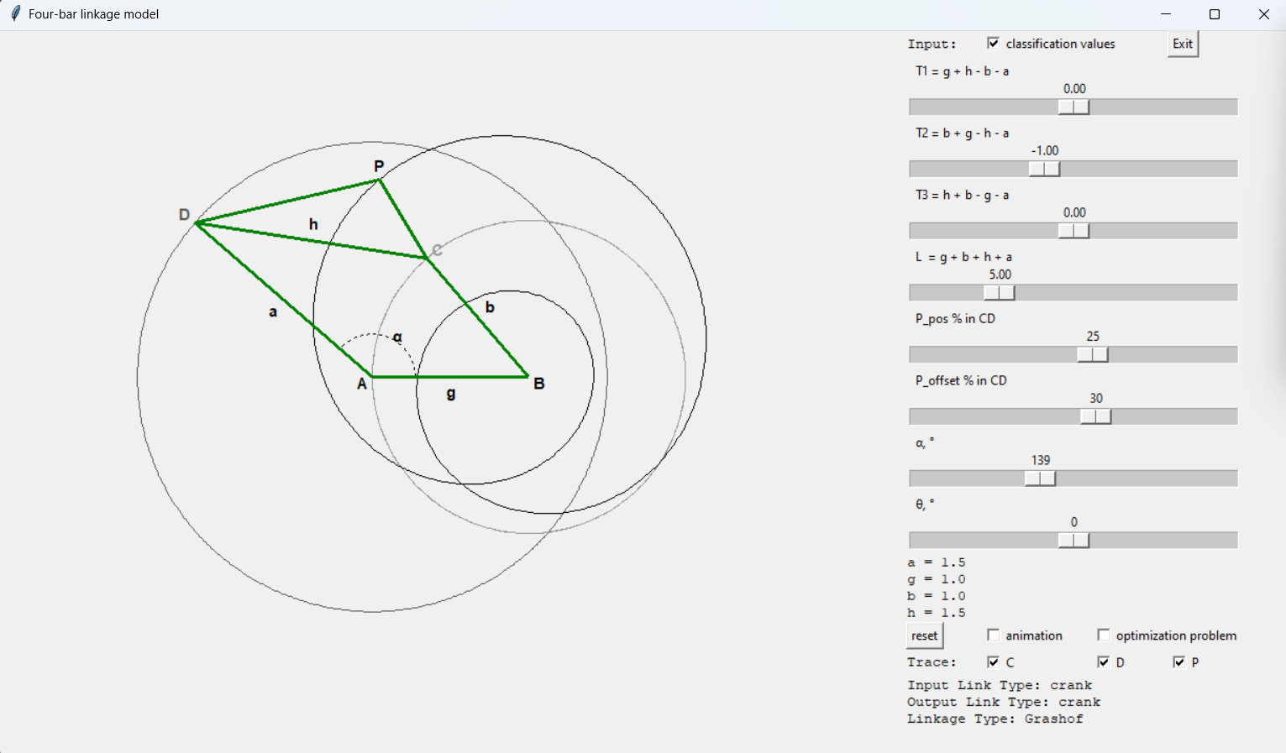
yes | 18 | - | - | 0 | 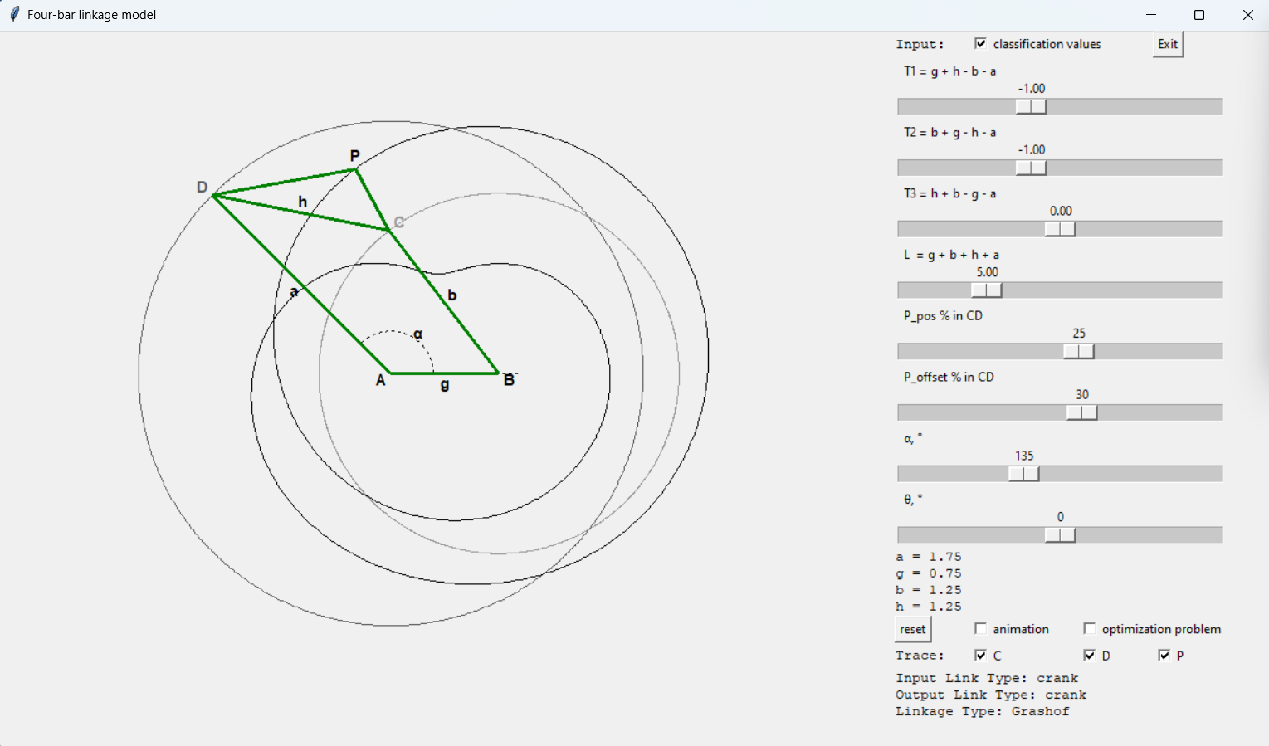
yes | 19 | + | + | - | 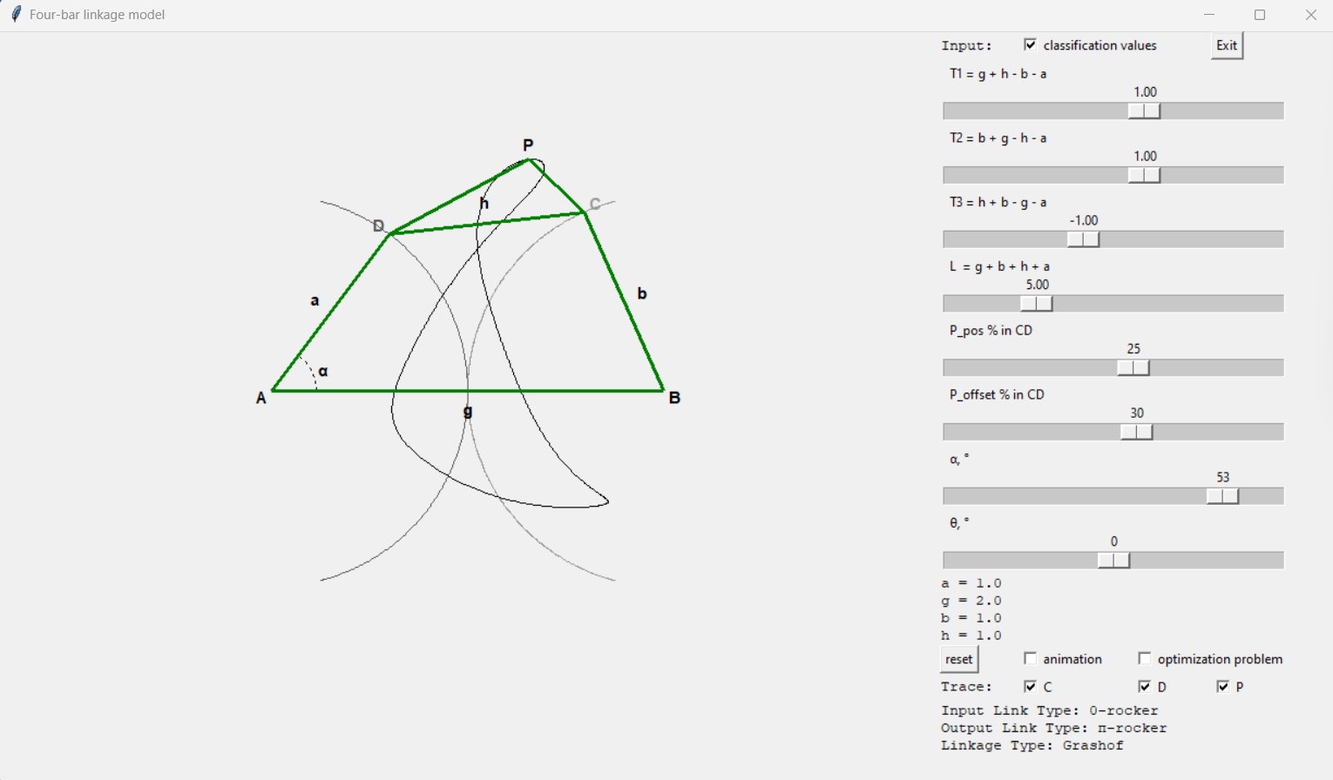
yes | 20 | 0 | + | - | 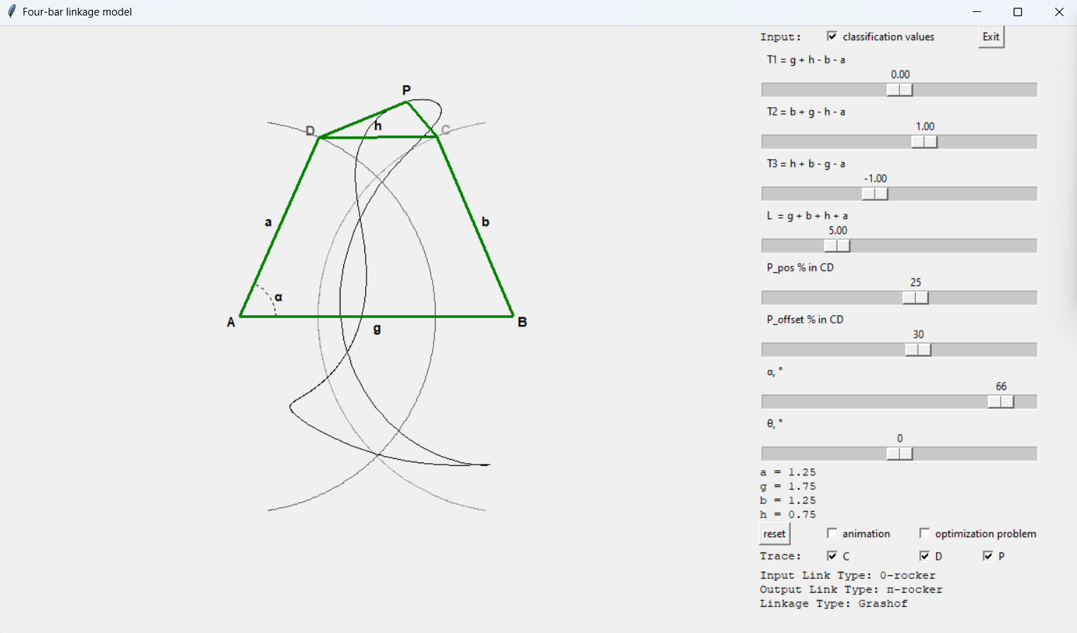
yes | 21 | - | + | - | 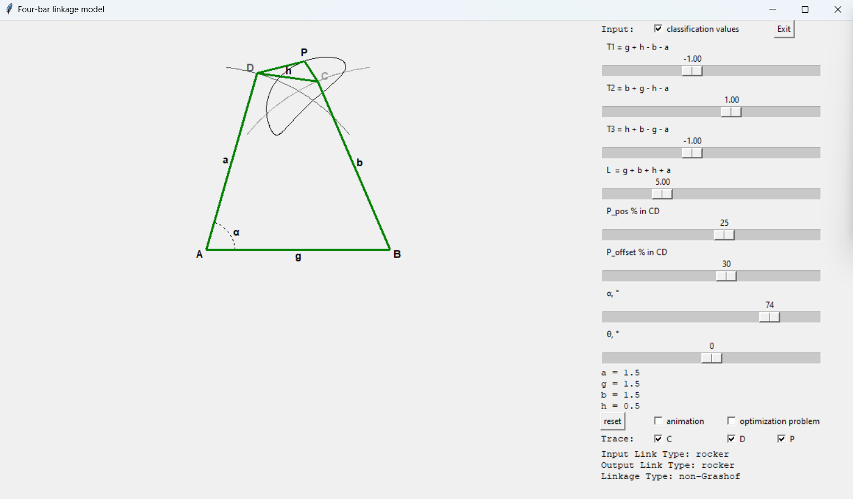
yes | 22 | + | 0 | - | 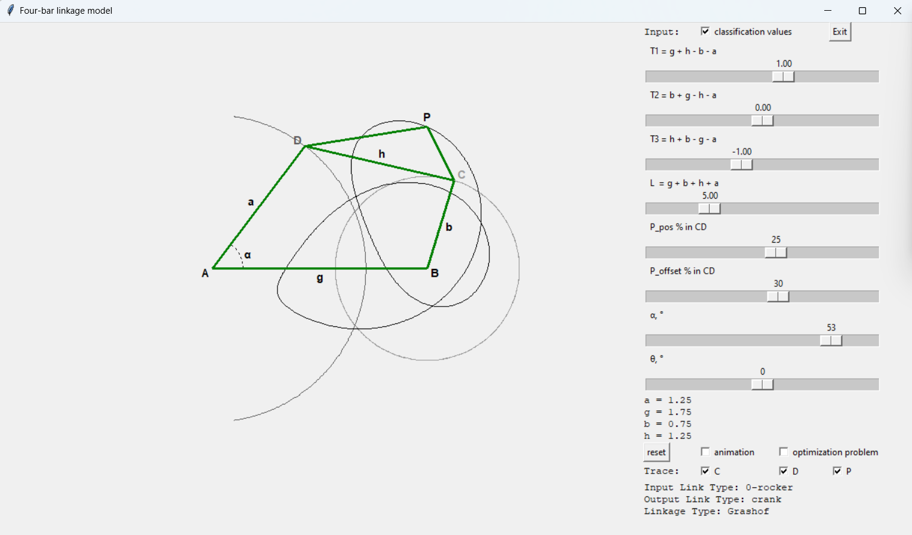
yes | 23 | 0 | 0 | - | 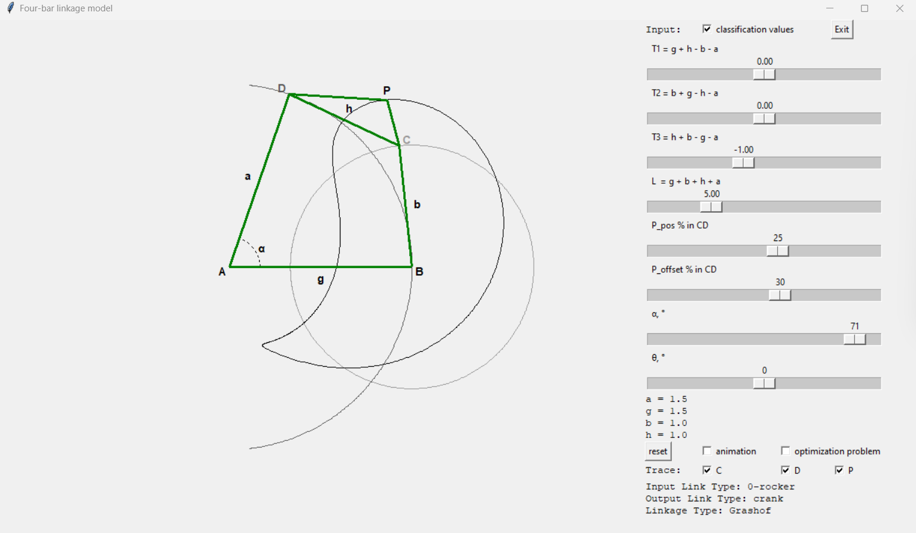
yes | 24 | - | 0 | - | 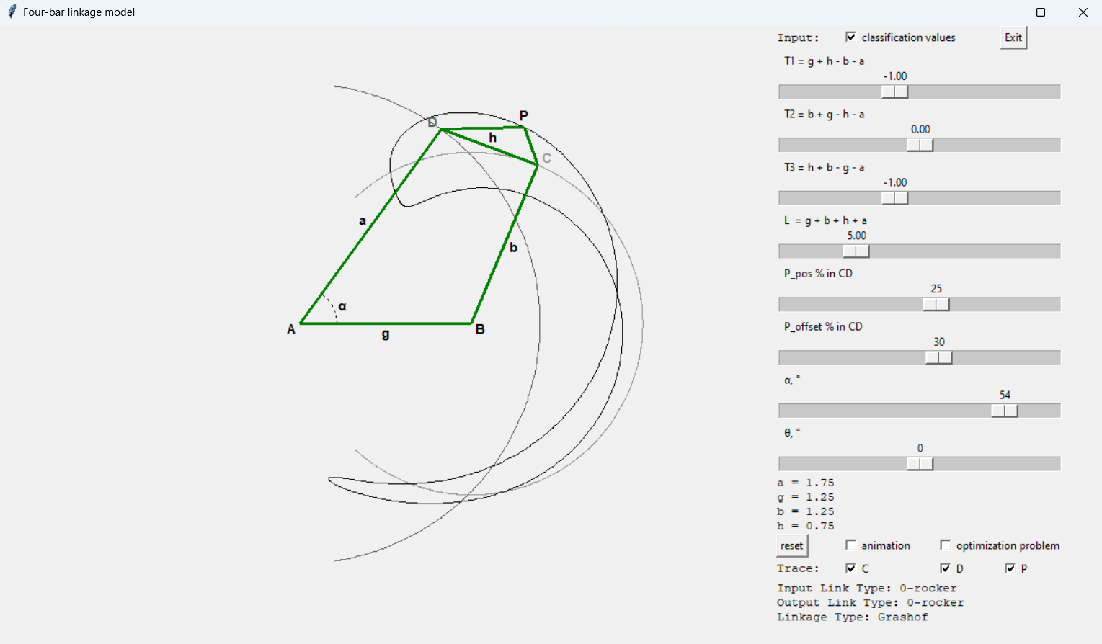
yes | 25 | + | - | - | 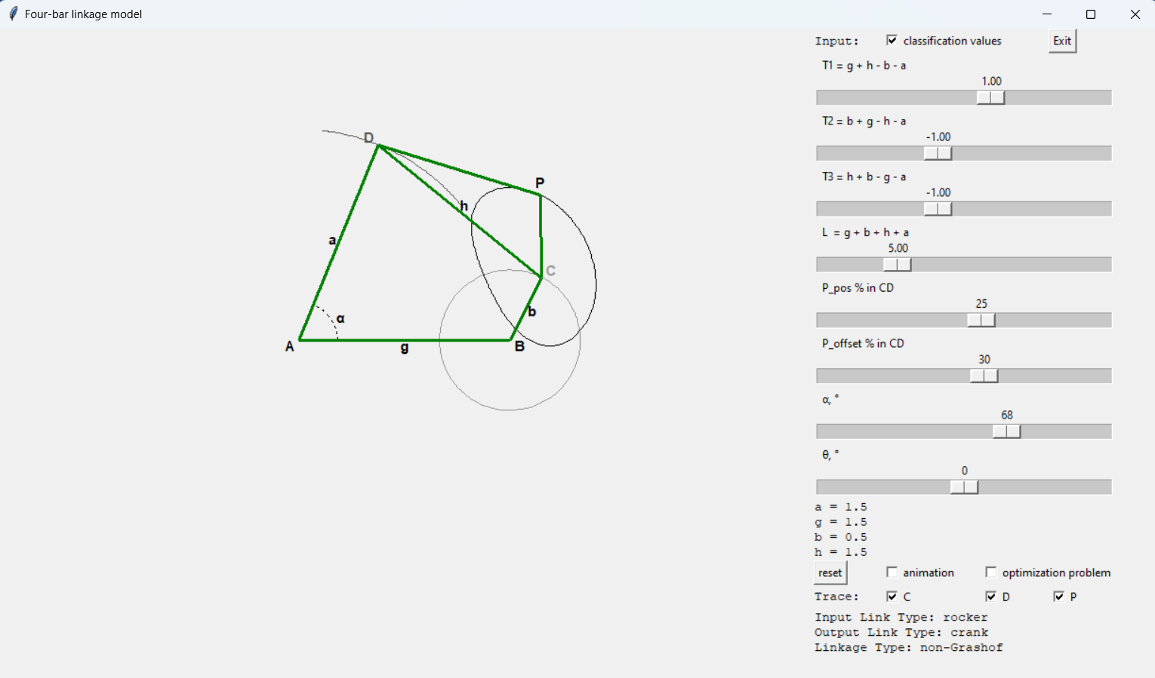
yes | 26 | 0 | - | - | 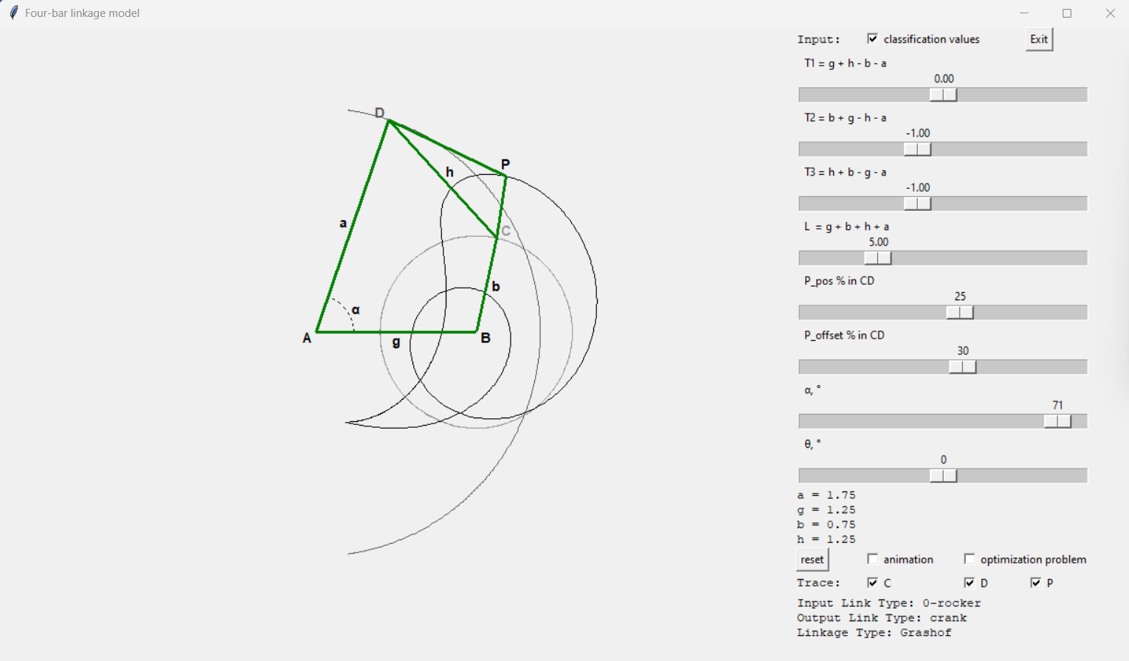
yes | 27 | - | - | - | 