From single to multiple drivers – combined effect of temperature, pH and lithium on the larvae of the sea urchin Paracentrotus lividus

Abstract
Accounting for multiple drivers is important when estimating the impacts of anthropogenic change on biota, but it is both conceptually and technically difficult. Driver interactions are seldom well understood from laboratory experiments and there is increased awareness of the experimental design shortfalls that have shed little light on multiple driver interactions. This study presents an experimental strategy to discern additive from non-additive effects for three drivers (temperature, pH and lithium) on the growth rate of purple sea urchin (Paracentrotus lividus) larvae. The performance curve for each driver was resolved and they were then merged together under a concentration-addition hypothesis to form a single additive curve. The outcome of a factorial multiple driver experiment was compared with the projected effect from the single driver curve, where any deviations highlighted non-additive interactive effects of multiple drivers. Second-degree polynomial models fit the single driver data for each of the drivers‘ performance curves. The multiple driver data that deviated from this curve were all treatments involving pH in combination with another driver out of reference conditions, highlighting an antagonistic interaction of pH with both temperature and lithium. The study presents a simplified experimental strategy to better understand the effect of multiple drivers on biota. The experimental design is a realistic step towards a more robust identification of driver interactions than the common scenario-based designs can offer. Future work should resolve driver interactions to assess the biological impacts of physico-chemical changes and supply this information to ecosystem management.

Introduction
Anthropogenic activities lead to ocean changes in a host of environmental drivers threatening ecosystems worldwide (Pörtner et al., 2021). These threats include global changes such as ocean warming (OW) and acidification (OA), compounded by local changes such as pollution, habitat destruction, and resource over-exploitation (Boyd et al., 2018; IPCC, 2014). Understanding and resolving the cumulative impact of multiple drivers is one of the UN Decade’s main challenges. Multiple drivers act simultaneously and often combine in non-linear ways, producing outcomes that are more complex than from individual drivers alone. These aspects are neglected in the tools currently used for management and policy. The main reason is the lack of scientific understanding of the cumulative biological impact of multiple drivers due to conceptual and technical complexities. Therefore, these tools strongly misestimate the real-world impacts, with the risk of measures that are not adapted to ensure a sustainable and healthy ocean.

Temperature (e.g. Byrne et al., 2022) and pH (Caillon et al., 2023) are two highly relevant drivers in the context of global changes and their response curves are commonly unimodal. For toxicants, dose-response curves are often described as sigmoidal, with thresholds below which significant adverse effects are not expected to occur (Bellas, 2008; Morroni et al., 2023; Philibert et al., 2021). Among those, lithium from industry and pharmaceuticals are running off into the marine environment and is a concern especially in urbanized coastal areas (Ruocco et al., 2016).

Experimental studies addressing the biological effects of single and multiple global drivers have increased rapidly in recent years (Boyd et al., 2018). Due to practical constraints, multi-driver studies are often limited to factorial designs with two or three treatment levels per driver. Not only does this approach often fail to account for the high degree of present natural variability experienced by the tested species or ecosystems (e.g. Vargas et al., 2017, 2022), but neither does it allow for an evaluation of potential interactions. Many authors assume linear response and confuse statistical interaction with more complex non-linear driver interactions (Burgess et al., 2021; Kreyling et al., 2018). Consequently, the nature of combined effects reported across studies varies and often reflects misconceptions (e.g. Crain et al., 2008; Stockbridge et al., 2020; Tekin et al., 2020). There is an increased awareness of the drawbacks of this experimental design (e.g. Collins et al., 2022; Kreyling et al., 2014), leading to different experimental designs and strategies (Carmichael et al., 2025).

The combined effect of multiple drivers on an organism depends on their modes of action, the mechanisms and functional changes leading to the observed effect of a given driver, and their potential interactions, when non-additive effects are observed. This leads to three main scenarios: (i) additivity with different modes of action, the observed combined effect on a given parameter is the pure mathematical addition of the two individual effects; (ii) additivity with the same mode of action (e.g. concentration-addition model), each driver contributes additively to the level of stress along the same response curve; (iii) interactivity, corresponding to any deviation from the additive models (Grant et al., 2010).

This study uses an experimental and analytical strategy designed to truly distinguish additive from non-additive effects of multiple stressors, accounting for non-linear effects (Espinel-Velasco et al., 2025). Specifically, two sets of experiments were combined to: (i) resolve the response curves for three drivers, temperature, pH, and lithium, across broad gradients; (ii) use these single-driver performance curves to project their expected combined effects under a concentration-addition hypothesis; and (iii) test these projections using a full factorial 2 × 2 × 2 multiple driver design. Comparing the observed outcome of the multiple driver experiment with the projections derived from a model allows the identification of true interactions. The concentration-addition model is used as default. Previous studies hypothesized that temperature and pH are sharing a similar mode of actions through changes in metabolisms and energy budgets (Gianguzza et al., 2014; Jager et al., 2016).

The implementation of such complex experiments is only realistic by using simple assays that are well-established and allow for the collection of robust data relatively fast. Sea urchins are such model organisms due to their ecological importance in benthic ecosystems, their sensitivity to environmental change, and their well-established use in ecotoxicology and climate change research (Agnetta et al., 2015; Bellas, 2008; Cuthbert et al., 2021; Dupont et al., 2010; Pagano et al., 2017). We assessed the effect of temperature, pH, and lithium, alone and in combination, on larval growth rate in the purple sea urchin Paracentrotus lividus to address two main questions: (i) do these three drivers share similar response curves as a prerequisite for similar modes of action?, and (ii) do the observed multi-driver responses deviate from the non-linear additive expectation derived from the single-driver experiments, thereby indicating true interactions?

- Materials and methods
2.1 Sampling and larval culture
Adults of the sea urchin Paracentrotus lividus were collected in Cap d’Ail, France, at 2-4m depth by snorkeling in October 2022. Organisms were kept in tanks with aerated seawater and transported within 30 minutes to the Marine Environment Laboratories of the International Atomic Energy Agency (IAEA) in Monaco. Animals were acclimated and maintained for 24h in an aquarium with flowing natural seawater (average pH_{T} = 8.1, temperature = 20°C, salinity = 38, dissolved oxygen at 100%).
Spawning was triggered by injection of 1 mL 0.5M KCl in seawater across the peristomial membrane. Sperm was collected dry whereas eggs were collected into 50 mL beakers filled with filtered seawater. Gametes from one male and one female were fertilized (20 µL of activated sperm in 1L of egg solution) with a fertilization success >95%. Three hours post-fertilization, two cell stages were transferred to 100 and 500 mL glass experimental bottles (~10 larvae mL⁻¹). A small subsample of eggs was fixed, and the initial size of eggs (IS) was recorded (see below). The adult sea urchins were returned live to the sampling location.

2.2 Experimental design
Both single and multi-driver experiments were performed to evaluate the effect of pH, temperature and lithium alone and in combination. pH was manipulated by bubbling seawater with CO₂ till the target level was reached; lithium levels were reached using a 1000 ppm stock solution, and the temperature was controlled using water baths connected to a feedback system (IKS Aquastar, Karlsbad, Germany). Experiments were carried out in closed 100 mL glass bottles, except for the temperature gradient experiment, which used 500 mL bottles. Embryos and larvae were exposed for 96 hours without addition of food. At the end of the exposure, seawater analyses and biological measurements were performed as described below.

Reference conditions (controls) of the experiments were chosen as the average of the natural variability at the sampling site: 20°C, pH 8.1 and lithium 0.18 ppm. The other treatment levels were chosen to extend beyond the natural variability for October/November: 15°C – 23°C and pH 8.15 – 7.97 (Gattuso et al., 2021), as well as providing a lithium range from ocean average up to heavily contaminated seawater (Barbosa et al., 2023).

The single driver experiment (experiment #1) was carried out in 15 bottles, with five bottles (treatment levels) for each driver, providing a range of temperature (12°C to 30°C), pH (pH 8.1 to 7.45) and lithium (0.18 to 20 ppm) treatments using regression-based designs (Figure 1a). The multiple driver experiment (experiment #2) used two levels of each of these drivers in a full crossed design to form eight treatments, performed in duplicates (Figure 1a and Table S1).

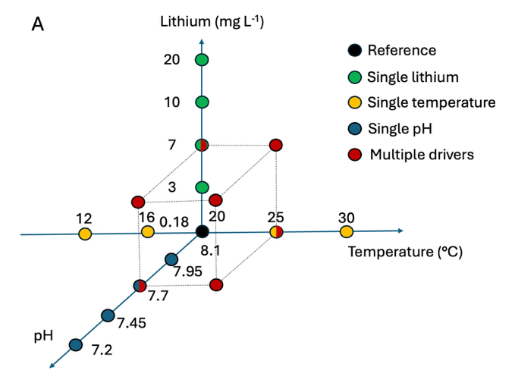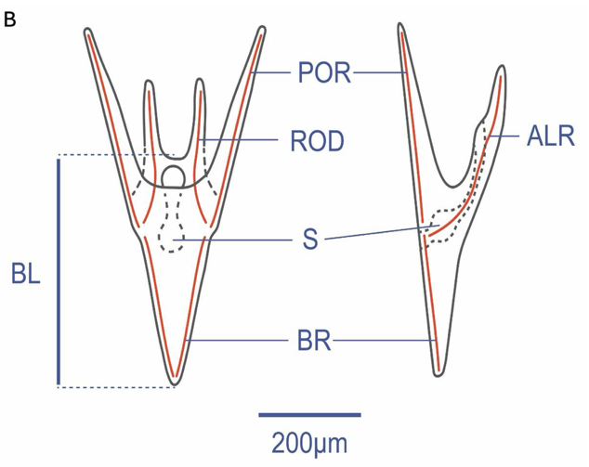
Figure 1. Treatment levels and larval morphology. A) An overview of the single and multi-driver treatment levels, showing the target levels of the three drivers for all 23 treatments. B) Paracentrotus lividus pluteus larvae morphology and measured morphometric variables. BL: body length, BR: body rod, ALR: antero lateral rod, and POR: post oral rod.

2.3 Biological measurements
After 96 hours, a 10 mL sample was taken from each bottle and fixed with 4% formaldehyde. Larvae were counted for density and photographed under a 10x microscope (Olympus; BX43 upright microscope with DP28 camera, Tokyo, Japan). Ten larvae were randomly selected from each treatment and body length (BL) measured using the Fiji software (Schindelin et al., 2012) (Figure 1b). The diameter of the eggs at the beginning of the experiment (Initial egg size; IS) was also measured. No change in density was detected except in the highest temperature treatment. Larval growth rate (GR in µm∗day⁻¹) was calculated for 10 larvae in each aquarium as the difference between BL (µm) and the mean IS (µm) divided by exposure time (3 days).

2.4 Data analyses
To evaluate the comparability between the two experiments, we tested for difference in growth rate between treatments in common to the single- (experiment #1) and multiple-driver (experiment #2) experiments using Student’s t-tests, Welch’s t-tests and Wilcoxon rank sum tests, depending on normality and homogeneity of residuals.

For each driver in experiment #1, the shape of the response curve for the growth rate was evaluated using linear models, second degree polynomial models, general additive models (GAMs), logit models and exponential models. There were no severe violations of assumptions for the models. Model performance was assessed by comparing the coefficient of determination (R²), standard error and Akaike Information Criterion (AIC) scores. The best-fitting model was selected based on these criteria for each driver.

For experiment #2, the effect of each driver on growth rate was compared when considered as a single driver (e.g. only high temperature) or when combined with one or two of the other drivers (e.g. any combination with low pH and/or high lithium). A Student’s t-test, Welch’s t-test and a Wilcoxon rank-sum test were used to test for statistical significance in the comparison of each pair.

Assuming a similar mode of action between drivers and using a concentration-addition approach, it was hypothesized that each driver contributed additively to the level of stress along a common second-degree polynomial curve (see below). The relative contribution of each driver (temperature, pH and lithium) was calculated using a driver index (DI) as the weighted (α_{driver}) deviation from the reference condition (Δ_{driver}):
DI_{driver} = α_{driver} ∗ Δdriver
α was set as 1 for temperature and estimated for pH and lithium by aligning the three single driver performance curves along the driver index axis (Figure 2). This allows to turn changes in pH or lithium concentration in “temperature equivalent”.

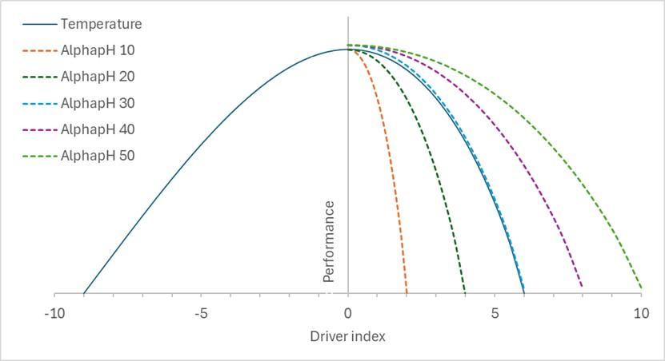
Figure 2. Illustration of the estimation of αpH. The performance curve for temperature is calculated along the driver index assuming an αtemp=1 (relative temperature deviation from the control; full blue line). Performance curves for pH are then calculated using the “relative temperature equivalent” driver index using different αpH (10 to 50, dashed lines). In this theoretical example, an αpH=30, corresponding to an equivalent effect of 30ºC for each pH unit, is the best fit with a perfect alignment between the temperature and pH performance curves.

Assuming a similar mode of action between drivers and using a concentration-addition approach, the combined DI was then calculated for multiple drivers as: DI = α_{Temp} DI_{Temp} + α_{pH} DI_{pH} + α _{Li} DI_{Li}
A single performance curve was modelled along this DI from all the single driver data and the data from multiple driver experiments were plotted against this model. Multiple driver data that does not fall within the confidence interval of the single driver model reveals an interaction between the drivers.

2.5 Seawater parameters
Temperature data were collected from continuous sensors (IKS Aquastar). pH_{T} (pH on the total scale) of the seawater was measured in each aquarium at the end of the experiment with a glass pH electrode (Metrohm (Herisau, Switzerland) calibrated with TRIS buffer solution (Andrew Dickson, Scripps Institution of Oceanography, San Diego, USA)). Total Alkalinity (TA) was measured using the automatic open cell potentiometric titration method (Metrohm, Titrando 888) following the protocol described by Dickson et al. (2007). pCO₂, calcite and aragonite saturation values were calculated from TA, pH_{T}, temperature and a salinity of 38 psu with the R package seacarb (Gattuso et al., 2016), using the dissociation constants from Lueker et al. (2005).

Lithium samples were filtered through 1.0 µm polycarbonate filters and lithium concentration analyses in seawater samples were carried out by Inductively coupled plasma - optical emission spectrometry technique (ICP-OES; Plasma Quant 9100, Analytik Jena, Jena, Germany). Samples were acidified with ultrapure HNO₃ and diluted 10 times with ultrapure H₂O before analysis. The instrumental conditions are summarized in supplementary material (Table S2). The radial analysis mode was used for lithium enriched samples while the axial mode (more sensitive) was used for non-enriched seawater samples. The quantification was carried out by means of external calibration, using proper dilution of lithium stock standard (TraceCert®, 997 ± 4 mgL⁻¹, Sigma-Aldrich, Buchs, Switzerland) in 0.35 % ultrapure NaCl (ESI Elemental Scientific, Omaha, Nebraska, USA), to assure matrix match with seawater samples diluted 10 times. In the absence of a seawater Reference Material certified for lithium (not available in the market), several spiked samples were analyzed to account for possible matrix effect and to evaluate the accuracy of results. The recoveries were always within acceptable range (90-110 %). The results are reported in mg L⁻¹ (≈ ppm) together with respective expanded uncertainty (Ue, k=2). The parameters of the seawater physico-chemical parameters for the two experiments are summarized in the Table S1 in the supplementary material.

Results
While exposed to the same treatments in the two experiments, larvae had no significant growth rate differences between the two experiments for pH and temperature (Figure 3). The lithium 7 ppm treatment had a higher growth rate in experiment #1 (74.5 µm day⁻¹, SD=2.8) than in the experiment #2 (68.6 µm day⁻¹, SD=6.6, Welch’s t-test: t(24.6)=3.4, p= 0.0026). There was also a slight but significant difference between the reference treatments, again with a higher growth rate in experiment #1 (74 µm day⁻¹, SD=4.6) than in experiment #2 (69.6 µm day⁻¹, SD=5.9, Wilcoxon rank test r=0.32, p=0.0091), with one of the replicates in experiment #2 having lower growth rate than the other one (63.8 vs. 74.9 µm day⁻¹). Details of all the statistical analyses are summarized in Table S3.

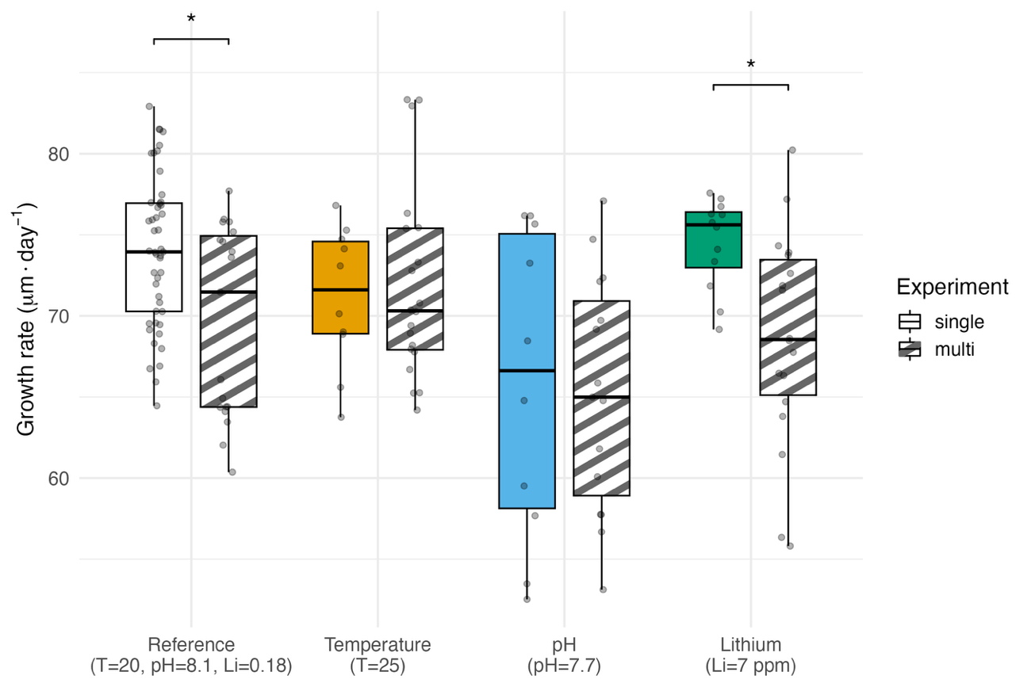Figure 3. Larval growth rate comparison of the treatments in common to the single driver experiment and the multiple driver experiment. The reference conditions (N=47 vs. N=19) and lithium 7 ppm (N=12 vs. N=18) are the only significantly different comparisons, indicated by an asterisk. Temperature (N=10 vs. N=20) and pH (N=10 vs. N=15) showed no significant differences. Group means, s.d. and statistics from the Wilcoxon and t-tests are summarized in Table S3 in supplementary material.

The second-degree polynomial model was significant and the best fit for temperature and pH growth rate responses (Figures 4a-c, Table S4). For temperature, the curve was bell-shaped with a good fit (adj. R² = 0.70, F_{(2,54)}= 66.82, p<0.05) and a tight confidence interval. Second degree polynomial model and GAM had comparable fits for the growth rate data from the pH treatments, but the polynomial was chosen with parsimony in mind. Compared to temperature, the polynomial model fit for pH had a lower fit and wider confidence interval (adj. R²: 0.36, F(_{2, 49})=15.68 p=5.837e-06). For lithium, the models had the poorest fit with the polynomial model being the best (adj. R²: 0.30, F(_{2,78})=17.99, p=3.771e-07), although the second-degree component was not significant (p = 0.061), indicating limited support for a nonlinear response within the observed range. For lithium, the fitted curvature should not be interpreted as evidence of a biologically meaningful nonlinear response. Nevertheless, the polynomial model was retained across all drivers to ensure consistency in model structure and support the concentration-addition hypothesis. For all drivers, the reference treatments (20ºC, pH_{T} 8.1, lithium 0.18 ppm) had the highest GR.

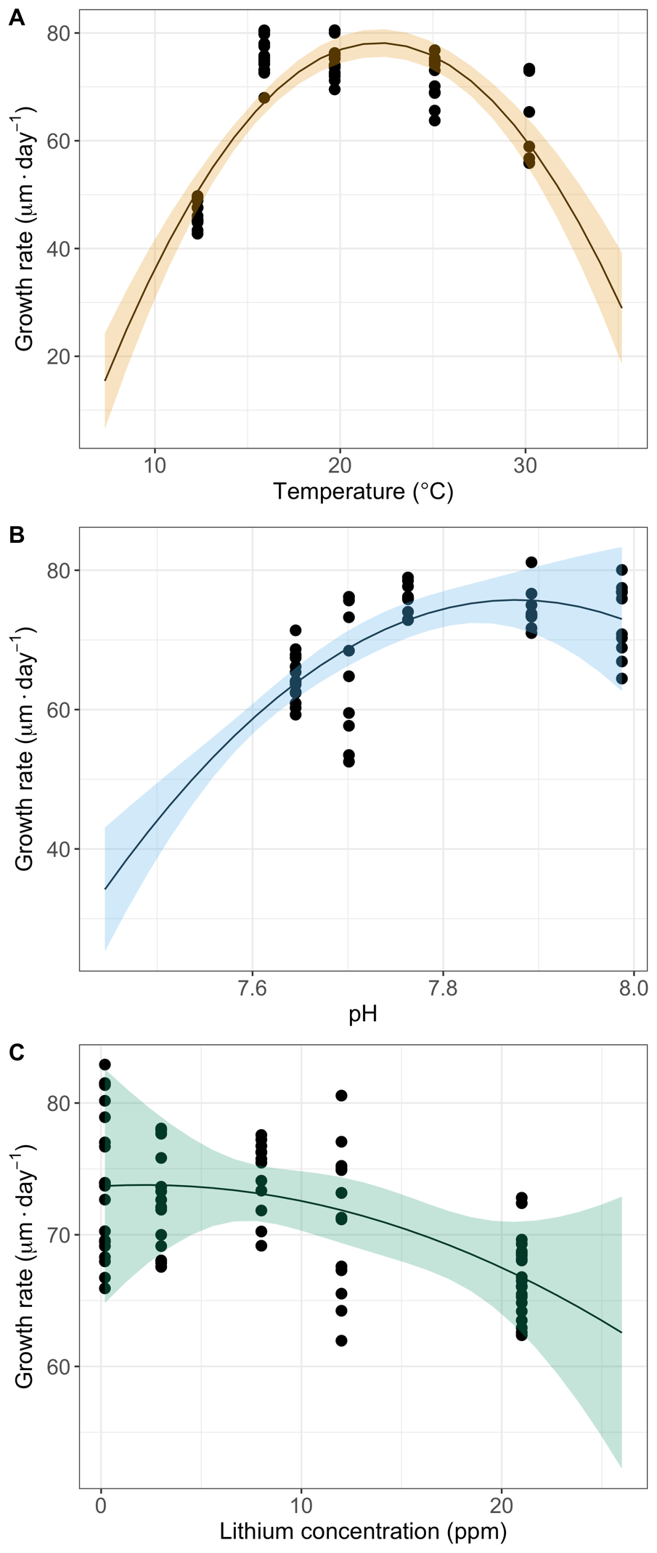
Figure 4. Growth rate of P. lividus larvae across different (A) temperature (N=57), (B) pH_{T} (N=52), and (C) lithium concentrations (N=81). The solid lines indicate second degree polynomial models fitted to the datapoints and the ribbons the 95% confidence interval for each model. Fits and statistics are summarized in Table S4 in supplementary material.

The comparison of growth rate of larvae exposed to single or multiple drivers in experiment #2 revealed (i) no significant differences at high temperature or high lithium when the larvae were exposed to those drivers alone or when combined with other drivers (Figures 5a and 4c), and (ii) a higher growth at low pH when combined with other drivers than when exposed to low pH alone (Figure 5b) (see Table S5 for statistical tests).

Several α values were compared to synchronize and align the three single driver performance curves along the driver index axis. The best fits were 1, 28 and 0. 35 for temperature, pH and lithium, respectively (Figure 6a). These can be interpreted as a decrease by 1 pH unit relative to the reference pH 8.1 is corresponding to an equivalent effect on the temperature performance curve of a 28ºC increase relative to the reference 20ºC. A performance curve combining the 3 single drivers growth rate data was fitted after transformation into a driver index (Figure 6a), and the best fit was a second-degree polynomial curve (adj. R² = 0.58, F(2, 187) = 129.43, p < 0.05 for both the linear and quadratic component).

The 8 treatments of the multiple driver experiment were converted into a driver index following the concentration addition model and the growth rate data were plotted and compared with the polynomial model derived from the single driver experiment (Figure 6b). All the multiple driver treatments involving low pH were deviating from the polynomial model with higher growth rate than predicted and suggesting an antagonistic interaction.

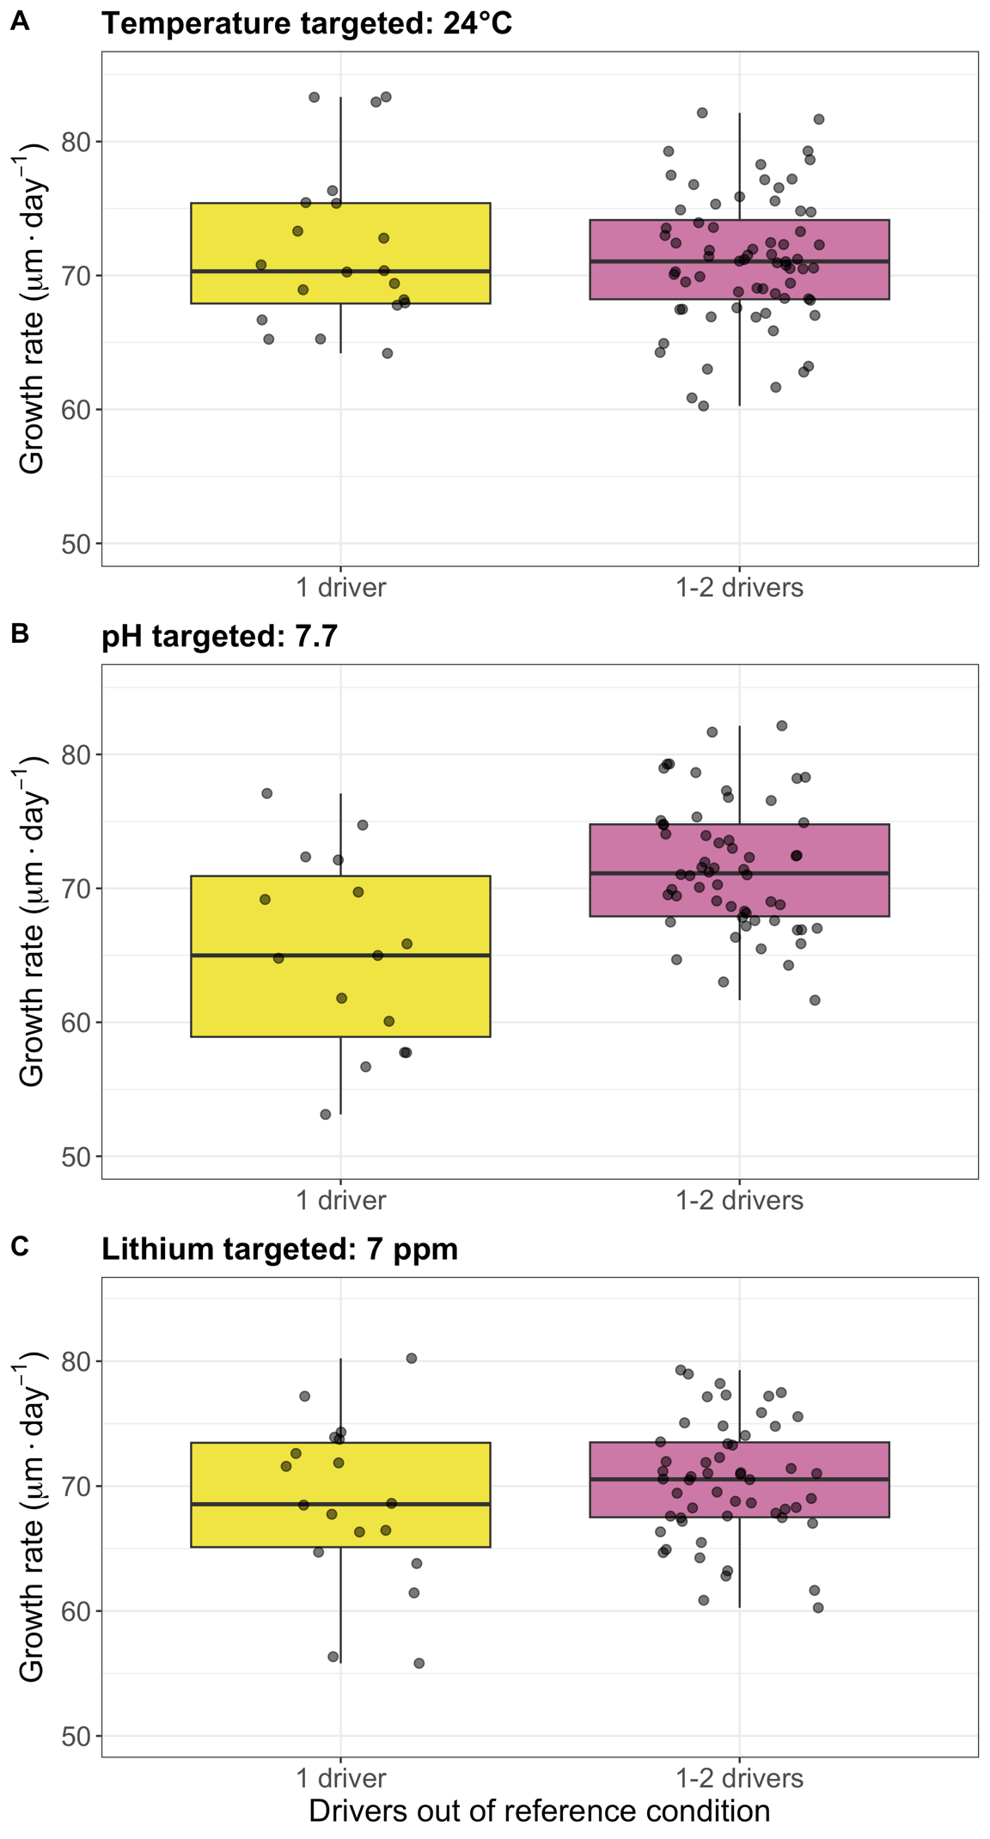
Figure 5. Growth rates in the multiple driver experiment. Comparison of the larval growth rate of those multi-driver treatments that had one driver out of reference conditions and those that additionally had more drivers out of reference conditions. The panels are split up by what driver is consistently out of reference condition: Temperature (A), pH (B) or Lithium (C). Statistical tests are summarized in Table S5.

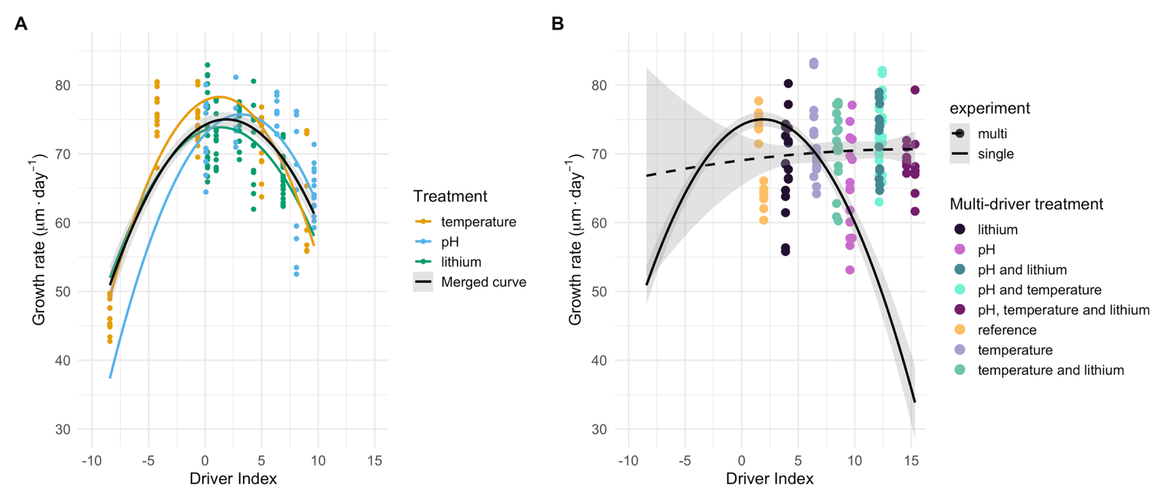
Figure 6. Single driver performance curves and the multiple driver comparison. A) The three single driver growth rate performance curves aligned on a common driver index axis, and a second-degree polynomial curve fit to all the single driver data combined (N=190). B) Comparison of the single driver curve with the second-degree polynomial multi-driver curve and points (N=149). The ribbons indicate 95% confidence intervals.

Discussion

Research aimed at resolving the biological impacts of multiple drivers has increased rapidly over the last two decades. Within the field of ocean acidification alone, thousands of articles are now documenting its combined effect with other drivers, often using relatively simple full-factorial designs. Despite this extensive effort, few generalizable conclusions have emerged and contrasting results remain common across the literature (e.g. Alter et al., 2024; Stockbridge et al., 2020). Another consequence is that the mechanisms behind combined effects are virtually unresolved. As biological responses are inherently non-linear, combining drivers can produce patterns that appear synergistic or antagonistic even when they arise from additive effects along a non-linear performance curve. As a consequence, simple full-factorial designs are not well suited to disentangle such effects, as statistical interactions do not necessarily reflect driver interactions, defined here as deviations from additivity (Boyd et al., 2018; Burgess et al., 2021; Collins et al., 2022).

To fully resolve combined effects, the ideal design would require full-factorial experiments with a large number of treatments for each individual driver allowing to model the full response landscape. This would also allow testing different hypotheses to resolve potential interactions (e.g. a comparison of a concentration addition model with the landscape). However, these are often logistically difficult to implement, and alternatives should then be considered. Our experiment was designed to test such an alternative.

A first step towards identifying potential interactions between drivers is to resolve the performance curve of each driver across a sufficiently broad gradient. In our experiment, the responses to temperature and pH were best described by unimodal second-degree polynomial models, although with varying levels of support. The temperature response showed the strongest fit and a clearly defined unimodal model, consistent with well-established thermal performance curves (Byrne et al., 2022; Silva Romero et al., 2021). The response to pH was less well resolved, with broader confidence intervals and lower explanatory power, indicating that the full shape of their performance curves was only partially captured within the explored range. In contrast, the lithium response was not well resolved. Although a polynomial model provided the best statistical fit among the tested models, the overall explanatory power was low and the quadratic term was not significant, indicating support for a nonlinear performance curve within the observed range. In addition, growth responses to lithium differed between the single- and multiple-driver experiments, suggesting that its effect may be context-dependent and not robustly reproducible across experimental conditions. Together these patterns indicate that the lithium performance curve is weakly constrained in the present dataset.

Rather than assuming identical modes of action, our approach relies on the empirical alignment of response curves onto a common performance axis. This provides a pragmatic basis for applying concentration addition as a null model of additivity, serving as a baseline expectation against which deviations can be interpreted, rather than as a mechanistic assumption of shared modes of action among drivers. Similar unimodal responses have been reported for pH and CO₂ effects in phytoplankton (Collins et al., 2022; Paul and Bach, 2020), whereas toxicant responses are often described as sigmoidal (Bellas, 2008; Morroni et al., 2023; Philibert et al., 2021). Our results suggest that, within the explored ranges, the three drivers can be approximated within a shared performance framework. The lower resolution of the lithium response curves suggests a different mode of action. Lithium affects membrane-based signaling systems and thereby ionic balance (Becchetti and Whitaker, 1997), which can lead to increased vegetalization with development tending more towards endoderm and mesoderm rather than ectoderm (Giudice, 1986). The embryonic development of the oral-aboral axis (Wikramanayake and Klein, 1997) and the expression of associated genes are also affected by lithium treatments (Duboc et al., 2004).

A second step consisted in constructing a driver index integrating the relative contribution of each driver, following an approach similar to Espinel-Velasco et al. (2025). This index was derived by aligning the single-driver performance curves onto a common axis, using temperature deviation from the reference condition of 20°C as the central unit. The weighting factors (α) for pH and lithium were estimated empirically to achieve the best overlap among the three response curves, resulting in coefficients of 28°C per pH unit and 0.35°C per ppm of lithium. This transformation provides a functional scaling that allows the integration of different drivers within a shared performance framework. In this context, the driver index is consistent with a concentration-addition approach used as a null model to predict combined effects (Drescher & Boedeker, 1995; Liess et al., 2016; Wang et al., 2015).

The third and final step of our strategy was to compare the outcome of the model derived from single-driver responses with the observations from the multi-driver experiment. Under our null hypothesis of additivity, the multi-driver data are expected to fall along the shared performance curve defined by the driver index (Figure 6b). However, all combinations involving reduced pH consistently deviated from this expectation, with higher growth rates than predicted by the model (Figure 6b). This pattern indicates a true antagonistic interaction, where the combined effect of multiple drivers is less severe than expected from their additive contributions along a non-linear model. This interpretation is also consistent with the direct comparison among treatments in the fully crossed design, where larvae exposed to low pH alone showed lower growth than those exposed to low pH in combination with additional drivers (Figure 5b). This contrasts with the results from Espinel et al. (2025) using a similar biological model and experimental approach. In their experiments, pH, temperature and salinity showed an additive effect on fertilization success. The observed antagonism in our experiment highlights the importance of considering how interactions between drivers reshape the performance landscape. The mechanisms underlying this antagonism remain unresolved and other experimental designs should be considered to understand how pH interacts with temperature and lithium.

Conclusion

Our study provides a simplified experimental framework allowing to resolve potential interactions between drivers taking into account non-linear effects. It allowed to identify true antagonistic interactions between pH and two other drivers (temperature and lithium). Future work should focus on other experimental designs allowing to resolve such interactions and provide the needed predictive power to bridge physico-chemical changes to biological impacts, a critical tool for ecosystem management.

References
Agnetta, D., Badalamenti, F., Ceccherelli, G., Di Trapani, F., Bonaviri, C. and Gianguzza, P. (2015). Role of two co-occurring Mediterranean sea urchins in the formation of barren from Cystoseira canopy. Estuar. Coast. Shelf Sci. 152, 73–77.
Alter, K., Jacquemont, J., Claudet, J., Lattuca, M. E., Barrantes, M. E., Marras, S., Manríquez, P. H., González, C. P., Fernández, D. A., Peck, M. A., et al. (2024). Hidden impacts of ocean warming and acidification on biological responses of marine animals revealed through meta-analysis. Nat. Commun. 15, 2885.
Barbosa, H., Soares, A. M. V. M., Pereira, E. and Freitas, R. (2023). Lithium: A review on concentrations and impacts in marine and coastal systems. Sci. Total Environ. 857, 159374.
Becchetti, A. and Whitaker, M. (1997). Lithium blocks cell cycle transitions in the first cell cycles of sea urchin embryos, an effect rescued by myo-inositol. Development 124, 1099–1107.
Bellas, J. (2008). Prediction and assessment of mixture toxicity of compounds in antifouling paints using the sea-urchin embryo-larval bioassay. Aquat. Toxicol. 88, 308–315.
Boyd, P. W., Collins, S., Dupont, S., Fabricius, K., Gattuso, J. P., Havenhand, J., Hutchins, D. A., Riebesell, U., Rintoul, M. S., Vichi, M., et al. (2018). Experimental strategies to assess the biological ramifications of multiple drivers of global ocean change—A review. Glob. Change Biol. 24, 2239–2261.
Burgess, B. J., Purves, D., Mace, G. and Murrell, D. J. (2021). Classifying ecosystem stressor interactions: Theory highlights the data limitations of the additive null model and the difficulty in revealing ecological surprises. Glob. Change Biol. 27, 3052–3065.
Byrne, M., Gall, M. L., Campbell, H., Lamare, M. D. and Holmes, S. P. (2022). Staying in place and moving in space: Contrasting larval thermal sensitivity explains distributional changes of sympatric sea urchin species to habitat warming. Glob. Change Biol. 28, 3040–3053.
Caillon, C., Pernet, F., Lutier, M. and Di Poi, C. (2023). Differential reaction norms to ocean acidification in two oyster species from contrasting habitats. J. Exp. Biol. 226, jeb246432.
Carmichael, H., Warfield, R. and Yvon‐Durocher, G. (2025). Reconciling Variability in Multiple Stressor Effects Using Environmental Performance Curves. Ecol. Lett. 28,.
Collins, S., Whittaker, H. and Thomas, M. K. (2022). The need for unrealistic experiments in global change biology. Curr. Opin. Microbiol. 68, 102151.
Crain, C. M., Kroeker, K. and Halpern, B. S. (2008). Interactive and cumulative effects of multiple human stressors in marine systems. Ecol. Lett. 11, 1304–1315.
Cuthbert, R. N., Sidow, A., Frost, K. F., Kotronaki, S. G. and Briski, E. (2021). Emergent effects of temperature and salinity on mortality of a key herbivore. J. Sea Res. 177, 102126.
Drescher, K. and Boedeker, W. (1995). Assessment of the Combined Effects of Substances: The Relationship between Concentration Addition and Independent Action. Biometrics 51, 716.
Duboc, V., Röttinger, E., Besnardeau, L. and Lepage, T. (2004). Nodal and BMP2/4 Signaling Organizes the Oral-Aboral Axis of the Sea Urchin Embryo. Dev. Cell 6, 397–410.
Dupont, S., Ortega-Martínez, O. and Thorndyke, M. (2010). Impact of near-future ocean acidification on echinoderms. Ecotoxicology 19, 449–462.
Espinel-Velasco, N., Kvernvik, A. C., Hop, H. and Dupont, S. (2025). Combined effects of ocean acidification, warming, and salinity on the fertilization success in an Arctic population of sea urchins. Sci. Rep. 15, 44090.
Gattuso, J.-P., Epitalon, J.-M. and Lavigne, H. (2016). seacarb: seawater carbonate chemistry with R. R package version 3.0.14.
Gattuso, J. P., Alliouane, S., & Mousseau, L. (2021). Seawater carbonate chemistry in the Bay of Villefranche, Point B (France), January 2007-June 2023.
Gianguzza, P., Visconti, G., Gianguzza, F., Vizzini, S., Sarà, G. and Dupont, S. (2014). Temperature modulates the response of the thermophilous sea urchin Arbacia lixula early life stages to CO2-driven acidification. Mar. Environ. Res. 93, 70–77.
Giudice, G. (1986). The sea urchin embryo: a developmental biological system. Springer Science & Business Media.
Grant, R., Combs, A. B. and Acosta, D. (2010). Experimental Models for the Investigation of Toxicological Mechanisms. In Comprehensive Toxicology, pp. 203–224.
IPCC (2014). Climate Change 2014: Impacts, Adaptation and Vulnerability.
Jager, T., Ravagnan, E. and Dupont, S. (2016). Near-future ocean acidification impacts maintenance costs in sea-urchin larvae: Identification of stress factors and tipping points using a DEB modelling approach. J. Exp. Mar. Biol. Ecol. 474, 11–17.
Kreyling, J., Jentsch, A. and Beier, C. (2014). Beyond realism in climate change experiments: gradient approaches identify thresholds and tipping points. Ecol. Lett. 17, 125.
Kreyling, J., Schweiger, A. H., Bahn, M., Ineson, P., Migliavacca, M., Morel‐Journel, T., Christiansen, J. R., Schtickzelle, N. and Larsen, K. S. (2018). To replicate, or not to replicate – that is the question: how to tackle nonlinear responses in ecological experiments. Ecol. Lett. 21, 1629–1638.
Liess, M., Foit, K., Knillmann, S., Schäfer, R. B. and Liess, H.-D. (2016). Predicting the synergy of multiple stress effects. Sci. Rep. 6, 32965.
Lueker, T. J., Dickson, A. G. and Keeling, C. D. (5 AD). Ocean pCO2 calculated from dissolved inorganic carbon, alkalinity, and equations for K1 and K2: validation based on laboratory measurements of CO2 in gas and seawater at equilibrium. Mar. Chem. 70, 105–119.
Morroni, L., Rakaj, A., Grosso, L., Flori, G., Fianchini, A., Pellegrini, D. and Regoli, F. (2023). Echinoderm larvae as bioindicators for the assessment of marine pollution: Sea urchin and sea cucumber responsiveness and future perspectives. Environ. Pollut. 335, 122285.
Pagano, G., Guida, M., Trifuoggi, M., Thomas, P., Palumbo, A., Romano, G. and Oral, R. (2017). Sea Urchin Bioassays in Toxicity Testing: I. Inorganics, Organics, Complex Mixtures and Natural Products. Expert Opin. Environ. Biol. 06,.
Paul, A. J. and Bach, L. T. (2020). Universal response pattern of phytoplankton growth rates to increasing CO₂. New Phytol. 228, 1710–1716.
Philibert, D., Parkerton, T., Marteinson, S. and De Jourdan, B. (2021). Assessing the Toxicity of Individual Aromatic Compounds and Mixtures to American Lobster (Homarus americanus) Larvae Using a Passive Dosing System. Environ. Toxicol. Chem. 40, 1379–1388.
Pörtner, H.-O., Scholes, R. J., Agard, J., Archer, E., Arneth, A., Bai, X., Barnes, D., Burrows, M., Chan, L., Cheung, W. L. (William), et al. (2021). Scientific outcome of the IPBES-IPCC co-sponsored workshop on biodiversity and climate change. Zenodo.
Ruocco, N., Costantini, M. and Santella, L. (2016). New insights into negative effects of lithium on sea urchin Paracentrotus lividus embryos. Sci. Rep. 6, 32157.
Schindelin, J., Arganda-Carreras, I., Frise, E., Kaynig, V., Longair, M., Pietzsch, T., Preibisch, S., Rueden, C., Saalfeld, S. and Schmid, B. (2012). Fiji: an open-source platform for biological-image analysis. Nat. Methods 9, 676–682.
Silva Romero, I., Bruno, J. F., Silbiger, N. J. and Brandt, M. (2021). Local conditions influence thermal sensitivity of pencil urchin populations (Eucidaris galapagensis) in the Galápagos Archipelago. Mar. Biol. 168, 34.
Stockbridge, J., Jones, A. R. and Gillanders, B. M. (2020). A meta-analysis of multiple stressors on seagrasses in the context of marine spatial cumulative impacts assessment. Sci. Rep. 10, 1.
Tekin, E., Diamant, E. S., Cruz‐Loya, M., Enriquez, V., Singh, N., Savage, V. M. and Yeh, P. J. (2020). Using a newly introduced framework to measure ecological stressor interactions. Ecol. Lett. 23, 1391–1403.
Vargas, C. A., Lagos, N. A., Lardies, M. A., Duarte, C., Manríquez, P. H., Aguilera, V. M., Broitman, B., Widdicombe, S. and Dupont, S. (2017). Species-specific responses to ocean acidification should account for local adaptation and adaptive plasticity. Nat. Ecol. Evol. 1, 0084.
Vargas, C. A., Cuevas, L. A., Broitman, B. R., San Martin, V. A., Lagos, N. A., Gaitán-Espitia, J. D. and Dupont, S. (2022). Upper environmental pCO2 drives sensitivity to ocean acidification in marine invertebrates. Nat. Clim. Change 12, 200–207.
Wang, N., Wang, X. C. and Ma, X. (2015). Characteristics of concentration–inhibition curves of individual chemicals and applicability of the concentration addition model for mixture toxicity prediction. Ecotoxicol. Environ. Saf. 113, 176–182.
Wikramanayake, A. H. and Klein, W. H. (1997). Multiple signaling events specify ectoderm and pattern the oral-aboral axis in the sea urchin embryo. Development 124, 13–20.

Supplementary material
Table S1. Measured and calculated seawater parameters in each experimental treatment. pCO₂, DIC, Ω_{ca} and Ω_{ar} were calculated from measured TA, pH_{T}, temperature and a salinity of 38 psu. S=Single, M=Multiple, T=Temperature and Li=Lithium. Multi-driver duplicates have been merged.
Treatment | T (°C) | pH_{T}-in situ | Li (mg L⁻¹) | TA (µmol kg⁻¹) | pCO₂ (µatm) | DIC (µmol kg⁻¹) | Ω_{ar} | Ω_{ca}
Single drivers
12 °C | 12.3 | 8.03 | 0.18 | 2548 | 461 | 2320 | 2.52 | 3.92
16 °C | 15.99 | 8.01 | 0.17 | 2552 | 489 | 2299 | 2.81 | 4.33
20 °C | 19.72 | 8.01 | 0.2 | 2557 | 479 | 2279 | 3.09 | 4.75
25 °C | 25.08 | 8.00 | 0.19 | 2532 | 482 | 2214 | 3.57 | 5.40
30 °C | 30.2 | 8.04 | 0.19 | 2575 | 435 | 2202 | 4.22 | 6.33
pH 8.1 | 19.72 | 7.99 | 0.19 | 2525 | 507 | 2259 | 2.98 | 4.57
pH 7.95 | 19.72 | 7.89 | 0.18 | 2519 | 654 | 2307 | 2.45 | 3.75
pH 7.7 | 19.72 | 7.76 | 0.18 | 2508 | 914 | 2358 | 1.88 | 2.88
pH 7.45 | 19.72 | 7.70 | 0.18 | 2502 | 1068 | 2379 | 1.65 | 2.53
pH 7.2 | 19.72 | 7.65 | 0.17 | 2511 | 1235 | 2410 | 1.48 | 2.26
0.18 ppm lithium | 19.72 | 7.98 | 0.19 | 2516 | 513 | 2258 | 2.89 | 4.43
3 ppm lithium | 19.72 | 7.99 | 3 | 2507 | 500 | 2245 | 2.92 | 4.48
7 ppm lithium | 19.72 | 7.98 | 8 | 2507 | 515 | 2250 | 2.88 | 4.41
10 ppm lithium | 19.72 | 7.98 | 12 | 2498 | 506 | 2239 | 2.88 | 4.42
20 ppm lithium | 19.72 | 8.00 | 21 | 2464 | 474 | 2196 | 2.95 | 4.53
Multiple drivers
MT20pH8.1Li0.18 | 20.8 | 7.97 | 0.18 | 2512 | 533 | 2256 | 2.88 | 4.40
MT20pH7.7Li0.18 | 20.6 | 7.67 | 0.19 | 2497 | 1149 | 2383 | 1.58 | 2.42
MT20pH8.1Li7 | 20.6 | 7.97 | 7.5 | 2482 | 523 | 2229 | 2.83 | 4.33
MT20pH7.7Li7 | 20.7 | 7.69 | 7.5 | 2471 | 1091 | 2350 | 1.62 | 2.48
MT25pH8.1Li0.18 | 25.5 | 7.97 | 0.18 | 2496 | 528 | 2201 | 3.34 | 5.04
MT25pH7.7Li0.18 | 25.5 | 7.76 | 0.18 | 2505 | 935 | 2323 | 2.24 | 3.39
MT25pH8.1Li7 | 25.4 | 7.97 | 7 | 2493 | 516 | 2194 | 3.37 | 5.09
MT25pH7.7Li7 | 25.6 | 7.76 | 7.5 | 2500 | 934 | 2318 | 2.25 | 3.39

Table S2. Instrumental conditions for Li analysis by ICP-OES in seawater.
Parameter | Value
Wavelength | 670.79 nm
Plasma power | 1300 W
Plasma gas | 14 L min⁻¹
Auxiliary gas | 0.5 L min⁻¹
Nebulizer gas | 0.6 L min⁻¹
Radial offset | 15 mm
Read time radial | 1 sec
Read time axial | 3 sec
Peak evaluation | 3 pixels

Table S3. Statistical tests comparing growth rate of treatments in common to experiment #1 and experiment #2.
Comparison | Mean  single | S.d.  single | N single | Mean multi | S.d. multi | N  multi | Test | p value
Reference | 74.04 | 4.64 | 47 | 69.62 | 5.92 | 19 | Wilcoxon | 0.0091
Temperature | 71.14 | 4.36 | 10 | 71.89 | 5.95 | 20 | Wilcoxon | 0.9828
pH | 65.77 | 9.49 | 10 | 65.2 | 7.25 | 15 | Student's t-test | 0.8661
Lithium | 74.5 | 2.79 | 12 | 68.62 | 6.62 | 18 | Welch's t-test | 0.0026

Table S4. Fits and statistics of the models fitted to growth rate data from single-driver experiments.
Driver | Term | Estimate | Std. Error | t- value | p-value | Adj. R² | Sig.
Temp | (Intercept) | 66.826 | 0.872 | 76.607 | < 2e-16 | 0.7016 | ***
Temp | poly(temp, 2)1 | 30.827 | 6.586 | 4.681 | 1.96e-05 |  | ***
Temp | poly(temp, 2)2 | -69.616 | 6.586 | -10.57 | 9.26e-15 |  | ***
pH | (Intercept) | 70.116 | 0.778 | 90.111 | < 2e-16 | 0.3636 | ***
pH | poly(pH, 2)1 | 27.019 | 5.611 | 4.815 | 1.45e-05 |  | ***
pH | poly(pH, 2)2 | -15.819 | 5.611 | -2.819 | 0.00693 |  | **
Lithium | (Intercept) | 71.51 | 0.48 | 149 | < 2e-16 | 0.2981 | ***
Lithium | poly(lithium, 2)1 | -24.573 | 4.319 | -5.689 | 2.14e-07 |  | ***
Lithium | poly(lithium, 2)2 | -8.206 | 4.319 | -1.9 | 0.0612 |  | .

Table S5. Statistical tests comparing treatments in experiment #2 that have one driver out of reference conditions, and those that have more out of reference condition in addition to that one.
Condition | Test | df | Statistic | p-value
T targeted: 25 °C | Wilcoxon | - | W = 676 | 0.9722
pH targeted: 7.7 | Welch’s t | 17.2 | t = -3.211 | 0.0051
Li targeted: 7 ppm | Student’s t | 70 | t = -1.197 | 0.2353

Table S6. Larvae counts.
Sample | Larvae count
ST1 | 99.5
ST2 | 109
ST3 | 106.5
ST4 | 110.5
ST5 | 4.5
SP1 | 102.5
SP2 | 106
SP3 | 111.5
SP4 | 106.5
SP5 | 104.5
SL1 | 111
SL2 | 105
SL3 | 107
SL4 | 104.5
SL5 | 96.5
ML1P1_20_R1 | 98.5
ML1P1_20_R2 | 115.5
ML1P2_20_R1 | 110
ML1P2_20_R2 | 111.5
ML2P2_20_R1 | 107.5
ML2P2_20_R2 | 112.5
ML2P1_20_R1 | 115
ML2P1_20_R2 | 113.5
ML1P1_24_R1 | 101.5
ML1P1_24_R2 | 100
ML1P2_24_R1 | 129
ML1P2_24_R2 | 118
ML2P2_24_R1 | 99
ML2P2_24_R2 | 101
ML2P1_24_R1 | 123.5
ML2P1_24_R2 | 107

Author list

Full name | email | Affiliation
Maria Soledad Yusseppone | msyusseppone@gmail.com | Instituto de Investigaciones Marinas y Costeras (IIMyC), FCEyN - Universidad Nacional de Mar del Plata (UNMDP), Consejo Nacional de Investigaciones Científicas y Técnicas (CONICET), Mar del Plata, Argentina.
 |  | Red de Investigación de Estresores Marinos-Costeros en Latinoamérica y el Caribe (REMARCO), Mar del Plata, Argentina.
Jurleys Paola Vellojin Furnieles | jurleys.vellojin@ifop.cl | Departamento de Medio Ambiente, División de Investigación en Acuicultura, Instituto de Fomento Pesquero (IFOP), Puerto Montt, Chile.
Zhenzhen Li | zhenzli@jou.edu.cn | School of Marine Science and Fisheries, Jiangsu Ocean University, Lianyungang, China
Yusmila Helguera Pedraza | yusmilahelguera@gmail.com | Centro de Estudios Ambientales de Cienfuegos
Natalija Suhareva | natalija.suhareva@bio.ku.dk | University of Copenhagen, Department of Biology, Marine Biological Section,Helsingør, Denmark
Einar Pétur Jónsson | einar.petur.jonsson@hafogvatn.is | Marine and Freshwater Research Institute. Fornubudir 5,Hafnarfjordur, Iceland.
Mirko Mutalipassi | mirko.mutalipassi@szn.it | Stazione Zoologica Anton Dohrn, Integrative Marine Ecology Department, Napoli, Italy;
 |  | National Biodiversity Future Center (NBFC), Palermo, Italy
Edson Piscoya | episcoya@doctorado.ucsc.cl | Programa de Doctorado en Ciencias mención en Biodiversidad y Biorecursos, Universidad Católica de la Santísima Concepción (UCSC), Alonso de Ribera 2850, Concepción 4090541
Joana Filipa Fernandes | joanafcf@ua.pt | ECOMARE - Laboratory for Innovation and Sustainability of Marine Biological Resources, CESAM – Centre for Environmental and Marine Studies, Department of Biology, University of Aveiro, Estrada do Porto de Pesca Costeira, 3830-565 Gafanha da Nazaré, Portugal
 |  | Marine Ecological and Evolutionary Physiology laboratory, Département de Biologie, Chimie et Géographie, Université du Québec à Rimouski, 300 Allée des Ursulines, Rimouski, QC G5L 3A1, Canada
 |  | UCIBIO - Applied Molecular Biosciences Unit, NOVA School of Science and Technology, NOVA University of Lisbon, Campus de Caparica, 2829-516 Caparica, Portugal
 |  | Associate Laboratory i4HB Institute for Health and Bioeconomy, NOVA School of Science and Technology, NOVA University of Lisbon, 2829-516 Caparica, Portugal
Sam Dupont | sam.dupont@bioenv.gu.se | University of Gothenburg, Sweden
Marc Metian | m.metian@iaea.org | IAEA Marine Environment Laboratories, Department of Nuclear Sciences and Applications, International Atomic Energy Agency, 98000 Monaco, Principality of Monaco
Anna Maria ORANI, | A.M.Orani@iaea.org | IAEA Marine Environment Laboratories, Department of Nuclear Sciences and Applications, International Atomic Energy Agency, 98000 Monaco, Principality of Monaco
Francois OBERHAENSLI, | F.R.Oberhaensli@iaea.org | IAEA Marine Environment Laboratories, Department of Nuclear Sciences and Applications, International Atomic Energy Agency, 98000 Monaco, Principality of Monaco
Khalil SDIRI | K.Sdiri@iaea.org | IAEA Marine Environment Laboratories, Department of Nuclear Sciences and Applications, International Atomic Energy Agency, 98000 Monaco, Principality of Monaco

