From single to multiple drivers – combined effect of temperature, pH and lithium on the larvae of the sea urchin Paracentrotus lividus

Abstract

Introduction
Anthropogenic activities lead to ocean changes in a host of environmental drivers threatening ecosystems worldwide (Pörtner et al., 2021). These threats include global changes such as ocean warming (OW) and acidification (OA), compounded by local changes such as pollution, habitat destruction, and resource over-exploitation (Boyd et al., 2018; IPCC, 2014). Understanding and resolving the cumulative impact of multiple drivers is one of the UN Decade’s main challenges. Multiple drivers act simultaneously and often combine in non-linear ways, producing outcomes that are more severe and complex than from individual drivers alone. These aspects are neglected in the tools currently used for management and policy. The main reason is the lack of scientific understanding of the cumulative biological impact of multiple drivers due to conceptual and technical complexities. Therefore, these tools strongly underestimate the impacts, with the risk of measures that are not drastic enough to ensure a sustainable and healthy ocean.
Experimental studies addressing the biological effects of single drivers and their combined impacts have increased rapidly in recent years (for a review, see Boyd et al., 2018). Most attempts to resolve the effects of global and local drivers still rely on scenario-based cross designs, typically comparing present-day and future conditions. Although widely used, these designs have important limitations. In particular, they often do not resolve the shape of the response curve for each driver and therefore provide only limited information on whether combined effects are truly additive, antagonistic, or synergistic. As a result, statistical interaction is often treated as equivalent to biological interaction, even though the two are not necessarily the same (Boyd et al., 2018). This distinction is critical because non-linear responses can generate apparent interaction patterns even when drivers combine additively on the underlying biological performance curve. Consequently, the nature of combined effects reported across studies often varies widely and may partly reflect differences in experimental design and interpretation rather than true mechanistic differences among systems (see Crain et al., 2008; Stockbridge et al., 2020; Tekin et al., 2020 for contrasting reported interactions).
Resolving the biological effects of temperature (Byrne et al., 2022) and pH (Caiollon et al., 2023), alone or in combination, are highly relevant for global change studies. Their response curves over a large gradient are commonly unimodal. Different dose-response curves are traditionally observed for toxicants. For example, lithium from industry and pharmaceuticals are running off into the marine environment and is a concern especially in urbanized coastal areas (Ruocco et al., 2016). Response curves over toxicant gradients are often described as sigmoidal, with thresholds below which adverse effects are not expected to occur (Bellas, 2008; Morroni et al., 2023; Philibert et al., 2021).
Due to practical constraints, multi-driver studies are often limited to two or three treatment levels per driver, typically using an ANOVA-based experimental design of ‘control’ against ‘future’ conditions. Not only does this approach often fail to account for the high degree of present natural variability experienced by the tested species or ecosystems (e.g., Vargas et al., 2017, 2022), but neither does it allow for an evaluation of potential interactions. Many authors assume linear response and confuse statistical interaction with more complex non-linear driver interactions (Burgess et al., 2021; Kreyling et al., 2018). There is an increased awareness of the drawbacks of this experimental design (e.g., Collins et al., 2022; Kreyling et al., 2014), leading to different experimental designs and strategies (Carmichael et al., 2025).
The aim of our study was to test an experimental and analytical strategy designed to distinguish additive from non-additive multi-driver effects. Specifically, we combined: (i) the resolution of the response curves for three drivers, temperature, pH, and lithium, across broad gradients; (ii) the use of these single-driver performance curves to project their expected combined effects under a concentration-addition framework; and (iii) the evaluation of these projections using a fully crossed 2 × 2 × 2 multi-driver design. By comparing the observed outcome of the multiple-driver experiment with the prediction derived from a non-linear additive model, this approach allows the identification of potential biological interactions that would not be resolved by a standard factorial interpretation alone (e.g., Espinel-Velasco et al., 2025).
The implementation of such complex experiments is only realistic by using simple assays that are well-established and allow for the collection of robust data relatively fast. Sea urchins are such model organisms due to their ecological importance in benthic ecosystems, their sensitivity to environmental change, and their well-established use in ecotoxicology and climate change research (Agnetta et al., 2015; Bellas, 2008; Cuthbert et al., 2021; Dupont et al., 2010; Pagano et al., 2017). We assessed the effect of temperature, pH, and lithium, alone and in combination, on larval growth rate in the purple sea urchin Paracentrotus lividus to address two main questions: (i) do these three drivers generate response curves that can be described within a comparable performance framework, and (ii) do the observed multi-driver responses deviate from the non-linear additive expectation derived from the single-driver experiments, thereby indicating true non-additive interactions?

- Materials and methods
2.1 Sampling and larval culture
Adults of the sea urchin Paracentrotus lividus were collected in Cap d’Ail, France, at 2-4m depth by snorkeling in October 2022. Organisms were kept in tanks with aerated seawater and transported within 30 minutes to the Marine Environment Laboratories of the International Atomic Energy Agency (IAEA) in Monaco. Animals were acclimated and maintained for 24h in an aquarium with flowing natural seawater (average pH_{T} = 8.1, temperature = 20°C, salinity = 38, dissolved oxygen? (100%)).
Spawning was triggered by injection of 1 mL 0.5M KCl in seawater across the peristomial membrane. Sperm was collected dry whereas eggs were collected into 50 mL beakers filled with filtered seawater. Gametes from one male and one female were fertilized (20 µL of activated sperm in 1L of egg solution). Three hours post-fertilization, two cell stages were transferred to 100 and 500 mL glass experimental bottles (~10 larvae mL⁻¹). A small subsample of eggs was fixed, and the initial size of eggs (IS) was recorded (see below).

2.2 Experimental design
Both single and multi-driver experiments were performed to evaluate the effect of pH, temperature and lithium alone and in combination. pH was manipulated by bubbling seawater with CO₂ till the target level was reached; lithium levels were reached using a 1000 ppm stock solution, and the temperature was controlled using water baths connected to a feedback system (IKS Aquastar, Germany). Experiments were carried out in closed 100 mL glass bottles, except for the temperature gradient experiment, which used 500 mL bottles. Embryos and larvae were exposed for 96 hours without addition of food. At the end of the exposure, seawater analyses and biological measurements were performed as described below.
Reference conditions (controls) of the experiments were chosen with the sampling site’s average level in mind: 20°C, pH 8 and lithium 0.18 ppm, and the ranges of the treatment levels chosen to extend beyond the natural variability for October/November of 15°C – 23°C and pH 8.15 – 7.97 (Gattuso et al., 2021), as well as providing a lithium range from ocean average up to heavily contaminated seawater (Barbosa et al., 2023).
The single driver experiment (experiment #1) was carried out in 15 bottles, where there were five bottles (treatment levels) for each driver, providing a range of temperature (15°C to 30°C), pH (pH 8 to 7.45) and lithium (0.18 to 20 ppm) treatments in regression-based designs (Figure 1a). The multiple driver experiment (experiment #2) used two levels of each of these drivers in a full crossed design to form eight treatments, performed in duplicates (Figure 1a).

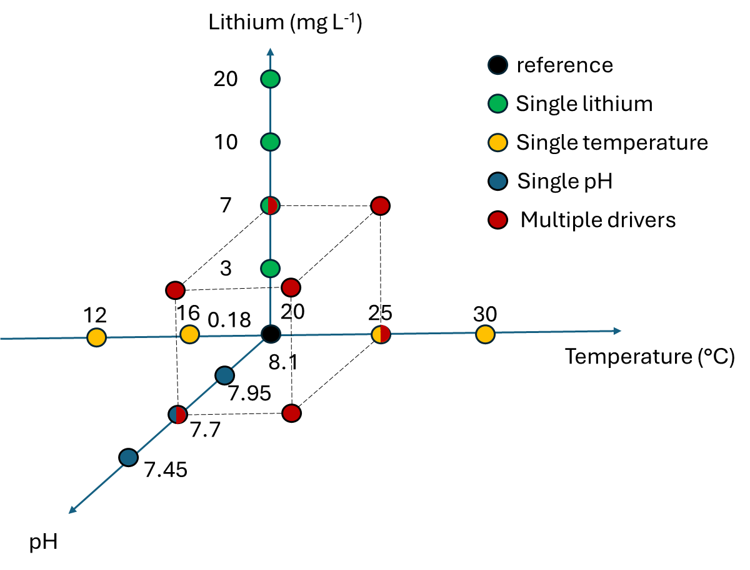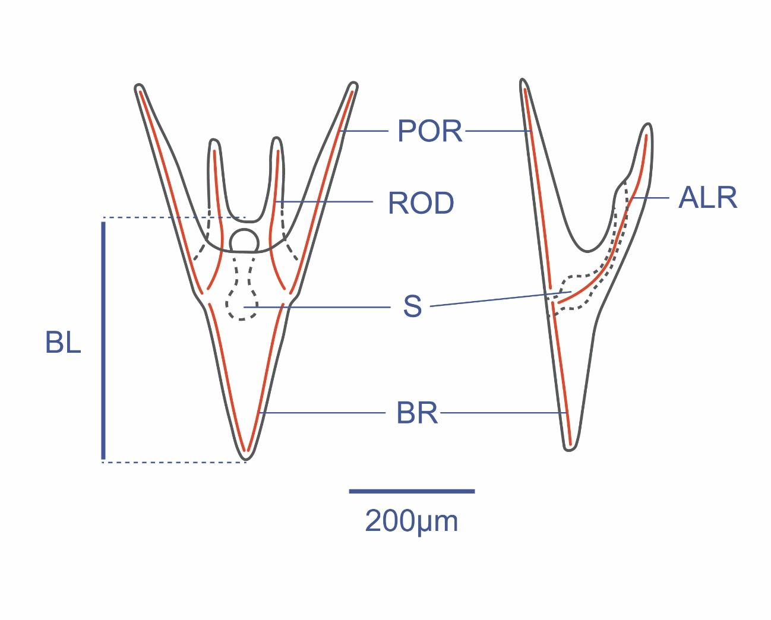
Figure 1. a) An overview of the single and multi-driver treatment levels, showing the target levels of the three drivers for all 23 treatments. b) Paracentrotus lividus pluteus larvae morphology and morphometric variables. BL: body length, BR: body rod, ALR: antero lateral rod, and POR: post oral rod.

2.3 Biological measurements
After 96 hours, a 10 mL sample was taken from each bottle and fixed with 4% formaldehyde. Larvae were counted for density and photographed under a 10x microscope (Olympus; BX43 upright microscope with DP28 camera). Ten larvae were randomly selected from each treatment and body length (BL) measured using the Fiji software (Schindelin et al., 2012) (Figure 1b). The diameter of the eggs at the beginning of the experiment (Initial egg size; IS) was also measured. No change in density was detected except in the highest temperature treatment.
Larval growth rate (GR in µm∗day⁻¹) was calculated for each aquarium as the difference between BL (µm) and IS (µm) divided by exposure time (3 days).

2.4 Data analyses
The consistency in growth rate between treatments in common in the single- (experiment #1) and multiple-driver (experiment #2) experiments was evaluated with one-way ANOVAs and t-tests. A Shapiro-Wilks test indicated a modest deviation from normality for the residuals for some of the tests, but these tests are robust to such deviations (Glass et al., 1972; Knief & Forstmeier, 2021).
For each driver in experiment #1, the shape of the response curve for growth rate was evaluated using linear models, second degree polynomial models, general additive models (GAMs), logit models and exponential models. There were no severe violations of assumptions for the models. Model performance was assessed usingby comparing the coefficient of determination (R²), standard error and Akaike Information Criterion (AIC) scores. The best-fittingmodel was selected based on these criteria for each driver. Additionally, alternative response curve models were evaluated using therTPC package in R (Padfield et al., 2021); however, these alternatives were excluded from the final analysis due to poor fit.
For experiment #2, the effect of each driver on growth rate was compared when considered as a single driver (e.g., only high temperature) or when combined with one or two of the other drivers (e.g., any combination with low pH and/or high lithium). Wilcoxon rank-sum tests were used to test for statistical significance in the comparison of each pair.
For a comparison between the 3 different drivers, a driver index was calculated for each driver (temperature, pH and lithium) as the weighted (α_{driver}) deviation from the reference condition (Δ_{driver}):
DI_{driver} = α_{driver} ∗ Δdriver
α was estimated for each driver by aligning the three single driver performance curves along the driver index axis. These curves were subsequently merged into one performance curve modelled from all the single driver data.
Assuming a similar mode of action between drivers and using a concentration-addition approach, the DI was then calculated for the multiple drivers experiments as: DI = α_{Temp} DI_{Temp} + α_{pH} DI_{pH} + α _{Li} DI_{Li}
The data from the single- and multiple driver experiments were compared on this driver index. Any deviation from the model built from the single driver experiment reveals an interaction between the drivers.

2.5 Seawater parameters
Temperature data were collected from continuous sensors (IKS Aquastar, Germany). pH_{T} (pH on the total scale) of the seawater was measured in each aquarium at the end of the experiment with a glass pH electrode (Metrohm, Electrode Plus calibrated with TRIS buffer solution (Andrew Dickson, Scripps Institution of Oceanography, San Diego, USA). Total Alkalinity (TA) was measured using the automatic open cell potentiometric titration method (Metrohm, Titrando 888) following the protocol described by Dickson et al. (2007). pCO₂, calcite and aragonite saturation values were calculated from TA, pH_{T}, and temperature at a salinity of 38 psu using the R package seacarb (Gattuso et al., 2016), using the dissociation constants from Lueker et al. (2005).
Lithium samples were filtered through 1.0 µm polycarbonate filters and lithium concentration analyses in seawater samples were carried out by Inductively coupled plasma - optical emission spectrometry technique (ICP-OES; Plasma Quant 9100, Analytik Jena, Germany). Samples were acidified with ultrapure HNO₃ and diluted 10 times with ultrapure H₂O before analysis. The instrumental conditions are summarized in supplementary material (Table S1). The radial analysis mode was used for lithium enriched samples while the axial mode (more sensitive) was used for non-enriched seawater samples. The quantification was carried out by means of external calibration, using proper dilution of lithium stock standard (TraceCert®, 997 ± 4 mgL⁻¹, Sigma Aldrich, Switzerland) in 0.35 % ultrapure NaCl (ESI Elemental Scientific, USA), to assure matrix match with seawater samples diluted 10 times. In the absence of a seawater Reference Material certified for lithium (not available in the market), several spiked samples were analyzed to account for possible matrix effect and to evaluate the accuracy of results. The recoveries were always within acceptable range (90-110 %). The results are reported in mg L⁻¹ (≈ ppm) together with respective expanded uncertainty (Ue, k=2).

Results
While exposed to the same treatments in the two experiments, larvae had no significant growth rate differences between the two experiments for pH and temperature (Figure 2). The lithium 7 ppm treatment had a higher growth rate in experiment #1 (74.5 µm day⁻¹, SD=2.8) than in the experiment #2 (68.6 µm day⁻¹, SD=6.6, Welch’s t-test: t(24.6)=3.4, p= 0.0026). There was also a slight but significant difference between the reference treatments, again with a higher growth rate in experiment #1 (74 µm day⁻¹, SD=4.6) than in experiment #2 (69.6 µm day⁻¹, SD=5.9, Wilcoxon rank test r=0.32, p=0.0091), with one of the replicates in experiment #2 having lower growth rate than the other one (63.8 vs. 74.9 µm day⁻¹).

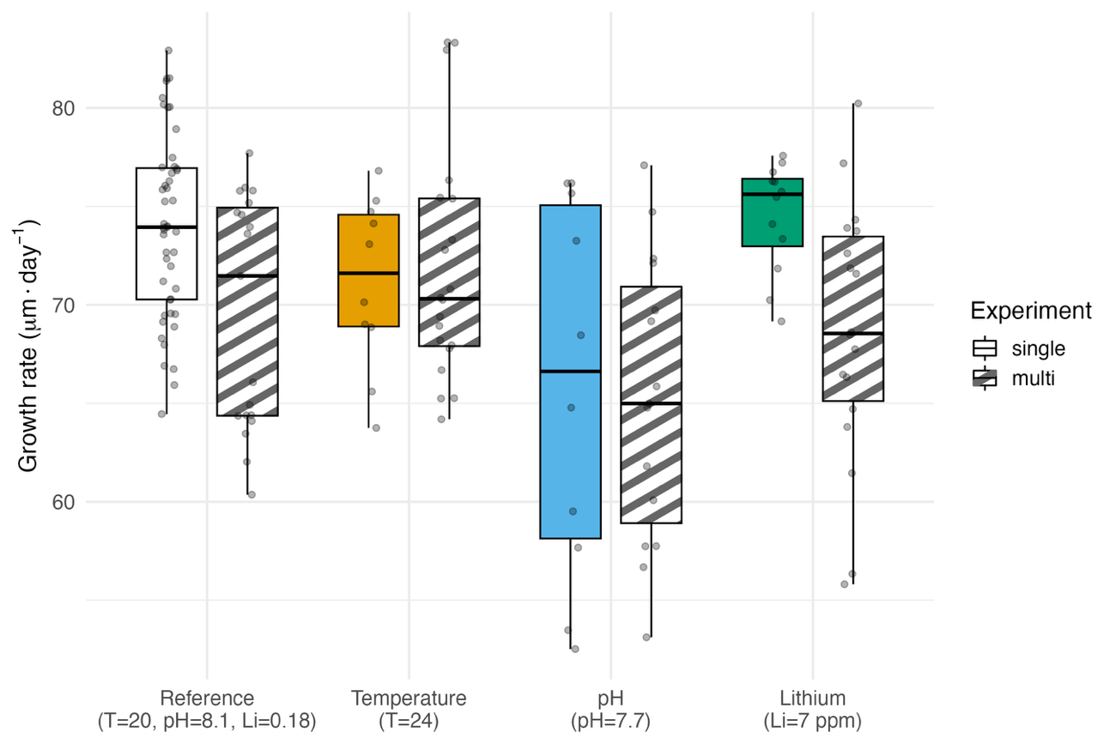
Figure 2. Growth rate comparison of the treatments in common to the two experiments. The reference conditions and lithium 7 ppm are the only significantly different comparisons.

The second-degree polynomial model was significant and the best fit for temperature and pH growth rate responses (Figures 3a-c, Table S2). For temperature, the curve was bell-shaped with a good fit (adj. R² = 0.70, F_{(2, 54)}= 66.82, p<0.05) and a tight confidence interval. Second degree polynomial model and GAM had comparable fits for the growth rate data from the pH treatments, but the polynomial was chosen with parsimony in mind. Compared to temperature, the polynomial model fit for pH had a lower fit and wider confidence interval (adj. R²: 0.36, F(_{2, 49})=15.68 p=5.837e-06). For lithium, the models had the poorest fit with the polynomial model being the best (adj. R²: 0.30, F(_{2,78})=17.99, p=3.771e-07), although the second-degree component was not significant (p = 0.061), indicating limited support for a nonlinear response within the observed range. Nevertheless, the polynomial model was retained across all drivers to ensure consistency in model structure. For lithium, the fitted curvature should not be interpreted as evidence of a biologically meaningful nonlinear response .
For all drivers, the reference treatments (20ºC, pH_{T} 8.0, lithium 0.18 ppm) had the highest GR.

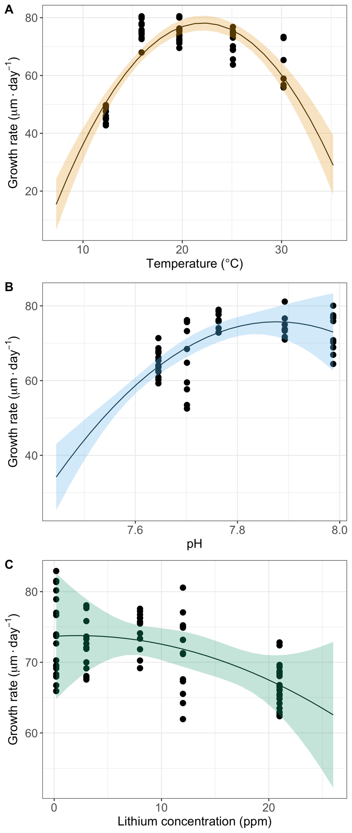
Figure 3a-c. Growth rate of P. lividus larvae across different (A) temperature, (B) pH_{T}, and (C) lithium concentrations. The solid lines indicate second degree polynomial models fitted to the datapoints and the ribbons the 95% confidence interval for each model.

The comparison of growth rate of larvae exposed to single or multiple drivers in experiment #2 revealed (i) no significant differences at high temperature or high lithium when the larvae were exposed to those drivers alone or when combined with other drivers (Figures 4a and 4c), and (ii) a higher growth at low pH when combined with other drivers than when exposed to low pH alone (Figure 4b) (see Table S3 for Wilcoxon tests).
Several α values were compared to synchronize and align the three single driver performance curves along the driver index axis. The best fits were 1, 28 and 0. 35 for temperature, pH and lithium, respectively (Figure 3a). These can be interpreted as a decrease by 1 pH unit relative to the reference pH 8.0 is corresponding to an equivalent effect on the temperature performance curve of a 28ºC increase relative to the reference 20ºC. A performance curve combining the 3 single drivers growth rate data was fitted after transformation into a driver index (Figure 3a), and the best fit was a second-degree polynomial curve (adj. R² = 0.58, F(2, 187) = 129.43, p < 0.05).
The 8 treatments of the multiple driver experiment were converted into a driver index following the concentration addition model and the growth rate data were plotted and compared with the polynomial model derived from the single driver experiment (Figure 3b). All the multiple driver treatments involving low pH were deviating from the polynomial model with higher growth rate than predicted and suggesting an antagonistic interaction.

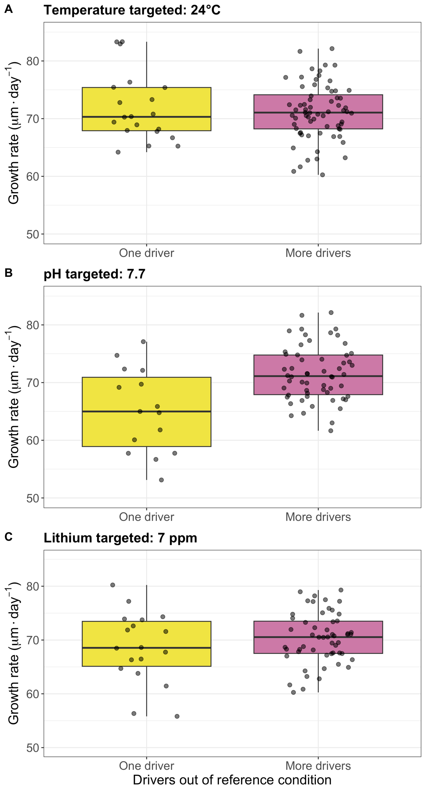
Figure 4??? a-c. Comparison the growth rate of those of multi-driver treatments that had one driver out of reference conditions and those that additionally had more drivers out of reference conditions.

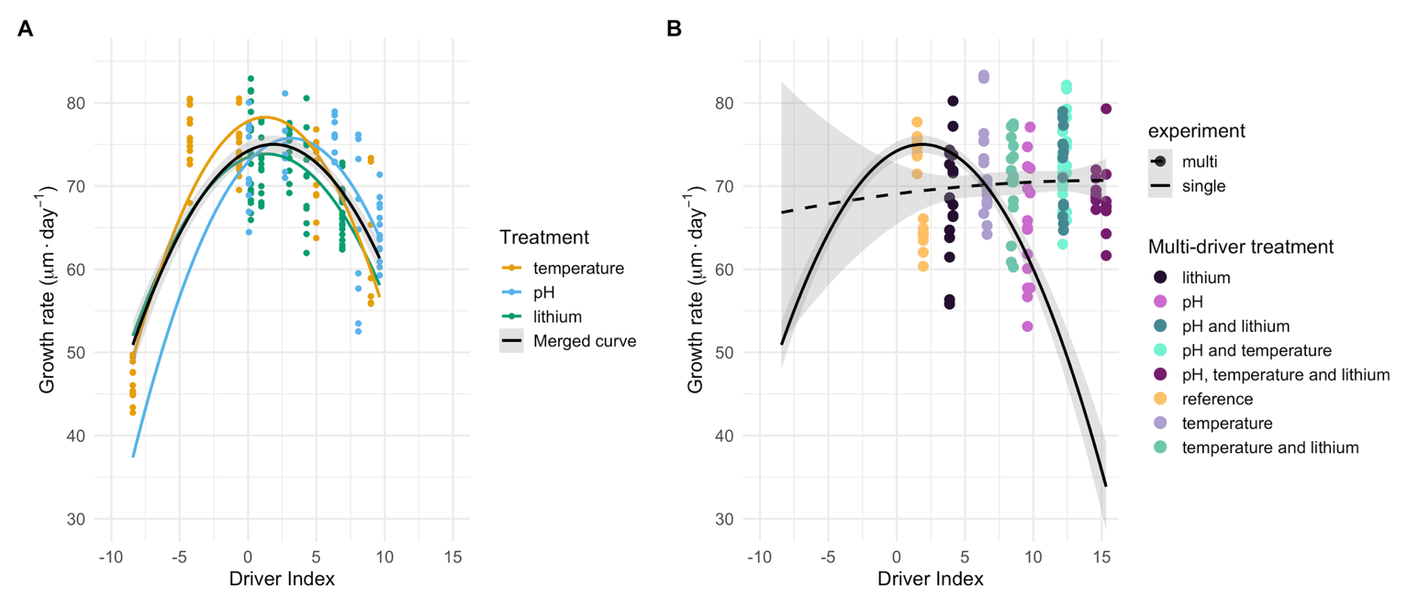
Figure 5???a-b. A) The three single driver growth rate performance curves aligned on a common driver index axis, and a curve fit to all the single driver data combined. B) Comparison of the single driver curve with the multi-driver curve and points.

The parameters of the seawater physico-chemical parameters in the two experiments are summarized in the Table 2.
Table 2. Measured and calculated seawater parameters in each experimental treatment. pCO₂, DIC, Ω_{ca} and Ω_{ar} were calculated from measured TA, pH_{T}, temperature and a salinity of 38 psu. S=Single, M=Multiple, T=Temperature and Li=Lithium. Multi-driver duplicates have been merged.

Treatment | T (°C) | pH_{T}-in situ | Li (mg L⁻¹) | TA (µmol kg⁻¹) | pCO₂ (µatm) | DIC (µmol kg⁻¹) | Ω_{ar} | Ω_{ca}
Single drivers
12 °C | 12.3 | 8.03 | 0.18 | 2548 | 461 | 2320 | 2.52 | 3.92
16 °C | 15.99 | 8.01 | 0.17 | 2552 | 489 | 2299 | 2.81 | 4.33
20 °C | 19.72 | 8.01 | 0.2 | 2557 | 479 | 2279 | 3.09 | 4.75
25 °C | 25.08 | 8.00 | 0.19 | 2532 | 482 | 2214 | 3.57 | 5.40
30 °C | 30.2 | 8.04 | 0.19 | 2575 | 435 | 2202 | 4.22 | 6.33
pH 8.1 | 19.72 | 7.99 | 0.19 | 2525 | 507 | 2259 | 2.98 | 4.57
pH 7.95 | 19.72 | 7.89 | 0.18 | 2519 | 654 | 2307 | 2.45 | 3.75
pH 7.7 | 19.72 | 7.76 | 0.18 | 2508 | 914 | 2358 | 1.88 | 2.88
pH 7.45 | 19.72 | 7.70 | 0.18 | 2502 | 1068 | 2379 | 1.65 | 2.53
pH 7.2 | 19.72 | 7.65 | 0.17 | 2511 | 1235 | 2410 | 1.48 | 2.26
0.18 ppm lithium | 19.72 | 7.98 | 0.19 | 2516 | 513 | 2258 | 2.89 | 4.43
3 ppm lithium | 19.72 | 7.99 | 3 | 2507 | 500 | 2245 | 2.92 | 4.48
7 ppm lithium | 19.72 | 7.98 | 8 | 2507 | 515 | 2250 | 2.88 | 4.41
10 ppm lithium | 19.72 | 7.98 | 12 | 2498 | 506 | 2239 | 2.88 | 4.42
20 ppm lithium | 19.72 | 8.00 | 21 | 2464 | 474 | 2196 | 2.95 | 4.53
Multiple drivers
MT20pH8.1Li0.18 | 20.8 | 7.97 | 0.18 | 2512 | 533 | 2256 | 2.88 | 4.40
MT20pH7.7Li0.18 | 20.6 | 7.67 | 0.19 | 2497 | 1149 | 2383 | 1.58 | 2.42
MT20pH8.1Li7 | 20.6 | 7.97 | 7.5 | 2482 | 523 | 2229 | 2.83 | 4.33
MT20pH7.7Li7 | 20.7 | 7.69 | 7.5 | 2471 | 1091 | 2350 | 1.62 | 2.48
MT24pH8.1Li0.18 | 25.5 | 7.97 | 0.18 | 2496 | 528 | 2201 | 3.34 | 5.04
MT24pH7.7Li0.18 | 25.5 | 7.76 | 0.18 | 2505 | 935 | 2323 | 2.24 | 3.39
MT24pH8.1Li7 | 25.4 | 7.97 | 7 | 2493 | 516 | 2194 | 3.37 | 5.09
MT24pH7.7Li7 | 25.6 | 7.76 | 7.5 | 2500 | 934 | 2318 | 2.25 | 3.39

Discussion

Research aimed at resolving the biological impacts of multiple drivers has increased rapidly over the last two decades. Within the field of ocean acidification alone, thousands of articles have now documented the effects of multiple drivers, often using relatively simple full-factorial designs. Despite this extensive effort, few generalizable conclusions have emerged and contrasting results remain common across the literature(e.g., Alter et al., 2024; Stockbridge et al., 2020). A key reason is that multi-driver effects are often interpreted without resolving the underlying shape of the response to each driver. Because many biological responses are inherently non-linear, combining drivers can produce patterns that appear synergistic or antagonistic even when they arise from additive effects along a shared performance curve. In addition, full-factorial designs are not well suited to disentangle such effects, as statistical interactions do not necessarily reflect biological interactions, defined here as deviations from a non-linear additive expectation (Boyd et al., 2018; Collins et al., 2022).
In an ideal world, one could perform full-factorial experiments with a large number of treatments for each individual driver allowing to model the full response landscape and test different hypotheses to resolve interactions (e.g., a comparison of a concentration addition model with the landscape). These are often logistically difficult to implement, and alternatives should then be considered. We proposed and tested here such an alternative divided into 3 steps.
A first step towards identifying potential interactions between drivers is to resolve the performance curve of each driver across a sufficiently broad gradient. In our experiment, the responses to temperature and pH were best described by unimodal second-degree polynomial models, although with varying levels of support. The temperature response showed the strongest fit and a clearly defined bell-shaped curve, consistent with well-established thermal performance relationships (Byrne et al., 2022; Silva Romero et al., 2021). The response to pH was less well resolved, with broader confidence intervals and lower explanatory power, indicating that the full shape of their performance curves was only partially captured within the explored range. In contrast, the lithium response was not well resolved. Although a polynomial model provided the best statistical fit among the tested models, the overall explanatory power was low and the quadratic term was not significant, indicating support for a nonlinear performance curve within the observed range. In addition, growth responses to lithium differed between the single- and multiple-driver experiments, suggesting that its effect may be context-dependent and not robustly reproducible across experimental conditions. Together these patterns indicate that the lithium performance curve is weakly constrained in the present dataset.
Rather than assuming identical modes of action, our approach relies on the empirical alignment of response curves onto a common performance axis. This provides a pragmatic basis for applying concentration addition as a null model of non-interacting effects, serving as a baseline expectation against which deviations can be interpreted, rather than as a mechanistic assumption of shared modes of action among drivers. Similar unimodal responses have been reported for pH and CO₂ effects in phytoplankton (Collins et al., 2022; Paul & Bach, 2020), whereas toxicant responses are often described as sigmoidal (Bellas, 2008; Morroni et al., 2023; Philibert et al., 2021). Our results suggest that, within the explored ranges, the three drivers can be approximated within a shared performance framework. The lower resolution of the pH and particularly the lithium response curves introduce uncertainty in the additive baseline and, consequently, in the magnitude of the estimated deviations. This uncertainty should be considered when interpreting interaction strength. Nevertheless, the consistency of the antagonistic pattern across all pH-involving treatments suggests that the deviation reflects a genuine biological signal rather than an artefact of curve fitting (Collins et al., 2022; Thibon et al., 2023).

A second step consisted in constructing a driver index integrating the relative contribution of each driver, following an approach similar to Espinel-Velasco et al. (2025). This index was derived by aligning the single-driver performance curves onto a common axis, using temperature as a reference scale centred on the reference condition of 20°C. The scaling factors for pH and lithium were estimated empirically to achieve the best overlap among the three response curves, resulting in coefficients of 28°C per pH unit and 0.35°C per ppm of lithium. This transformation provides a functional scaling that allows the integration of different drivers within a shared performance framework. In this context, the driver index is consistent with a concentration-addition approach used as a null model to predict combined effects (Drescher & Boedeker, 1995; Liess et al., 2016; N. Wang et al., 2015). The resulting driver index can therefore be interpreted as a proxy for the overall distance from optimal conditions defined at 20°C. When expressed along this axis, the combined data revealed a unimodal response with a tipping point around 25°C, corresponding to a deviation of approximately 5°C from the reference condition.
The third and final step of our strategy was to compare the outcome of the additive model derived from single-driver responses with the observations from the multi-driver experiment. Under a non-linear additivity assumption, the multi-driver data are expected to fall along the shared performance curve defined by the driver index (Figure 3b). However, all combinations involving reduced pH consistently deviated from this expectation, with higher growth rates than predicted by the model (Figure 3b). This pattern indicates an antagonistic interaction, where the combined effect of multiple drivers is less severe than expected from their additive contributions. This interpretation is also consistent with the direct comparison among treatments in the fully crossed design, where larvae exposed to low pH alone showed lower growth than those exposed to low pH in combination with additional drivers (Figure 2b). This pattern contrasts with previous studies reporting increased stress under combined exposure to acidification and contaminants (Wang et al., 2025). The observed antagonism highlights the importance of considering how multiple drivers reshape the organism's position along a performance landscape, rather than assuming purely additive effects among drivers. Our results demonstrate that deviations from non-linear additivity can reveal emergent biological responses that would remain undetected under standard factorial interpretations. While the empirical pattern is robust, the mechanisms underlying this antagonism remain unresolved. One possibility is that reduced pH alters acid-base regulation or calcification dynamics in ways that interact non-linearly with temperature or contaminant stress, but these interpretations should be treated as working hypotheses pending further investigation (Boyd et al., 2018).

Conclusion

Our study provides a framework to integrate the effects of multiple environmental drivers by projecting them onto a shared performance landscape. By combining single-driver responses into a unified index, we show that organismal performance under multi-driver conditions can be approximated by a non-linear additive model, but also that systematic deviations from this expectation reveal emergent biological responses.
The observed antagonistic interaction highlights that multiple stressors do not necessarily accumulate in a linear or even synergistic manner. Instead, interactions among drivers can reshape the physiological state of the organism in ways that are not predictable from single driver experiments alone. This finding challenges the common assumption that combined stressors will amplify negative effects and emphasizes the need to consider the structure of the performance landscape when interpreting multi-driver experiments.
More broadly, our approach suggests that the apparent complexity of multi-driver systems can be reduced by identifying common axes of organismal response. Although these findings are based on a single species and a specific combination of drivers, the logic of the approach is not system dependent. This opens the possibility of developing predictive frameworks that move beyond purely factorial designs and instead focus on the functional integration of environmental constraints. Such an approach may improve our ability to anticipate biological responses to global change, where organisms are simultaneously exposed to multiple, interacting drivers.

References
Agnetta, D., Badalamenti, F., Ceccherelli, G., Di Trapani, F., Bonaviri, C., & Gianguzza, P. (2015). Role of two co-occurring Mediterranean sea urchins in the formation of barren from Cystoseira canopy. Estuarine, Coastal and Shelf Science, 152, 73–77. https://doi.org/10.1016/j.ecss.2014.11.023
Alter, K., Jacquemont, J., Claudet, J., Lattuca, M. E., Barrantes, M. E., Marras, S., Manríquez, P. H., González, C. P., Fernández, D. A., Peck, M. A., Cattano, C., Milazzo, M., Mark, F. C., & Domenici, P. (2024). Hidden impacts of ocean warming and acidification on biological responses of marine animals revealed through meta-analysis. Nature Communications, 15(1), 2885. https://doi.org/10.1038/s41467-024-47064-3
Barbosa, H., Soares, A. M. V. M., Pereira, E., & Freitas, R. (2023). Lithium: A review on concentrations and impacts in marine and coastal systems. Science of The Total Environment, 857, 159374. https://doi.org/10.1016/j.scitotenv.2022.159374
Bellas, J. (2008). Prediction and assessment of mixture toxicity of compounds in antifouling paints using the sea-urchin embryo-larval bioassay. Aquatic Toxicology, 88(4), 308–315. https://doi.org/10.1016/j.aquatox.2008.05.011
Boyd, P. W., Collins, S., Dupont, S., Fabricius, K., Gattuso, J. P., Havenhand, J., Hutchins, D. A., Riebesell, U., Rintoul, M. S., Vichi, M., Biswas, H., Ciotti, A., Gao, K., Gehlen, M., Hurd, C. L., Kurihara, H., McGraw, C. M., Navarro, J. M., Nilsson, G. E., … Pörtner, H. O. (2018). Experimental strategies to assess the biological ramifications of multiple drivers of global ocean change—A review. Global Change Biology, 24(6), 2239–2261. https://doi.org/10.1111/gcb.14102
Burgess, B. J., Purves, D., Mace, G., & Murrell, D. J. (2021). Classifying ecosystem stressor interactions: Theory highlights the data limitations of the additive null model and the difficulty in revealing ecological surprises. Global Change Biology, 27(13), 3052–3065. https://doi.org/10.1111/gcb.15630
Byrne, M., Gall, M. L., Campbell, H., Lamare, M. D., & Holmes, S. P. (2022). Staying in place and moving in space: Contrasting larval thermal sensitivity explains distributional changes of sympatric sea urchin species to habitat warming. Global Change Biology, 28(9), 3040–3053. https://doi.org/10.1111/gcb.16116
Carmichael, H., Warfield, R., & Yvon‐Durocher, G. (2025). Reconciling Variability in Multiple Stressor Effects Using Environmental Performance Curves. Ecology Letters, 28(1). https://doi.org/10.1111/ele.70065
Collins, S., Whittaker, H., & Thomas, M. K. (2022). The need for unrealistic experiments in global change biology. Current Opinion in Microbiology, 68, 102151. https://doi.org/10.1016/j.mib.2022.102151
Crain, C. M., Kroeker, K., & Halpern, B. S. (2008). Interactive and cumulative effects of multiple human stressors in marine systems. Ecology Letters, 11(12), 1304–1315. https://doi.org/10.1111/j.1461-0248.2008.01253.x
Cuthbert, R. N., Sidow, A., Frost, K. F., Kotronaki, S. G., & Briski, E. (2021). Emergent effects of temperature and salinity on mortality of a key herbivore. Journal of Sea Research, 177, 102126. https://doi.org/10.1016/j.seares.2021.102126
Drescher, K., & Boedeker, W. (1995). Assessment of the Combined Effects of Substances: The Relationship between Concentration Addition and Independent Action. Biometrics, 51(2), 716. https://doi.org/10.2307/2532957
Dupont, S., Ortega-Martínez, O., & Thorndyke, M. (2010). Impact of near-future ocean acidification on echinoderms. Ecotoxicology, 19(3), 449–462. https://doi.org/10.1007/s10646-010-0463-6
Espinel-Velasco, N., Kvernvik, A. C., Hop, H., & Dupont, S. (2025). Combined effects of ocean acidification, warming, and salinity on the fertilization success in an Arctic population of sea urchins. Scientific Reports, 15(1), 44090. https://doi.org/10.1038/s41598-025-27725-z
Gattuso, J. P., Alliouane, S., & Mousseau, L. (2021). Seawater carbonate chemistry in the Bay of Villefranche, Point B (France), January 2007-June 2023. (n.d.).
Gattuso, J.-P., Epitalon, J.-M., & Lavigne, H. (2016). seacarb: Seawater carbonate chemistry with R. R package version 3.0.14 [Computer software].
Glass, G. V., Peckham, P. D., & Sanders, J. R. (1972). Consequences of Failure to Meet Assumptions Underlying the Fixed Effects Analyses of Variance and Covariance. Review of Educational Research, 42(3), 237–288. https://doi.org/10.3102/00346543042003237
IPCC. (2014). Climate Change 2014: Impacts, Adaptation and Vulnerability.
Knief, U., & Forstmeier, W. (2021). Violating the normality assumption may be the lesser of two evils. Behavior Research Methods, 53(6), 2576–2590. https://doi.org/10.3758/s13428-021-01587-5
Kreyling, J., Jentsch, A., & Beier, C. (2014). Beyond realism in climate change experiments: Gradient approaches identify thresholds and tipping points. Ecology Letters, 17(1), 125. https://doi.org/10.1111/ele.12193
Kreyling, J., Schweiger, A. H., Bahn, M., Ineson, P., Migliavacca, M., Morel‐Journel, T., Christiansen, J. R., Schtickzelle, N., & Larsen, K. S. (2018). To replicate, or not to replicate – that is the question: How to tackle nonlinear responses in ecological experiments. Ecology Letters, 21(11), 1629–1638. https://doi.org/10.1111/ele.13134
Liess, M., Foit, K., Knillmann, S., Schäfer, R. B., & Liess, H.-D. (2016). Predicting the synergy of multiple stress effects. Scientific Reports, 6(1), 32965. https://doi.org/10.1038/srep32965
Lueker, T. J., Dickson, A. G., & Keeling, C. D. (5 C.E.). Ocean pCO2 calculated from dissolved inorganic carbon, alkalinity, and equations for K1 and K2: Validation based on laboratory measurements of CO2 in gas and seawater at equilibrium. Marine Chemistry, 70(1–3), 105–119. https://doi.org/10.1016/S0304-4203(00)00022-0
Morroni, L., Rakaj, A., Grosso, L., Flori, G., Fianchini, A., Pellegrini, D., & Regoli, F. (2023). Echinoderm larvae as bioindicators for the assessment of marine pollution: Sea urchin and sea cucumber responsiveness and future perspectives. Environmental Pollution, 335, 122285. https://doi.org/10.1016/j.envpol.2023.122285
Padfield, D., O’Sullivan, H., & Pawar, S. (2021). rTPC and nls.multstart: A new pipeline to fit thermal performance curves in r. Methods in Ecology and Evolution, 12(6), 1138–1143. https://doi.org/10.1111/2041-210X.13585
Pagano, G., Guida, M., Trifuoggi, M., Thomas, P., Palumbo, A., Romano, G., & Oral, R. (2017). Sea Urchin Bioassays in Toxicity Testing: I. Inorganics, Organics, Complex Mixtures and Natural Products. Expert Opinion on Environmental Biology, 06(01). https://doi.org/10.4172/2325-9655.1000142
Paul, A. J., & Bach, L. T. (2020). Universal response pattern of phytoplankton growth rates to increasing CO₂. New Phytologist, 228(6), 1710–1716. https://doi.org/10.1111/nph.16806
Philibert, D., Parkerton, T., Marteinson, S., & De Jourdan, B. (2021). Assessing the Toxicity of Individual Aromatic Compounds and Mixtures to American Lobster (Homarus americanus) Larvae Using a Passive Dosing System. Environmental Toxicology and Chemistry, 40(5), 1379–1388. https://doi.org/10.1002/etc.4988
Pörtner, H.-O., Scholes, R. J., Agard, J., Archer, E., Arneth, A., Bai, X., Barnes, D., Burrows, M., Chan, L., Cheung, W. L. (William), Diamond, S., Donatti, C., Duarte, C., Eisenhauer, N., Foden, W., Gasalla, M. A., Handa, C., Hickler, T., Hoegh-Guldberg, O., … Ngo, H. (2021). Scientific outcome of the IPBES-IPCC co-sponsored workshop on biodiversity and climate change (Version 5). Zenodo. https://doi.org/10.5281/ZENODO.4659158
Ruocco, N., Costantini, M., & Santella, L. (2016). New insights into negative effects of lithium on sea urchin Paracentrotus lividus embryos. Scientific Reports, 6(1), 32157. https://doi.org/10.1038/srep32157
Schindelin, J., Arganda-Carreras, I., Frise, E., Kaynig, V., Longair, M., Pietzsch, T., Preibisch, S., Rueden, C., Saalfeld, S., Schmid, B., Tinevez, J. Y., White, D. J., Hartenstein, V., Eliceiri, K., Tomancak, P., & Cardona, A. (2012). Fiji: An open-source platform for biological-image analysis. Nature Methods. https://doi.org/10.1038/nmeth.2019
Silva Romero, I., Bruno, J. F., Silbiger, N. J., & Brandt, M. (2021). Local conditions influence thermal sensitivity of pencil urchin populations (Eucidaris galapagensis) in the Galápagos Archipelago. Marine Biology, 168(3), 34. https://doi.org/10.1007/s00227-021-03836-9
Stockbridge, J., Jones, A. R., & Gillanders, B. M. (2020). A meta-analysis of multiple stressors on seagrasses in the context of marine spatial cumulative impacts assessment. Scientific Reports, 10(1). https://doi.org/10.1038/s41598-020-68801-w
Tekin, E., Diamant, E. S., Cruz‐Loya, M., Enriquez, V., Singh, N., Savage, V. M., & Yeh, P. J. (2020). Using a newly introduced framework to measure ecological stressor interactions. Ecology Letters, 23(9), 1391–1403. https://doi.org/10.1111/ele.13533
Thibon, F., Weppe, L., Churlaud, C., Lacoue-Labarthe, T., Gasparini, S., Cherel, Y., Bustamante, P., & Vigier, N. (2023). Lithium isotopes in marine food webs: Effect of ecological and environmental parameters. Frontiers in Environmental Chemistry, 3, 1060651. https://doi.org/10.3389/fenvc.2022.1060651
Vargas, C. A., Cuevas, L. A., Broitman, B. R., San Martin, V. A., Lagos, N. A., Gaitán-Espitia, J. D., & Dupont, S. (2022). Upper environmental pCO2 drives sensitivity to ocean acidification in marine invertebrates. Nature Climate Change, 12(2), 200–207.
Vargas, C. A., Lagos, N. A., Lardies, M. A., Duarte, C., Manríquez, P. H., Aguilera, V. M., Broitman, B., Widdicombe, S., & Dupont, S. (2017). Species-specific responses to ocean acidification should account for local adaptation and adaptive plasticity. Nature Ecology & Evolution, 1(4), 0084. https://doi.org/10.1038/s41559-017-0084
Wang, L., Wang, F., & Ma, Y. (2025). Combined effects of ocean acidification and copper exposure on the polyps of moon jellyfish Aurelia coerulea. Ecotoxicology, 34(5), 712–724. https://doi.org/10.1007/s10646-025-02869-w
Wang, N., Wang, X. C., & Ma, X. (2015). Characteristics of concentration–inhibition curves of individual chemicals and applicability of the concentration addition model for mixture toxicity prediction. Ecotoxicology and Environmental Safety, 113, 176–182. https://doi.org/10.1016/j.ecoenv.2014.12.008

Supplementary material

Table S1. Instrumental conditions for Li analysis by ICP-OES in seawater
Parameter | Value
Wavelength | 670.79 nm
Plasma power | 1300 W
Plasma gas | 14 L min⁻¹
Auxiliary gas | 0.5 L min⁻¹
Nebulizer gas | 0.6 L min⁻¹
Radial offset | 15 mm
Read time radial | 1 sec
Read time axial | 3 sec
Peak evaluation | 3 pixels

Table S2. Fits and statistics of the models fitted growth rate data from single-driver experiments.
Driver | Term | Estimate | Std. Error | t- value | p-value | Adj. R² | Sig.
Temp | (Intercept) | 66.826 | 0.872 | 76.607 | < 2e-16 | 0.7016 | ***
Temp | poly(temp, 2)1 | 30.827 | 6.586 | 4.681 | 1.96e-05 |  | ***
Temp | poly(temp, 2)2 | -69.616 | 6.586 | -10.57 | 9.26e-15 |  | ***
pH | (Intercept) | 70.116 | 0.778 | 90.111 | < 2e-16 | 0.3636 | ***
pH | poly(pH, 2)1 | 27.019 | 5.611 | 4.815 | 1.45e-05 |  | ***
pH | poly(pH, 2)2 | -15.819 | 5.611 | -2.819 | 0.00693 |  | **
Lithium | (Intercept) | 71.51 | 0.48 | 149 | < 2e-16 | 0.2981 | ***
Lithium | poly(lithium, 2)1 | -24.573 | 4.319 | -5.689 | 2.14e-07 |  | ***
Lithium | poly(lithium, 2)2 | -8.206 | 4.319 | -1.9 | 0.0612 |  | .

Table S3. Statistical tests comparing treatments in experiment #2 that have one driver out of reference conditions, and those that have more out of reference condition in addition to that one.
Condition | Test | df | Statistic | p-value
T targeted: 24 °C | Wilcoxon | - | W = 676 | 0.9722
pH targeted: 7.7 | Welch’s t-test | 17.2 | t = -3.211 | 0.0051
Li targeted: 7 ppm | Student’s t-test | 70 | t = -1.197 | 0.2353

Table S4. Larvae counts
Sample | Larvae count
ST1 | 99.5
ST2 | 109
ST3 | 106.5
ST4 | 110.5
ST5 | 4.5
SP1 | 102.5
SP2 | 106
SP3 | 111.5
SP4 | 106.5
SP5 | 104.5
SL1 | 111
SL2 | 105
SL3 | 107
SL4 | 104.5
SL5 | 96.5
ML1P1_20_R1 | 98.5
ML1P1_20_R2 | 115.5
ML1P2_20_R1 | 110
ML1P2_20_R2 | 111.5
ML2P2_20_R1 | 107.5
ML2P2_20_R2 | 112.5
ML2P1_20_R1 | 115
ML2P1_20_R2 | 113.5
ML1P1_24_R1 | 101.5
ML1P1_24_R2 | 100
ML1P2_24_R1 | 129
ML1P2_24_R2 | 118
ML2P2_24_R1 | 99
ML2P2_24_R2 | 101
ML2P1_24_R1 | 123.5
ML2P1_24_R2 | 107

List of authors
Full name | email | Affiliation | Conceptual work | Experimental work | Data analysis | Writing | Reviewing
Maria Soledad Yusseppone | msyusseppone@gmail.com | Instituto de Investigaciones Marinas y Costeras (IIMyC), FCEyN - Universidad Nacional de Mar del Plata (UNMDP), Consejo Nacional de Investigaciones Científicas y Técnicas (CONICET), Mar del Plata, Argentina.  Red de Investigación de Estresores Marinos-Costeros en Latinoamérica y el Caribe (REMARCO), Mar del Plata, Argentina. | X | X |  | X | X
Jurleys Paola Vellojin Furnieles | jurleys.vellojin@ifop.cl | Departamento de Medio Ambiente, División de Investigación en Acuicultura, Instituto de Fomento Pesquero (IFOP), Puerto Montt, Chile. | X | X |  |  | X
Zhenzhen Li | zhenzli@jou.edu.cn | School of Marine Science and Fisheries, Jiangsu Ocean University, Lianyungang, China | X | X |  |  | X
Yusmila Helguera | yusmilahelguera@gmail.com
Natalija Suhareva | natalija.suhareva@bio.ku.dk | University of Copenhagen, Department of Biology, Marine Biological Section,Helsingør, Denmark | X | X | X |  | X
Einar Pétur Jónsson | einar.petur.jonsson@hafogvatn.is |  | X | X | X | X
Mirko Mutalipassi | mirko.mutalipassi@szn.it | Stazione Zoologica Anton Dohrn, Integrative Marine Ecology Department, Napoli, Italy;  National Biodiversity Future Center (NBFC), Palermo, Italy; | X | X |  | X
Edson Piscoya | edpiscoya20@gmail.com
Joana Filipa Fernandes | joanafcf@ua.pt | ECOMARE - Laboratory for Innovation and Sustainability of Marine Biological Resources, CESAM – Centre for Environmental and Marine Studies, Department of Biology, University of Aveiro, Estrada do Porto de Pesca Costeira, 3830-565 Gafanha da Nazaré, Portugal  Marine Ecological and Evolutionary Physiology laboratory, Département de Biologie, Chimie et Géographie, Université du Québec à Rimouski, 300 Allée des Ursulines, Rimouski, QC G5L 3A1, Canada  UCIBIO - Applied Molecular Biosciences Unit, NOVA School of Science and Technology, NOVA University of Lisbon, Campus de Caparica, 2829-516 Caparica, Portugal  Associate Laboratory i4HB Institute for Health and Bioeconomy, NOVA School of Science and Technology, NOVA University of Lisbon, 2829-516 Caparica, Portugal | X | X |  |  | X
Jawaher Alyafei
Sam Dupont | sam.dupont@bioenv.gu.se | University of Gothenburg, Sweden | X | X |  | X | X
Marc Metian | m.metian@iaea.org | IAEA Marine Environment Laboratories, Department of Nuclear Sciences and Applications, International Atomic Energy Agency, 98000 Monaco, Principality of Monaco | xX |  |  |  | X
Anna Maria ORANI, | A.M.Orani@iaea.org | Same |  | x | x
Francois OBERHAENSLI, | F.R.Oberhaensli@iaea.org | Same |  | x
Khalil SDIRI | K.Sdiri@iaea.org | Same |  | x

