All are non linear. Polynomial. Similar
Comparison in driver index. pH and temp are strongest
Antagonistic interaction
What you would need to really resolve the interaction.
Design
Mode of action
From single to multiple drivers – cumulative effect of temperature, pH and lithium on the larvae of the sea urchin Paracentrotus lividus

Abstract

Introduction
Anthropogenic activities lead to ocean changes in a host of environmental drivers threatening ecosystems worldwide (Pörtner et al., 2021). These threats include global changes such as ocean warming (OW) and acidification (OA), compounded by local changes such as pollution, habitat destruction, and resource over-exploitation (IPCC, 2014; Boyd et al., 2018; Preslawski et al., 2015). Understanding and resolving the cumulative impact of multiple stressors is one of the UN Decade’s main challenges. Multiple stressors act simultaneously and often combine in non-linear ways, producing outcomes that are more severe and complex than from individual stressors alone. These aspects are neglected in the tools currently used for management and policy. The main reason is the lack of scientific understanding of the cumulative biological impact of multiple stressors due to conceptual and technical complexities. Therefore, these tools strongly underestimate the impacts, with the risk of measures that are not drastic enough to ensure a sustainable and healthy ocean.
Experimental studies on the biological impacts of the exposure to single drivers, and their combined effects has been the subject of many recent studies (for a review, see Boyd et al., 2018). At present, attempts to resolve the impact of global and local stressors are mostly performed using scenario-based cross-design experiments. These do not allow identifying non-linear effects or interactions and statistical interactions are often confused with stressor interactions (Boyd et al., 2018). Therefore, the reported nature of interaction and combined effects varies between studies and is often based on misconceptions (e.g. see Stockbridge, Jones and Gillanders (2020); Crain et al. (2008); Tekin et al. (2020) for contrasting reported interactions).
Resolving the biological effects of temperature (Byrne et al., 2022) and pH (Caiollon et al., 2023), alone or in combination, are highly relevant for global change studies. Their response curves over a large gradient are commonly unimodal. Different dose-response curves are traditionally observed for toxicants. For example, lithium from industry and pharmaceuticals are running off into the marine environment and is a concern especially in urbanized coastal areas (Ruocco et al., 2016). Response curves over toxicant gradients are often described as sigmoidal, with thresholds below which adverse effects are not expected to occur (Bellas, 2008; Philibert et al., 2021; Morroni et al., 2023).
Because of practical limitations, multi-driver studies are often limited to two or three treatment levels per driver, using an ANOVA-based experimental design of ‘control’ and ‘future’ conditions. Not only does this approach often ignore the high level of present natural variability experienced by the tested species or ecosystems (e.g. Vargas et al., 2017, 2022), but neither does it allow for an evaluation of potential interactions. Many authors assume linearity of the response and confuse statistical interaction with more complex non-linear stressor interactions (Kreyling et al., 2018; Burgess et al., 2021). There is an increased awareness of the drawbacks of this experimental design (e.g. Kreyling et al., 2014; Collins et al., 2022), leading to different experimental designs and strategies (Carmichael et al., 2025).
The aim of our study is to test a strategy that combines (i) the resolution of the shape of the response curves of 3 drivers (temperature, pH, and lithium); (ii) use these performance to project their combined impacts under a concentration-addition hypothesis; and (iii) evaluate the projections using a fully crossed design (2x2x2=8 treatments). This allows to identify potential interactions (non-additive effects) by comparing the outcome of the multiple stressors experiment with the results of a non-linear additive model (e.g. Espinel Velasco et al., 2026).
The implementation of such complex experiments is only realistic by using simple assays that are well-established and allow for the collection of robust data relatively fast. Sea urchins are such model organisms due to their ecological importance in benthic ecosystems, their sensitivity to environmental change, and their well-established use in ecotoxicology and climate change research (Bellas, 2008; Dupont et al., 2010; Agnetta et al., 2015; Pagano et al., 2017; Cuthbert et al., 2021). We assessed the effect of temperature, pH and lithium alone and combined on the growth rate and fitness of larvae of the purple sea urchin (Paracentrotus lividus) to answer two main questions:
(i) What is the shape of their response curves for temperature, pH and lithium?
(ii) Are there interactions (non-additive effects) between the drivers?

- Materials and methods
2.1 Sampling and larval culture
Adults of the sea urchin Paracentrotus lividus were collected in Cap d’Ail, France, at 2-4m depth by snorkelling in October 2022. Organisms were kept in tanks with aerated seawater and transported within 30 minutes to the Marine Environment Laboratories of the International Atomic Energy Agency (IAEA) in Monaco. Animals were acclimated and maintained for 24h in an aquarium with flowing natural seawater (average pH_{T} = 8.1, temperature = 20°C, salinity = 38, dissolved oxygen? (x%)).
Spawning was triggered by injection of 1mL 0.5M KCl in seawater across the peristomial membrane. Sperm was collected dry whereas eggs were collected into 50 mL beakers filled with filtered seawater. Gametes from one male and one female were fertilized (20 µL of activated sperm in 1L of egg solution). Three hours post-fertilization, two cell stages were transferred to 100 and 500 mL glass experimental bottles (~10 larvae mL⁻¹). A small subsample of eggs were fixed and the initial size of eggs (IS) was recorded (see below).

2.2 Experimental design
Both single and multi-driver experiments were performed to evaluate the effect of pH, temperature and lithium alone and in combination. pH was manipulated by bubbling seawater with CO₂ till the target level was reached; lithium levels were reached using a 1000 ppm stock solution, and the temperature was controlled using water baths connected to a feedback system (IKS Aquastar, Germany). Experiments were carried out in closed 100 mL glass bottles, except for the temperature experiment, which used 500 mL bottles. Embryos and larvae were exposed for 96 hours without addition of food. At the end of the exposure, seawater analyses and biological measurements were performed as described below.
Single driver experiments were carried out in 15 bottles where five levels of each driver were tested while the other two were maintained constant at the sampling site’s average level. The levels tested were selected considering natural variability range (Alliouane et al., 2025; Gattuso et al., 2021) and the future projections from SSP 4 and 5. For the multiple driver experiment, a full crossed design was used with 2 levels per drivers and performed in duplicates (Figure Xa).

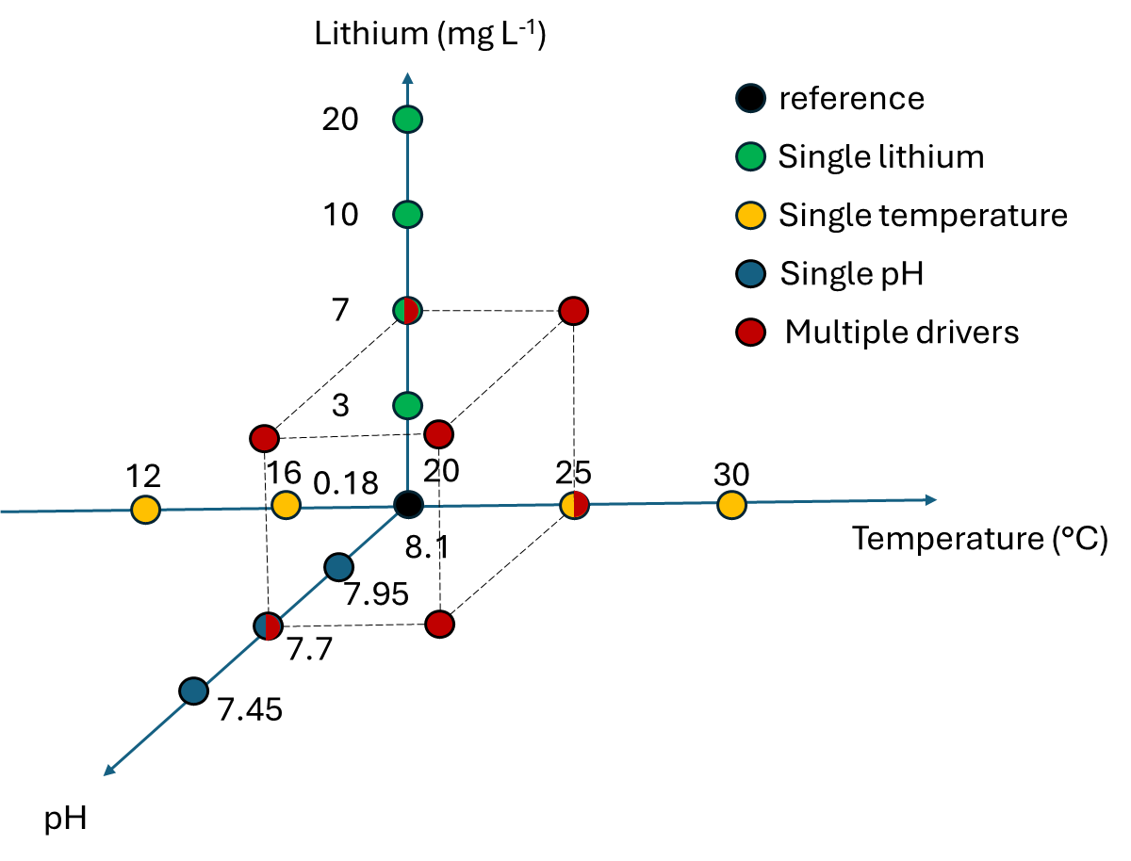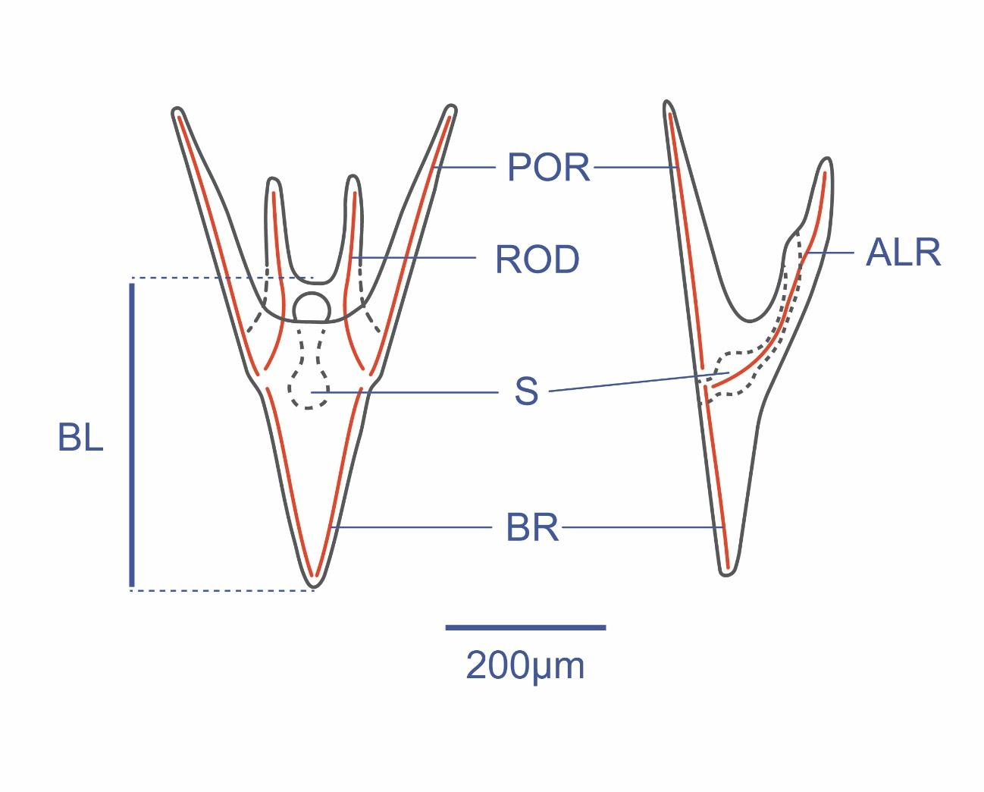
Figure X. a) An overview of the single and multi-driver treatment levels, showing the target levels of the three drivers for all 23 treatments. b) Paracentrotus lividus pluteus larvae morphology and morphometric variables. BL: body length, BR: body rod, ALR: antero lateral rod, and POR: post oral rod.

2.3 Biological measurements
After 96 hours, a 10 mL sample was taken from each bottle and fixed with 4% formaldehyde. Larvae were counted for density and photographed under a 10x microscope (Brand of the microscope). Ten larvae were randomly selected from each treatment and body length (BL) measured using the Fiji software (Schindelin et al., 2012) (Fig. Xb). The diameter of the eggs at the beginning of the experiment (Initial egg size, IS) was also measured. No change in density was detected except in the highest temperature treatment.
Larval growth rate (GR in µm day⁻¹) was calculated for each aquarium as the difference between BL (µm) and IS (µm) divided by exposure time (3 days).

2.4 Data analyses
The consistency in growth rate between treatments in common in the single- (experiment #1) and multiple-driver (experiment #2) experiments was evaluated with one-way ANOVAs and t-tests. A Shapiro-Wilks test indicated a modest deviation from normality for the residuals for some of the tests, but these tests are robust to such deviations (Glass et al., 1972; Knief & Forstmeier, 2021).
For each driver in the experiment #1, the shape of the response curve for growth rate was evaluated using linear models, second degree polynomial models, general additive models (GAMs), logit models and exponential models. There were no severe violations of assumptions for the models. The performance of the models was evaluated by comparing their R², standard error and AIC scores, and the appropriate model chosen for each driver based on these metrics. Other response curve models were also explored using the rTPC package in R (Padfield & Windram, 2024), but none fit well.
For the experiment #2, the effect of each driver on growth rate was compared when considered as a single driver (e.g. only high temperature) or when combined with one or two of the other drivers (e.g. any combination with low pH and/or high lithium). Wilcoxon rank-sum tests were used to test for statistical significance in the comparison of each pair.
For a comparison between the 3 different drivers, a driver index was calculated for each driver (temperature, pH and lithium) as the weighted (α_{stressor}) deviation from the reference condition (Δ_{stressor}):
SI_{stressor} = α_{stressor} x Δstressor
α was estimated for each driver by aligning the three single driver performance curves along the driver index axis. These curves were subsequently merged into one performance curve modelled from all the single driver data.
Assuming a similar mode of action between drivers and using a concentration-addition approach, the SI was then calculated for the multiple stressor experiments as:SI = α_{Temp} SI_{Temp} + α_{pH} SI_{pH} + α _{Li} SI_{Li}
The data from the single- and multiple stressor experiments were there compared. Any deviation from the model built from the single stressor experiment reveals an interaction between the stressors.

2.5 Seawater parameters
Temperature data were collected from continuous sensors (Brand of the probes?) . pH_{T} (pH on the total scale) of the seawater was measured in each aquarium at the end of the experiment with a glass pH electrode (brand?) calibrated with TRIS buffer solution (Andrew Dickson, Scripps Institution of Oceanography, San Diego, USA). Total Alkalinity (TA) was measured using the automatic open cell potentiometric titration method (brand) following the protocol described by Dickson et al. (2007). pCO₂, calcite and aragonite saturation values were calculated from TA, pH_{T}, and temperature at a salinity of 38 psu using the R package seacarb (Lavigne et al., 2009), using the dissociation constants from Lueker et al. (2000).
Lithium samples were filtered through 1.0 μm polycarbonate filters and lithium concentration analyses in seawater samples were carried out by Inductively coupled plasma - optical emission spectrometry technique (ICP-OES; Plasma Quant 9100, Analytik Jena, Germany). Samples were acidified with ultrapure HNO₃ and diluted 10 times with ultrapure H₂O before analysis. The instrumental conditions are summarized in supplementary material (Table S1). The radial analysis mode was used for Li enriched samples while the axial mode (more sensitive) was used for non-enriched seawater samples. The quantification was carried out by means of external calibration, using proper dilution of Li stock standard (TraceCert®, 997 ± 4 mg/L, Sigma Aldrich, Switzerland) in 0.35 % ultrapure NaCl (ESI Elemental Scientific, USA), to assure matrix match with seawater samples diluted 10 times. In the absence of a seawater Reference Material certified for Li (not available in the market), several spiked samples were analyzed to account for possible matrix effect and to evaluate the accuracy of results. The recoveries were always within acceptable range (90-110 %). The results are reported in mg/L (≈ ppm) together with respective expanded uncertainty (Ue, k=2).

Results
While exposed to the same treatments in the two experiments, larvae had a similar growth rate and no significant differences between the two experiments were observed for pH and temperature (Figure. Y). The lithium 7 ppm treatment had a higher growth rate in experiment #1 (STATS) than in the experiment #2 (STATS). There was also a slight but significant difference between the reference treatments, again with a higher growth rate in experiment #1 (STATS) than in experiment #2 (STATS), with one of the replicates in experiment #2 being markedly lower than the other one (STATS vs.)
showed only exception was observed for the lithium 7 ppm treatment where the larvae in the single driver experiment had a higher growth rate (mean=74.8 um/day, SD=2.8) than the ones in the multi driver experiment (mean=68.6 um/day, SD=6.6; t-test: t(26)=-2.81, p=0.009).

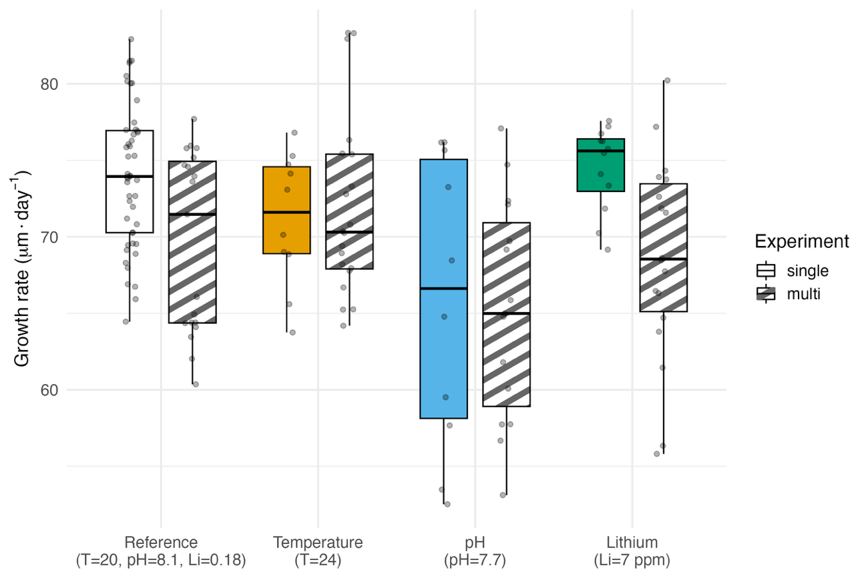
Figure Y. Growth rate comparison of the treatments in common to the two experiments. The reference conditions and lithium 7 ppm are the only significantly different comparisons.

The second degree polynomial model was significant and the best fit for each drivers’ growth rate data (Fig. 1a-c, Table SX). For temperature, the curve was bell-shaped with a good fit (adj. R² = 0.70, F_{(2, 54)}= 66.82, p<0.05) and a tight confidence interval. Second degree polynomial model and GAM had comparable fits for the growth rate data from the pH treatments, but the polynomial was chosen with parsimony in mind. Compared to temperature, the polynomial model fit for pH had a lower fit and wider confidence interval (adj. R²: 0.36, F(_{2, 49})=15.68 p=5.837e-06). For lithium, the models had the poorest fit with the polynomial model being the best (adj. R²: 0.30, F(_{2,78})=17.99, p=3.771e-07), although the second degree component was not significant. For all drivers, the reference treatments (20ºC, pH_{T} 8.0, lithium 0.18ppm) had the highest GR.

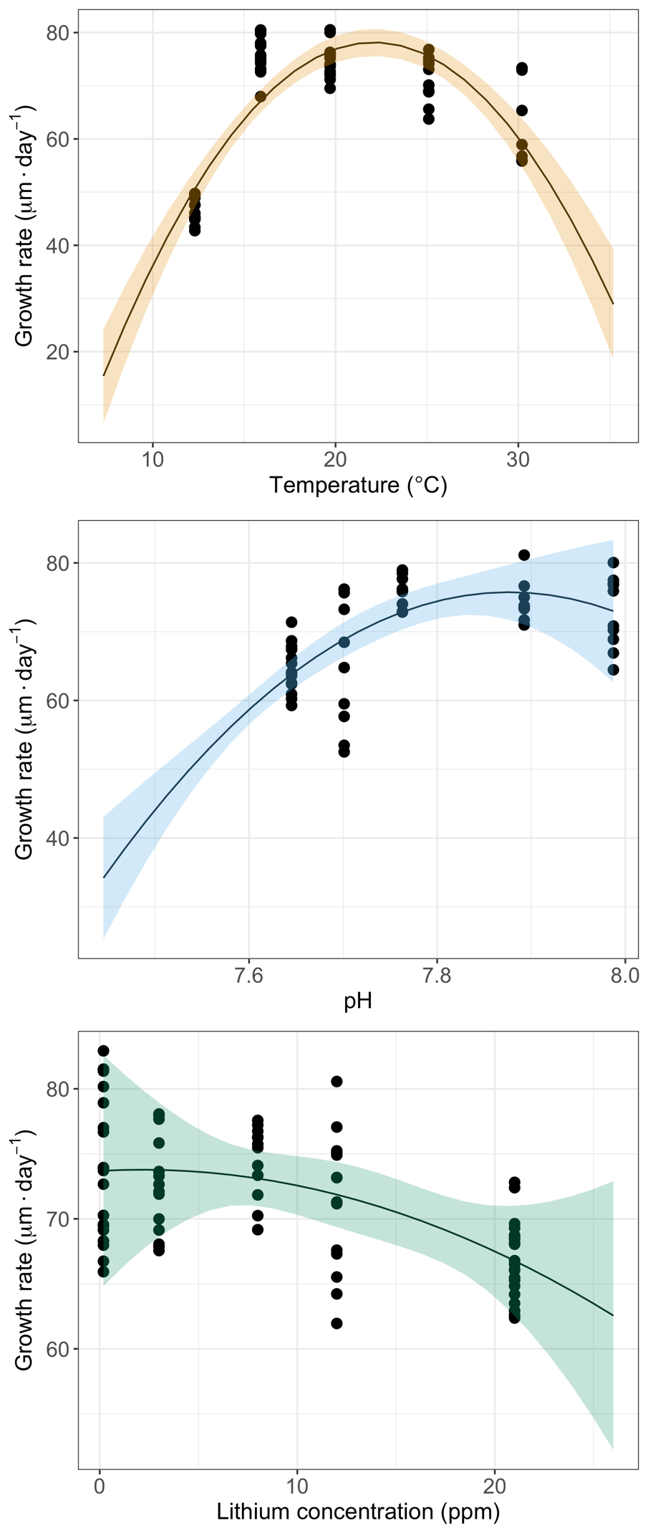
Figure 1 a-c. growth rate of P. lividus larvae across different (a) temperature, (b) pH_{T}, and (c) lithium concentrations. The solid lines indicate second degree polynomial models fitted to the datapoints and the ribbons the 95% confidence interval for each model.

The comparison of the growth rate of larvae exposed to single or multiple stressors in the experiment #2 revealed (i) no significant differences at high temperature or high lithium when the larvae were exposed to those drivers alone or when combined with other drivers (Fig. 2a and 2c), and (ii) a higher growth when low pH was combined with other drivers than when alone (Fig. 2b) (see Table S3 for Wilcoxon tests).
Several α values were compared to synchronize and align the three single driver performance curves along the driver index axis. The best fits were 1, 28 and 0. 35 for temperature, pH and lithium, respectively (Fig. 3a). These can be interpreted as a decrease by 1 pH unit relative to the reference pH 8.0 is corresponding to an equivalent effect on the temperature performance curve of a 28ºC increase relative to the reference 20ºC. A performance curve combining the 3 single drivers growth rate data was fitted after transformation into a driver index (Fig. 3a), and the best fit was a second degree polynomial curve (adj. R² = 0.58, F(2, 187) = 129.43, p < 0.05).

The 8 treatments of the multiple drivers experiment were converted into a driver index following the concentration addition model and the growth rate data were plotted and compared with the polynomial model derived from the single driver experiment (Fig 3b). All the multiple driver treatments involving low pH were deviating from the polynomial model with higher growth rate than predicted and suggesting an antagonistic interaction.

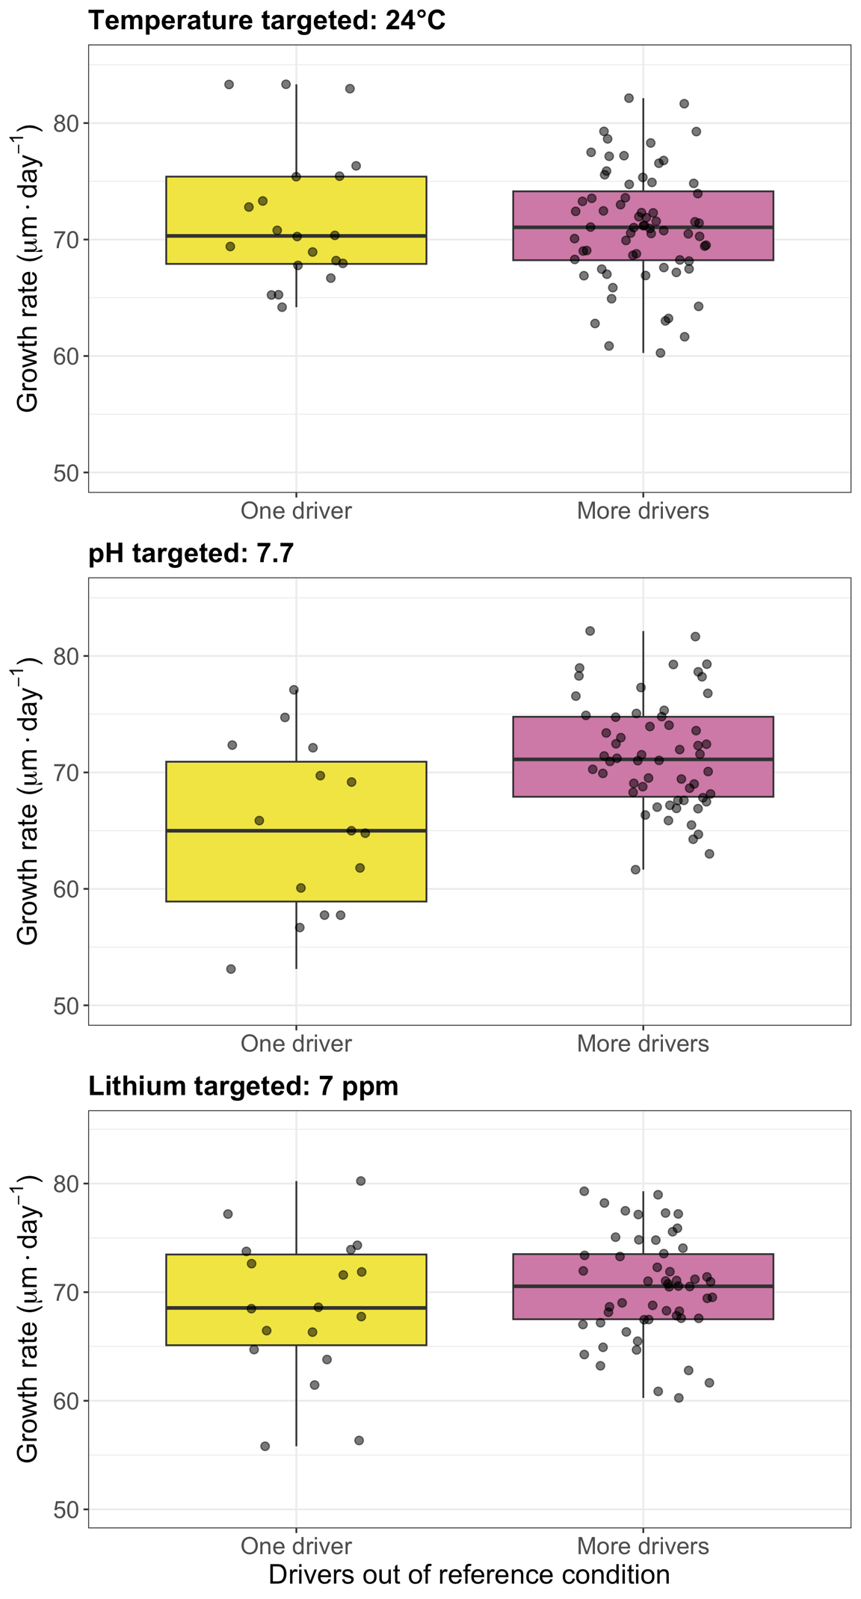
Figures 2a-c. Growth rate comparison of multi-driver treatments with one and more drivers out of reference conditions.

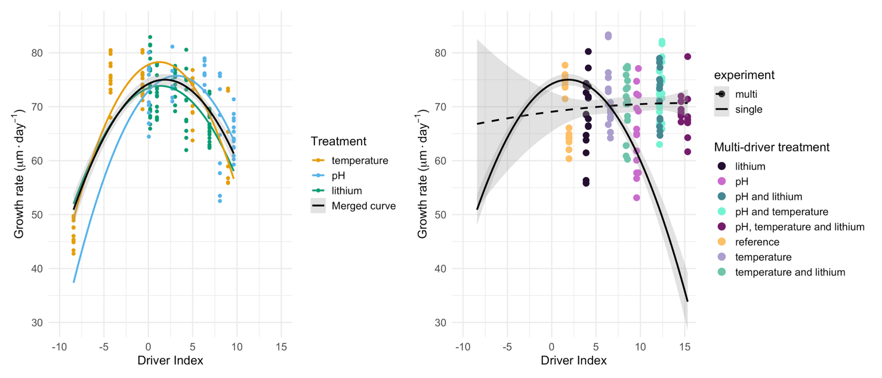
Figure 3a-b. A) The three single driver growth rate performance curves aligned on a common driver index axis, and a curve fit to all the single driver data combined. B) A comparison of the single driver curve with the multi-driver curve and points.

The parameters of the seawater physico-chemical parameters in the two experiments are summarized in the Table 2.
Table 2. Measured and calculated seawater parameters in each experimental treatment. pCO₂, DIC, Ω_{ca} and Ω_{ar} were calculated from measured TA, pH_{T}, temperature and a salinity of 38 psu. S=Single, M=Multiple, T=Temperature and Li=Lithium. Multi-driver duplicates have been merged.

Treatment | T (°C) | pH_{T}-in situ | Li (mg L⁻¹) | TA (µmol kg⁻¹) | pCO₂ (µatm) | DIC (µmol kg⁻¹) | Ω_{ar} | Ω_{ca}
Single drivers
12 °C | 12.3 | 8.03 | 0.18 | 2548 | 461 | 2320 | 2.52 | 3.92
16 °C | 15.99 | 8.01 | 0.17 | 2552 | 489 | 2299 | 2.81 | 4.33
20 °C | 19.72 | 8.01 | 0.2 | 2557 | 479 | 2279 | 3.09 | 4.75
25 °C | 25.08 | 8.00 | 0.19 | 2532 | 482 | 2214 | 3.57 | 5.40
30 °C | 30.2 | 8.04 | 0.19 | 2575 | 435 | 2202 | 4.22 | 6.33
pH 8.1 | 19.72 | 7.99 | 0.19 | 2525 | 507 | 2259 | 2.98 | 4.57
pH 7.95 | 19.72 | 7.89 | 0.18 | 2519 | 654 | 2307 | 2.45 | 3.75
pH 7.7 | 19.72 | 7.76 | 0.18 | 2508 | 914 | 2358 | 1.88 | 2.88
pH 7.45 | 19.72 | 7.70 | 0.18 | 2502 | 1068 | 2379 | 1.65 | 2.53
pH 7.2 | 19.72 | 7.65 | 0.17 | 2511 | 1235 | 2410 | 1.48 | 2.26
0.18 ppm lithium | 19.72 | 7.98 | 0.19 | 2516 | 513 | 2258 | 2.89 | 4.43
3 ppm lithium | 19.72 | 7.99 | 3 | 2507 | 500 | 2245 | 2.92 | 4.48
7 ppm lithium | 19.72 | 7.98 | 8 | 2507 | 515 | 2250 | 2.88 | 4.41
10 ppm lithium | 19.72 | 7.98 | 12 | 2498 | 506 | 2239 | 2.88 | 4.42
20 ppm lithium | 19.72 | 8.00 | 21 | 2464 | 474 | 2196 | 2.95 | 4.53
Multiple drivers
MT20pH8.1Li0.18 | 20.8 | 7.97 | 0.18 | 2512 | 533 | 2256 | 2.88 | 4.40
MT20pH7.7Li0.18 | 20.6 | 7.67 | 0.19 | 2497 | 1149 | 2383 | 1.58 | 2.42
MT20pH8.1Li7 | 20.6 | 7.97 | 7.5 | 2482 | 523 | 2229 | 2.83 | 4.33
MT20pH7.7Li7 | 20.7 | 7.69 | 7.5 | 2471 | 1091 | 2350 | 1.62 | 2.48
MT24pH8.1Li0.18 | 25.5 | 7.97 | 0.18 | 2496 | 528 | 2201 | 3.34 | 5.04
MT24pH7.7Li0.18 | 25.5 | 7.76 | 0.18 | 2505 | 935 | 2323 | 2.24 | 3.39
MT24pH8.1Li7 | 25.4 | 7.97 | 7 | 2493 | 516 | 2194 | 3.37 | 5.09
MT24pH7.7Li7 | 25.6 | 7.76 | 7.5 | 2500 | 934 | 2318 | 2.25 | 3.39

Discussion – has not been changed with new manuscript edits

Key messages
- Performance curves are not linear and follow similar unimodal pattern
- Each drivers contributes relatively to the overall stress:
  - 1pH unit = 28C
  - 1 Li unit = 0.35C
It is then possible to build a model using the concentration addition hypothesis following the same unimodal pattern. The tipping point is around 25 degrees equivalent.
Within the range of the tested scenarios, temperature covers a wider range than the other drivers (temp: [-10 +10], pH [0 +9.8], Lithium [0 +7.4])
- The two experiments were comparable for the same treatments and true interaction could be identified as deviation from model with MS scenarios involving pH. The model over-estimate the effects suggesting an antagonistic interaction with pH.
- Model needs to be improved by incorporating this interaction. For this, need information on the mode of action and mechanisms if interaction (different experiments and experimental design).
Note: I thought we could do something like this:
It is then possible to “rank” the different drivers under different scenarios or calculate when the tipping point will be crossed under different scenarios of change for each combination of driver. For example, in a future of +4C, -0.4pH and 10mg Lithium (extreme mine pollution), the relative contribution of each stressor (in degree equivalent) would be:
Temperature: 4C
pH: 28*0.4=11.2C
Li: 10*0.35=3.5C
It is possible to translate those into biological effects using the model. However, the antagonistic effect of pH is exaggerating these effects.
It is then key to resolve the mechanisms of interactions and correct the model.

Discussion skeleton
- Performance curves are not linear and follow a similar unimodal pattern
  - Although the thermal performance curve was clearly the one best captured, all curves followed a unimodal second degree polynomial form.
  - Having treatments at more extreme levels of both pH and lithium would be beneficial to get a clearer view of their curves.
  - What shape we expect from literature for the three curves

- The unimodal pattern shared by the three curves gave the opportunity to work with a concentration addition hypothesis to build a model driver index following this unimodal pattern.
  - The contribution of each driver to the driver index (in Celsius deviations from reference scale) was 28°C for each pH unit change and 0.35°C for each lithium ppm change.
  - The tipping point of the shared unimodal curve for the three drivers is equivalent to around 25°C, a 5°C deviation from the reference condition.
  - Comparing the range of the three drivers on the driver index Celsius scale clearly shows the wider range of temperature (-10 to 10 °C deviation from reference conditions) compared to pH (0 to 9.8°C) and lithium (0 to 7.4°C). This exemplifies how the calculations of such shared driver indices can benefit future experimental design when choosing treatment levels so that the range of the drivers is comparable and extreme enough to capture the curve.

- Antagonism hint from boxplots:
  - The increase in performance with more drivers out of reference is weird.
  - This is possibly a hint of antagonism between pH and the other drivers
    - This is not commonly seen before.
    - Novel or poor experiment
- Then go into antagonism from the driver index

------- Old discussion here below ---------

This study attempts to shed light on the nature of multi-driver effects in an informed manner by also understanding each drivers’ response curve. The effort is in line with a call for global-change experiments to be more oriented towards employing regression-based experimental designs to give a better understanding of response curves and surfaces instead of using ANOVA–based experimental designs, which do not capture the complexity of driver interactions (Collins et al. (2022), Kreyling et al. (2014)). Our experimental design presents an approach to study the response curves of three drivers and evaluate their additivity or interaction in a multi-driver experiment. Although the thermal response curve was clear, there was too much noise and too little effect in the data to clearly see the other response curves or to confidently estimate the nature of the multi-driver effects.

4.1 Single driver response curves
The thermal response curve of the larval growth was quite well described by a second degree model and was clearly bell shaped, as expected from literature (e.g. Silva Romero et al. (2021), Byrne et al. (2022)), albeit with few data points at the highest temperature (30 ºC). The effect of the highest temperature treatment was also supported by the high mortality in that treatment, which has been previously observed in this species (Cuthbert et al., 2021). An unusually warm summer preceding the experiment (data from Samir et al., 2025) raises the question of whether the thermal tolerance of offspring from the adult urchins that went through that heatwave was affected. This potential carry-over effect is consistent with transgenerational plasticity observed in other echinoderms, where parental exposure to thermal anomalies modulates larval thermal tolerance (Uthicke et al., 2013; Foo & Byrne, 2016). Such parental effects could partially explain the relatively broad tolerance window observed here, despite the high mortality at the upper extreme. Integrating this perspective emphasizes that thermal performance curves in nature may embed not only acute physiological limits but also the legacy of environmental history. There was a decline in growth rate with lower pH and higher lithium, but the effect of these drivers was weak, the variance high and conclusions can hardly be drawn about the shape of their response curves (Fig. 1, Table SX). Larval responses to a decrease in pH have been described as linear in some studies, where a tipping point may be associated with calcium carbonate saturation states (e.g. Waldbusser et al. (2015)) as calcification systems are affected (Stumpp et al., 2012). It can be argued that the linear observations may well be a linear part of a unimodal curve, such as is observed for phytoplankton (Paul et al. (2020), Collins et al. (2022)). The shape and sensitivity of the response of course depends on the organism, and a tipping point is commonly observed for sea urchin larvae (Dorey et al. (2013), Lee et al. (2019)), below which the fitness or survival of the organism is severely impacted. Although the shape of marine larva response to lithium has, to our knowledge, not been documented, their responses to toxicants commonly follow a sigmoidal curve (Bellas (2008), Philibert et al. (2021), Morroni et al. (2023)).

The small effect-to-noise for pH and lithium may likely be attributed to the treatment levels or time scale of the experiment. Going outside the current range of variability of a driver is important in order to understand the biological effects that changes in the driver will have (Vargas et al., 2017). The pH of the lowest two treatments did not reach their targets and the pH treatment essentially did not go well below the range of natural variability, reaching only ˜pH 7.7 when the natural variability goes down to at least pH_{T} 7.9 (Gattuso et al., 2021). García et al. (2015a) found P. lividus larvae to be robust to low pH within the range of their natural variability (down to pH_{T} 7.6 in their case), with high growth rate and only slight developmental delay, while below that they were affected. The pH may therefore not have had an effect in the present study as it did not reach the extremes beyond the natural range experienced by the larvae, where stronger responses would be expected. The absence of a pronounced pH effect at the tested levels further supports the notion that P. lividus larvae can buffer moderate acidification within the boundaries of their natural diel and seasonal pH variability. This resilience may derive from physiological homeostasis mechanisms, such as upregulation of ion-transporters and acid–base regulatory enzymes, which have been reported in echinoid larvae under sublethal acidification (Dupont & Thorndyke, 2009; Evans et al., 2013). Consequently, identifying thresholds likely requires experimental levels that exceed the organism’s acclimatization envelope. The duration of the experiment is another possible explanation for the small effect. Even at very low pH levels, a short experiment may not show much effect of pH on P. lividus larvae (Martin et al., 2011). Schulte (2011) pointed out that the time scales of the exposure need to be kept in mind when drawing conclusions about the shape of the thermal performance of an organism, and this could also be true for other response curves. Although the lithium concentrations used here have been shown to be detrimental to P. lividus in another study (Ruocco et al., 2016), there the effect was much smaller when eggs were exposed to lithium after fertilization, compared to before fertilization. The levels used in the present study (which introduced lithium post-fertilization) are within the range of the lithium concentration that had no effect in the post-fertilization exposure part of that study, and may therefore be inside the range of short-term tolerance for the larvae. A caveat to that comparison is the different population origin of the larvae, Gulf of Naples vs. Cap d’Ail, and the possible difference in sensitivity between these populations. Additionally, lithium concentrations follow a biodiminution effect in marine food webs, and zooplankton from close to our sampling area (Villefranche-sur-Mer) have recently been found to naturally have a very high lithium concentration, with the concentration range even surpassing the levels used in our study (Thibon et al., 2023). Considering lithium’s anthropogenic relevance, its ecological implications merit further attention. As its toxicity seems dependent on ontogenetic timing of exposure, bioaccumulative capacity and likely duration of exposure, future work could benefit from a gradient extending well above environmental baselines to better resolve the potential sigmoidal nature of the response curve.

4.2 Exploring the multi-driver effect
Multi-driver effects were detectable but were dwarfed by the effect of temperature on growth rate. Although growth rate was generally lower in multi-driver treatments, high temperature was likely the principal driver behind this difference, except at 20°C (ambient). Temperature is the most influential driver for marine organisms, and its effects on various biological parameters have been studied extensively (Vernberg (1962), Olive (1995), Dahms and Killen (2023), with its dominant effect over other concurrent drivers’ effect commonly observed (e.g. Byrne et al., 2009). The multi-driver data showed that the treatments that had low pH (7.76), had higher growth rate than was expected from the single-driver data modelling, which could be due to the interaction rather than additivity of the drivers at these levels. As toxicants commonly intensify a stress response to low pH (Wang et al., 2025), that interaction is an unlikely candidate to explain this higher-than-expected growth rate for the multi-driver low pH treatments. Interaction between temperature and pH is commonly detected and quite varied (see Alter et al. (2024) and Hu et al. (2024) for recent meta-analyses). In the present case, where there is less effect of pH in the multi-driver data than anticipated from the single-driver data, temperature could be dampening the effect of pH, as has been noted before for the larvae of other sea urchin species (P. lividus (García et al., 2015b), Tripneustes gratilla (Sheppard Brennand et al., 2010) and Arbacia lixula (Gianguzza et al., 2014)). From an ecological standpoint, such interactions could have profound implications under climate change, where simultaneous warming and acidification are expected. If higher temperatures partially offset acidification stress within certain physiological windows, population-level projections based solely on additive models could overestimate negative outcomes. However, this mitigation may only occur under sublethal warming and could invert under extreme heat stress, underscoring the importance of mapping complete response surfaces. The nature and direction of the interaction between drivers depends on the treatment levels’ location on each response curve and their combined response surface, so simple generalizations about the interaction of drivers are not applicable (see Collins et al. (2022) and Carmichael et al. (2025) for more on response surfaces and response curves). This inherent instability in interaction outcomes aligns with meta-analytic findings that multi-driver effects in marine invertebrates are highly context-dependent (Boyd et al., 2018; Alter et al., 2024). Thus, reproducibility in such experiments hinges on careful selection and calibration of treatment levels relative to the underlying single-driver curves. The potential interaction between warming and acidification observed here exemplifies this context dependency of multi-driver effects, as small shifts in treatment positioning along response surfaces may change or even invert the direction of interaction. As global change scenarios continue to unfold, embedding such regression-based, gradient-oriented designs into multi-driver research will be essential to move from descriptive outcomes toward predictive understanding.

The driver index may be a useful way to visualize multi-driver effects alongside the response curves, but it shed no further light on the effects in this study. The calculation of the index was in part inspired by ecotoxicologies’ concentration addition (Drescher and Boedeker (1995), Wang et al. (2013)) and stress addition (Liess et al. (2016)) calculations, but its employment in marine multi-driver studies is novel, as far as we know. The conversion factors that translate changes in pH and lithium into changes in degrees celsius can be altered, but that only shifts or spreads the data along the x-axis, and in the present case does not change the results: apart from temperature, there is little effect and much noise. The models fitted to the pooled data from the two experiments further underscore the dominance of the temperature effect, although the GAMs’ modest outperformance of the polynomial models may indicate that they are capturing some non-linear trend in the data that the polynomial models do not pick up. This non-linear signal can be an interesting point in some cases, but the noise and lack of effect in the present study make it an unhelpful point to pursue. Our findings echo the rationale outlined in the Introduction: without a precise understanding of single-driver response curves, the interpretation of multi-driver outcomes remains uncertain and prone to misclassification of interaction types. In this study, the thermal performance curve of P. lividus was captured with high resolution and confirmed as a dominant driver of larval growth, while pH, lithium, and multi-driver effects remained within a high-noise, low-signal zone, likely reflecting both the treatment levels being within natural variability and the relatively short exposure time.

- Conclusion
The importance of understanding multi-driver responses by studying the drivers individually and in combination is the main motivation behind this study. With maybe the exception of lithium, which seems to have varied and complex effects in experimental studies, the treatment levels of the drivers were well chosen. The small effect and large variability seen for all treatments except the temperature alone may be due to complications in the execution of the experiment (not reaching desired pH levels), its short duration and larval robustness to the lithium levels tested. The study gives a good example of a well-rounded experimental design to understand response curves and multi-driver effects, but we highlight three learning outcomes: i) a critical design principle for single- and multi-driver experiments is to extend experimental gradients well beyond the range of environmental fluctuation to which organisms are acclimatized – the treatment levels must be “bold” to catch the response curve, ii) when studying toxicants, it helps to know the bioaccumulative capacity of the model organism and iii) care should be taken to reach the treatment level goals.

Supplementary material

Figure S1. Paracentrotus lividus pluteus larvae morphology and morphometric variables. BL: body length, BR: body rod, ALR: antero lateral rod, and POR: post oral rod.

Table S1. Instrumental conditions for Li analysis by ICP-OES in seawater
Parameter | Value
Wavelength | 670.79 nm
Plasma power | 1300 W
Plasma gas | 14 L/min
Auxiliary gas | 0.5 L/min
Nebulizer gas | 0.6 L/min
Radial offset | 15 mm
Read time radial | 1sec
Read time axial | 3 sec
Peak evaluation | 3 pixels

Table S2. Larvae counts
Sample | Larvae count
ST1 | 99.5
ST2 | 109
ST3 | 106.5
ST4 | 110.5
ST5 | 4.5
SP1 | 102.5
SP2 | 106
SP3 | 111.5
SP4 | 106.5
SP5 | 104.5
SL1 | 111
SL2 | 105
SL3 | 107
SL4 | 104.5
SL5 | 96.5
ML1P1_20_R1 | 98.5
ML1P1_20_R2 | 115.5
ML1P2_20_R1 | 110
ML1P2_20_R2 | 111.5
ML2P2_20_R1 | 107.5
ML2P2_20_R2 | 112.5
ML2P1_20_R1 | 115
ML2P1_20_R2 | 113.5
ML1P1_24_R1 | 101.5
ML1P1_24_R2 | 100
ML1P2_24_R1 | 129
ML1P2_24_R2 | 118
ML2P2_24_R1 | 99
ML2P2_24_R2 | 101
ML2P1_24_R1 | 123.5
ML2P1_24_R2 | 107

Table S3. Wilcoxon rank-sum test results comparing single- and multi-driver treatments targeting the same value in at least one driver.
Condition | W-value | p-value
T targeted: 20 °C | 786 | 1.64E-03
T targeted: 24 °C | 444 | 9.67E-01
pH targeted: 7.7 | 537 | 2.03E-03
pH targeted: 8.1 | 584 | 8.06E-02
Li targeted: 0.18 ppm | 1047 | 4.39E-02
Li targeted: 7 ppm | 669 | 2.50E-03

Table SX. Fits and statistics of the models fitted to growth rate data from single-driver experiments.
Driver | Term | Estimate | Std. Error | t- value | p-value | Adj. R² | Sig.
Temp | (Intercept) | 66.826 | 0.872 | 76.607 | < 2e-16 | 0.7016 | ***
Temp | poly(temp, 2)1 | 30.827 | 6.586 | 4.681 | 1.96e-05 |  | ***
Temp | poly(temp, 2)2 | -69.616 | 6.586 | -10.57 | 9.26e-15 |  | ***
pH | (Intercept) | 70.116 | 0.778 | 90.111 | < 2e-16 | 0.3636 | ***
pH | poly(pH, 2)1 | 27.019 | 5.611 | 4.815 | 1.45e-05 |  | ***
pH | poly(pH, 2)2 | -15.819 | 5.611 | -2.819 | 0.00693 |  | **
Lithium | (Intercept) | 71.51 | 0.48 | 149 | < 2e-16 | 0.2981 | ***
Lithium | poly(lithium, 2)1 | -24.573 | 4.319 | -5.689 | 2.14e-07 |  | ***
Lithium | poly(lithium, 2)2 | -8.206 | 4.319 | -1.9 | 0.0612 |  | .

