**Summary Lanex Calibration**

1. **Absolute calibration**

Figure 1: Absolute charge calibration of seven different scintillation screens. The data points of Lanex Fine Buck et al. are generated by multiplying the charge from our Lanex Fine measurement with the slope reported in his paper. Also included are two reference points, one is the datapoint reported in buck (1.54 *10^9 ph/(pC*sr)) and a data point due to our calculation (1.05*10^9 []).

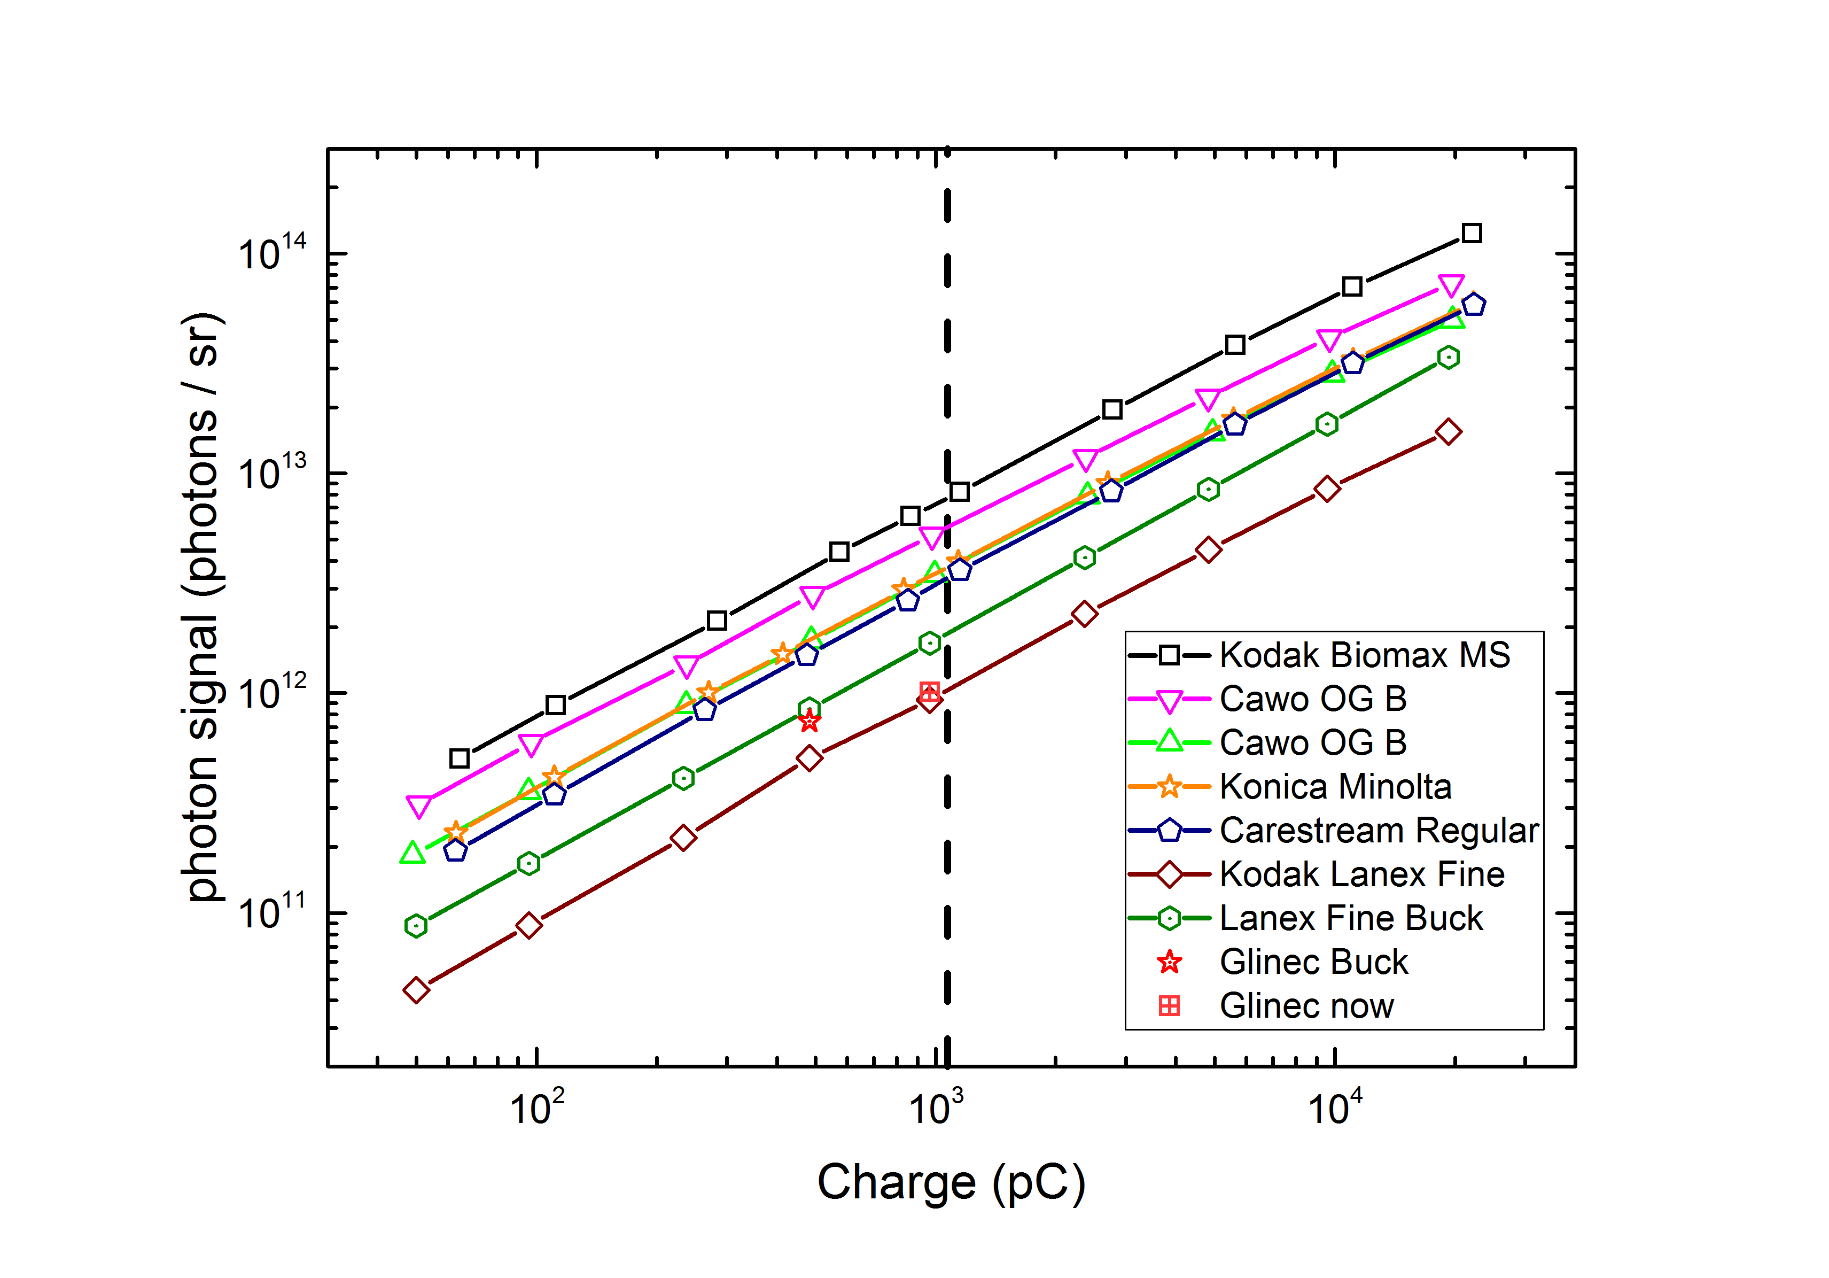

|  |  |
| --- | --- |
| Name | Slope (109 phot / (sr * pC) |
| KODAK BioMAX | 7.67 ± 0.42 |
| Cawo OG B | 5.81 ± 0.32 |
| Cawo OG F | 3.70 ± 0.26 |
| Konica Minolta | 3.67 ± 0.18 |
| Carestream Regular | 3.10 ± 0.15 |
| Lanex Fine | 0.95 ± 0.06 |
| Kodak BioMAX (Buck ) | 14.8 ± 1.3 |
| Lanex Fine (Buck) | 1.75 ± 0.15 |
| Glinec @ Buck | 1.54 ± 0.19 |
| Glinec @ now | 1.05 ± 0.13 |

Table : Results of absolute charge calibration within the linear region, including two reference values. Compared to old values: New Quantum Efficiency measurement (12 % increase 29.5 🡪 33%) and new charge values due to amplification factor ( 6% decrease)

1. **Comparison between September 2015, May 2016 and November 2016 Beam time**

|  |  |  |  |  |  |
| --- | --- | --- | --- | --- | --- |
| Name | September 2015 | May 2016 | November 2016 | Ratio to May | Ratio to November |
| KODAK BioMAX | 9.24 | 7.67 ± 0.42 | 7.45 ± 0.42 | 1.20 | 1.24 |
| Cawo OG B | 7.22 | 5.81 ± 0.32 | --- | 1.24 | --- |
| Konica Minolta | 4.82 | 3.67 ± 0.18 | 3.42 ± 0.18 | 1.31 | 1.41 |
| Lanex Fine | 1.25 | 0.95 ± 0.06 | 0.86 ± 0.05 | 1.33 | 1.45 |

Table : Comparison between our three beam times

* We see 20%-30% more signal in the September beamtime.
* We only compare the first data point in September to the linear fit in May and November since we do not trust the charge measurement for more than one bunch in the pulse train
* In order to explain the difference we make a rough dark current measurement (wasn’t measured in September) so it’s taken from the May data:

Darkcurrent-signal: 3.45*10^8 counts @ 10000 ms

Biomax Signal: 1.99*10^8 counts @ 20 ms 🡪 0.35% @ 65 pC

Scaling to September

7.7 pC and exposure of 100,200 ms 🡪 15% --30% dark current component which wasn’t subtracted

Interpretation:

Enhanced signal in September is due to dark current

1. 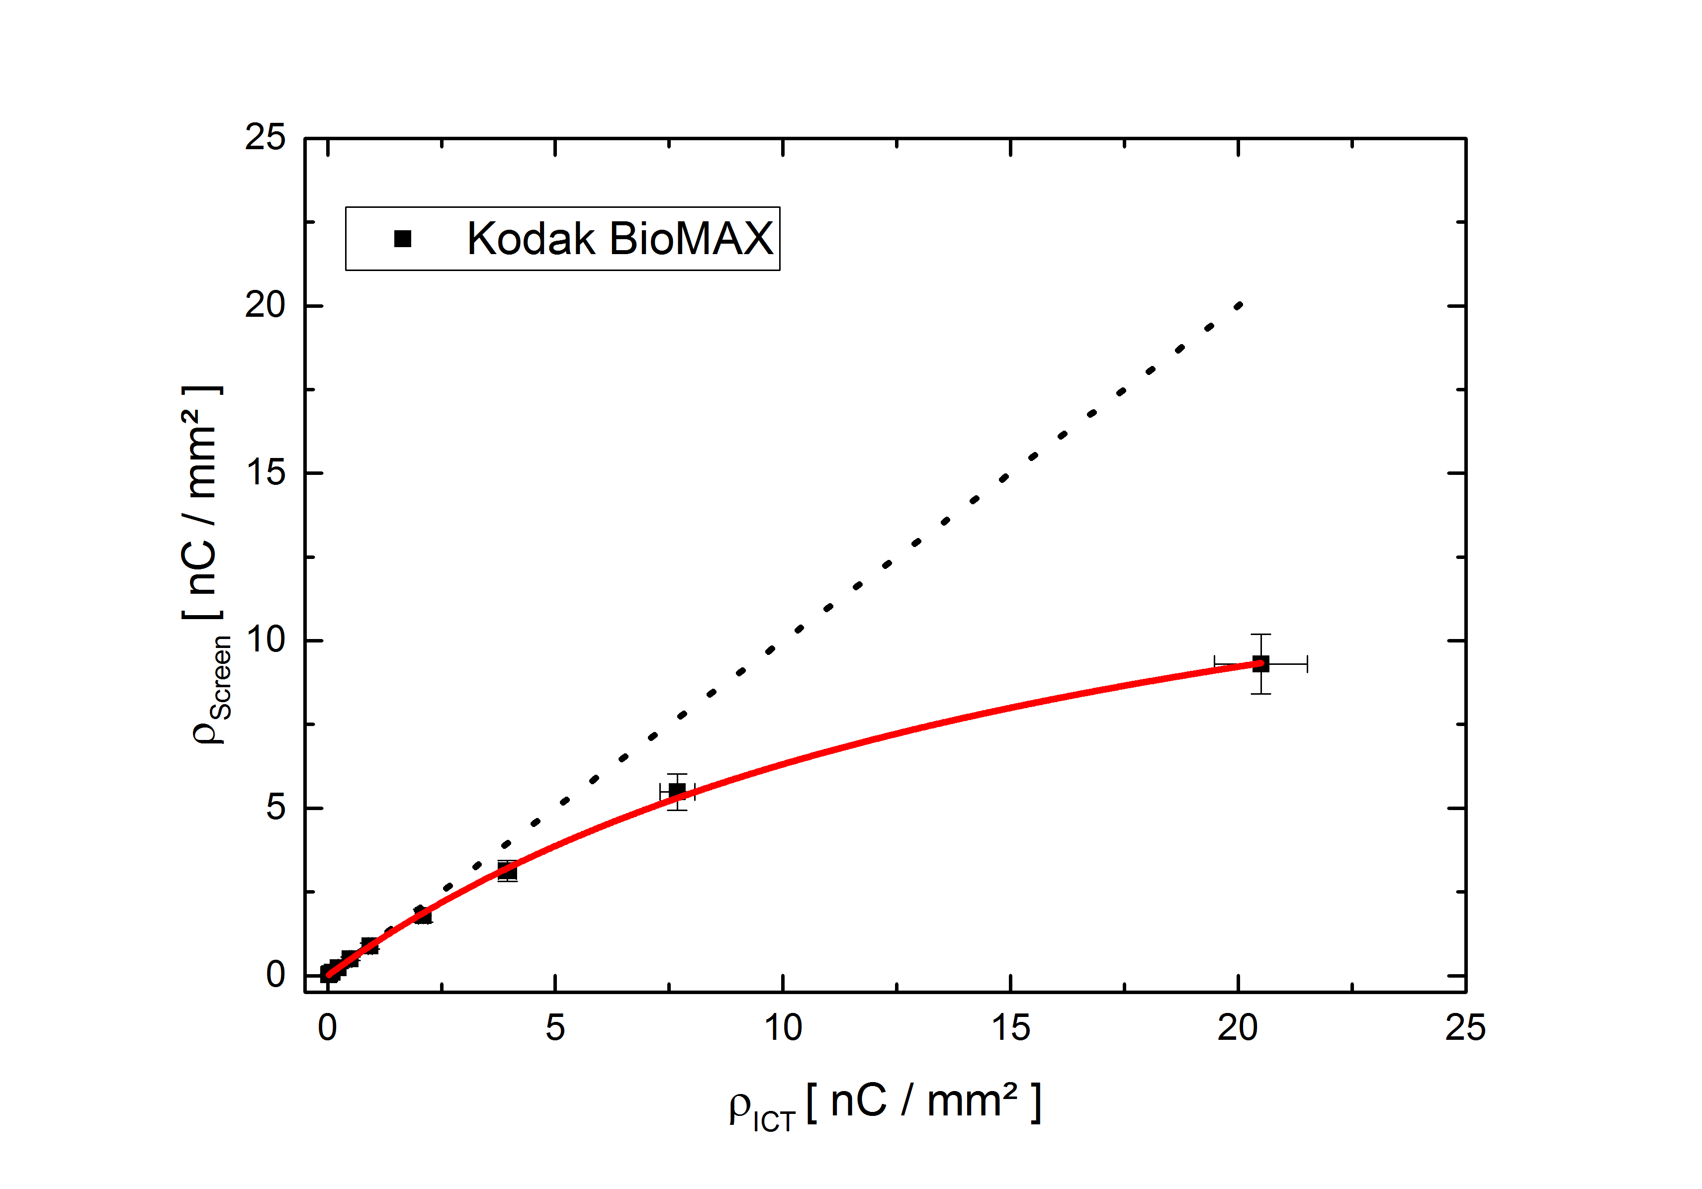Saturation

Figure 2: Typical Saturation curve of Kodak Biomax MS: The charge density emitted by the screen vs the charge density calculated by the ICT data and the beam profile shows a significant saturation at high peak charge densities. The measured data is fitted with Birk’s law of saturation (red line). The black dotted line indicates ρScint = ρICT. ρScint is also corrected due to the reference measurement in between each data point. Thus this reversible saturation effect is separated from degeneration effects due to the dose irradiated at a certain area of the screen. Additionally a saturation threshold at a certain difference (20% for ex.) compared to the linear response could be added.

|  |  |
| --- | --- |
| Name | Birk’s constant (10-5 mm²/pC) |
| KODAK BioMAX | 5.9 ± 0.3 |
| Carestream BioMAX | 5.7 ± 0.3 |
| Cawo OG B | 5.0 ± 0.3 |
| Cawo OG F | 5.1 ± 0.3 |
| Konica Minolta | 4.8 ± 0.4 |
| Carestream Regular | 4.9 ± 0.3 |
| Lanex Fine | 2.6 ± 0.3 |

Table : Saturation values for all detection screens. B is the fitting parameter in the saturation function y α 1 / (1 + B*x) (Birk’s law of Saturation)

1. Dauertest Konica Minolta in May 2016

Figure 3: “Dauertest” of Konica Minolta. The screen was irradiated constantly for 1.5h with 1Hz repetition rate, 100 pC charge and a spot size of 4-5 mm² at FWHM. The data was fitted with an exponential decay function. The decay of the photon signal during this experiment was ~11%. Since the set of parameters is comparable to LWFA experiments this effect is definitely relevant for the community.

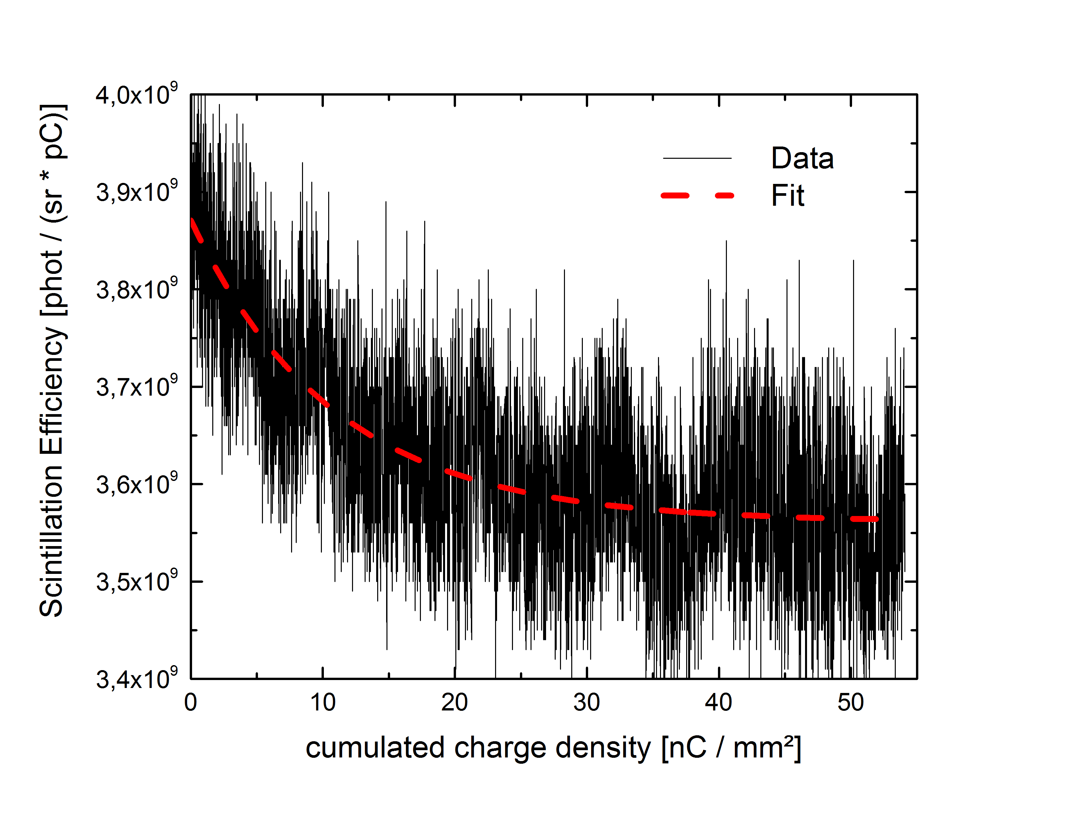

Fit

$$f\left(x\right)=y0+A ×\exp\left(\frac{-x}{b}\right)$$

$$y0=3.5×109$$

$$A=4×108$$

$$b=2×104 nC /mm$$

1. **Damage Threshold**

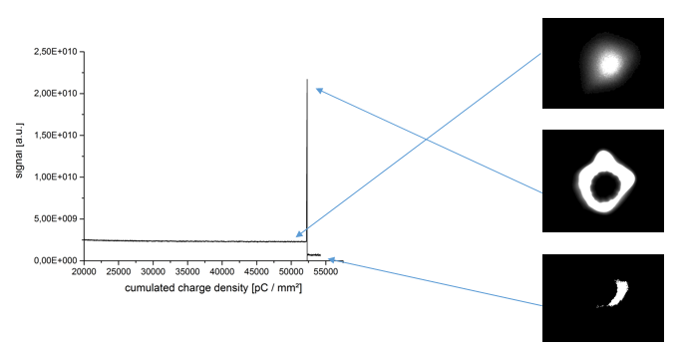

Figure 4: Damage of Konica Minolta after Dauertest (done in November). The decay of the signal was ~16% (but the gamma value in this measurement was set to 3, therefore only qualitative results are discussed). After an applied dose of ~50 nC/mm² the screen was probably “thermally melted”. After this singularity the screen was dark at this spot (even visible after days by eye and by x-ray irradiation).

1. Back to Calibration
2. 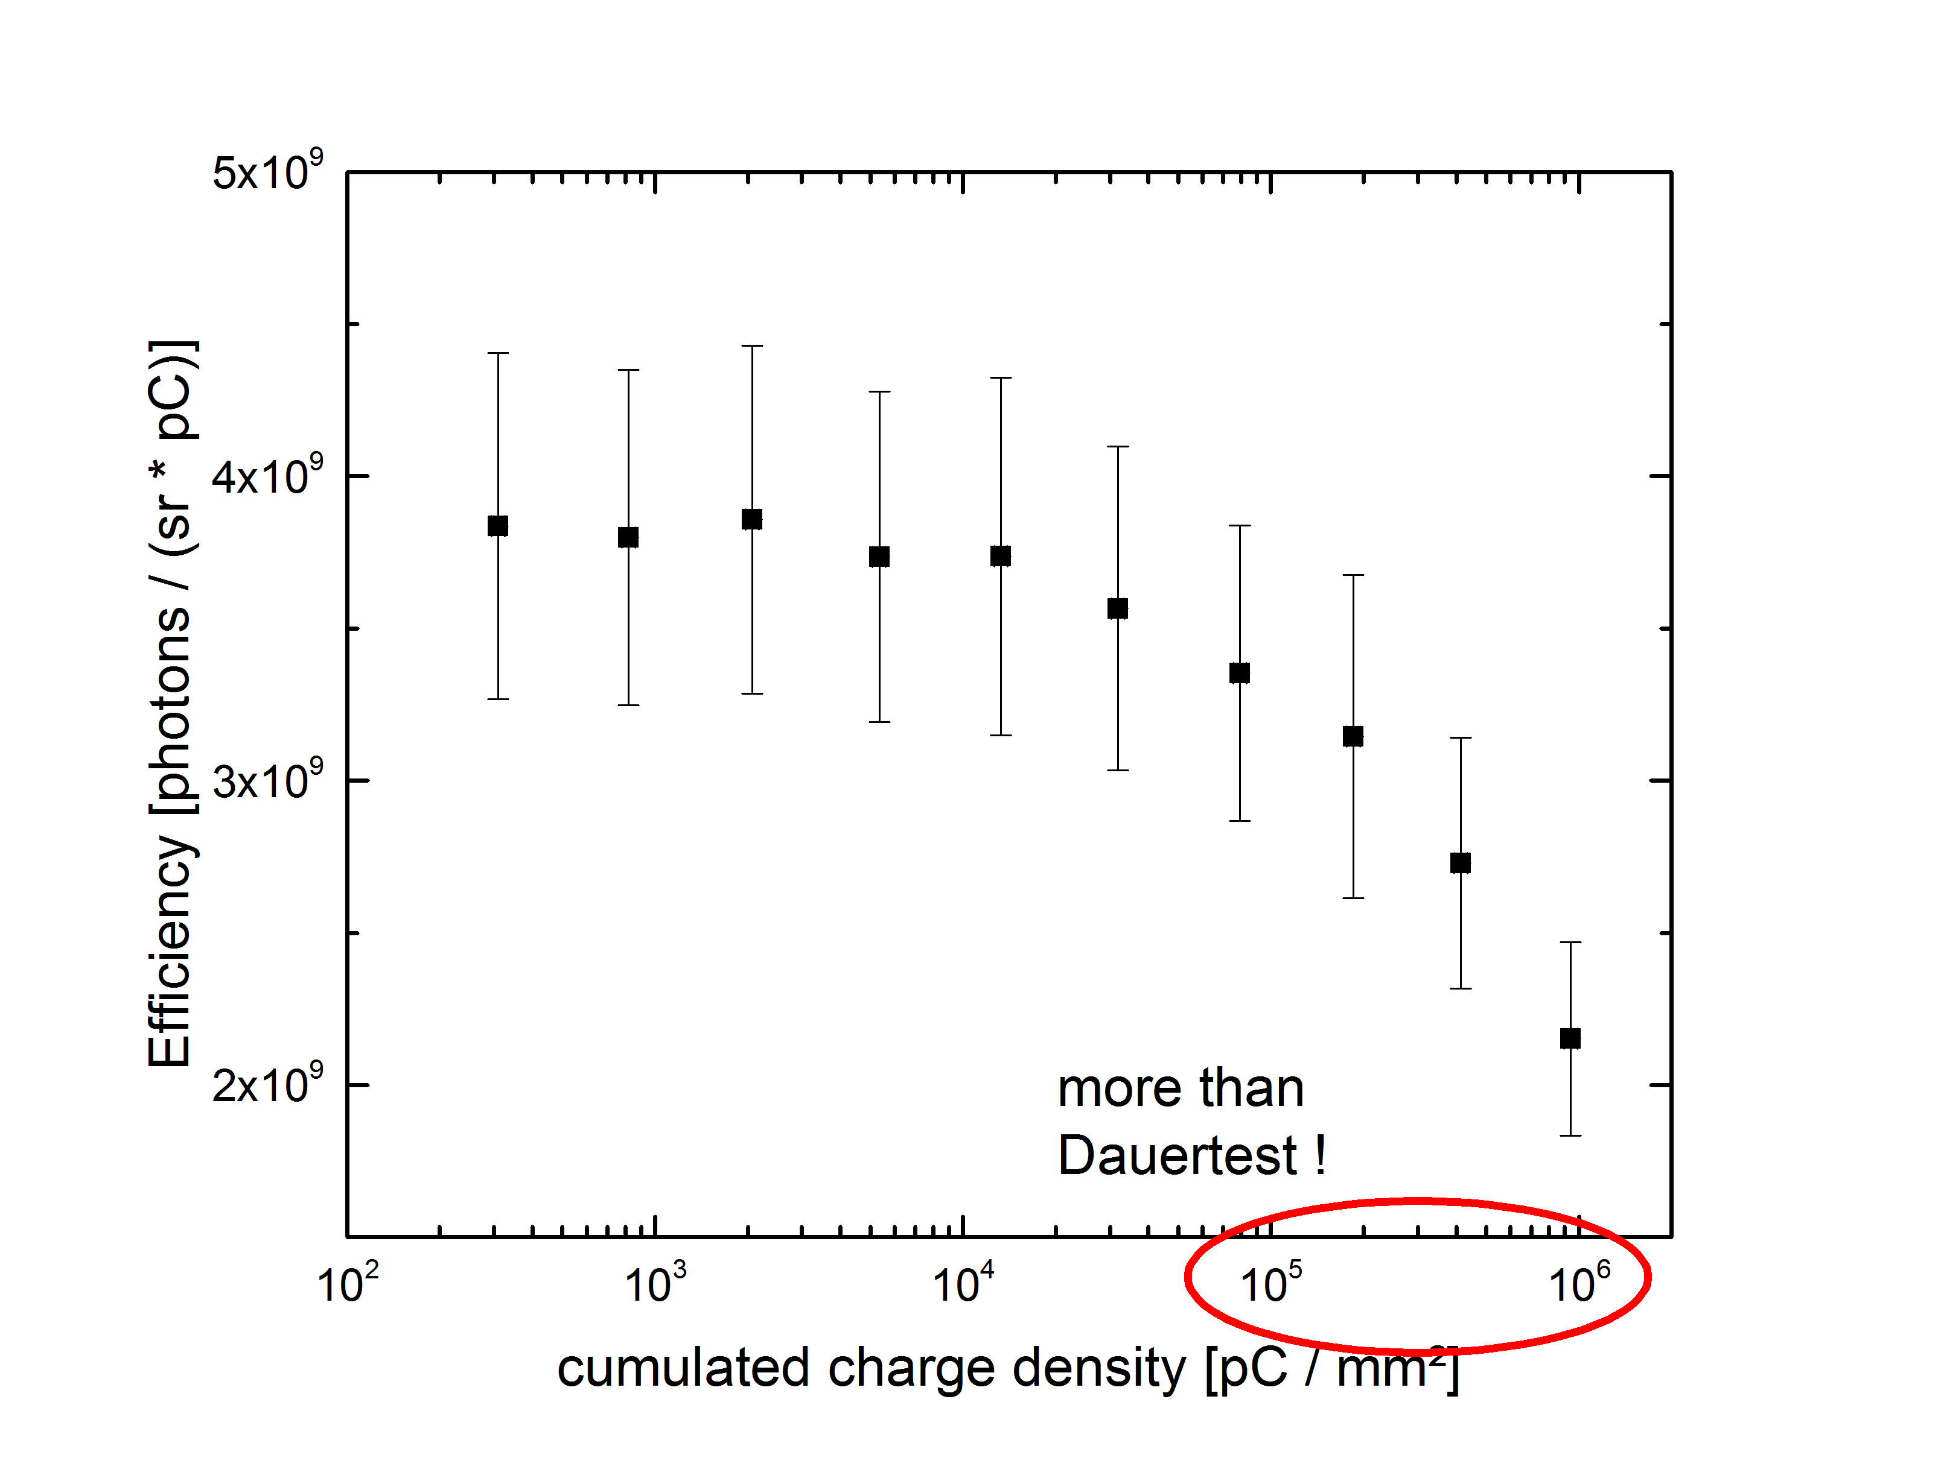Summary and discussion

Figure 5: Efficiency of Konica. Interesting part is the x-axis: The cumulated charge density in the calibration run exceeds the applied doses in the dauertests by far. If this bright singularity is induced by thermal melting of the scintillator then the question arises why this phenomena was not present during the calibration run.

* 1. The results of the beam times in May and November are consistent. Old September 2015 seems to be wrong. Since there was no single shot ICT signal recorded this is not that surprising.
  2. The difference to buck is still present. Kodak Lanex Fine is a very old screen and probably not the best to compare. Kodak BioMAX MS (2012) is 44% lower that Buck’s Kodak BioMAX. The influence of the Beryllium window still need to be checked. Maybe this can explain the difference in efficiency.
  3. The saturation curve and thus the fitting parameters of the saturation fit function were corrected by the reference signal measured in between each charge increment.
  4. Long term measurement with relevant parameters shows significant signal loss.
  5. The singularity (probably melting or burning of the material) was reached at ~50 nC /mm² with relevant parameters. We are sure that this high brightness was definitely not induced by a high charge (nC or higher) shot from the LINAC, because on the one hand the ICT recorded a regular signal of ~100 pC and we crosschecked with some ELBE-logfiles. We looked at the log-files of ELBE-bpms and were able to distinguish between 100 and 200 pC. Right at the time of this bright image the log-file showed a constant (+- 5%) current for the whole measurement. If necessary, Jakob can definitely provide more details on that. Furthermore this singularity has happened twice in the November beamtime: We have also implemented another Konica Minolta for a split dauertest:   
     We’ve irradiated a fresh Minolta for half an hour. Afterwards the calibration run of all the screens were done and at the end of the day we took this half hour irradiated screen to shoot 1 hour with the same parameters (the goal was to see if this screen refreshes again, but this could not be proven due to the wrong gamma setting) onto it. The results was that this screen also showed this singularity at ~55nC /mm².
  6. Describing the bright peak in the dauertests (1.5h and 0.5+1.0h) in November as a thermal melting leads to the question why this was not present during the calibration with even much higher cumulated charge densities (see fig. 7).

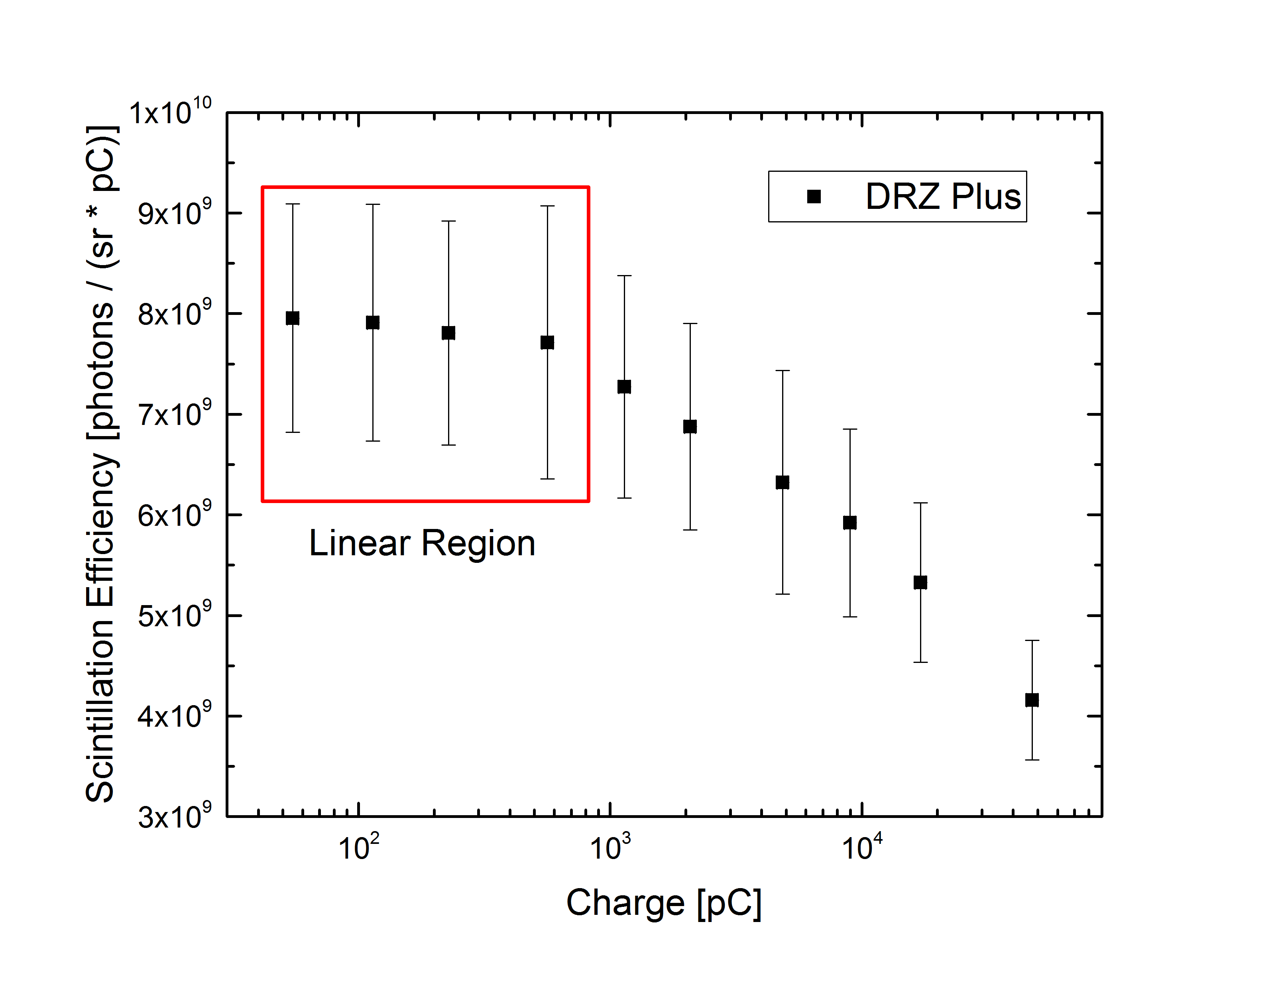

1. Appendix DRZ PLUS from Hamburg

Figure 6: Scintillation Efficiency of DRZ Plus. 4 data points define the liner region spanning over 2 orders of magnitude in charge in our case.

|  |  |
| --- | --- |
| Scintillation Efficiency | 7.75 +- 0.38 * 10^9 phot / (sr * pC) |
| Birk’s constant | 1. +- 0.8 * 10^-5 mm² / pC |