Power BI Test Solution Guide

Part 1 Data Modelling
Star Schema

FactOrders related many-to-one to DimCustomers on CustomerID and DimProducts on ProductID. I have created a Date table(DimCalendar) to related to Orders[OrderDate].
I believe that adding DimCalendar to the data model, even though it wasn't in the initial test specifications, is a fundamental best practice because it unlocks native DAX time intelligence functions like year-to-date and period-over-period comparisons without breaking calculations. It also ensures that any days with zero transactions still show up cleanly on the dashboard charts with zero values instead of creating disruptive gaps. Additionally, Power BI's storage engine handles pre-calculated date attributes much faster than processing them on-the-fly, while giving users a clean and consistent way to slice data by months, weekdays, or weekends without cluttering the transactional orders table.
DimCalendar =
ADDCOLUMNS(
CALENDAR(DATE(2024, 1, 1), DATE(2024, 6, 30)),
"DateKey", FORMAT([Date], "YYYYMMDD"),
"Year", YEAR([Date]),
"Quarter", "Q" & FORMAT([Date], "Q"),
"MonthNumber", MONTH([Date]),
"MonthName", FORMAT([Date], "MMMM"),
"WeekDayNumber", WEEKDAY([Date], 2), -- 1 = Monday, 7 = Sunday
"WeekDayName", FORMAT([Date], "dddd"),
"IsWeekend", IF(WEEKDAY([Date], 2) >= 6, TRUE, FALSE)
)

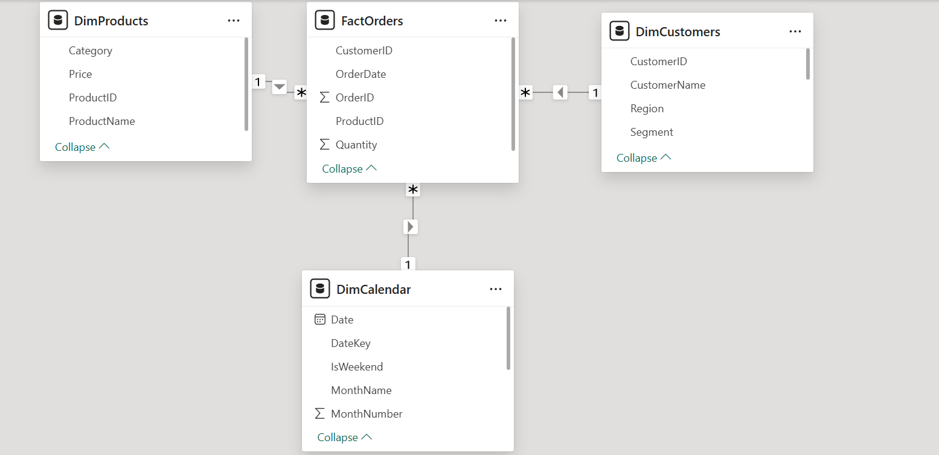

Data Origination & Generation Specification
- Business Framework: Built upon a controlled, business-realistic international online retail simulation spanning January through June 2024 (approx. 180 days) to avoid arbitrary random noise.
- Volume Constraints: Engineered around a deterministic total of 100 orders distributed chronologically across six months, featuring seasonal spikes peaking in Q2 (March–June).
- Customer Behavioral Distribution: Comprises 40 distinct customer profiles (C101–C140) categorized into behavioral purchasing tiers:
  - VIP Customers: 4 accounts driving 35 total orders (8–10 purchases each).
  - Frequent Customers: 8 accounts driving 34 total orders (4–6 purchases each).
  - Regular Customers: 15 accounts driving 30 total orders (2 purchases each).
  - One-Time Customer: 1 account (C140) driving 1 order.
- Regional Representation: Balanced geographic distribution mapping customers evenly across North America, Europe, Asia, and South America.
- Product Assortment & Pricing: Standardized across 10 distinct product categories (P1–P10) ranging from high-value premium assets (e.g., Laptops at $1,200) to lower-cost transaction items (e.g., Jackets at $150).
- Quantity & Transaction Spread: Order quantities follow a realistic frequency model where single-unit purchases account for 52% of rows, scaling up to multi-unit bundle orders that drive high-value revenue thresholds exceeding $500.

Part 2 - DAX Measures

Candidates must create the following measures.
Task 1 — Total Revenue
Orders table does not contain price. Candidate must retrieve price from Products table.
Response:
Total Revenue = SUMX(FactOrders, FactOrders[Quantity] * RELATED(DimProducts[Price]))

Task 2 — Revenue for Electronics Category
Create a measure showing revenue for electronics products only.
Response:
Electronics Revenue = CALCULATE([Total Revenue], DimProducts[Category] = "Electronics")

Task 3 — High Value Orders
Calculate total revenue from orders where revenue > $500.

Response:
High Value Orders = CALCULATE(
[Total Revenue],
FILTER(
FactOrders,
(FactOrders[Quantity] * RELATED(DimProducts[Price])) > 500
)

Task 4 — Regional Revenue
Calculate revenue by region.
Response:
Regional Revenue = [Total Revenue]

I used [Total Revenue] with Customers[Region] on visuals. (see the donut chart on the dashboard)
Task 5 — Revenue from Repeat Customers
Define repeat customers as customers with more than 1 order.
Response:
Repeat Customer Revenue = CALCULATE(
[Total Revenue],
FILTER(
DimCustomers,
CALCULATE(COUNTA(FactOrders[OrderID])) > 1
)
)

Part 3 — Dashboard Requirements
Candidates must build a decision-focused dashboard.
Section 1 – Executive KPIs
Section 2 – Revenue Trends
Section 3 – Regional Performance
Section 4 – Product Category Analysis
Section 5 – Customer Analysis
Response<: (see PowerBI_Test_Solution.pbix)

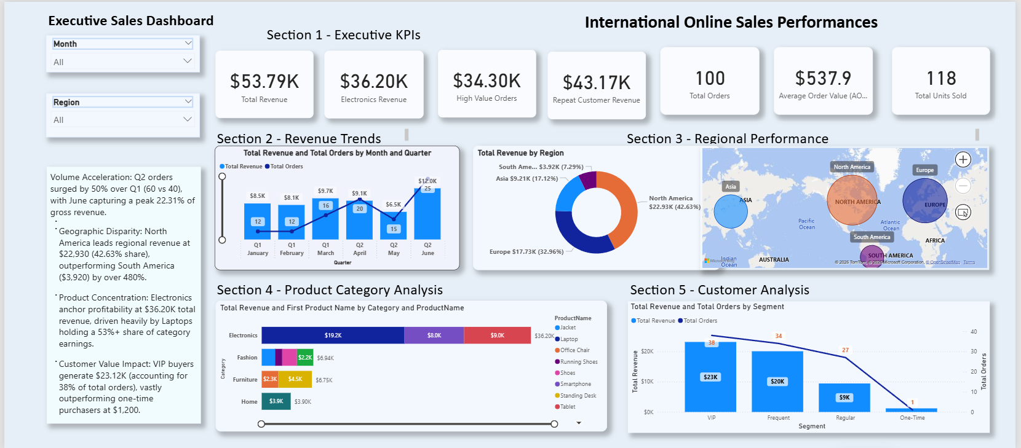

Part 4 — Business Insight Questions
Candidates must provide a short report in bullet format to summarize the insights and recommendation

- Response:
Key Insights & Recommendations
- Quarterly Growth Momentum: Total order volume accelerated significantly in Q2 (60 orders) compared to Q1 (40 orders), with June alone driving peak performance and representing 22.31% of total gross revenue.
  - Recommendation: Front-load high-demand electronic assets (specifically Laptops and Tablets) ahead of the March–June demand spike to prevent stockouts during peak buying windows.
- Geographic Concentration: North America is the dominant revenue driver at $22,930.00 (42.63% share), outperforming South America ($3,920.00) by over 480%.
  - Recommendation: Implement localized digital marketing and localized retention incentives in underperforming markets like South America to close the performance gap with North America and Europe.
- Product Category Dominance: Electronics anchor profitability, accounting for $36.20K (35.69%) of total revenue, with Laptops making up over 53% of category earnings.
  - Recommendation: Front-load high-demand electronic assets (specifically Laptops and Tablets) ahead of the March–June demand spike to prevent stockouts during peak buying windows.
- Customer Lifetime Value (LTV) Disparity: VIP customers generate the highest total revenue ($23.12K) and account for 38% of total orders, outperforming one-time buyers who generated only $1,200.00.
  - Recommendation: Develop dedicated cross-sell and up-sell campaigns designed to transition "Frequent" and "Regular" shoppers into the high-value "VIP" tier, protecting baseline revenue health.
- Volume Correlation: Total Revenue and Total Orders exhibit a strong positive correlation across all months and customer segments.
Recommendation: Leverage multi-channel volume incentives to drive transaction frequency, capitalizing on the proven direct correlation between order counts and gross revenue generation.

