 | 

EclipseIR And INDIface

Technology Libraries
Tech Note 2140
Table Of Contents
Overview 2
Fundimental Concepts 2
AbstractWorker base class 2
The “BEGgar” 3
VariableSet class 3
MessageMachine process 3
INDIbase data store and INDImage caching image manager 4
EclipseIR Libraries 6
eirBase Library 8
eirType Library 8
eirKID Library 8
eirFile Library 8
eirCfg Library 8
eirLog Library 9
Log.h file 9
Logger 9
LogFunction 9
LogItem 9
BaseLogDevice 9
LogThread 9
eirRes Library 10
eirVar Library 10
Variable class 10
VariableSet class 10
eirExe Library 10
eirMsg Library 10
eirEnt Library 10
eirState Library 10
Plugins 10
Frame Preprocessing 10
Detector Grouping 10
Face Detection 10
Feature Location 11
Vector Generator 11
Vector Comparison 11
Face-based Analytics 11
Frame Source 11
Object Detector 11
INDIbase Interface 11
Message Transport 12
Message Encoding 12
Revision History 12

Overview
The basic operations of INDIface² can be broken into five functional blocks in addition to the separate processes for INDIbase and INDImage image manager service NoSQL interfaces: Frame Processing, Face Processing, Analytic Processing, Template Processing, and Result Fusion.
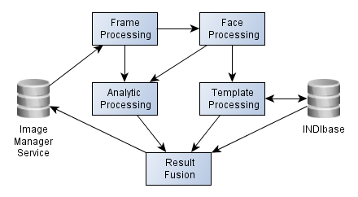

Fundimental Concepts

AbstractWorker base class

Results ← Configuration  Input Data

This formula represents the fundamental unit of work for the EclipseIR and INDIface technologies. Configuration information (encapsulated in a container derived from EclipseConfiguration base class) is combined with input data (encapsulated in a container derived from VariableSet) producing a set of results (encapsulated in a ResultSet). The dot-product in the formula represents a single set of calculations that contribute to the overall technology. It is implemented in a class derived from AbstractWorker:
class AbstractWorker : public ResultSet
{
public:
AbstractWorker(const Configuration & config,
const VariableSet & data);
Severity process(void);
static QStringList contexts(void);
};

You will notice there is no persistent data; an instance of the derived class only lives long enough to process the data and retrieve the results. However there is “context” support to supply data that the worker classes need. This is typically read only, but might also be written, for example to accumulate statistics. The best example is the data for the face layers needed to encode and decode INDIface vectors. The base Context is derived from a shared VariableSet with a QReadWriteLock.
An AbstractWorker-derived class can be wrapped by a QObject, QRunner (which runs in a global thread pool), or a QThread itself. A WorkerSupervisor class will be used to manage prerequisite results needed before an individual worker is ready to be called. A Context server on the network and a local Context cache manage the global data.

The “BEGgar”
Like the “BAGger”, Biometric Application Generator, is used to customize the appearance and capability of the MatchPoint^{IR} series of user applications, the INDIface engine can be implemented as a Biometric Engine Generator. Since each worker is included in the QMetaType system, they can be instantiated our of blue sky. This can allow message handlers to be built from just a text-based script.

VariableSet class
The VariableSet class is the basic unit of storage within the INDIface system. It contains binary storage, a list of QVariants, and a named map of Variable data identified by a numeric key, identification string, and name.
From VariableSet, we derive
- ConfigurationSet to manage external configuration data,
- Entity as the basic unit of persistent storage in INDIbase,
- EclipseMessage as the base message template,
- ResultSet to capture the results of an action.
And, as we saw above, it also contains input data to the worker classes. Since VariableSet-related classes are in the QMetaType system, they can be converted from and to QVariants, which allows instances to be embedded in and extracted from other VariableSet instances.

MessageMachine process
The MessageMachine ties a MessageQueue receiver to a generic EclipseStateMachine. Through the “BEGgar” facility, we can have completely generic worker message handlers. A message session maintains configuration for each client. Messages can be transported directly (Qt to Qt within the process space) or via 0MQ (Zero Message Queue) or basic TCP/IP port socket, possibly SQL or other database, and at the most primitive, file-based. Messages can be encoded in a Qt IO stream (binary or text) or XML, either pure or with binary attachments.
This allows deployments to scale smoothly to extremely large systems merely by adding more processes to a cloud of MessageMachine's.

INDIbase data store and INDImage caching image manager
TBD

EclipseIR Libraries

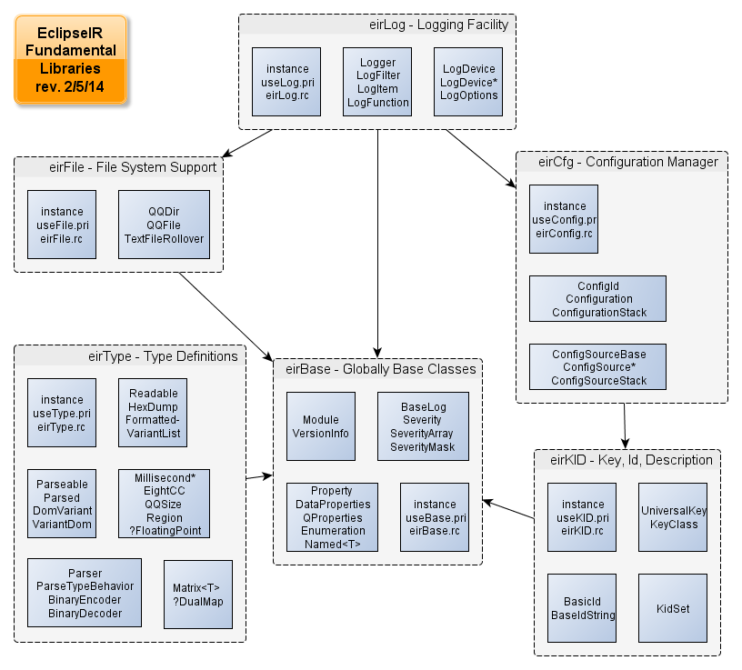
The libraries diagrammed above will comprise the core of the EclipseIR support libraries.

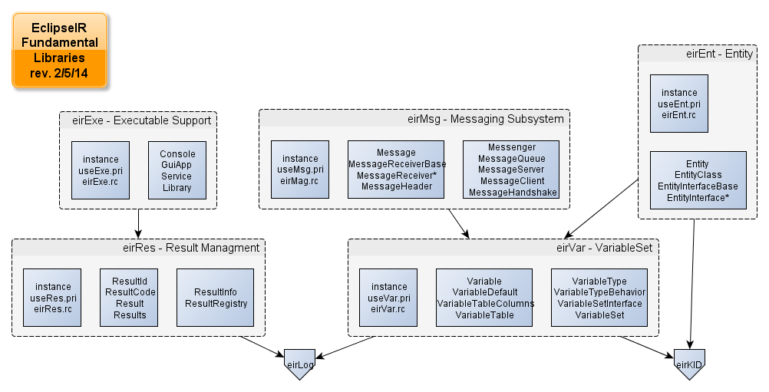
The VariableSet class will be the root of all evil for the EclipseIR higher level libraries.

eirBase Library
The eirBase library provides classes and templates that support the other libraries. The BaseLog class provides low level “blogging” facility in libraries that eirLog depends upon. The Property, QProperty, and DataProperty facilities provide named value sets for “normal” class member variables, QObject dynamic properties, and members of a QSharedData-based class. The Module class tracks the version and capabilities of each of the libraries and executables.

eirType Library
The eirType library provides reimplementations of Qt classes; templates for our collections; translations of QVariant to and from human readable, parse-able text, and XML elements; binary encoding and decoding; and a millisecond timer. The DataType class will interface QVariant::Type and QMetaType.

eirKID Library
The eirKID library provides creation and management of unique keys, identification strings, and Unicode descriptions.

eirFile Library
The eirFile library provides assistance with file system elements in a platform independent manner.

eirCfg Library
The eirCfg library provides an empty base Configuration class of named QVariants. Derived configuration classes can use the DataProperty facility from eirBase to specify names and initial values. The ConfigurationSet class will provide the configured item with the latest value specified.
Multiple classes derived from ConfigurationInterface will interface with Windows Registry and various configuration files (INI, XML, etc.) and finally ConfigurationSet will provide structured access to the most recent values.

eirLog Library
The eirLog library provides a very powerful logging facility for all other classes and applications.
The logging facility comes in three waves:
- Basic Log (available to eirBase, eirTypes, and eirLog itself)
  - Provided by eirBase's BaseLog class.
  - hyuuuumTroll output only, can be redirected to a file.
  - Minimum and Fatal severity levels can be set.
  - Basic BASSERT, BEXPECT, BFUNCTION, BFNRETURN macros
  - Fixed at four variables per item
  - BDUMPVAR only
  - No BTODO filtering
- Pre-Log (available below eirExe)
  - Provided by the main Log facility, but with limited capabilities.
  - Zero to nine variables with sophisticated formatting via eirType's Readable class.
  - DUMPVAR for complex variables, DUMPHEX as needed.
  - Four EXPECT macros with bool values.
  - TODO filtering
- Fill Log (available after exeStart() with command line and application configuration)
  - Preamble collections
  - Volatile configuration URLs where changes are recognized
  - Plugin devices available
  - LogThread available

Log.h file
Provides the macro definitions for all other libraries and applications to use, such as ASSERT, EXPECT*, TRACE, DUMPVAL, etc. This is really the public interface for logging with the classes below mostly for internal use.
TODO: List of macros.

Logger
This is a singleton class that coordinates all of the logging.

LogFunction
This class supports the FUNCTION, FNRETURN macros for Enter, EnterArg, and Leave severity messages.

LogItem
This class contains a single logged event.

BaseLogDevice
The TrollLogDevice, TxtFileLogDevice, and StdioLogDevice classes are derived from this class to interface between the queue of output items and writing to the actual devices. Once the Q[Core]Application's message handler has been started, other devices will be available via the plugin architecture. They can provide rollover files, binary storage of log events, etc.

LogThread
A background thread can be employed to minimize the effect of logging on the application running above it.

eirRes Library
The eirRes library provides management of lists of results from a function call.

eirVar Library
The eirVar library provides the VariableSet class upon which the base Message and Entity classes are built. This library provides all the interface and support classes that those classes can inherit.

Variable class
The Variable class consists of a multi-part VariableId, a Type identifier, and current and default values.

VariableSet class
The VariableSet class will contain a list of QVariant members, a QByteArray, and a map of named Variable members. Each VariableSet and its descendants will have their meta type declared so that a VariableSet can be stored whole in another VariableSet as well as having sections imported or exported from another VariableSet.

eirExe Library
The eirExe library provides support for all executables in a platform independent manner. Support for console and GUI applications, Windows services, and Linux daemons.

eirMsg Library
The eirMsg library provides the EclipseMessage base class and all support classes needed to pass messages between MessageQueue classes.

eirEnt Library (eirData)
The eirEnt library provides the EclipseEntity base class and all support classes needed to convert, store, retrieve, and manage entities in storage via NoSQL, SQL, etc.

eirState Library
The eirState machine supports a standard state machine for all connections and worker threads, in particular MessageMachine which has a message queue attached. TODO: State Diagram

Plugins
EclipseIR's INDI technology will be delivered in Qt Plugin form. This will allow other technologies to be mixed in in the future allowing for hybrid templates. Also general purpose technologies from outside EclipseIR will also be in plugIns so that they can be swapped in and out.

Frame Preprocessing
Includes Image Transformation, Luminance Stretching, Skin Detection, and Variance Detection.

Detector Grouping
Groups raw detections from generic object detector plug in to find individual objects.

Face Detection
Specializing object detection to find multiple frontal face images in frames.

Feature Location
Using object detection and other methods to locate multiple facial features in a detected frontal face.

Vector Generator
Generating facial recognition vectors from detected faces using located features.

Vector Comparison
Comparing facial recognition vectors to determine their similarity.

Face-based Analytics
Including Skin Tone, Clothes Color, Height Estimation, Resolver.

Frame Source
Interface to various IP-based image sources.

Object Detector
Interface to general purpose object detection.

INDIbase Interface
Interface to INDIbase for storage of templates, images, and related entities.
Results initialize(baseUrl.toString());
Results configure(IbInterfaceConfig);

Message Transport
TBD: via 0MQ, TCP, SQL, NoSQL?, file-based.

Message Encoding
TBD: Direct, QBinaryStream, QTextStream, XML with binary attachments, Pure-XML.

Log Device
TBD

Revision History
- February 2014: Initial document started.

