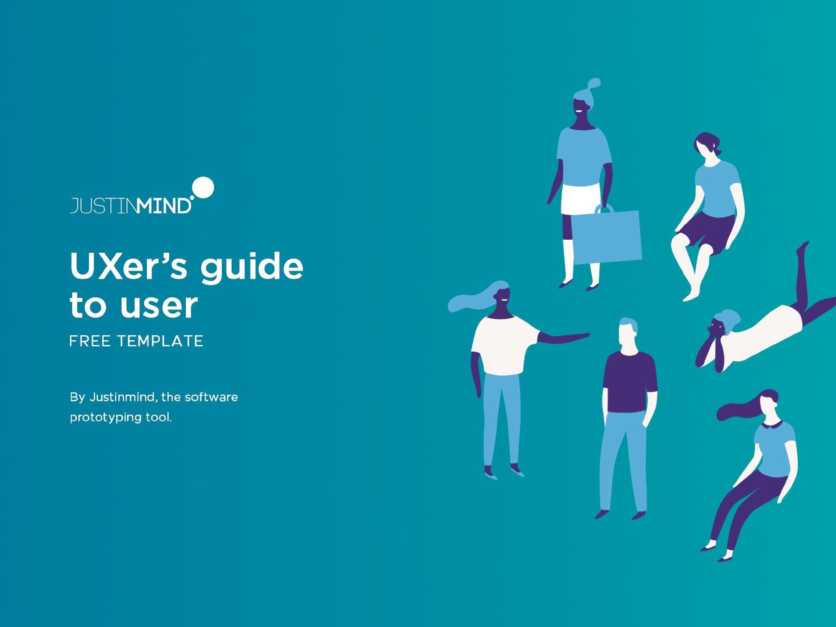













CHARLOTTE WALKER
, Los Angeles
27
UX DESIGNER
· STATUS
SINGLE
· TIER
MID
-
LEVEL
· SALARY
$50K
· ARCHETYPE
PERFECTIONIST
PERSONALITY
BIO
Charlotte recently started a new job as a UX design in a
mid
-
size bank. She moved over from the start
-
up world
and is still getting used to all the changes, particularly the
paperwork. She’s excited to bring a user
-
focused
perspective to the design department but nervous
because she’s the bank’s first UXer.
Outside of the office she’s a sports
-
mad psychology grad
.
She enjoys reading UX blogs and will sometimes go to UX
-
related conferences if they’re nearby. She’s also tuned
into design channels like Dribbble.
•
Introduce user focused mentality and
methods into traditional company
landscape
•
Improve usability of bank’s customer
facing interfaces
•
Grow the UX team
•
Getting buy
-
in for the new
department’s activities
•
Dealing with more bureaucracy than in
her old job
•
Communicating necessity for change
to development
team
Goals
Frustrations
Motivations
•
Prototyping
•
Interviewing
•
Design Thinking
•
Empathy
•
Coding
“I want to help my team
deliver great user
experiences”
Behavior
Influences
Overseeing builds
Writing specs
Designing features
Meetings
User testing
· CREDIBILITY
·
COLLEAGUES
· TECHNOLOGY
· BLOGS/ FORUMS
·
PSYCHOLOGY
·
UI TRENDS
IMPACT
TEAMWORK
PROMOTION
USER NEEDS
Justinmind
Frequently used apps
Google
Calendar
PocketGuard


