**Figure 1:** Navy training ranges with estimated tracks of a) seven Blainville’s beaked whales (*Mesoplodon densirostris*) at AUTEC and b) 12 Cuvier’s beaked whales (*Ziphius cavirostris*) at SCORE. Gray shadings indicate the parts of the tracks that are considered to be on range and red lines demarcate different areas.

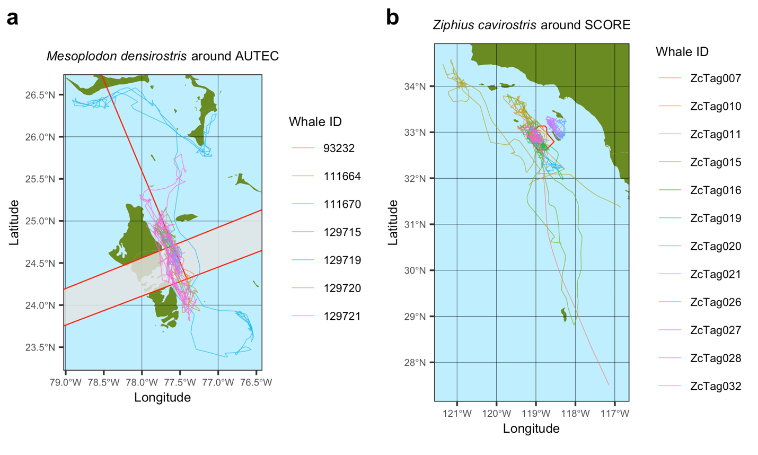

**Figure 2:** Characteristics of MFAS use on SCORE and AUTEC navy training ranges. Left panel shows the GAM prediction of the effect of standardized sonar area on the relative dive count rate (number of beaked whale dive starts per hour). A relative dive count rate of 1 means no decrease and a dive count rate of 0.5 implies a 50% lower dive count rate. Middle panels: the distributions of the time-interval between different sonar events on western range areas. Right panels: distributions of the daily sum of ‘standardized sonar area’ for western range areas. Corresponding plots for eastern range areas are shown in Supporting Information Figures S5 & S6.

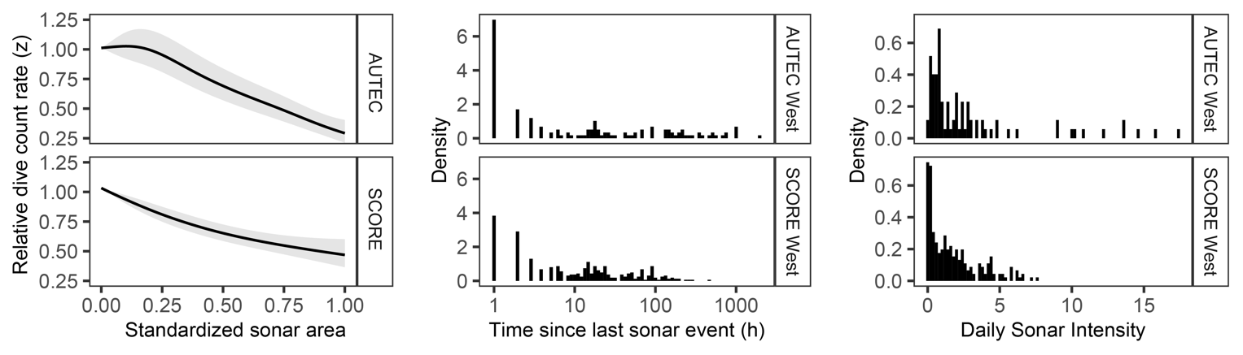

**Figure 3**: Population dynamics of *Zc* at SCORE in response to onset of MFAS disturbance at time *t* = 100 y. Disturbance either leads to cessation of foraging (left panels), displacement from range (right panels) or both (center panels), in which case the *Zc* population goes extinct. In the first scenario, the recovery of the population after cessation of MFAS disturbance at time *t* = 200 y is plotted. Trajectory of population recovery for the displacement response scenario is similar. Lines and shaded areas indicate mean and standard deviation of 100 replicate simulations, respectively. Middle rows show reproductive classes of females. For sake of presentation, standard deviations are omitted in this row. Note the differences in time scales between panels. All parameters as default (Table S3).

**Figure 4**: Population dynamics of *Md* at AUTEC in response to onset of disturbance at *t* = 100 y. Disturbance either leads to cessation of foraging (left panels), displacement from range (right panels) or both (center panels). In the first scenario, the recovery of the population after cessation of MFAS disturbance at *t* = 300 y is plotted. Lines and shaded areas indicate mean and standard deviation of 100 replicate simulations, respectively. Middle rows show reproductive classes of females. For sake of presentation, standard deviations are omitted in this row. Note the differences in time scales between panels. All parameters as default (Table S3).

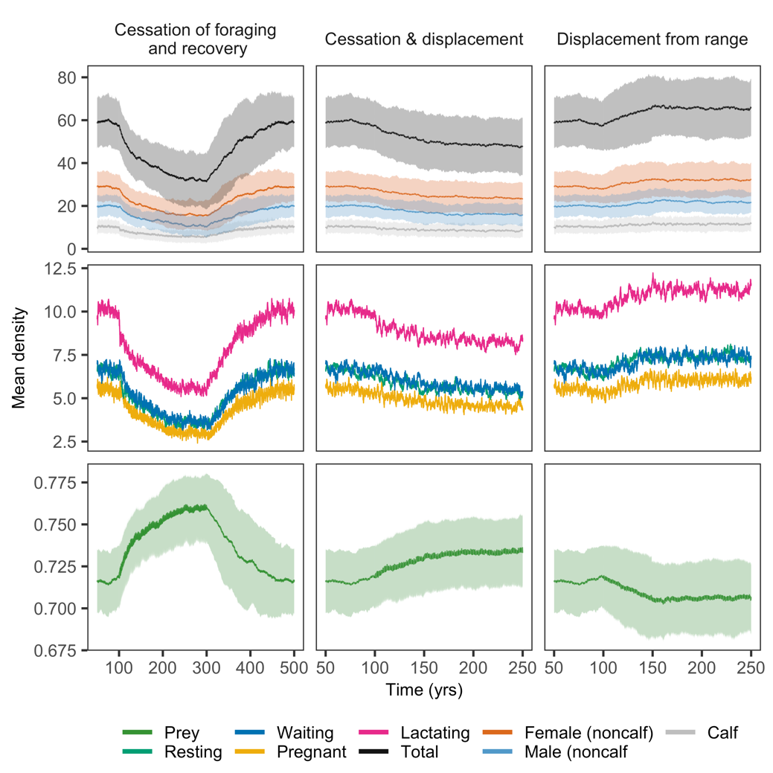

**Figure 5**: The effect of disturbance, differences in habitat quality (quantified by the attack rate ) and movement patterns (**Q** – matrix) on population abundance. The maximum prey density in absence of whale foraging (*Rmax*) was adjusted for each combination of attack rate ratio and **Q** – matrix, to obtain an approximately equal undisturbed population abundance. Labels indicate the value of *Rmax* used. Points show time-averaged values of mean population abundance across different replicate simulations. Line ranges show time-averaged values of the standard deviation of population abundance across different replicate simulations. Attack rate ratio () for *Zc* and *Md* equaled 13.3 and 5.0 by default, and 20 and 10 under the ‘high’ attack rate ratio scenario. All other parameters as default (Table S3).

**Figure 6**: The interaction between species, the pattern of MFAS use and the response to MFAS. By default, the time-series of MFAS from AUTEC was applied to the population of *Md* (blue symbols top panel) and the MFAS signal from SCORE was applied to *Zc* (red symbols bottom panel). This plot shows the effect of the hypothetical scenario in which *Md* would be exposed to the MFAS pattern at SCORE (red symbols top panel) and *Zc* to MFAS at AUTEC (blue symbols bottom panel). For both species, MFAS as used at SCORE has a stronger effect on population abundance compared to MFAS as used at AUTEC.

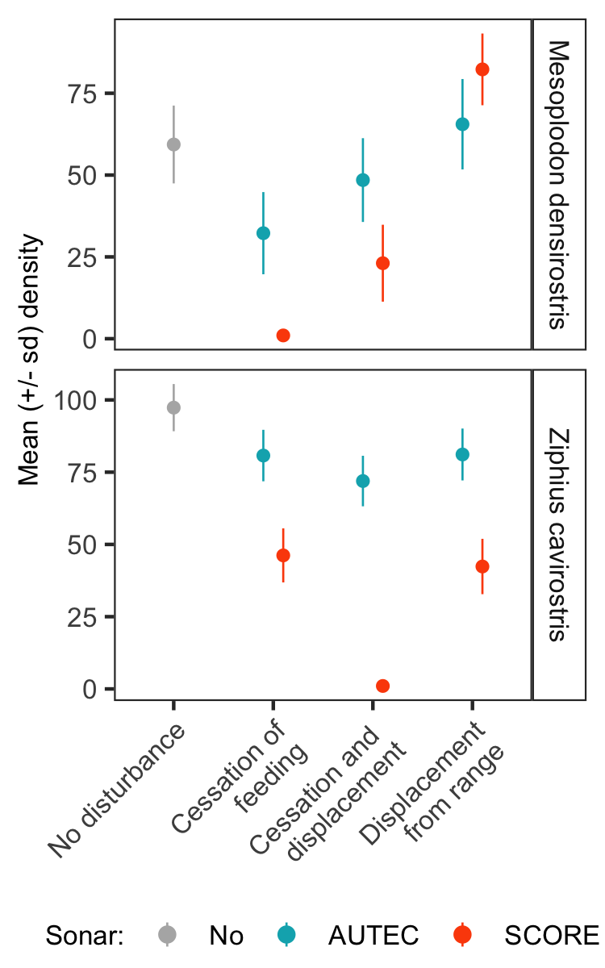

**Figure 7:** The effect of increasing the mean duration of cessation of foraging on population density of *Zc* and *Md* for the two relevant disturbance scenarios. Population density at zero mean disturbance duration represents undisturbed population density. Upon disturbance, duration of cessation of foraging was randomly determined from an Erlang distribution with shape parameter 2 and scale parameter equal to half the mean disturbance duration. By default, a mean disturbance duration of 1.5 days was used, corresponding to a scale parameter of 0.75. Points represent time-averaged values of mean population abundance calculated from eight replicate simulations. Lines represent time-averaged values of the standard deviation of population abundance across replicate simulations. All other parameter as default (Table S3).

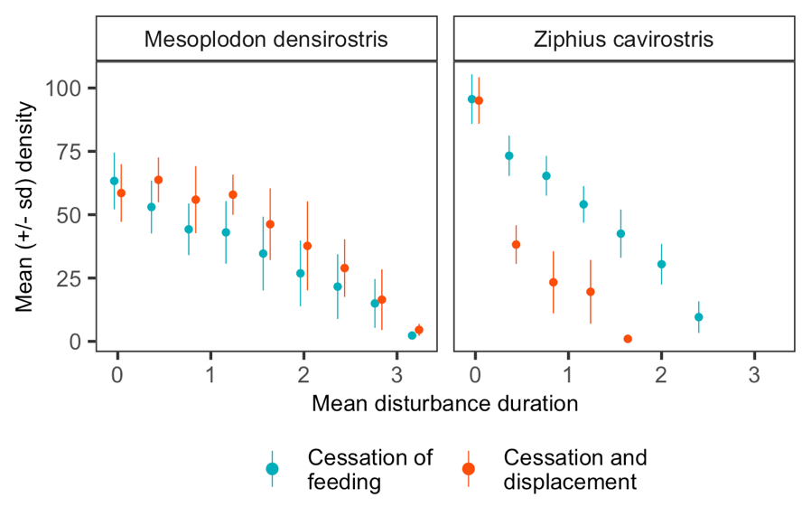

**Figure 8:** Distributions offemale age at onset of reproduction with and without disturbance from MFAS, distinguishing between age at first receptive, age at first reproduction and age at weaning first calf.

**Figure 9:** Distribution of female body condition as a function of reproductive status with and without disturbance from MFAS. Triangles indicate mean values. The lactating female group also represent females that are simultaneously ‘waiting’ or ‘pregnant’. Data represent body condition values of all females in a stationary population from single simulation of 100 y, with output collected each day. For *Zc* a *Rmax* – value of 2 was used for the cessation of displacement scenario, as the population went extinct with the default value of *Rmax* = 1.35.

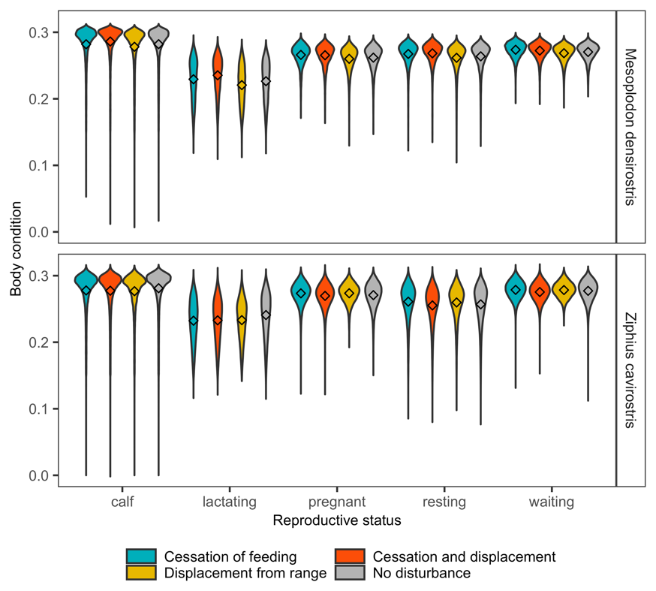

**Figure 10:** Six replicate simulations (panels) of the modelled population abundance of *Mesoplodon densirostris* in response to MFAS disturbance for three different behavioral response scenarios (colors). These simulations contribute to the mean population abundance of *Md* as shown in Fig. 4. As opposed to mean population abundance, output from individual simulations give a better representation of the variation of population abundance across time and between replicate simulations. All parameters as default (Table S3).

