SUPPORTING INFORMATION

# Telemetry data and transition rates estimation

Details of the tag deployment for *Md* can be found in (Joyce et al., 2019).

Stable distribution of the transition rate matrix **Q** is calculated as follows…

# Energy budget model

We used the energy budget model originally developed by De Roos et al., (2009) for ungulates and adapted for the long-finned pilot whale (*Globicephala melas*) by (Hin et al., 2019). This model describes individual energy acquisition from prey feeding (and milk suckling for calves) and utilization of energy on metabolism, growth in body size, pregnancy and lactation, as a function of an individual's state. All individual state variables are listed in Table S1 and model equations are given in Table S2.

**Table S1**: Individual state variables

|  |  |  |  |
| --- | --- | --- | --- |
| **State variable** | **Symbol** | **Equation** | **Unit** |
| Age |  | - | day |
| Time since conception |  | - | day |
| Structural length |  |  | cm |
| Structural length fetus |  | for | cm |
| Structural mass |  |  | kg |
| Reserve mass |  | - | kg |
| Total mass |  |  | kg |
| Maintenance mass |  |  | kg |
| Body condition | - |  | - |

Individual whales are composed of structural mass and reserve mass. Structure represents tissue that requires maintenance and cannot be used as energy store (e.g. bones and organs), while reserves can and require little or no maintenance (Kooijman, 2009). Structural length of free-living individuals is a fixed Von Bertalanffy function of age (Table S1) with parameters length at birth (), asymptotic length () and Von Bertalanffy growth constant . We do not consider sexual dimorphism in structural size for the two beaked whale species. Growth in structural size is non-plastic: growth rate and asymptotic size do not vary with rate of energy assimilation. Therefore, this energy budget model describes demand-driven growth, which was assumed more appropriate for mammals than the supply-driven Dynamics Energy Budget (DEB) formulation of (Kooijman, 2009). Demand-driven growth implies that rates of energy expenditure are independent of the energy acquired from feeding, because growth rate does not depend on energy intake. Instead, individuals regulate their body composition (relative contribution of reserves) by adjusting their feeding effort (see below). For fetuses, structural length is a linear function of time since conception (). Structural mass is directly related to structural length through a length-weight relationship and is therefore a fixed function of age too. Total body mass equals the sum of structural mass and reserve mass and includes structural mass of any fetus. Maintenance body mass is a weighted measure of body mass and discounts the mass-specific contribution of reserve mass to metabolic rate through parameter .

Energy acquisition from prey feeding (*IR*) and milk suckling (*IL*) are directly used to cover all energetic costs and any remaining energy is stored as reserves (*F*). All individuals spend energy on maintenance costs (*CM*) and growth (*CG*). Gestation (*Cp*) and lactation (*CL*) costs are paid by, respectively, pregnant and lactating females only. If energy acquisition is insufficient to cover all energy expenditures, additional energy is made available by catabolizing reserves. Vice versa, if energy intake exceeds energy expenditure, the surplus energy is stored as reserves (anabolism). Consequently, dynamics of reserve mass (dF/da) depend on the rates of energy intake and expenditure, which in turn depend on the reproductive status of an individual:

|  |  |
| --- | --- |
|  |  |

Here, the anabolic if and catabolic if conversion parameters account for the efficiency of storing and utilizing reserves.

Energy assimilated from prey feeding (*IR* in MJ day-1) is proportional to prey density *R*, structural surface-area *S2/3* and an attack rate parameter , which varies between areas (*i*) (Table S2). The feeding effort component of prey foraging () describes the fraction of time spent foraging and is modelled as a decreasing sigmoidal function of body condition (F/W), which equals 0.5 at the target body condition . Lastly, prey foraging depends on prey feeding efficiency (capture success), which lower for younger whales and gradually increases with age according to a hyperbolic function ().

The lactation rate is proportional to calf structural surface-area () and subject to the decrease in feeding effort of the calf in response to calf body condition. The lactation rate is modified by a hyperbolic function of maternal body condition (*Fm* / *Wm*) that equals zero if maternal body condition falls below and one at . Furthermore, beyond age *TN*, milk demand by the calf declines as the calf approaches weaning age (*TL*).

Costs for structural growth (*CG*) are obtained from the derivative of structural mass with respect to age multiplied by costs of growth parameter . Metabolic costs follow a quarter power relationship of maintenance body mass (*WM*) following Kleiber (1975) and (Lockyer, 2007). Pregnancy costs (*CP*) are proportional to fetal growth in structural mass. Fetal survival is assumed to be 0.8 over the whole of the gestation period and probability of abortion is independent of female state. Lactation costs (*CL*) for the female are proportional to the lactation rate (*IL*) of the calf, accounting for the efficiency of milk production and consumption through parameter ().

**Table S2**: Model equations

|  |  |  |
| --- | --- | --- |
| **Function** | **Equation** | **Description** |
|  |  | Energy assimilation rate from resource feeding in area |
|  |  | Energy assimilation rate from milk |
|  |  | Field metabolic costs |
|  |  | Somatic growth costs |
|  |  | Pregnancy costs |
|  |  | Lactation costs |
|  |  | Mortality rate calves and weaned females |
|  |  | Mortality rate weaned males |
|  | if | Starvation mortality rate |
|  |  | Pregnancy threshold |
|  |  | Reserve mass at birth |
|  |  | Resource dynamics |

## Mortality and survival

Calves and weaned females experience age-dependent mortality rate (Db(a)) according to a Siler model with three components: i) constant background mortality, ii) early life mortality that declines with age and iii) senescence mortality that increases with age (Barlow and Boveng, 1991; Siler, 1979). Weaned males experience constant background mortality only, with rate . In addition, individuals experience additional starvation-induced mortality if their body condition falls below the starvation body condition threshold . The starvation mortality rate is a hyperbolic function that increases with decreasing body condition (Table S2). The survival function H(a) is the integrated outcome of both starvation and (age-dependent / background) mortality: , which is a decreasing function of age with . In natural populations, there is variation in age at death even in the abscence of starvation mortality. To capture this variation, each individual was assigned a survival threshold: a uniform random number between 0 and 1. If H(a) falls below this threshold the individual was considered death and removed from the population.

## Reproduction

Whales are assumed to initiate pregnancy based on absolute amount of reserves. Once reserve mass exceeds a predefined threshold, termed the pregnancy threshold, the female becomes receptive and is assigned the 'waiting' status, as she awaits the onset of pregnancy. Each time a female enters the 'waiting' period, its duration is randomly determined from an exponential distribution with a mean of 445 days. The pregnancy threshold is defined as: , where is the reserve mass threshold below which starvation mortality occurs and *Fneo* is the amount of female reserves required to produce a neonate. Gestation last *TG* days and during gestation fetuses experience a daily mortality rate of , which is independent of the body condition of their mother. Hence, termination of pregnancy by the female was not considered. Fetal growth in structural length is a linear function of time since conception (Table S1). Fetuses do not contain any reserve mass, as they are directly linked to the reserves of their mother. Upon parturition, the minimum amount of reserves to offset starvation mortality (*Fb*) is transferred from the mother to the neonate (Table S2). Lactation lasts *TL* days and females can reinitiate the next pregnancy (enter the waiting period) during the last *TG* days of the lactation period if their reserve mass exceeds *Fpreg*. This restriction is to prevent females from having two calves simultaneously. Waiting females can become pregnant during the last phase of lactation if the waiting period happens to be shorter than the gestation period (*TG*).

# Parameterization

Little is known about the biology of beaked whales compared to other odontocetes and several parameter values for *Globicephala melas* (hereafter *Gm*) from Hin et al. (2019) are therefore retained for *Zc* and *Md*. Model parameter and their sources are summarized in Table S3. For several parameter their derivation is described below.

## Asymptotic length

Length estimates for beaked whales are given in Mead (1984) and, more recently, MacLeod (2006). According to Mead (1984), the maximum length of females *Zc* is 754 cm. However, Heyning (1989) notes that reported lengths > 7m for *Zc* probably represent misidentified individuals, as these are all derived from individuals that co-occurred with larger beaked whale species (*Berardius* spp. and *Hyperoodon*). Indeed, the vast majority (93%) of *Zc* individuals reported in MacLeod (2006) are under 7m in length and according to Heyning (1989), the largest accurately identified *Zc* measured 693 cm in length. Data from catches of *Zc* in the North Pacific indicate a maximum length for females of 670 cm (MacLeod, 2006; Nishiwaki and Oguro, 1972). Because there is no significant different in total length between sexes of *Zc*, we adopt 670 as our asymptotic length estimate for *Zc* (Table S3). For *Md* we adopt an asymptotic length of 475 cm, based on the observation by MacLeod (2006) that *Md* rarely reaches over 4.8 m in length.

## Size at birth

For *Zc*, we adopt the mean length at birth estimate of Mead (1984), which is 270 cm. Following (New et al., 2013), length at birth for *Md* was set to 198 cm. This value also falls in between the length of longest fetus (190 cm) and length of shortest calf (261 cm), as reported by Mead (1984).

## Von Bertalanffy growth constant

The Von Bertalanffy growth constant was calculated by rewriting the growth equation and using estimates of mean age () and length at sexual maturity ().

For *Zc*, Mead (1984) reports mean length at sexual maturity of 580 cm and age at sexual maturity was estimated at 2250 days, which give for Zc. Applying the same procedure for *Md* with mean length and age at sexual maturity of, respectively, 378 cm and 3285 days (9 yrs; Claridge, (2013)) gives.

## Structural length – mass relationship

To estimate the scaling constant and exponent of the length – mass relationship of structure, we collect length-weight data from stranded *Zc* and *Md* individuals. Data from emaciated or starved individuals were excluded from analysis, as well as those reported to be in a moderate or advanced state of decomposition. Because of the limited number of data points, we pooled observations from both species and fitted a single equation. This approach is supported by the general observation that body shape and proportions are extremely conserved in Ziphiids (Mead et al., 1982). The data and the fitted equation are shown in Figure S2. We assume that 27% of total weight consisted of reserve mass and multiplied the scaling constant by (1 – 0.27) to obtain . Applying these estimates to newborns that are assumed to receive minimum amount of reserves (Table S2) leads to *Fb* = 13.9 for *Md* and *Fb* = 33.2 for *Zc* (Table S3).

**Table S3**: Model parameters

|  |  |  |  |  |  |
| --- | --- | --- | --- | --- | --- |
| Symbol | Unit | Description | Md | Zc | Source |
|  |  | Gestation period | 365 | 365 | 1 |
|  |  | Lactation period (age at weaning) | 986 | 730 | 2 |
|  |  | Age at which milk consumption starts to decrease | 365 | 365 | 3 |
|  |  | Age at which prey feeding efficiency is 50% | 365 | 365 | 3 |
|  |  | Structural length at birth | 198 | 270 | 4, 1 |
|  |  | Ultimate structural length | 475 | 670 | 5, 6 |
|  |  | Von Bertalanffy growth rate | 0.000319 | 0.000663 | this study |
|  |  | Structural mass-length scaling constant | 2.93·10–5 | 2.93·10–5 | this study |
|  | – | Structural mass-length scaling exponent | 2.8 | 2.8 | this study |
|  | – | Relative metabolic cost of reserves | 0.2 | 0.2 | 7 |
|  | – | Target body condition threshold | 0.3 | 0.3 | 3 |
|  | – | Starvation body condition threshold | 0.15 | 0.15 | 3 |
|  |  | Prey encounter rate high quality | 5.0 | 13.3 | 8, 9 |
|  |  | Prey encounter rate low quality | 1.0 | 1.0 | this study |
|  |  | Lactation scalar | 2.1 | 2.6 | this study |
|  | – | Steepness of assimilation response around target body condition | 15 | 15 | 3 |
|  | – | Shape parameter of prey assimilation-age response | 2 | 2 | 3 |
|  | – | Non-linearity in female body condition-milk provisioning relation | –2 | –2 | 3 |
|  | – | Non-linearity in milk assimilation-calve age relation | 0.25 | 0.25 | this study |
|  |  | Field metabolic rate scalar | 0.6 | 0.6 | this study |
|  |  | Energetic costs per unit structural mass growth | 20 | 20 | this study |
|  | – | Lactation conversion efficiency | 0.86 | 0.86 | 3 |
|  |  | Mortality parameter females & calves | 4.01·10–4 | 4.01·10–4 | 3 |
|  |  | Mortality parameter females & calves | 5.82·10–4 | 5.82·10–4 | 3 |
|  |  | Mortality parameter females & calves | 6.04·10–6 | 6.04·10–6 | 3 |
|  |  | Mortality parameter females & calves | 3.01·10–4 | 3.01·10–4 | 3 |
|  |  | Mortality parameter males | 2.13·10-4 | 2.13·10-4 | 3 |
|  |  | Starvation mortality scalar | 0.2 | 0.2 | 3 |
|  |  | Fetal mortality rate | 0.000611 | 0.000611 | this study |
|  |  | Daily chance of becoming pregnant | 0.00225 | 0.00225 | 3 |
|  |  | Anabolic reserves conversion efficiency | 30 | 30 | this study |
|  |  | Catabolic reserves conversion efficiency | 20 | 20 | this study |
|  |  | Amount of reserves required to produce structural mass of neonate | 78.98 | 360 | this study |
|  |  | Reserve mass at birth | 13.9 | 33.2 | this study |
|  |  | Prey productivity | varied | varied |  |
|  |  | Prey turn-over rate | 0.05 | 0.05 | 3 |
|  |  | Volume scalar between whale and prey density | 1·106 | 1·106 | 3 |
| Sources: (1) Mead (1984); (2) Claridge (2013); (3) Hin et al. (2019); (4) New et al. (2013); (5) MacLeod, (2006); (6) Nishiwaki and Oguro (1972); (7) Pabst et al., (2016); (8) Southall et al. (2019); (9) Benoit-Bird et al., (2020) | | | | | |

## Energetic parameters

We set the metabolic rate constant to 0.6, which equals 2 times the resting metabolic rate as estimated by Kleiber (1975). This low proportionality constant reflects the ‘cheap’ body structure and low energy expenditure that is associated with extreme deep-diving lifestyle of beaked whales (Pabst et al., 2016). The parameters and represent the anabolic and catabolic conversion efficiencies of build-up and use of reserves. For *Gm*, Hin et al., (2019) argued that the catabolic conversion efficiency resembled the energy density of lipids (reported as 40 MJ kg-1 by Lockyer (1993)) and assumed a roughly 90% efficiency of catabolic conversion. This led to the value . Hin et al. (2019) considered anabolic conversion less efficient and set . However, lipids in the blubber of *Gm* are mostly (>90%) triacylglycerols, while blubber lipids of beaked whales are dominated by wax esters (70-100\%, (Koopman, 2018, 2007)). Although wax-rich blubber has a higher energy density than blubber consisting of triacylglycerols, it is currently unknown whether wax esters in the blubber of beaked whales (and other odontocetes) are used as an energy source during periods of energy deficiency (Koopman, 2018). Moreover, the blubber of beaked whales displays low density of microvasculature, suggesting that blubber of beaked whales is relatively inert and mainly serves other functions than that of an energy store (Pabst et al., 2016). If indeed beaked blubber plays a marginal role as energy store, beaked whales must mobilize other types of lipids or different biochemical compounds (such as proteins) to overcome periods of energy deficiency. To account for the possibility that beaked whales have a lower potential to store energy, we take a precautionary approach and considerably decrease the values of the anabolic and catabolic conversion efficiency parameters compared to *Gm,* and adopt and by default.

**Figure S1** : Length-weight relationship of various stranded beaked whales

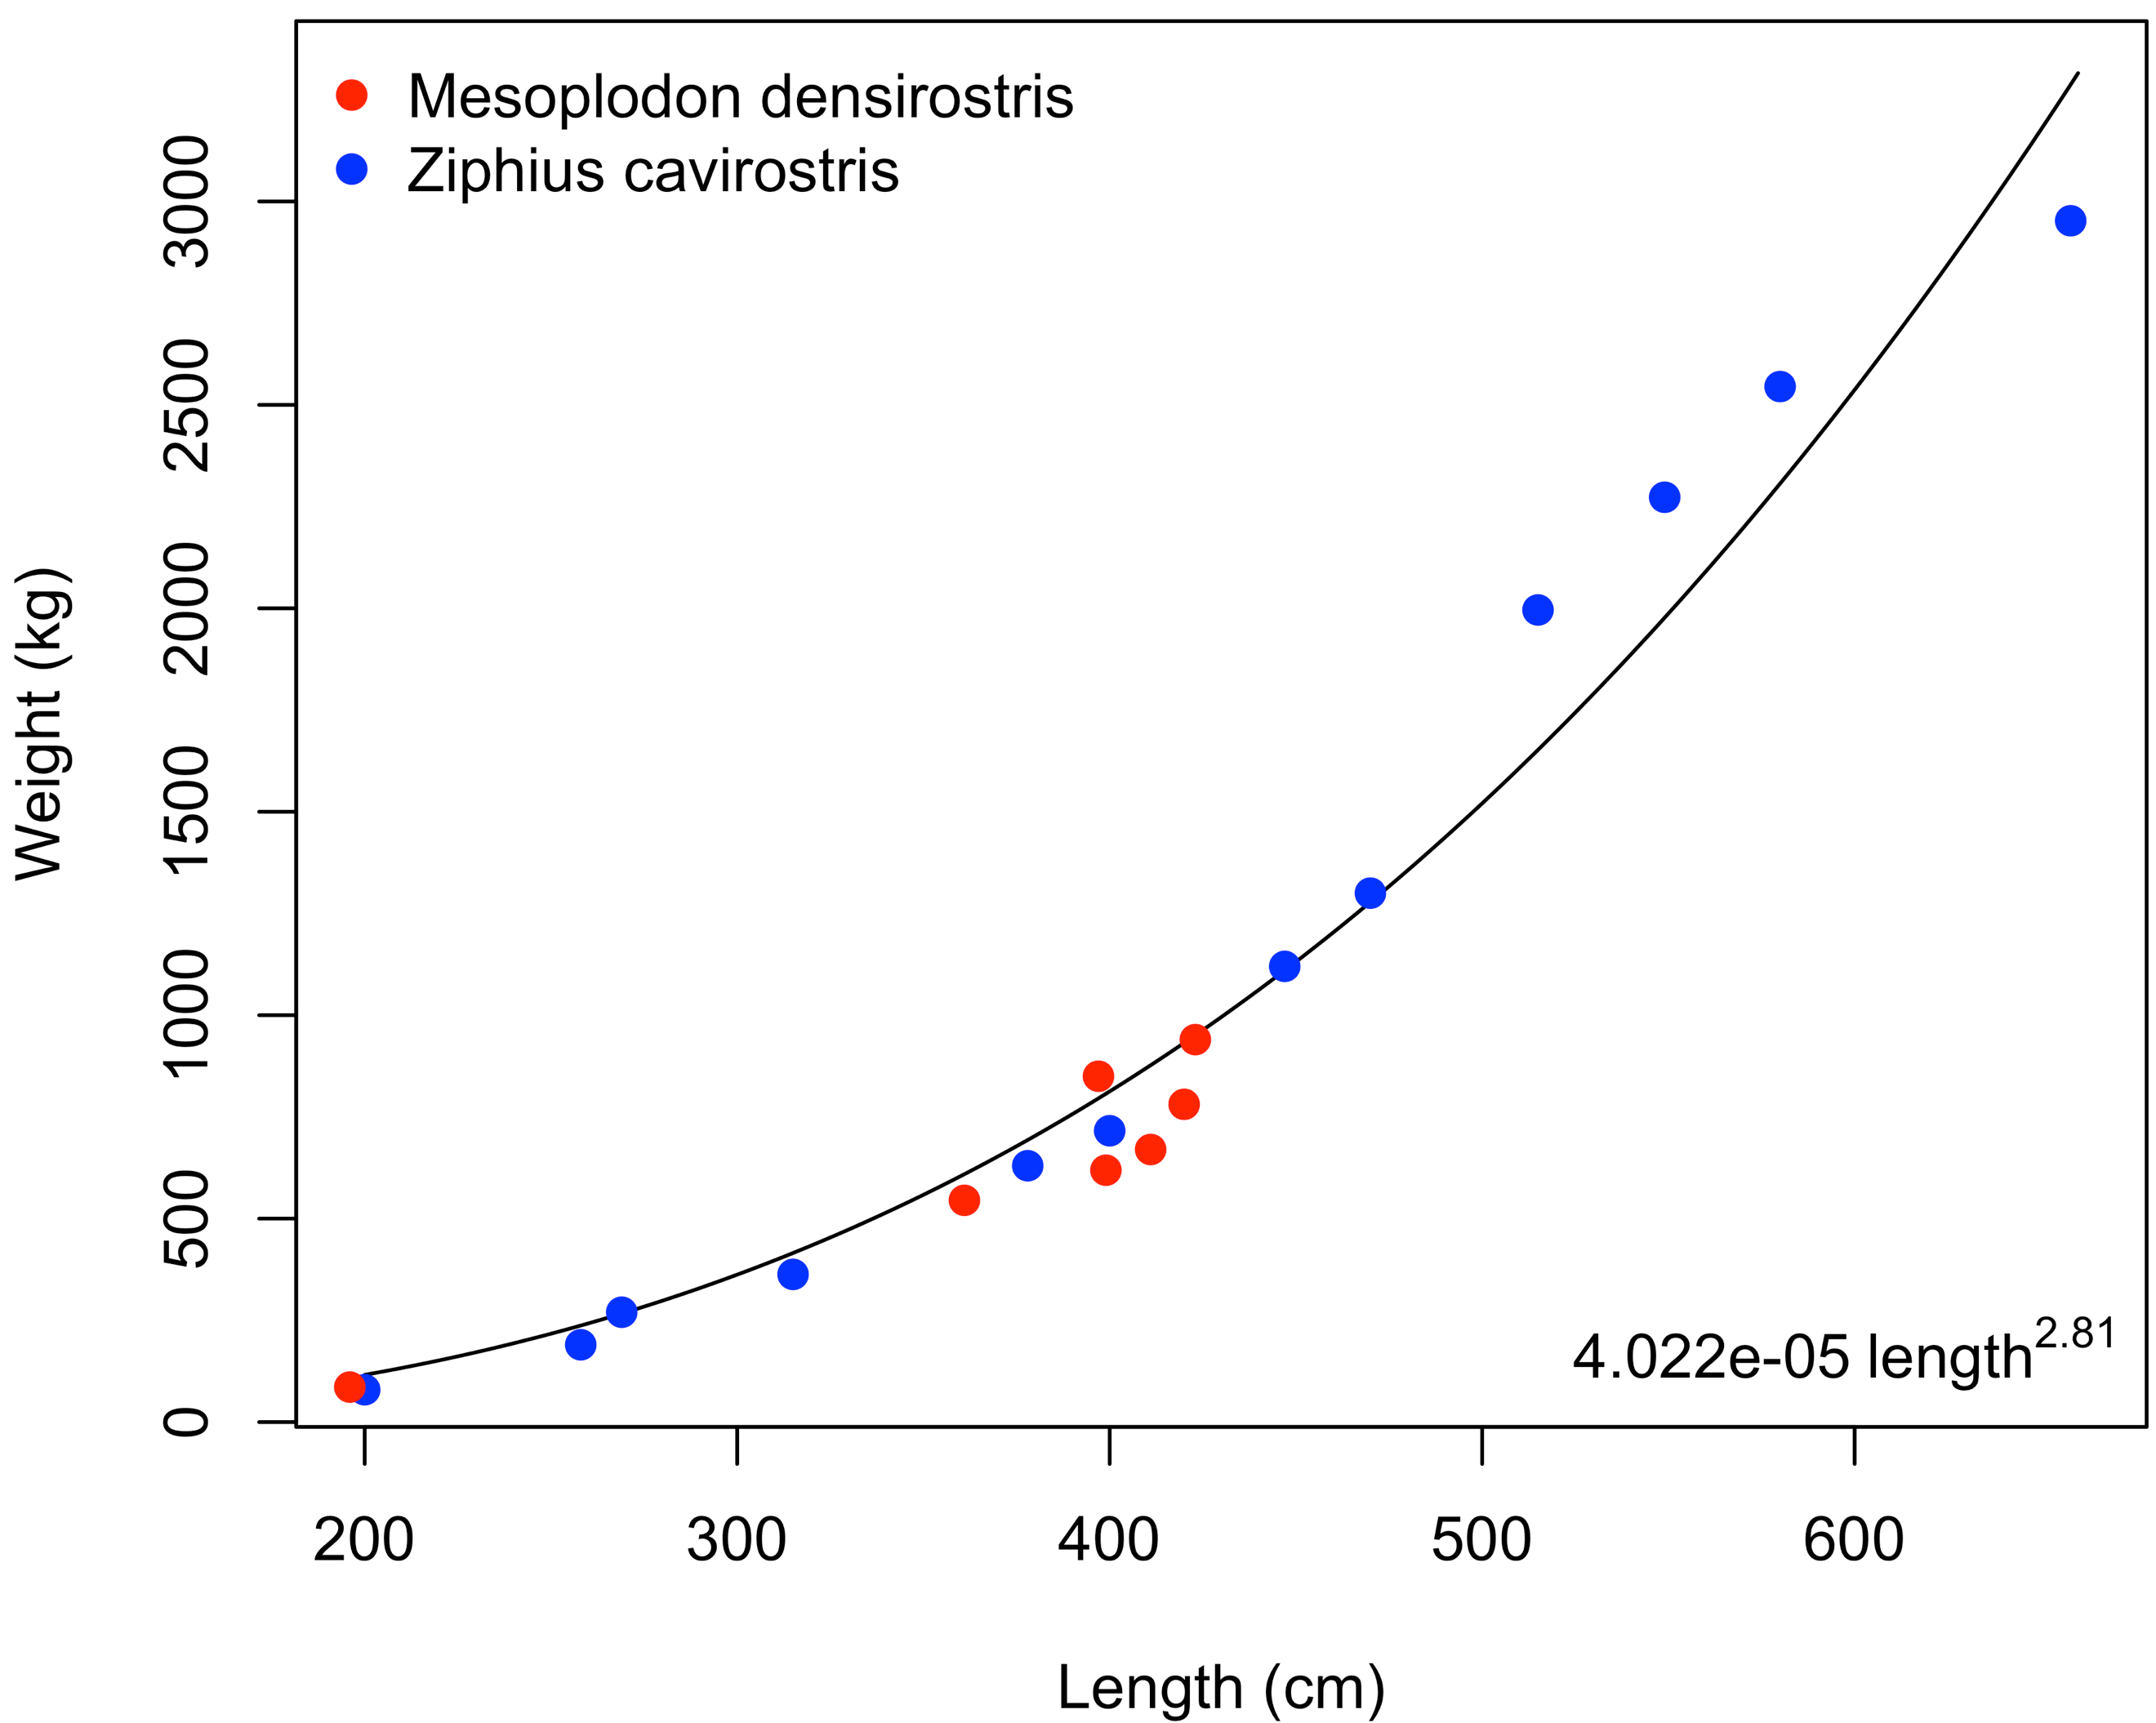

The parameter denote the energetics cost of growing one kg of structural mass. For beaked whales, no empirical estimates are available for this parameter, but for Gm it was derived to be around 30 MJ kg-1 by Hin et al. (2019). In line with the notion that beaked whales are build ‘cheap’, we deviate from this value and adopt a lower value of MJ kg-1.

The lactation rate scalar parameter was recalculated for *Zc* and *Md* using the approach described in Hin et al. (2019). This approach assumes that milk supply of a female at target body condition () is sufficient to cover metabolic and growth expenses of her calf during its first year of life. For *Gm* this led to a value of (Hin et al., 2019) and values for *Md* and *Zc* are similar (Table S3).

## Pregnancy threshold

The female age at first reproduction is largely determined by the age at which female reserve mass exceeds the pregnancy threshold for the first time (‘age at first receptive’). In addition to the amount of reserves below which individuals experience starvation mortality (), the pregnancy threshold includes a constant value (*Fneo*) that can be used to control the modelled age at first receptive. For *Gm*, Hin et al. (2019) assumed that *Fneo* consisted of the amount of stored reserves that are needed to produce a neonate, which can be derived from the structural size at birth () and amounts to:

Here, the first term represents the amount of female reserve mass required to build the structural mass of a newborn and the second term equals the amount of reserves transferred from the mother to the newborn at birth (*Fb*). For *Gm* this approach resulted in a modelled age at first reproduction that corresponded well with its observed counterpart (Hin et al., n.d.). For *Zc*, this approach gives *Fneo* = 250, while for Md this leads to *Fneo* = 92.9.

In the population model, body condition of each individual changes through time as it tracks changes in resource density and energy expenditure. To infer values of *Fneo* that result in good correspondence between observed age at maturity and the modelled age at first receptive we ran the full population model for a range of *Fneo* – values. We should note that the observed age at maturity for *Md* (9 y) was assumed one year earlier than the observed age at first parturition (Claridge, 2013) and does not include a receptive period before the onset of pregnancy, as is included in our model. Accounting for this 'waiting' period, the modelled age at first receptive should correspond to 9 – 445 / 365 = 7.8 y. For *Zc* we do not know how the estimate for the age at maturity (6.2 y) was derived and the corresponding modelled age at first receptive should therefore be in the range of 5 – 6.2 yrs.

**Figure S2:** Female age at first receptive, first reproduction and weaning of first calf as a function of *Fneo*. Red horizontal lines indicate estimates of the observed age at first receptive.

Figure S2 shows how the distributions of the age at first receptive, first reproduction and weaning of first calf, change as a function of *Fneo* for *Md* and *Zc*. For *Md* a value of *Fneo* = 80 kg results in good correspondence between the age at first receptive and observed age at maturity. This value for *Fneo* is approximately equal to the energetic costs of producing the structural mass of a neonate for *Md*, which evaluates to 78.98 kg. For *Md*, we therefore settle for this latter value. For *Zc*, we adopt the value of *Fneo* = 360 by default.

# GAM analysis of hydrophone data

**Table S4**: Results of the Generalized Additive Model (GAM) on the hydrophone data from AUTEC. Adjusted R-square = 0.142; deviance explained = 9.8%; UBRE = 0.20909; n = 32334

|  |  |  |  |  |
| --- | --- | --- | --- | --- |
| **Parametric coefficients** | **Estimate** | **Std. error** | **Z-value** | **P-value** |
| (Intercept) | -6.291023 | 0.007530 | -835.41 | <2e-16 |
| Zone East | -0.350338 | 0.009431 | -37.15 | <2e-16 |
| Year 2014 | -0.113552 | 0.009272 | -12.25 | <2e-16 |
|  |  |  |  |  |
| **Smooth terms** | **Edf** | **Ref.df** | **Chi.sq** | **P-value** |
| Julian day | 7.885 | 8.000 | 732.004 | <2e-16 |
| Hour | 7.916 | 8.000 | 1178.366 | <2e-16 |
| Standardized sonar area | 3.197 | 3.913 | 89.697 | <2e-16 |
| Time since last sonar | 7.646 | 8.522 | 232.286 | <2e-16 |
| Length of sonar event | 1.903 | 2.400 | 2.906 | 0.439 |

**Figure S3**: Smooth terms of the GAM on the hydrophone data from AUTEC

**Table S5**: Results of the Generalized Additive Model (GAM) on the hydrophone data from SCORE. Adjusted R-square = 0.121; deviance explained = 13%; UBRE = 0.24375; n = 23300

|  |  |  |  |  |
| --- | --- | --- | --- | --- |
| **Parametric coefficients** | **Estimate** | **Std. error** | **Z-value** | **P-value** |
| (Intercept) | -20.80495 | 0.01197 | -1738.60 | <2e-16 |
| Zone East | -0.21907 | 0.01331 | -16.45 | <2e-16 |
| Year 2015 | -0.20165 | 0.01359 | -14.83 | <2e-16 |
|  |  |  |  |  |
| **Smooth terms** | **Edf** | **Ref.df** | **Chi.sq** | **P-value** |
| Julian day | 7.841 | 8.000 | 1882.26 | <2e-16 |
| Hour | 6.399 | 8.000 | 970.94 | <2e-16 |
| Standardized sonar area | 1.596 | 1.975 | 76.54 | <2e-16 |
| Time since last sonar | 6.282 | 7.363 | 118.69 | <2e-16 |
| Length of sonar event | 1.005 | 1.010 | 10.61 | 0.00111 |

**Figure S4**: Smooth terms of the GAM on the hydrophone data from SCORE

**Figure S5**: Distribution of the time since last MFAS use at AUTEC and SCORE ranges, showing both western and eastern range areas.



**Figure S6**: MFAS use aggregated by day (daily sum of standardized sonar area) for both western and eastern areas of the AUTEC and SCORE ranges



**Figure S7**: Mean (+/- sd) population density in response to the prey encounter rate in high-quality areas () for different disturbance scenarios (colors) at overall low prey productivity. Top panels are for default transition rates and bottom panels for adjusted transition rates, which have a 10-fold lower rate of leaving range areas compared to the default transition rates. With adjusted transition rates, 80% of the *Md* population resides on the range without disturbance (compared to 30% under default). For *Zc* this difference is 85% vs. 36%. All parameters at default values (Table S3) and *Rmax* = 0.5 for *Md* and *Rmax* = 1.0 for *Zc*.

**Figure S8**: Mean (+/- sd) population density in response to the prey encounter rate in high-quality areas () for different disturbance scenarios (colors) at overall high prey productivity. Top panels are for default transition rates and bottom panels for adjusted transition rates, which have a 10-fold lower rate of leaving range areas compared to the default transition rates. With adjusted transition rates, 80% of the *Md* population resides on the range without disturbance (compared to 30% under default). For *Zc* this difference is 85% vs. 36%. All parameters at default values (Table S3) and *Rmax* = 2.0 for *Md* and *Rmax* = 3.0 for *Zc*.

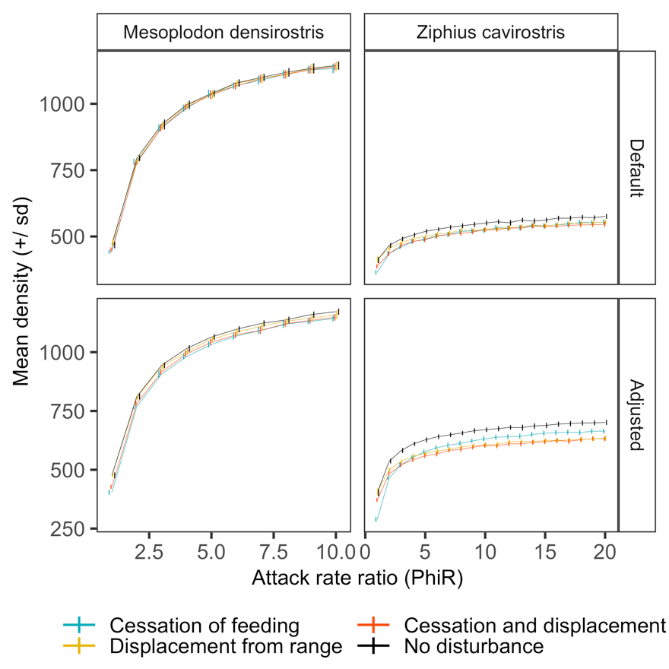

**Figure S9**: Onset of reproduction of *Md* and *Zc* female individual for different disturbance scenarios. Female age at first receptive denotes the age at which the female crosses the pregnancy threshold for the first time (enters the waiting period). First reproduction corresponds to the female age at birth of her first calf. Number of females used for each boxplot depends on the particular disturbance scenario and ranges between 9406 to 9505 for *Md* and in between 5161 and 7238 for *Zc*.

**Figure S10**: Mean number of calves born and weaned per female for different disturbance scenarios. The mean number of calves (both sexes) born to a single female equals 2 in any stationary population (lifetime reproductive output) and this is unaffected by disturbance. Across different disturbance scenarios, mean number of calves weaned per female equals 1.05 for *Md* and 1.27 for *Zc*.

# References

Barlow, J., Boveng, P., 1991. Modelling Age-Specific Mortality for Marine Mammal Populations. Marine Mammal Sci 7, 50–65. https://doi.org/10.1111/j.1748-7692.1991.tb00550.x

Benoit-Bird, K., Southall, B., Moline, M., Claridge, D., Dunn, C., Dolan, K., Moretti, D., 2020. Critical threshold identified in the functional relationship between beaked whales and their prey. Mar. Ecol. Prog. Ser. https://doi.org/10.3354/meps13521

Claridge, D.E., 2013. Population Ecology of Blainville’s Beaked Whales (Mesoplodon densirostris). University of St. Andrews, St. Andrews, United Kingdom.

De Roos, A.M., Galic, N., Heesterbeek, H., 2009. How resource competition shapes individual life history for nonplastic growth: ungulates in seasonal food environments. Ecology 90, 945–960. https://doi.org/10.1890/07-1153.1

Heyning, J.E., 1989. Cuvier’s beaked whale Ziphius cavirostris G. Cuvier, 1823, in: Ridgway, S.H., Harrison, R. (Eds.), Handbook of Marine Mammals. London and San Diego, pp. 289–308.

Hin, V., Harwood, J., De Roos, A.M., 2019. Bio‐energetic modeling of medium‐sized cetaceans shows high sensitivity to disturbance in seasons of low resource supply. Ecol Appl 29. https://doi.org/10.1002/eap.1903

Hin, V., Harwood, J., De Roos, A.M., n.d. Density dependence can obscure nonlethal effects of disturbance on life history of medium-sized cetaceans. submitted manuscript.

Joyce, T.W., Durban, J.W., Claridge, D.E., Dunn, C.A., Hickmott, L.S., Fearnbach, H., Dolan, K., Moretti, D., 2019. Behavioral responses of satellite tracked Blainville’s beaked whales ( *Mesoplodon densirostris* ) to mid‐frequency active sonar. Mar Mam Sci 36, 29–46. https://doi.org/10.1111/mms.12624

Kleiber, M., 1975. The fire of life: an introduction to animal energetics. R.E. Krieger Pub. Co., Huntington, N.Y.

Kooijman, B., 2009. Dynamic Energy Budget Theory for Metabolic Organisation, 3rd ed. Cambridge University Press, Cambridge. https://doi.org/10.1017/CBO9780511805400

Koopman, H.N., 2018. Function and evolution of specialized endogenous lipids in toothed whales. J Exp Biol 221, jeb161471. https://doi.org/10.1242/jeb.161471

Koopman, H.N., 2007. Phylogenetic, ecological, and ontogenetic factors influencing the biochemical structure of the blubber of odontocetes. Mar Biol 151, 277–291. https://doi.org/10.1007/s00227-006-0489-8

Lockyer, C., 2007. All creatures great and smaller: a study in cetacean life history energetics. J. Mar. Biol. Ass. 87, 1035–1045. https://doi.org/10.1017/S0025315407054720

Lockyer, C., 1993. Seasonal Changes in Body Fat Condition of Northeast Atlantic Pilot Whales, and their Biological Significance. Report of the International Whaling Commission, Special Issue 14 325–350.

MacLeod, C.D., 2006. How big is a beaked whale? A review of body length and sexual size dimorphism in the family Ziphiidae. Journal of Cetacean Research and Management 7, 301–308.

Mead, J.G., 1984. Survey of Reproductive Data for the Beaked Whales (Ziphiidae). Report of the International Whaling Commission, Special Issue 6 91–96.

Mead, J.G., Walker, W.A., Houck, W.J., 1982. Biological Observations on Mesoplodon carlhubbsi (Cetacea: Ziphiidae), Smithsonian Contributions to Zoology. Smithsonian Institution Press, Washington.

New, L.F., Moretti, D.J., Hooker, S.K., Costa, D.P., Simmons, S.E., 2013. Using Energetic Models to Investigate the Survival and Reproduction of Beaked Whales (family Ziphiidae). PLoS ONE 8, e68725. https://doi.org/10.1371/journal.pone.0068725

Nishiwaki, M., Oguro, N., 1972. Catch of the Cuvier’s Beaked Whales Off Japan in Recent Years. Sci. Rep. Whales Res. Inst. 35–41.

Pabst, D.A., McLellan, W.A., Rommel, S.A., 2016. How to Build a Deep Diver: The Extreme Morphology of Mesoplodonts. Integr. Comp. Biol. 56, 1337–1348. https://doi.org/10.1093/icb/icw126

Siler, W., 1979. A Competing-Risk Model for Animal Mortality. Ecology 60, 750–757. https://doi.org/10.2307/1936612

Southall, B.L., Benoit‐Bird, K.J., Moline, M.A., Moretti, D., 2019. Quantifying deep‐sea predator–prey dynamics: Implications of biological heterogeneity for beaked whale conservation. J Appl Ecol 56, 1040–1049. https://doi.org/10.1111/1365-2664.13334