**Figure 1**

**Figure 2:** Characteristics of MFAS use on SCORE and AUTEC navy training ranges. Left panel shows the GAM prediction of the effect of standardized sonar area on the relative dive count rate (number of beaked whale dive starts per hour). A relative dive count rate of 1 means no decrease and a dive count rate of 0.5 implies a 50% lower dive count rate. Middle panels: the distributions of the time-interval between different sonar events on western range areas. Right panels: distributions of the daily sum of ‘standardized sonar area’ for western range areas. Corresponding plots for eastern range areas are shown in Supporting Information Figures S5 & S6.



**Figure 3**: Population dynamics of *Zc* at SCORE in response to onset of MFAS disturbance at time = 20 (y). Disturbance either leads to cessation of foraging (left panels), displacement from range (center panels) or both (right panels). In the latter scenario, the recovery of the population after cessation of MFAS disturbance at time = 120 (y) is plotted. Lines and shaded areas indicate mean and standard deviation of 100 replicate simulations, respectively. Middle rows show reproductive classes of females. For sake of presentation, standard deviations are omitted in this row. All parameters as default and *Rmax* = 1.0 (Table S3).

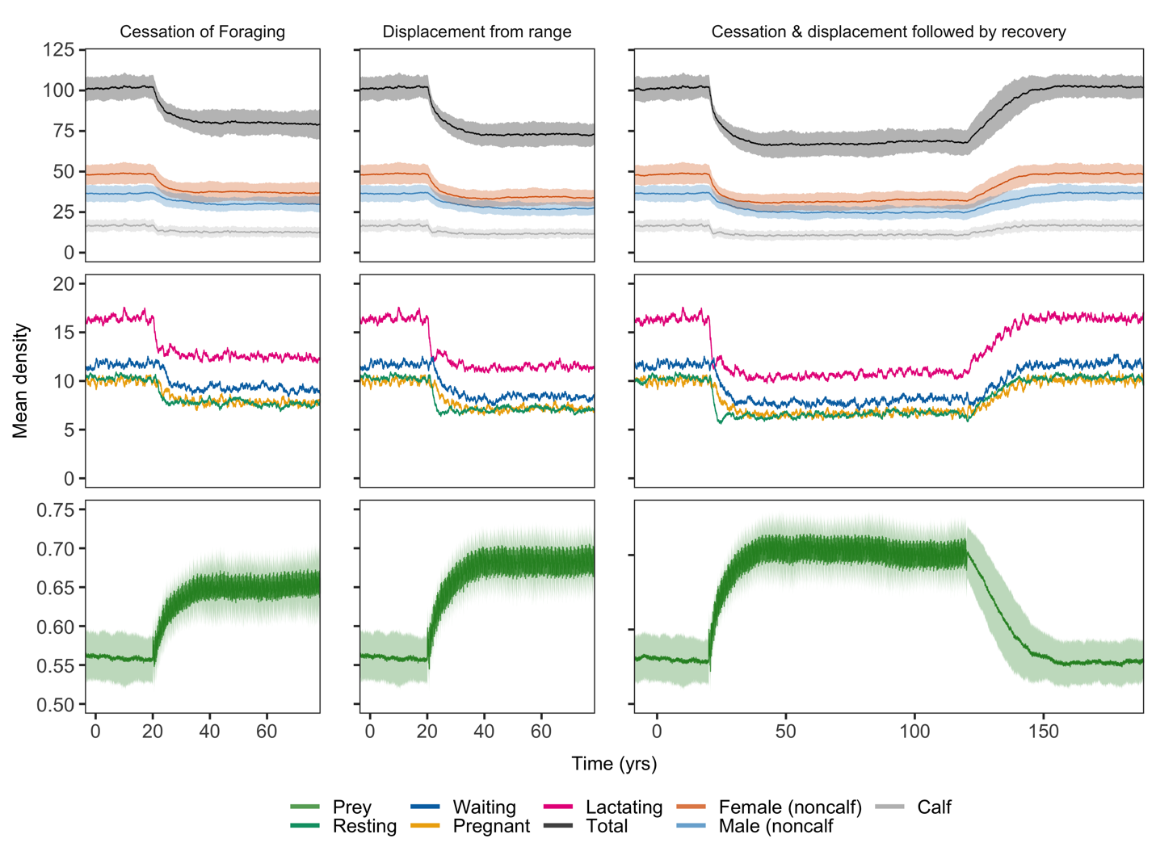

**Figure 4**: Population dynamics of *Md* at AUTEC in response to onset of disturbance at time = 20 (y). Disturbance either leads to cessation of foraging (left panels), displacement from range (center panels) or both (right panels). In the latter scenario, the recovery of the population after cessation of MFAS disturbance at time = 120 (y) is plotted. Lines and shaded areas indicate mean and standard deviation of 100 replicate simulations, respectively. Middle rows show reproductive classes of females. For sake of presentation, standard deviations are omitted in this row. All parameters as default and *Rmax* = 0.5 (Table S3).

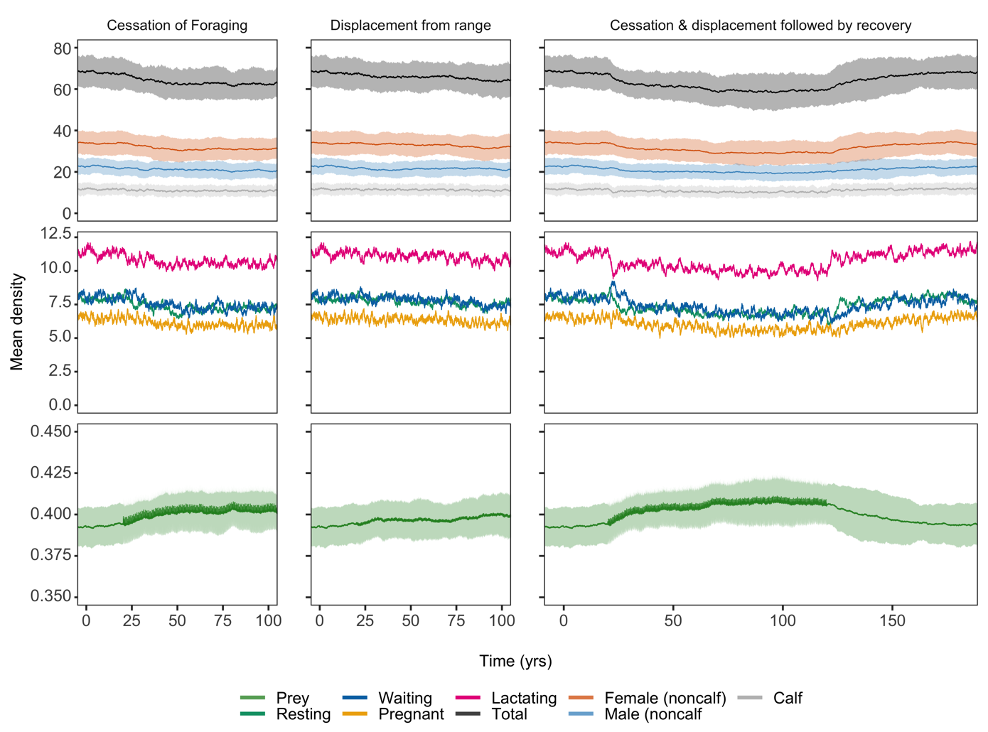

**Figure 5:** Distribution of population density at steady state for disturbed and non-disturbed populations of *Md* at AUTEC (top) and *Zc* at SCORE (bottom). Each distribution is based on output of 100 replicate simulations across 50 years with output collected every day (1,825,000 observations for each scenario and species).

**Figure 6:** The effect of disturbance, differences in habitat quality, baseline movement patterns and overall prey productivity (*Rmax*) on population density, expressed relative to the mean undisturbed population density. For *Md*, high and low *Rmax* – values were 2.0 and 0.5, respectively. For *Zc*, this was 3.0 and 1.0. Dashed vertical lines indicate default values for the prey encounter rate in high quality areas (): 5.0 and 13.3 for *Md* and *Zc,* respectively. All other parameters as default (Table S3).

**Figure 7:** The effect of increasing the mean duration of cessation of foraging on population density of *Zc* and *Md* for high and low prey productivity levels and the two relevant disturbance scenarios. Population density at zero mean disturbance duration represents undisturbed population density. Upon disturbance, duration of cessation of foraging was randomly determined from an Erlang distribution with shape parameter 2 and scale parameter being equal to half the mean disturbance duration as plotted here. For *Md*, high and low *Rmax*-values were 2.0 and 0.5, respectively. For *Zc*, this was 3.0 and 1.0.

