|  |  |
| --- | --- |
| Hilary Brown  Policy Advisor  Air Quality and Combustion  Resource, Atmosphere and Sustainability  Department for Environment, Food and Rural Affairs  Area 2C,  Nobel House,  17 Smith Square,  London,  SW1P 3JR  Date: ${TodayDate} |  |

**Re: ${ApplicationNumber}/Recommendation/${Manufacturer} /Issue1**

Dear Hilary,

Recommendation FOR Fuel Authorisation under section 20 of the Clean Air act and Statutory instrument 2020 No. 1095 for England

${Manufacturer} have applied for the authorisation of XX fuel(s). The fuel is detailed below:

${FuelName} (ready to Burn certificate number MSF${FuelID})

(N.B this is a branded version of authorised fuel ${FuelName}, Ready to Burn Certificate number MSF ${FuelID})

This approval is for the addition of the brand names given which are based on the original authorised fuels given in brackets above. **${Manufacturer}** have confirmed to HETAS that the products are identical to the original manufactured products and are not altered physically or chemically in any way or blended with other fuels when bagged as the named brands. On this basis HETAS are satisfied that the fuels meet the requirements under the above regulations. Manufactured fuels sold in England must display the Ready to Burn certification logo on packaging etc. in accordance with the requirements of regulation SI 2020 No. 1095 for England.

The applicant’s contact details are below:

${ManufacturerContact}

Email: XXXXXXXXXXXXXXXXXX

**Logos**

The applicant has been informed Defra do not give permission for the Defra logo, or wording such as ‘Defra approved’ to be used on commercial sites. This recommendation means that we are recommending that the Secretary of State specify ${FuelName} as authorised fuels under section 20 of the Clean Air Act 1993 and that they are certified with the Ready to Burn certification number MSF${FuelID} under regulation SI 2020 No. 1095 for England. It is not an endorsement of the products’ features generally or indeed of your business as a whole. The applicant has been made aware that for marketing purposes the following details may however be used:

Fuels can be burned in smoke control areas if they have been listed, by the Secretary of State, as authorised fuels in accordance with section 20 of the Clean Air Act 1993. ${FuelName} may therefore be used in smoke control areas under section 20 of the Clean Air Act 1993. From May 1st 2021 all manufactured solid fuels sold in England must display the Ready to Burn certification logo in accordance with regulation SI 2020 No. 1095. The certification number and Ready to Burn logo will be supplied to the applicant upon final approval.

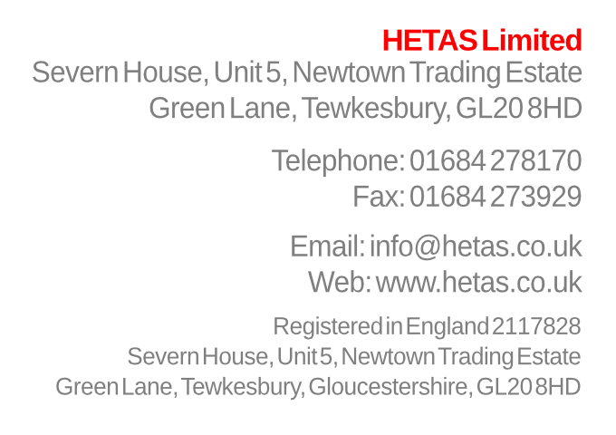

The emissions & sulphur content from the fuel(s) are detailed in the table below:

|  |  |  |
| --- | --- | --- |
| Fuel name | Smoke emission measurement (g/h) | Sulphur content (%) |
| XXX | XXX | XXX |
| XXX | XXX | XXX |

The proposed fuel schedules are attached to this recommendation.

For information the cost to the applicant for the assessment of the fuels that they have applied for was a total of £XXXX.XX+VAT.

If you have any questions relating to the recommendation of the fuels, please do not hesitate to contact me.

Yours faithfully

NAME  
POSITION

CC: Defra, Devolved Administrations of Scotland, Wales and Northern Ireland and the applicant

**Fuel Schedule**

**COPIED FROM DEFRA DATABASE**