**Problem 2**

**a)**

Changes done to MainKinematics:

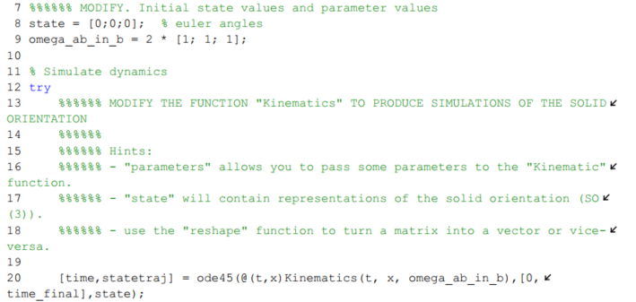



**b)**

Changes done to MainKinematicsDCM:

