Class Diagram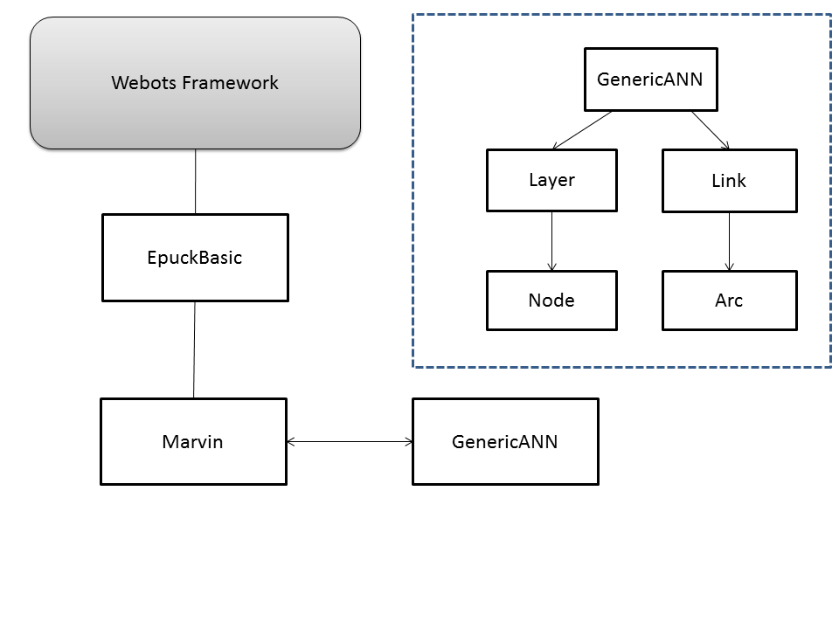
The main structure of the program is similar to the approach suggested by the assignment paper, webots-ann, except for the omission of the two parent classes in-between the Marvin-class and the GenericANN class.

Marvin
This is our interface to the Webots framework. It inherits from EpuckBasic, and is responsible for:
- Creating an instance of the GenericANN class
- Retrieving sensor-data from the framework and feeding this to the neural net.
- Retrieving the output-data from the network, and using this to manipulate the movements of the Epuck robot.

GenericANN
This is the core class of our program. It is responsible for generating the ANN that is used by the Marvin-class. Its main responsibilities are:
- Reading and parsing the ANN-script.
- Intializing Layers and Links according to the parameters specified by the script.
- Executing the layers during the execution of the neural network.
- Training the network.

Layer
The main responsibilities of this class are:
- Executing the nodes within its own layer.
- Doing back-propagation on its own layer, and calling back-propagation on layers that are linked to it.

Link
The main responsibilities of this class are:
- Connecting the arcs between the nodes of the different layers, consistently with the correct topology.
- Updating the weights of its associated arcs, during back-propagation.
- Adding the weighted outputs of the nodes in the previous layer that are connected to some specified by node.

Arc
The main responsibility of this class is mainly to connect to nodes, and to associate a weight with this connection.

