ImProc:

Stuff to learn:

Image spectrum pairs
Region adjeceny matrix, metode og ligning
Hough
Drawing Hough

Calucalting Hough:

θ > 90 =>

Notes colorimetry:

Color perception depends on: 1. illumination source, 2. Characteristics of object, 3. Characteristics of eyes, 4. Brain color interpretation

Eyes sensitive to [780nm, 380nm] (less than 1% of total EM range)

Light sources ex; incandescence, gas discharge, photoluminescence, chemical reactions
Light sources described by; color temperature(Kelvin of black body to reach the color) & spectral power distribution

Human eye
retina (membrane on inner eyewall)
fovea (center of retina)

Retinas 2 photosensitive cells:
Rods(brightness) ~120mill. Covers periphery.
Cones(colors) ~ 5 mill. Predominantly on fovea.

Cone facts:
Sensitivity peaks in green.
Red (L) 64%, Green(M) 32%, Blue 4%

Color illusions; lightness contrast, saturation contrast, hue contrast, complementary contrast

Color blindness:
Pronatope (L-cone def)
Deuteratope (M-cone def)
Tritanope (S-cone def)
Anomalus trichromacy
Dichromacy
Rod monochromacy (no cones)

Color naming: 11 culture colors

Additive color mixing:
Primary; red, green, blue
secondary; yellow , cyan, magenta
Grassman’s laws:
1. Any color can be matched by a linear combination of three other colors
2. A mixture of two colors can be matched by linearly adding their components
3. Proportionality

Subtractive color mixing:
Primary; yellow, cyan, magenta
Secondary; red, green, blue

White balance, bayer interpolation: R = B = G, G’=R’a=bB’
Arrangement of color filters used in most single-chip digital image sensors used in cameras…

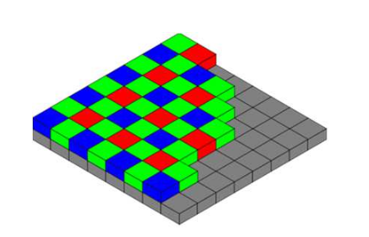

R and B values are interpolated from the (2 or 4) nearest neighbors of the same color.

Color models
Used to classify and qualify colors according to hue, saturation, chroma, lightness, brightness.

Three classification manners:
Visual approach: Munsell, Chevreul, Ostwald
Physical approach: RGB, HSV, CIE, XYZ, etc.
Physical and phsychometrical: CIE Lab, CIE Luv, etc.

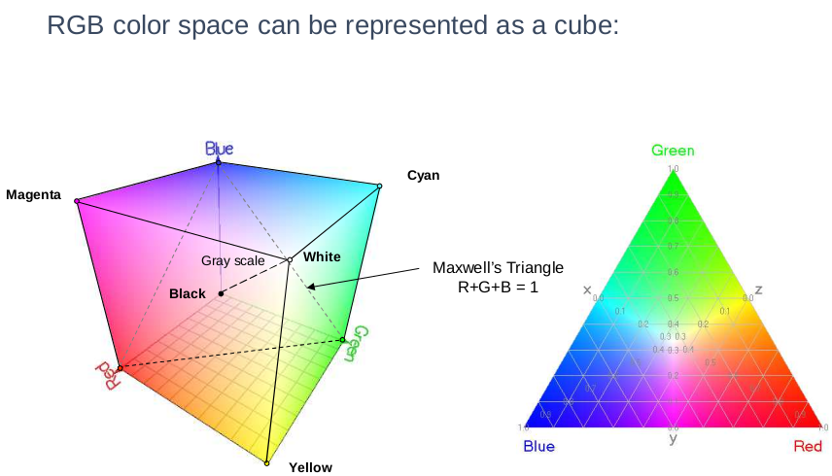

Problems with RGB
Small range of perceivable colors.
Difficult to determine how much of R,G,B to make a color.
Perceptually non-linear (distance in space).

Colormaking attributes
19th century: hue, lightness, chroma best for conscious color judgment.

Munsell color system
Rational way to describe color with decimal notation.

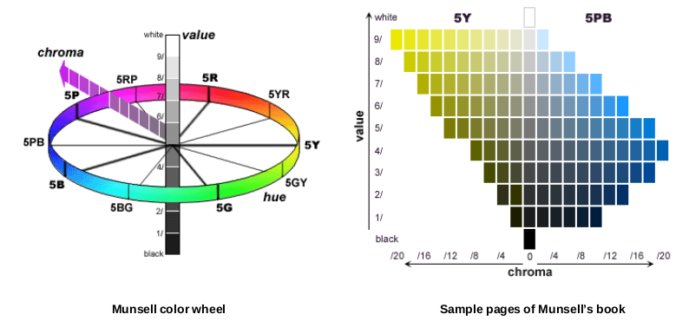

HSV
Hue, saturation, value → transformation of RGB more natural to artists.
HLS
Hue, lightness, saturation → Analogous to HSV, Value != Lightness

CIE XYZ model
1931: Defined XYZ to describe full space of perceptible colors, RGB→XYZ.

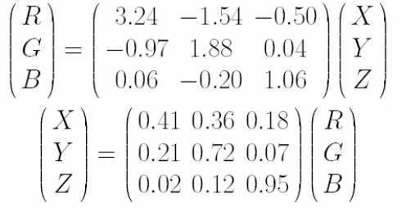

Represents all colors, but not physically possible.

Color matching

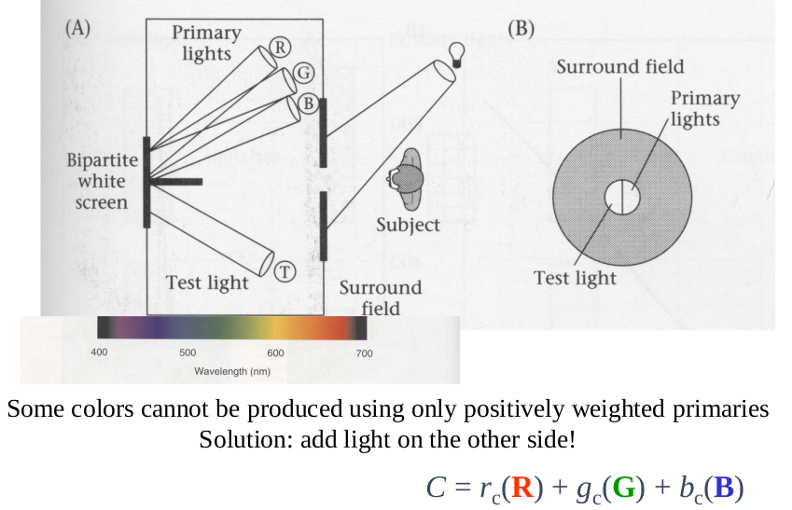

CIE chromaticity diagram

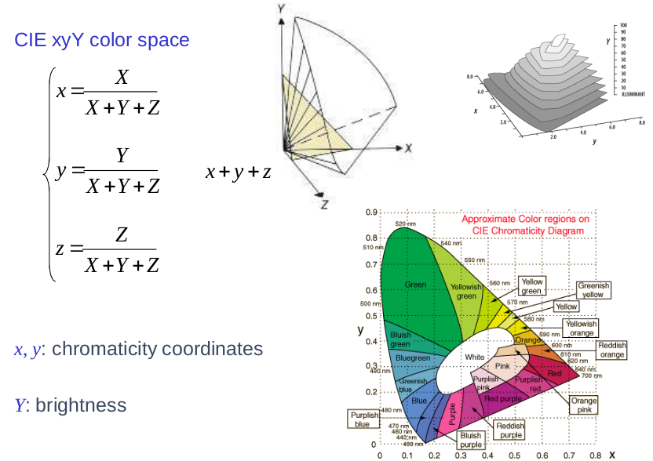

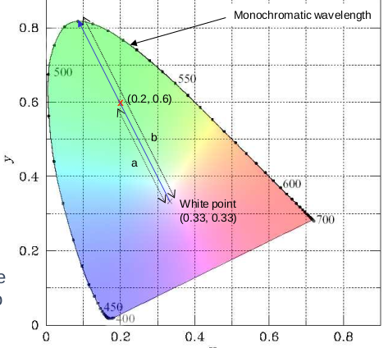
Dominant wavelength

White point (x, y) = (0.33, 0.33).
Purity (saturation) = percentage distance from white point to edge.
Purity = a/b.

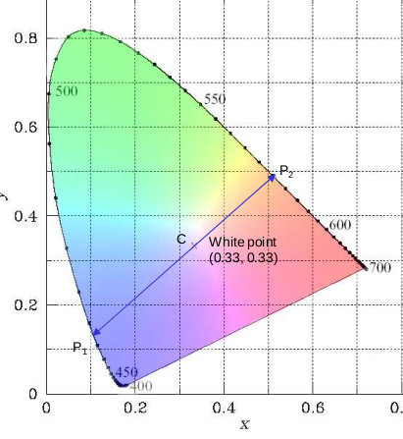
Complementary wavelength
Line passing through white point creates complementary color segments CP1 and CP2.

Additive color mixing
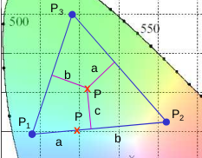
Two color mixing: P = aP1 + bP2
Three color mixing:

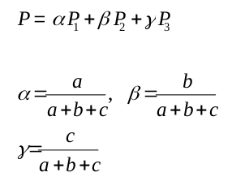

Color gamuts: film > monitor > printing press

Gamut coverage

Mac Adam’s ellipsees
Color lying just outside ellipse is just noticeably different from the center of the ellipse.

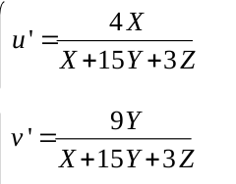
CIE 1976 USC diagram

Chromatically cordinates (u’, v’)

More uniform than (x, y) diagram.

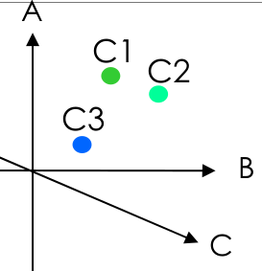
Perceptual uniform color model

Is perceptual uniform if perceptual distance matches measurable distance.

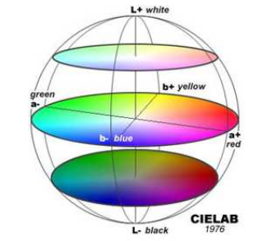

L*a*b* color space
L* Luminosity
a*: red/green axis
b* yellow/blue axis

YIQ color model
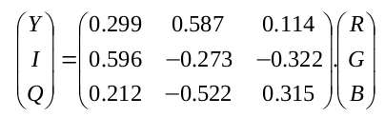
Used by commercial TV.
Y encodes luminance
I, Q encode color (chromatically)

People more sensitive to illuminance, so more bits used
to encode Y.

YCrCb color model (YUV)

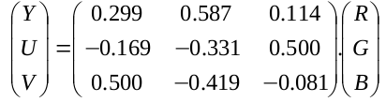
Y = 0.299R + 0.587G + 0.114B
Cr = R – Y
Cb = B – Y

U = 0.492(B – Y)
V = 0.877( R – Y)

True color image: red channel, green chanel blue channel
Look-up table: each pixel value is an index in color map.

