Exercise 2 – Report

Dataset creation and problem formulation, Eirik Fagerhaug and Novian Habibie

## Code

We wrote a small custom dataloader class (dataloader.py) that collects n random images from the database and does random transformations on them.

Utility (utility.py) provides functions for data loading to and from database (SQLite) and transformation functions for raw image and ground truth (label image). Transform functions provided are:

1. Resize() : Resize image to new desired resolution
2. Rotate() : Rotate image to desired angle(in degree), empty pixel resulted by rotation filled by black
3. Flip_lr() : Flip/mirror image left to right
4. Blur() : Blur the image using Gaussian filter with desired sigma. Simulating rainy or foggy weather
5. Contrast_set() : Change brightness of the image. Simulating different light intensity depends on the weather condition.

The label image is rebuilt using the polygon json files found in the dataset (stored in the database), and our program only using label “road”, while another labels is ignored and considered as “non-road”.

When retrieving a set of images from the dataloader, it will retrieve n random images from the database, build the output images and execute a list of transformations with a chance c on both the input image and the output image.

## Results

Retrieving 64 images took between 20 and 30 seconds on multiple tries.

Result input and output image with a rotation transformation:

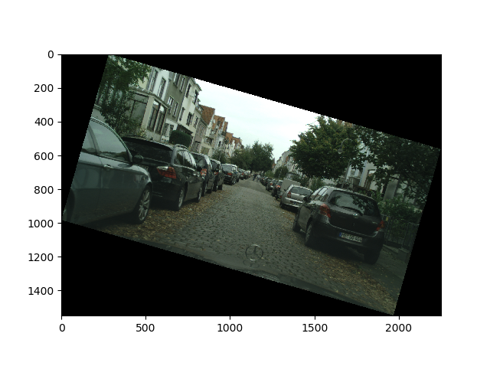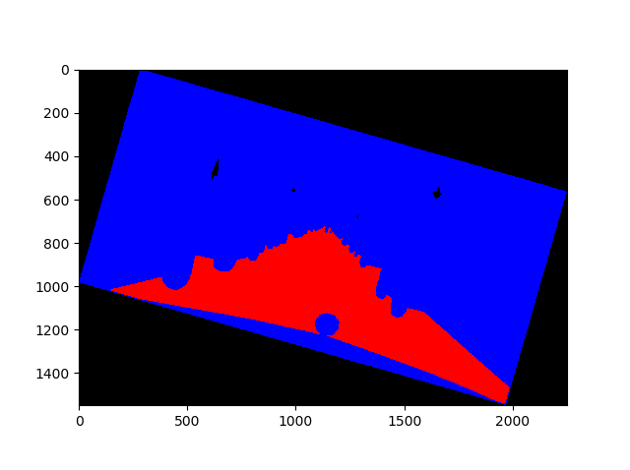

## Discussion

There is still a little bit of work that needs to be done, we must check how significant the retrieval time is compared to training time, and if very significant it needs to be reduced.