**GAMERLOG USER GUIDE**

[Gamerlog](http://83.212.110.203:8080/gamerlog/arxikh.html) is an attempt at creating a user-friendly internet database for video games, in the spirit of IMDb and designed to help fans explore the world of gaming.

[Gamerlog](http://83.212.110.203:8080/gamerlog/arxikh.html) lets you keep track of every game you’ve played, so you can instantly recommend one the moment someone asks, or check comments on a game you’ve just heard about. We aspire to be a global community of gaming fans who live to discuss, rate and rank what we play.

**In Gamerlog, you can:**

* *Mark the games you’ve heard about and want to play and they will appear on your profile page*

The **To-Play List**, lets you keep a list of games you want to play. You can start by browsing **New with Friends** on our homepage to see the community trends and mark a few games you want to play yourself.

If you mark a game as **Played**, we’ll move it from your **To-Play List** and add it to your **Played** titles.

* *Keep track of the games you’ve played*

Try visiting our **Popular with Friends** section and marking a few games you’ve played.

When you’ve added some games, you can find them in your profile. As you add more content, your profile starts to reflect your taste.

* *Create a list of your favorite games*

Lists are a great way to share a collection of related games, or to rank what you’ve played. It’s fun to welcome suggestions for your lists from other members.

* *Leave ratings on the games you’ve played and share your opinion about your favorite titles*

Read reviews of games you like (or hate), check out the community’s opinion on new games you haven’t played yet and share your own reviews and comments

**Our homepage (**[**link**](http://83.212.110.203:8080/gamerlog/homepage.html)**)**

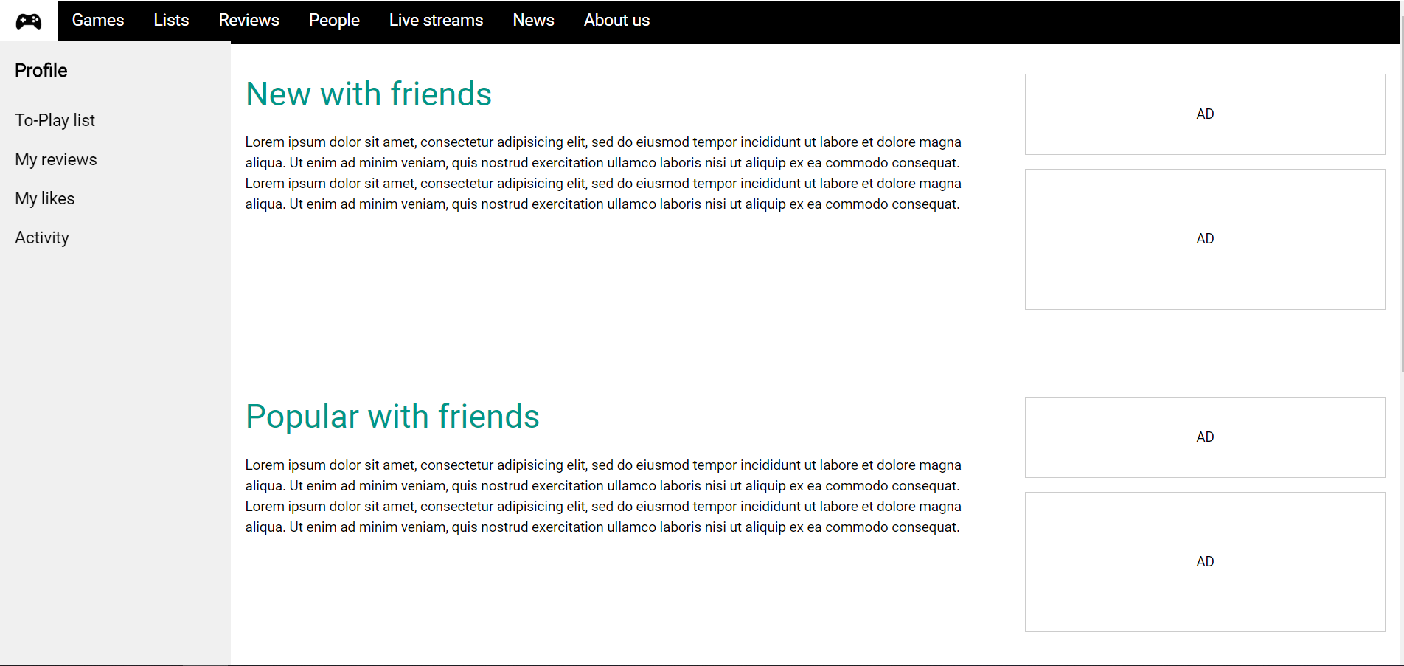

Popular and new games appear on the corresponding sections in our homepage. The sidebar provides shortcuts to your profile, such as your **To-Play List**, your **Reviews** and your **Likes**.

The banner on top lets you browse the community by checking out the games database, popular lists, reviews, news about the gaming world and more.

**Your profile page (**[**link**](http://83.212.110.203:8080/gamerlog/profilepage.html)**)**

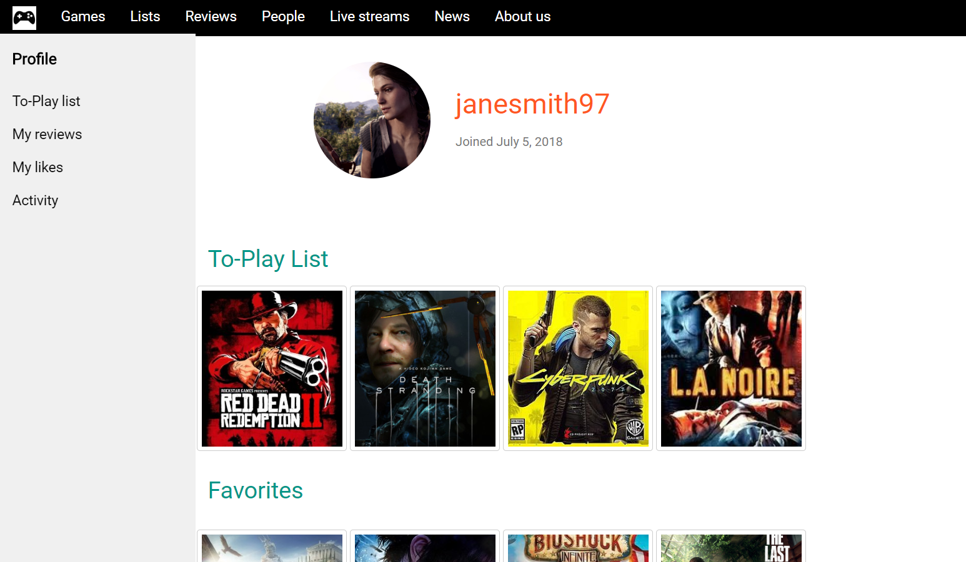

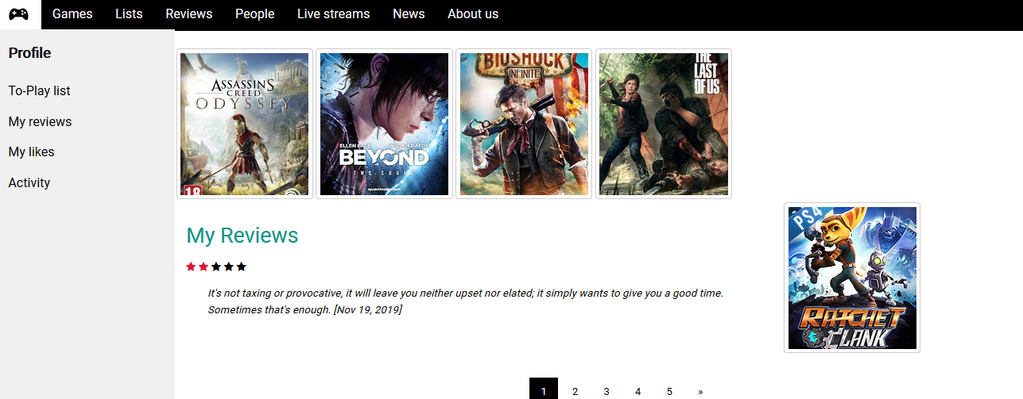

You can choose a unique username and a profile pic for your profile. Your lists appear here, as well as your reviews.

**Let’s check out a game page (**[**link**](http://83.212.110.203:8080/gamerlog/gameprof.html)**)**

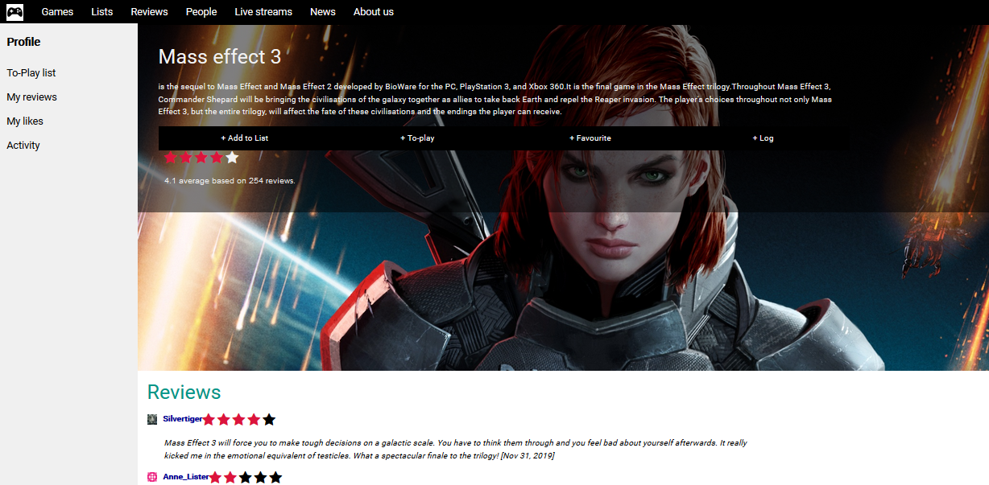Each game page includes a description of the game, the average user rating, user reviews as well as buttons that allow you to either: log the game, add it to your favorites or to a list.

**And a list page (**[**link**](http://83.212.110.203:8080/gamerlog/listpage.html)**)**

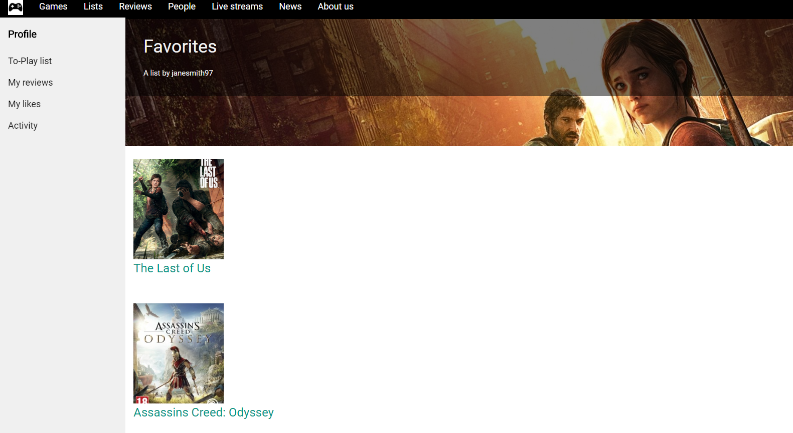

You will be able to review and favorite other users’ lists as well!