|  |  |
| --- | --- |
| ***Introduction To Database*** | **Project Spring**  **2017-18** |

**Project Name:**

*Database of Restaurants*

**Course Teacher:** Kawser Irom Rushee

***Project Theme:***

A relational database management of Restaurants

**Group Members**

|  |  |
| --- | --- |
| **Name** | **ID** |
| **Prodhan, Sadia Zahin** | **17-33081-1** |
| **Rokon, Md. Shafaat Jamil** | **17-33084-1** |
| **Saif, A.M.** | **17-33143-1** |
| **Mahmud, Sharif** | **17-33205-1** |

|  |
| --- |
| **Database Project Report** |

#### Table of Contents

1. **ER Diagram Scenario**
2. **ER Diagram**
3. **Normalization of Database and Functional Dependencies**
4. **Tables screen shot with data**
5. **Query with data screenshot**
6. **Enable ,disable constraints of table with screenshot**

A restaurant has a unique restaurant ID(R_id), name(R_name), contact number(contact_no) and address. Many customers can go to one restaurant. A customer has unique customer ID(Cus_id), Name(Cus_name), contact number(contact_no). One waiter can serve more than one customers. A waiter has a unique ID(w_id) and name(W_name). A customer places order via waiter and the order is prepared by Chef. An order has unique order number(order_no), Number of items(no_items) and order time(ord_time). A chef has unique ID number(chef_id) and name(chef_name). An order contains food which has unique food number(food_no), quantity, price and description. Customers pay bills that contains a unique bill number(b_no), price, order detail (ord_detail)and vat.

ER_diagram

***Serves***

***Takes***

***Pays***

***Goes***

***Bill***

***Food***

***Contains***

***Places***

***Waiter***

***Chef***

***Prepares***

***Order***

***Restaurant***

***Customer***

Normalization

Goes:

UNF: R_id, R_name,Contact_no, Address, Cus_id, Contact_no,Cus_name

1NF:

Customer- Cus_id, Cus_name, Contact_no, R_id

Restaurant_ R_id, R_name, Contact_no, address

2NF:

Customer- Cus_id, Cus_name, Contact_no, R_id

Restaurant_ R_id, R_name, Contact_no, address

3NF:

Restaurant- R_id, R_name, contact-no, R_id

Restaurant_info- R_name, Address

Serves:

UNF: Cus_Id, Cus_name, Contact_no, W_id, Wname

1NF:

Customer: Cus_id, Cus_name, contact_no

Waiter: W_id, W_name, Cus_id

2NF:

Customer: Cus_id, Cus_name, contact_no

Waiter: W_id, W_name, Cus_id

3NF:

Customer: Cus_id, Cus_name, contact_no

Waiter: W_id, W_name, Cus_id

Prepares:

UNF: chef_id, Chef_name, order_no, no_items, ord_time

1NF:

Chef: Chef_id, Chef_name, order_no

Order- order_no, no_items, ord_time

2NF:

Chef: Chef_id, Chef_name, order_no

Order- order_no, no_items, ord_time

3NF:

Chef: Chef_id, Chef_name, order_no

Order- order_no, no_items

Order_info: no_items, ord_time

Takes:

UNF: W_id, W_name, order_no, no_items, ord_time

1NF:

Waiter: W_id, W_name, order_no

Order- order_no, no_items, ord_time

2NF:

Waiter: W_id, W_name, order_no

Order- order_no, no_items, ord_time

3NF:

Waiter: W_id, W_name, order_no

Order- order_no, no_items

Order_info: no_items, ord_time

Places:

UNF: Cus_id, Cus_name, contact_no, order_no, no_items, ord_time

1NF:

Customer: Cus_id, Cus_name, contact_no

Order- order_no, no_items, ord_time

2NF:

Customer: Cus_id, Cus_name, contact_no

Order- order_no, no_items, ord_time

3NF:

Customer: Cus_id, Cus_name, contact_no

Order- order_no, no_items

Order_info: no_items, ord_time

Contains:

UNF: Order_no, No_items, ord_date, food_no, quantity, price, description

1NF:

Order- order_no, no_items, ord_time

Food- food_no, quantity, price, description, order_no

2NF:

Order- order_no, no_items, ord_time

Food- food_no, quantity, price, description, order_no

3NF:

Order- order_no, no_items, ord_time

Food- food_no, price, description, order_no

Food_detail- quantity, price

Pays:

UNF: Cus_id, Cus_name, contact_no, b_no, price, ord_detail,vat

1NF:

Customer: Cus_id, Cus_name, contact_no

Bill- b_no, price, ord_detail,vat, Cus_id

2NF:

Customer: Cus_id, Cus_name, contact_no

Bill- b_no, price, ord_detail,vat, Cus_id

3NF:

Customer: **Cus_id**, Cus_name, contact_no

Bill- b_no, price, ord_detail, Cus_id

Bill_description- price, vat

Screenshot of Database Table

Relationship: Goes

CREATE TABLE RESTAURANT

(

RID NUMBER(8) CONSTRAINT RID PRIMARY KEY,

RNAME VARCHAR(20),CONTACTNO NUMBER(11)

)

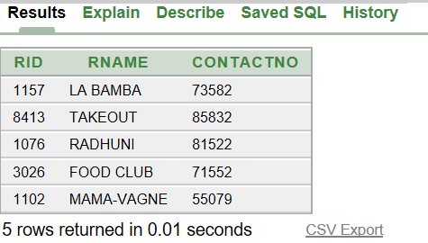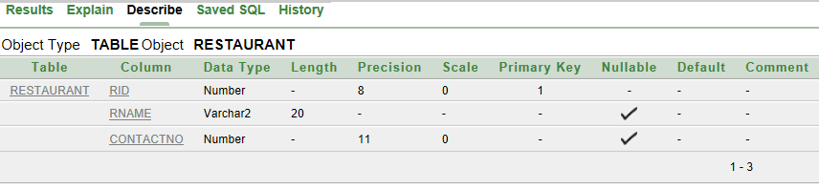

CREATE TABLE CUSTOMER

(

CUSID NUMBER (8) CONSTRAINT CUS_PK PRIMARY KEY,

CUSNAME VARCHAR2 (10),CNTNO NUMBER(11),RID NUMBER(8),

CONSTRAINT FK_PK FOREIGN KEY(RID) REFERENCES RESTAURANT(RID)

)

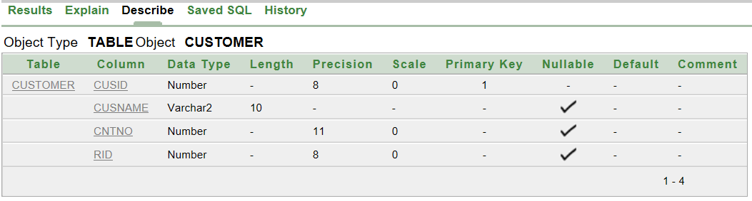

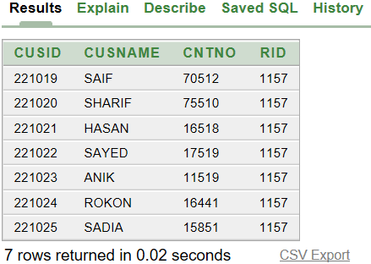

CREATE TABLE RESTAURANT_INFO

(

RNAME VARCHAR2(20) CONSTRAINT RN PRIMARY KEY,

ADDRESS VARCHAR2(20)

)

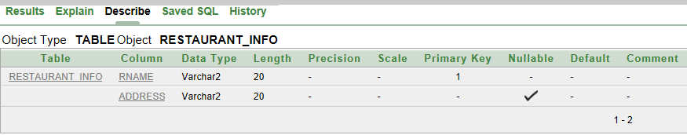

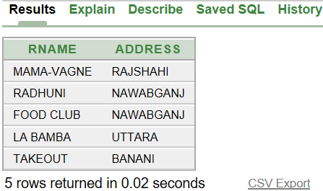

Relationship: Serves

CREATE TABLE WAITER

(

WID NUMBER (8) CONSTRAINT W_PK PRIMARY KEY,

WNAME VARCHAR2 (10),CUSID NUMBER(8),ORDER_NO NUMBER(8),

CONSTRAINT CK_PK FOREIGN KEY(CUSID) REFERENCES CUSTOMER(CUSID),

CONSTRAINT OK_PK FOREIGN KEY(ORDER_NO) REFERENCES ORDERR(ORDER_NO)

)

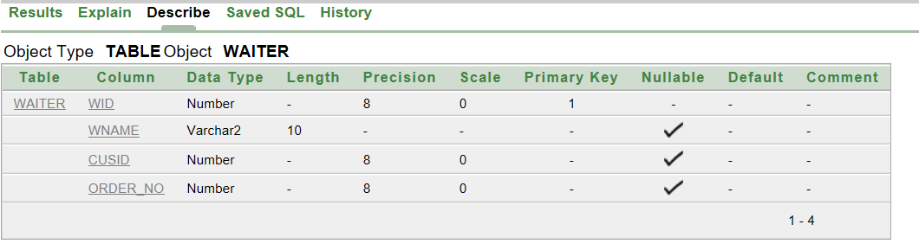

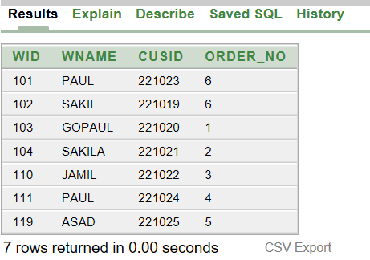

Relationship:Places

CREATE TABLE ORDERR

(

ORDER_NO NUMBER (8) CONSTRAINT OR_PK PRIMARY KEY,

NO_OF_ITEM NUMBER (4)

)

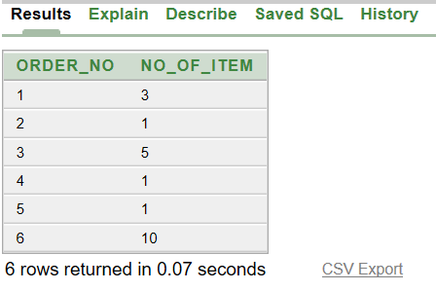

CREATE TABLE ORDER_INFO

(

NO_OF_ITEM NUMBER(4) CONSTRAINT NO_PK PRIMARY KEY,

ORDER_TIME VARCHAR2(20)

)

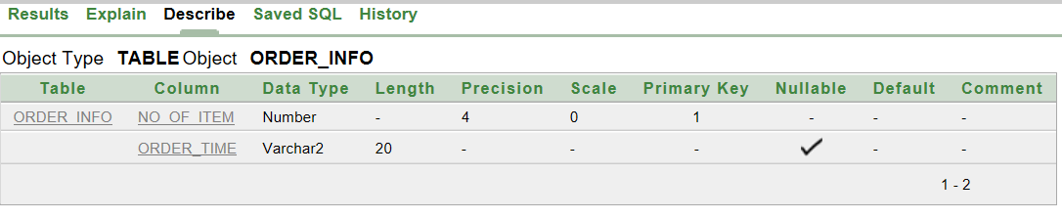

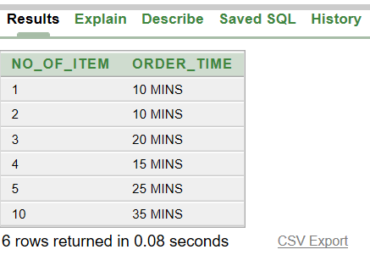

Relationship : Contains

CREATE TABLE FOOD

(

FOOD_NO NUMBER (8) CONSTRAINT FO_PK PRIMARY KEY,

QUANTITY NUMBER (4),DESCRIPTION VARCHAR2(20),ORDER_NO NUMBER(8),

CONSTRAINT FRD_PK FOREIGN KEY(ORDER_NO) REFERENCES ORDERR(ORDER_NO)

)

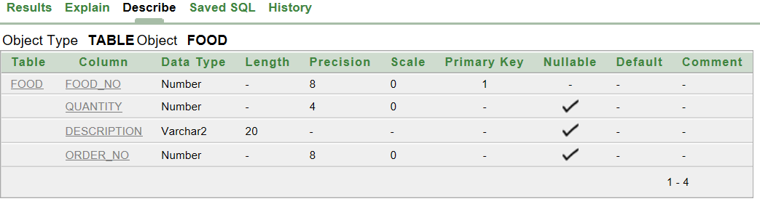

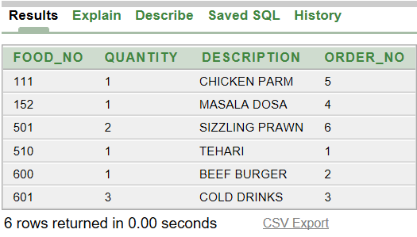

CREATE TABLE FOOD_DETAILS

(

FOOD_NO NUMBER (8),

QUANTITY NUMBER (2),PRICE NUMBER(5),

CONSTRAINT FD_PK FOREIGN KEY(FOOD_NO) REFERENCES FOOD(FOOD_NO)

)

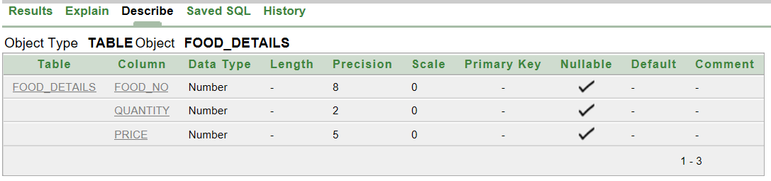

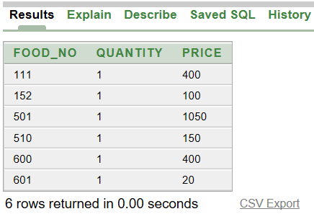

Relationship: Prepares

CREATE TABLE CHEF

(

CHEFID NUMBER (8) CONSTRAINT CHEF_PK NOT NULL,

CHEFNAME VARCHAR2(10),ORDER_NO NUMBER(8),

CONSTRAINT FOR_PK FOREIGN KEY(ORDER_NO) REFERENCES ORDERR(ORDER_NO)

)

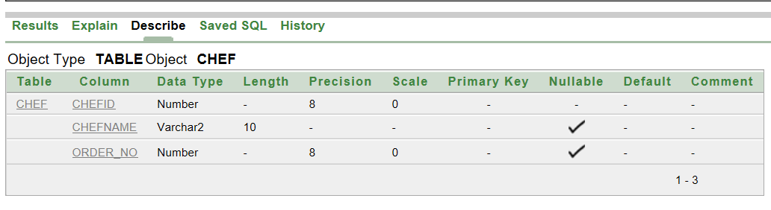

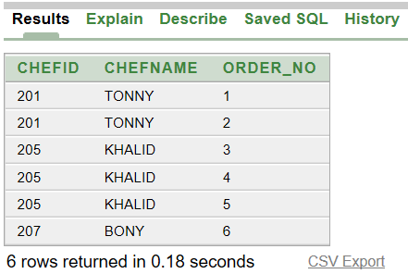

Relationship: pays

CREATE TABLE BILL

(

BILLNO NUMBER (8) CONSTRAINT BILL_PK PRIMARY KEY,

PRICE NUMBER(4),ORDER_DTL VARCHAR2(20),CUS_ID NUMBER(8),

CONSTRAINT CS_PK FOREIGN KEY(CUS_ID) REFERENCES CUSTOMER(CUSID)

)

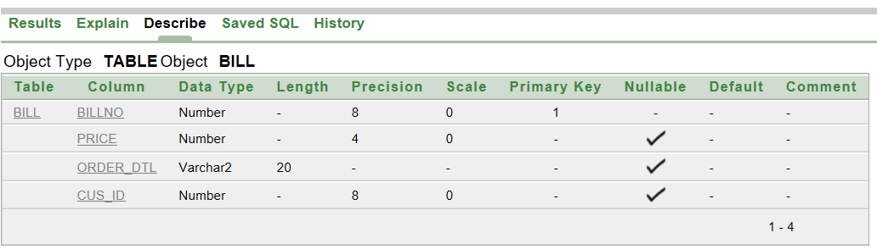

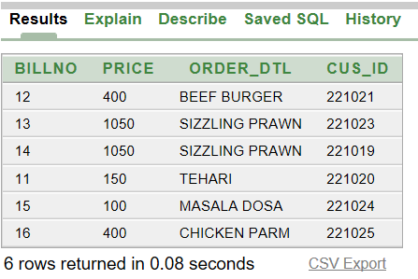

CREATE TABLE BILL_DTLS

(

PRICE VARCHAR2 (15) CONSTRAINT PC_PK PRIMARY KEY,

VAT VARCHAR2(15)

)

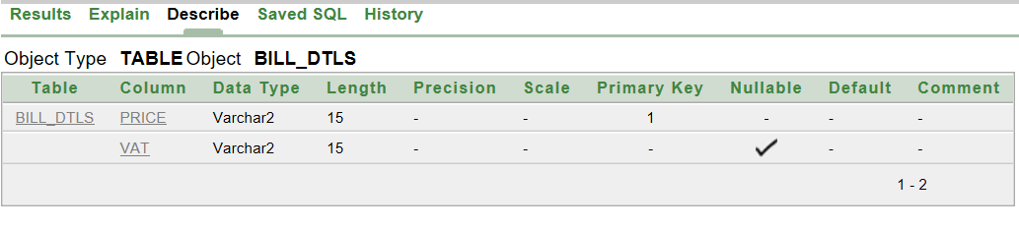

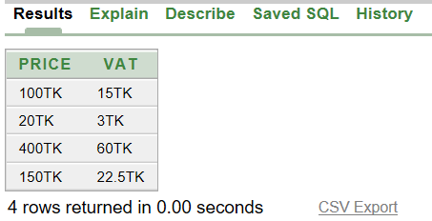

SUBQUERY

Que-01: Display the customers name and contact no. who goes La Bamba

Ans:SELECT CUSNAME,CNTNO FROM CUSTOMER WHERE RID=(SELECT RID FROM RESTAURANT WHERE RNAME='LA BAMBA')

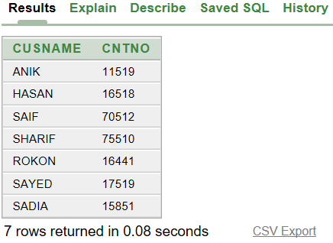

Que-02:Display waiter name who takes order from Sadia

Ans:SELECT WNAME FROM WAITER WHERE CUSID=(SELECT CUSID FROM CUSTOMER WHERE CUSNAME='SADIA')

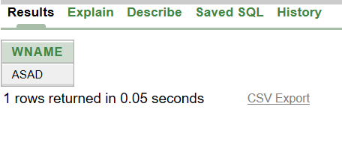

Que-03:Display customer name who order sizzling prawn

Ans:SELECT CUSNAME FROM CUSTOMER WHERE CUSID IN

(SELECT CUSID FROM WAITER WHERE

ORDER_NO=(SELECT ORDER_NO FROM FOOD WHERE DESCRIPTION='SIZZLING PRAWN'))

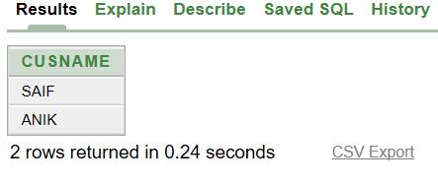

Que-04:Disply waiters who works in La Bamba

Ans:SELECT WID,WNAME FROM WAITER WHERE CUSID IN

(SELECT CUSID FROM CUSTOMER WHERE

RID=(SELECT RID FROM RESTAURANT WHERE RNAME='LA BAMBA'))

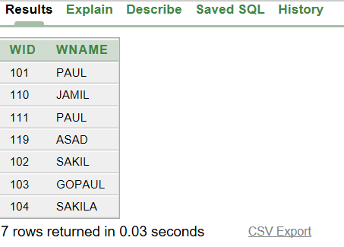

Joining

Que-01:Display customer name,contact no and restaurant name

Ans:SELECT C.CUSNAME,C.CNTNO,R.RNAME FROM CUSTOMER C,RESTAURANT R WHERE C.RID=R.RID

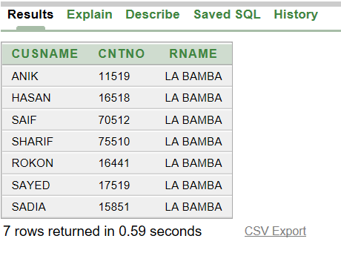

Que-02:Display waiter name who takes order

Ans:SELECT W.WNAME FROM WAITER W,FOOD F WHERE W.ORDER_NO=F.ORDER_NO

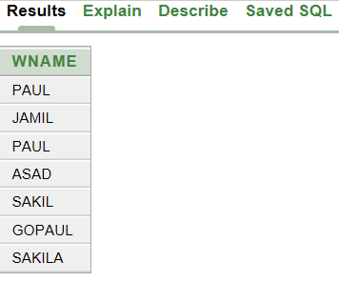

Que-03:Dispaly foods,food_no which ordered by customes

Ans:SELECT F.DESCRIPTION,F.FOOD_NO,W.CUSID FROM FOOD F,WAITER W WHERE F.ORDER_NO=W.ORDER_NO

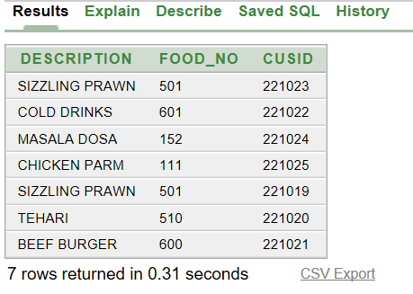

Enable and Disable

1. ALTER TABLE RESTAURANT_INFO DISABLE CONSTRAINT RN

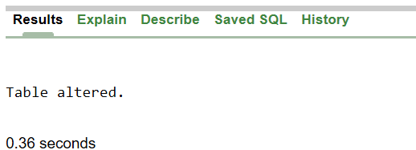

ALTER TABLE RESTAURANT_INFO ENABLE CONSTRAINT RN

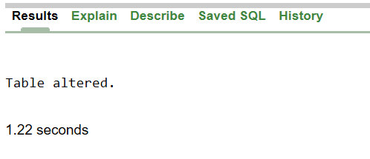

ALTER TABLE BILL_DTLS DISABLE CONSTRAINT PC_PK



ALTER TABLE BILL_DTLS ENABLE CONSTRAINT PC_PK

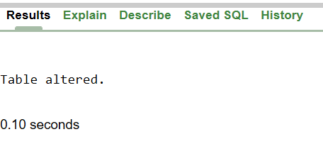

Relationship- Goes

CREATE TABLE RESTAURANT

(

RID NUMBER(8) CONSTRAINT RID PRIMARY KEY,

RNAME VARCHAR(20),CONTACTNO NUMBER(11)

)

INSERT INTO RESTAURANT VALUES(1076,'RADHUNI',081522)

INSERT INTO RESTAURANT VALUES(3026,'FOOD CLUB',071552)

INSERT INTO RESTAURANT VALUES(1157,'LA BAMBA',073582)

INSERT INTO RESTAURANT VALUES(8413,'TAKEOUT',085832)

INSERT INTO RESTAURANT VALUES(1102,'MAMA-VAGNE',055079)

CREATE TABLE RESTAURANT_INFO

(

RNAME VARCHAR2(20) CONSTRAINT RN PRIMARY KEY,

ADDRESS VARCHAR2(20)

)

INSERT INTO RESTAURANT_INFO VALUES('RADHUNI','NAWABGANJ')

INSERT INTO RESTAURANT_INFO VALUES('FOOD CLUB','NAWABGANJ')

INSERT INTO RESTAURANT_INFO VALUES('LA BAMBA','UTTARA')

INSERT INTO RESTAURANT_INFO VALUES('TAKEOUT','BANANI')

INSERT INTO RESTAURANT_INFO VALUES('MAMA-VAGNE','RAJSHAHI')

CREATE TABLE CUSTOMER

(

CUSID NUMBER (8) CONSTRAINT CUS_PK PRIMARY KEY,

CUSNAME VARCHAR2 (10),CNTNO NUMBER(11),RID NUMBER(8),

CONSTRAINT FK_PK FOREIGN KEY(RID) REFERENCES RESTAURANT(RID)

)

INSERT INTO CUSTOMER VALUES(221023,'ANIK',011519,1157)

INSERT INTO CUSTOMER VALUES(221021,'HASAN',016518,1157)

INSERT INTO CUSTOMER VALUES(221022,'SAYED',017519,1157)

INSERT INTO CUSTOMER VALUES(221019,'SAIF',070512,1157)

INSERT INTO CUSTOMER VALUES(221020,'SHARIF',075510,1157)

INSERT INTO CUSTOMER VALUES(221024,'ROKON',016441,1157)

INSERT INTO CUSTOMER VALUES(221025,'SADIA',015851,1157)

Relationship:Places

CREATE TABLE ORDERR

(

ORDER_NO NUMBER (8) CONSTRAINT OR_PK PRIMARY KEY,

NO_OF_ITEM NUMBER (4)

)

INSERT INTO ORDERR VALUES(01,03)

INSERT INTO ORDERR VALUES(02,01)

INSERT INTO ORDERR VALUES(03,05)

INSERT INTO ORDERR VALUES(04,01)

INSERT INTO ORDERR VALUES(05,01)

INSERT INTO ORDERR VALUES(06,10)

CREATE TABLE ORDER_INFO

(

NO_OF_ITEM NUMBER(4) CONSTRAINT NO_PK PRIMARY KEY,

ORDER_TIME VARCHAR2(20)

)

INSERT INTO ORDER_INFO VALUES(01,'10 MINS')

INSERT INTO ORDER_INFO VALUES(02,'10 MINS')

INSERT INTO ORDER_INFO VALUES(05,'25 MINS')

INSERT INTO ORDER_INFO VALUES(03,'20 MINS')

INSERT INTO ORDER_INFO VALUES(10,'35 MINS')

INSERT INTO ORDER_INFO VALUES(04,'15 MINS')

Relationship: Serves

CREATE TABLE WAITER

(

WID NUMBER (8) CONSTRAINT W_PK PRIMARY KEY,

WNAME VARCHAR2 (10),CUSID NUMBER(8),ORDER_NO NUMBER(8),

CONSTRAINT CK_PK FOREIGN KEY(CUSID) REFERENCES CUSTOMER(CUSID),

CONSTRAINT OK_PK FOREIGN KEY(ORDER_NO) REFERENCES ORDERR(ORDER_NO)

)

INSERT INTO WAITER VALUES(101,'PAUL',221023,6)

INSERT INTO WAITER VALUES(102,'SAKIL',221019,6)

INSERT INTO WAITER VALUES(103,'GOPAUL',221020,1)

INSERT INTO WAITER VALUES(104,'SAKILA',221021,2)

INSERT INTO WAITER VALUES(110,'JAMIL',221022,3)

INSERT INTO WAITER VALUES(111,'PAUL',221024,4)

INSERT INTO WAITER VALUES(119,'ASAD',221025,5)

Relationship: Contains

CREATE TABLE FOOD

(

FOOD_NO NUMBER (8) CONSTRAINT FO_PK PRIMARY KEY,

QUANTITY NUMBER (4),DESCRIPTION VARCHAR2(20),ORDER_NO NUMBER(8),

CONSTRAINT FRD_PK FOREIGN KEY(ORDER_NO) REFERENCES ORDERR(ORDER_NO)

)

INSERT INTO FOOD VALUES(510,1,'TEHARI',1)

INSERT INTO FOOD VALUES(600,1,'BEEF BURGER',2)

INSERT INTO FOOD VALUES(601,3,'COLD DRINKS',3)

INSERT INTO FOOD VALUES(152,1,'MASALA DOSA',4)

INSERT INTO FOOD VALUES(111,1,'CHICKEN PARM',5)

INSERT INTO FOOD VALUES(501,2,'SIZZLING PRAWN',6)

CREATE TABLE FOOD_DETAILS

(

FOOD_NO NUMBER (8),

QUANTITY NUMBER (2),PRICE NUMBER(5),

CONSTRAINT FD_PK FOREIGN KEY(FOOD_NO) REFERENCES FOOD(FOOD_NO)

)

INSERT INTO FOOD_DETAILS VALUES(601,1,20)

INSERT INTO FOOD_DETAILS VALUES(501,1,1050)

INSERT INTO FOOD_DETAILS VALUES(600,1,400)

INSERT INTO FOOD_DETAILS VALUES(510,1,150)

INSERT INTO FOOD_DETAILS VALUES(152,1,100)

INSERT INTO FOOD_DETAILS VALUES(111,1,400)

Relationship: Prepares

CREATE TABLE CHEF

(

CHEFID NUMBER (8) CONSTRAINT CHEF_PK NOT NULL,

CHEFNAME VARCHAR2(10),ORDER_NO NUMBER(8),

CONSTRAINT FOR_PK FOREIGN KEY(ORDER_NO) REFERENCES ORDERR(ORDER_NO)

)

INSERT INTO CHEF VALUES(201,'TONNY',1)

INSERT INTO CHEF VALUES(201,'TONNY',2)

INSERT INTO CHEF VALUES(205,'KHALID',3)

INSERT INTO CHEF VALUES(205,'KHALID',4)

INSERT INTO CHEF VALUES(205,'KHALID',5)

INSERT INTO CHEF VALUES(207,'BONY',6)

Relationship: Pays

CREATE TABLE BILL

(

BILLNO NUMBER (8) CONSTRAINT BILL_PK PRIMARY KEY,

PRICE NUMBER(4),ORDER_DTL VARCHAR2(20),CUS_ID NUMBER(8),

CONSTRAINT CS_PK FOREIGN KEY(CUS_ID) REFERENCES CUSTOMER(CUSID)

)

INSERT INTO BILL VALUES(11,150,'TEHARI',221020)

INSERT INTO BILL VALUES(12,400,'BEEF BURGER',221021)

INSERT INTO BILL VALUES(13,1050,'SIZZLING PRAWN',221023)

INSERT INTO BILL VALUES(14,1050,'SIZZLING PRAWN',221019)

INSERT INTO BILL VALUES(15,100,'MASALA DOSA',221024)

INSERT INTO BILL VALUES(16,400,'CHICKEN PARM',221025)

CREATE TABLE BILL_DTLS

(

PRICE VARCHAR2 (15) CONSTRAINT PC_PK PRIMARY KEY,

VAT VARCHAR2(15)

)

INSERT INTO BILL_DTLS VALUES('20TK','3TK')

INSERT INTO BILL_DTLS VALUES('400TK','60TK')

INSERT INTO BILL_DTLS VALUES('150TK','22.5TK')

INSERT INTO BILL_DTLS VALUES('100TK','15TK')

SUBQUERY

Que-01: Display the customers name and contact no. who goes La Bamba

Ans:SELECT CUSNAME,CNTNO FROM CUSTOMER WHERE RID=(SELECT RID FROM RESTAURANT WHERE RNAME='LA BAMBA')

Que-02:Display waiter name who takes order from Sadia

Ans:SELECT WNAME FROM WAITER WHERE CUSID=(SELECT CUSID FROM CUSTOMER WHERE CUSNAME='SADIA')

Que-03:Display customer name who order sizzling prawn

Ans:SELECT CUSNAME FROM CUSTOMER WHERE CUSID IN

(SELECT CUSID FROM WAITER WHERE

ORDER_NO=(SELECT ORDER_NO FROM FOOD WHERE DESCRIPTION='SIZZLING PRAWN'))

Que-04:Disply waiters who works in La Bamba

Ans:SELECT WID,WNAME FROM WAITER WHERE CUSID IN

(SELECT CUSID FROM CUSTOMER WHERE

RID=(SELECT RID FROM RESTAURANT WHERE RNAME='LA BAMBA'))

Joining

Que-01:Display customer name,contact no and restaurant name

Ans:SELECT C.CUSNAME,C.CNTNO,R.RNAME FROM CUSTOMER C,RESTAURANT R WHERE C.RID=R.RID

Que-02:Display waiter name who takes order

Ans:SELECT W.WNAME FROM WAITER W,FOOD F WHERE W.ORDER_NO=F.ORDER_NO

Que-03:Dispaly foods,food_no which ordered by customes

Ans:SELECT F.DESCRIPTION,F.FOOD_NO,W.CUSID FROM FOOD F,WAITER W WHERE F.ORDER_NO=W.ORDER_NO  
Enable and Disable

ALTER TABLE RESTAURANT_INFO DISABLE CONSTRAINT RN

ALTER TABLE RESTAURANT_INFO ENABLE CONSTRAINT RN

ALTER TABLE BILL_DTLS DISABLE CONSTRAINT PC_PK

ALTER TABLE BILL_DTLS ENABLE CONSTRAINT PC_PK