Emotionally Adaptive Gaming: Gaming Profiles

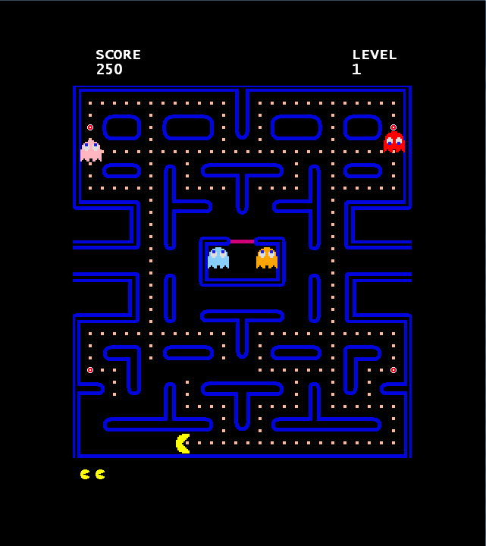

Researchers: Etienne I.R. van Delden, Vincent J.P. van den Goor, Martijn M.M. Frissen, Tom Koppenol

Coaches: Wouter M. van den Hoogen, Joris H. Janssen, Raymond H. Cuijpers

Eindhoven, University of Technology, Human Technology Interaction

Abstract
This document describes the performed research on emotionally adaptive gaming. Using psychophysical gamers’ input gathered during a calibration phase, three adaptive versions of Pac-Man are used to discover the optimal gaming experience. The study uses 18 human participants aged 19-27 with varying experience with games. Data from electromyography sensors on facial muscles, galvanic skin response sensors on fingers and gamepad pressure sensors are researched to find possible associations between this data and the experienced level of difficulty during gameplay. Gamer profiles are created using these data and accordingly three Pac-Man versions are tested. Version A seeks the optimal gaming experience around the experienced between the boundaries of easy and hard. Version B aims around the experienced difficulty level of hard and version C is targeted around the experienced difficulty level of easy.
Data analysis shows that the optimal gaming experience lies at …… with a significance of …. .
The research concludes that ….

Index

Introduction 4
Method 7
Results 12
Discussion and Conclusions 17
References 20
Appendices 21
Appendix A: GEQ 21
Appendix B: General questionnaire 22
Appendix C: SPSS Output Hypothesis 1 23

Introduction

The game industry is one of the biggest industries in the world today, generating tens of billions of dollars in revenues yearly. Since there is a lot of competition, new games should be special. After multiplayer games, the influence of the internet and role-playing games, it is time for a game which adapts itself to the emotions of the gamer. In the past decade, several researchers have worked on the foundations for this new game feature. The aim of our project is to build and test an emotionally adaptive game.
Research by Tijs, Brokken and IJsselsteijn (2008) indicated that emotionally adaptive games optimize players’ gaming experience by adapting their mechanisms to the emotional state of the player. They analyzed the emotional responses of their participants who had played an altered version of the classic arcade game Pac-Man. By changing the difficulty of the game, they were able to find several emotion-data features to distinguish between a boring, frustrating and enjoyable game mode. These features were found by using correlations between data on player emotion, filled in through a questionnaire, and several physiological measurements such as electromyography (EMG), pressure sensors and skin conductance (galvanic skin resistance or GSR). Tijs, Brokken and IJsselsteijn (2008) have also investigated the relation between game difficulty and the interaction of frustration, boredom and enjoyment. They considered an optimal range in which gamers experience enjoyment (see Figure 1). In the slow game mode, almost all of their participants indicated to be bored. The fast game mode was considered to be more enjoyable than frustrating. However, this seemed to be due to the participants’ knowledge of the method of the experiment.
Research by Sykes and Brown (2003) shows that a high difficulty level leads to high pressure on an input device, such as a controller or keyboard. However, they have not found a significant difference between easy and medium game difficulty levels, let alone that the high pressure indicates frustration or enjoyment. This finding was later supported and extended by research from Van den Hoogen, IJsselsteijn and De Kort (2008) which indicated that the level of arousal (determined by the amount of pressure) can have a positive and a negative valence. In other words, high pressure levels on the input device have the potential to be related to both frustration and to enjoyment.
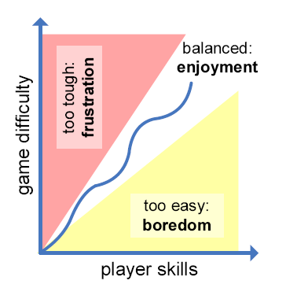
Figure 1: Gamer experience based on interaction between game difficulty and player skills (adapted from Adams and Rollings, 2007 as used by Tijs, Brokken and IJselsteijn)

Gilleade and Dix (2004) researched the use of frustration in adaptive video-games. They were able to identify two important dimensions of frustration within a gaming perspective and called them at-game frustration and in-game frustration respectively. According to Gilleade and Dix, at-game frustration is “that which arises from a failure to operate the input device (e.g. gamepad, keyboard, joystick) in a manner that would give the player the potential to progress (i.e. compete).” Their definition of in-game frustration was as follows: “that which arises from a failure to know how a challenge is to be completed.” Furthermore, they stressed that a better understanding of these (and potential other) dimensions of frustration is required in order to successfully use frustration as an indicator for when change is needed during gameplay.
To be able to separate enjoyment from frustration, both the gamers’ arousal and valence need to be measured. Research by Gilleade and Dix (2004) indicate that skin conductivity is a commonly used indicator of arousal. Mandryk and Atkins (2007) measured skin conductivity using Galvanic Skin Resistance (GSR), which was applied to two fingers on the same hand. They also used Electromyography (EMG) on the smiling and frowning muscles of the face, to find additional physiological evidence for particular emotions: 1) fun 2) excitement 3) frustration 4) challenge and 5) boredom. By using the circumplex model of emotion, common sense and their own understanding of where the five emotions exist in arousal-valence space (AV-space), Mandryk and Atkins (2007) were able to use measurements represented in AV-space to identify the aforementioned emotions. They also learned that some emotions are not so easy to define in AV-space, such as schadenfreude, which means taking pleasure in the misery of others. Still, from their research it can be concluded that there is great potential for using physiological metrics to model emotional experience.
Our research continues with these possibilities to perform measurements on gamers’ emotion. Instead of changing the game speed manually as Tijs, Brokken and IJsselsteijn (2008) have done in their research, the speed of the game will change automatically in response to changes in the physiological signals obtained from the player. A real-time feedback loop is inserted into an open-source version of the arcade game Pac-Man. The game adapts itself based on measurements from GSR, EMG and pressure sensors. As Sykes and Brown (2003) indicate, measurements on GSR are only suitable for states of relaxation and stillness. When the player tightens a muscle, the skin resistance will change, leading to a decrease of accurate data. Therefore the GSR will be applied to two unused fingers of the participants’ hand. The EMG sensors will be used to analyze the zygomaticus major (ZYG, facial muscle used for smiling) and the corrugator supercilii (CORR, facial muscle used for frowning). The pressure sensors are located inside the controller. The target is to discover whether difficulty profiles can be built from these data sets and whether these profiles are usable for an adaptive Pac-Man game. The reasons for choosing Pac-Man to modify with a feedback loop are that it is a classic game with a high recognition factor. Also, it is a relatively easy game to adapt when it comes to the difficulty of the game and the implementation of the measuring techniques. Besides, in 2008, Tijs, Brokken and IJsselsteijn considered Pac-Man to be a successful game choice as a stimulus.

Research questions and hypotheses
Two research questions were composed. Considering that we were bound to a short period of time to perform experiments, the experiment was designed in such a way that both questions could be answered at once. However, it was uncertain whether the first question would provide us with significant results for the second question to be relevant. The experiment is described in the Method chapter. The research questions were stated as follows:
- Can distinctive profiles from physiological measurements be found which correspond to an easy and difficult game level?
- Are the found profiles usable to create an adaptive game which can evoke a certain game experience?

Considering the research questions, the following hypotheses were defined:
1. It is possible to find distinctive profiles from physiological measurements which correspond to a certain game difficulty.
2. When EMG/GSR/Pressure signals are detected which combined indicate that the game is too difficult, a decrease of the game difficulty level will lead to a decrease of the detected difficulty level.
3. When EMG/GSR/Pressure signals are detected which combined indicate that the game is too easy, an increase of the game difficulty level will lead to an increase of the detected difficulty level.
4. Gamers will have an optimal gaming experience when the game difficulty level adapts within boundaries of easy and difficult as found during a calibration session.

Based on our common sense we define an optimal gaming experience to entail little to no boredom, little frustration and a high positive affect.

Method

Design
This study used a within subject design. The experiment consisted out of two parts. The first was a calibration phase to determine the different difficulty profiles per person. Accordingly, three adaptive Pac-Man versions were tested per participant in the second part.

To test our hypotheses, we required various (in)dependant variables. Table 1 states the classification of these variables in the experiment.

Table 1: Classification of Independent and Dependent variables
Independent Variable | Dependent Variable
H1
Experienced Difficulty (Calibration) | EMG Zygomaticus Major
Too Easy – Good – Too Difficult | GSR
 | Pressure
H2 & H3
Game Difficulty (Adaptive) | EMG Zygomaticus Major
Easier - No Change – Harder | GSR
Ghost Speed | Pressure
H4
Game Difficulty (Adaptive) | GEQ Frustration
Easier - No Change – Harder | GEQ Boredom
 | GEQ Positive Affect

During the experiment a second facial muscle group was also measured, namely the Corrugator Supercilii. But due to technical issues, this wasn’t measured for every participant and as such will not be taken into account as a dependent variable.
GEQ stands for Gamers Experience Questionnaire. In the observation sessions we used GEQs to measure frustration, boredom and positive affect.
The following design scheme was obtained for the experiment:

X_{A} → O₁ → X_{B}→ O₂ → X_{C} → O₃

X_{A} is the Pac-Man game containing feedback loop A.
X_{B} is the Pac-Man game containing feedback loop B.
X_{C} is the Pac-Man game containing feedback loop C.
O₁, O₂ and O₃ are the observation sessions of the effect of the previously played game session on the players’ gaming experience.

The feedback loops had the following designs:
- Feedback loop “A”. This loop aimed to reach specific GSR-, EMG-, and Pressure-values which corresponded with a difficulty level which the participants found “not too difficult“. The loop attempted to remain between the difficulty levels which the participants had indicated to be too easy and too difficult during the calibration session. (See Figure 2)
- Feedback loop “B”. This loop aimed to reach specific GSR-, EMG-, and Pressure-values which corresponded with a difficulty level which is continuously a little too high for the participants. In other words, the loop adapted between levels of difficulty were somewhat above and below the level of difficulty that the player had indicated to be too difficult during the calibration session. (See Figure 3)
- Feedback loop “C”. This loop aimed to reach specific GSR-, EMG-, and Pressure-values which corresponds with a difficulty level which is continuously low for the participants. In other words, the loop adapted between levels of difficulty that were near to the level of difficulty that the player had indicated to be too easy during the calibration session. (See Figure 4)

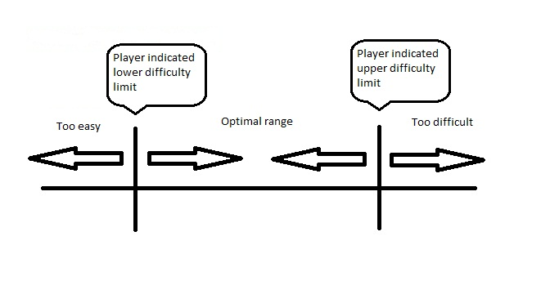

Figure 2: Optimal Range for Feedbackloop "A"
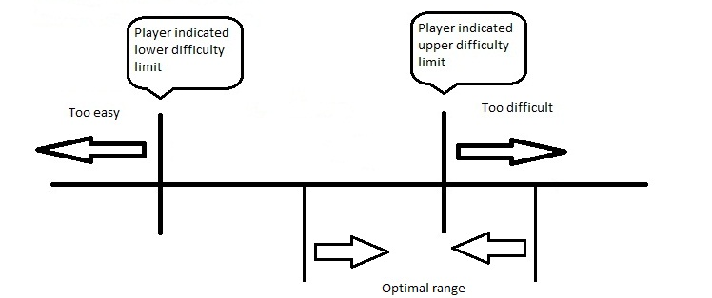

Figure 3: Optimal Range for Feedbackloop "B"
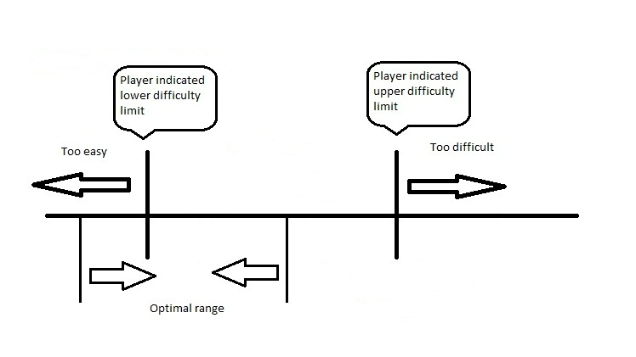

Figure 4: Optimal Range for Feedbackloop "C"

We aimed to present the participants with the feedback loops in differing orders in such a way that every combination of orders is tested. However, due to technical problems in the implementation, this was not possible.

Participants
Through a mailing to friends and acquaintances volunteers were drafted for the experiment. In total, the experiment was completed by 18 participants (12 Male, Mean Age = 21,7 and 6 Female, Mean Age = 22,3). They were mainly students or ex-students, ranging in age from 19 to 27. Prior to the experiment, the participants washed their hands (without using soap) and signed an informed consent form in the game room. The participants were required to shave themselves and not to wear make-up before the experiment.

Apparatus
The participants’ physiological state was measured through 1) a DualShock3 controller to measure the pressure which the participant exerted on the control buttons, 2) electrodes on facial muscles used during smiling (EMG Zygomaticus Mayor) and 3) a strip for measuring skin conductance was applied to two fingers of the non-playing hand (GSR). These devices communicated their values through a TMSI Mobi6.
We adjusted an existing implementation of Pac-Man, which was created to resemble the original arcade version of Pac-Man as closely as possible.
The pressure data was processed directly by our adjusted Pac-Man. The EMG-, and GSR-data was recorded in a separate document but could not be processed by our Pac-Man implementation due to technical problems with converting the values.

Before starting the experiment, a baseline was collected from every participant by playing a calming, aquatically themed movie (8 minutes in length).
During the calibration session, the participants indicated whether they thought that the game was too easy, good or too difficult. They used the square, triangle and circle button respectively to show their experience as can be seen in Figure 5.
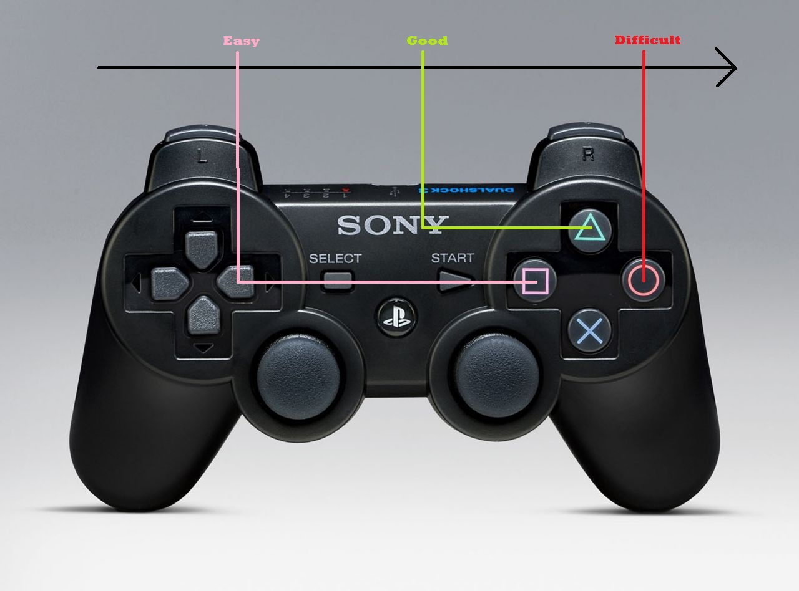
Figure 5: A DualShock3 controller, the buttons used to express game experience during calibration are indicated.

At the end of every adaptive session (when a feedback loop was used), the participants answered a Gamers Experience Questionnaire (GEQ). The experienced levels of frustration, boredom and positive affect were measured through 15 questions on a five-point scale, see Appendix A. The results were averaged and the versions were compared based on their effect on the gamers’ experiences. As method, pair-wise comparisons using a Bonferroni correction were used.

A final questionnaire with some basic questions regarding age, gender and previous experiences with Pac-Man was given to the participants when they had filled in the GEQ for the final adaptive session. This questionnaire can be found in Appendix B.

Procedure
The participants were welcomed and were asked to wash their hands. Then they were guided to their seat where the participants signed the informed consent form. They were given instructions on the calibration session, the electrodes were attached to their facial muscles for smiling and the GSR strip was applied to two fingers of the non-playing hand.
The calibration session was performed to determine the GSR-, EMG-, and Pressure-values for the participants when they indicate that the game is either too difficult or too easy. At first, the game difficulty gradually became higher until the participants indicated that the game was too difficult. The GSR, EMG-, and Pressure data were then recorded and stored in a users’ profile. Consequently, the game difficulty gradually decreased until the participants indicated that the game had become too easy. Again, the GSR, EMG-, and Pressure data were recorded and stored in a users’ profile. This continued for 10 minutes per participant.

After completing the calibration session, the participants were instructed on the next stage. The participants played three adaptive sessions (5 minutes per session). The adaptive games were assigned in the same order for every participant: Average, Easy and Difficult. During the sessions, the game detected whether the game was considered too easy or too difficult, based on a comparison between the Pressure-values and the stored users’ profile. Subsequently the game changed the difficulty level depending on the type of feedback loop the participants were presented with.
After every session, the participants were given a Gamers Experience Questionnaire to indicate their emotions after playing the game.
When the three sessions were completed, the sensors were removed and the participants were thanked and paid for their participation. They were given the opportunity to ask questions concerning the experiment. If they wrote down their email-addresses, the results of the research were sent to them.

Analysis preparation
Before we could start with the analysis, the data needed to be converted. The EMG-, and GSR-data files were converted to microvolts and a bandwidth-filter had to be applied so that we only used data between 30Hz and 500 Hz.
The pressure data – originally ranging ‘-1000 - 1000’ – were transformed by adding ‘1000’ and dividing the data by ‘2’ so that the range became ‘0 – 1000’.

Results

Because the experimental setup was designed as a Within Subjects, a Repeated Measures ANOVA would yield the most insight into general trends between all of the participants and which dependent variables would be the best predictors for the independent variables.

Hypothesis I

Hypothesis II & III

2. When EMG/GSR/Pressure signals are detected which combined indicate that the game is too difficult, a decrease of the game difficulty level will lead to a decrease of the detected difficulty level.
3. When EMG/GSR/Pressure signals are detected which combined indicate that the game is too easy, an increase of the game difficulty level will lead to an increase of the detected difficulty level.

The different adaptive Pac-Man versions decided when to adjust the game difficulty level, which is realized by changing the ghost speed. These versions based their decisions solely on pressure data (mean pressure data during a certain amount of time), because the implementation and concurrently running of other psychophysical measurements in the adaptive loops could not be realized within the time planned for this project.
Since the hypotheses state that a combination of psychophysical measurements is able to affect the detected difficulty level, and we were only able to use one of the measurements, we consider that we can’t appropriately accept or reject these hypotheses. Further explanation will be given in the discussion of the method.

Hypothesis IV

The versions that were played made the game easier (1), more difficult (3) or wandered in between easy and difficult (2). The results from the GEQ were analyzed using a general linear model analysis based on a repeated measures method. The three emotional factors (boredom, frustration and positive affect) were analyzed independently and compared pair-wise including a Bonferroni correction.

Boredom:
Table 2: Descriptive Statistics Boredom
 | Mean | Std. Deviation | N¹
Boredom1 | 2,9333 | ,64439 | 15
Boredom2 | 2,2133 | ,54755 | 15
Boredom3 | 2,2133 | ,68229 | 15
1. 15 participants were used for the analysis instead of the 18 participants used. During the experiment, 3 participants were not able to answer a GEQ. More on this in the Discussion chapter.

Table 3: Pairwise Comparisons
Measure: boredom
(I) difficulty | (J) difficulty | Mean Difference (I-J) | Std. Error | Sig.ª | 95% Confidence Interval for Difference ª
 |  |  |  |  | Lower Bound | Upper Bound
1 | 2 | ,720* | ,167 | ,002 | ,267 | 1,173
1 | 3 | ,720* | ,199 | ,008 | ,180 | 1,260
2 | 1 | -,720* | ,167 | ,002 | -1,173 | -,267
2 | 3 | -4,441E-16 | ,143 | 1,000 | -,390 | ,390
3 | 1 | -,720* | ,199 | ,008 | -1,260 | -,180
3 | 2 | 4,441E-16 | ,143 | 1,000 | -,390 | ,390
Based on estimated marginal means
*. The mean difference is significant at the ,05 level.
a. Adjustment for multiple comparisons: Bonferroni.

As can be seen from the comparisons from Table 3, the values obtained for the player’s degree of boredom in the easy adaptive version differs significantly (Sig. <0,01) from the others. The other two adaptive versions were not distinctive from each other. This means that our ‘average’ and ‘difficult’ version evoked an equal amount of boredom.

Frustration:

Table 4: Descriptive Statistics Frustration
 |  | Mean | Std. Deviation |  | N¹
Frustration1 |  | 2,2400 | ,39424 |  | 15
Frustration2 |  | 3,0667 | ,73160 |  | 15
Frustration3 |  | 2,8400 | ,68951 |  | 15
1. 15 participants were used for the analysis instead of the 18 participants used. During the experiment, 3 participants were not able to answer a GEQ. More on this in the Discussion chapter.
Table 5: Pairwise Comparisons
Measure: frustration
(I) difficulty | (J) difficulty |  |  | Mean Difference (I-J) |  | Std. Error |  |  |  | Sig.ª | 95% Confidence Interval for Difference ª
 |  |  |  |  |  |  |  |  |  |  | Lower Bound | Upper Bound
1 | 2 |  |  | -,827* |  | ,143 |  |  |  | ,000 | -1,216 | -,437
1 | 3 |  |  | -,600* |  | ,161 |  |  |  | ,007 | -1,037 | -,163
2 | 1 |  |  | ,827* |  | ,143 |  |  |  | ,000 | ,437 | 1,216
2 | 3 |  |  | ,227 |  | ,228 |  |  |  | 1,000 | -,394 | ,847
3 | 1 |  |  | ,600* |  | ,161 |  |  |  | ,007 | ,163 | 1,037
3 | 2 |  |  | -,227 |  | ,228 |  |  |  | 1,000 | -,847 | ,394
Based on estimated marginal means
*. The mean difference is significant at the ,05 level.
a. Adjustment for multiple comparisons: Bonferroni.

As can be seen from the comparisons from Table 5, the values obtained for the player’s degree of frustration in the easy adaptive version differs significantly (Sig. <0,01) from the others. The other two adaptive versions were not distinctive from each other. This means that our ‘average’ and ‘difficult’ version evoked an equal amount of frustration.
Positive Affect:

1. 15 participants were used for the analysis instead of the 18 participants used. During the experiment, 3 participants were not able to answer a GEQ. More on this in the Discussion chapter.
Table 7: Pairwise Comparisons
Measure: posaff
(I) difficulty | (J) difficulty | Mean Difference (I-J) | Std. Error |  | Sig.ª | 95% Confidence Interval for Difference ª
 |  |  |  |  |  | Lower Bound | Upper Bound
1 | 2 | -,347 | ,177 |  | ,212 | -,828 | ,135
1 | 3 | -,253 | ,219 |  | ,798 | -,848 | ,341
2 | 1 | ,347 | ,177 |  | ,212 | -,135 | ,828
2 | 3 | ,093 | ,148 |  | 1,000 | -,310 | ,497
3 | 1 | ,253 | ,219 |  | ,798 | -,341 | ,848
3 | 2 | -,093 | ,148 |  | 1,000 | -,497 | ,310
Based on estimated marginal means
a. Adjustment for multiple comparisons: Bonferroni.

As can be seen from the comparisons from Table 7, the values obtained for the player’s degree of positive affect in the easy adaptive version does not differ significantly (Sig. > 0,05) from the others. The other two adaptive versions were also not distinctive from each other. This means that our ‘easy’, ‘average’ and ‘difficult’ version evoked an equal amount of positive affect.
Table 6: Descriptive Statistics PosAff
 | Mean | Std. Deviation | N¹
PosAff1 | 3,1067 | ,71661 | 15
PosAff2 | 3,4533 | ,74629 | 15
PosAff3 | 3,3600 | ,72190 | 15

Discussion and Conclusions

Discussion of used method
There were some mistakes and difficulties in the implementation of our method which could have affected our results. In this section we shall describe them chronologically.

Now and then we had troubles with correctly attaching the sensors to our participants. This could have made the participants anxious. Fortunately the sensors were attached before showing the aquatic movie.

There were problems with the Dual Shock 3 controller reaction time, which lagged for an unknown reason. This means that whenever the player would issue a (directional) command, Pac-Man could possibly not respond immediately, but did so after a small delay. This made the game considerably more frustrating, especially at higher levels of difficulty when quick responses are vital to Pac-Mans survival. Participants might have had the feeling that they should press harder to issue their command.
The gained pressure data from the Dual Shock 3 controller showed a range from -1000 (no pressure) to 1000 (full pressure). Full pressure has often been applied, even when the game was fairly easy. This means that when the range was less upper-limited, we could receive more precise pressure data, leading to more distinction between easy, good and difficult in the calibration phase.

During calibration, the participants were asked for their experience every 10 seconds. In hindsight the participants were not given enough time to play and experience the game in between.
While calibrating, the game recorded pressure and physiological data 2 seconds before the beep till 3 seconds after the beep. After the beep, the game paused for a second, enabling the participants to press the appropriate button to indicate their experience. This entails that we recorded data from the participant while he/she was not been playing the game at all. This had severe consequences for the adaptive phase, which was now based on only 3 to 4 seconds of actual data and 1 to 2 seconds of noise per beep.
Moreover, the pressure data used in calibration also includes moments when there has been no pressure on the buttons. In Pac-Man, this is not unlikely, since buttons only need to be pressed when Pac-Man should make a turn. Next to the 1 to 2 seconds of noise, there could be 1 to 3 seconds without any action, causing the calibrated pressure data to be highly unrepresentative.
In our analysis for research question 1 we sought for profiles in a different manner, taking 6 seconds prior to the beep into account and ignoring pressure data of -1000.
In the adaptive part of the experiment we had other problems. Due to programming difficulties, there were no clearly defined pauses implemented in between sessions with different adaptive loops. As a result, the starting difficulty was not reset to a standard value once one session ended and the next began. Thus it is possible that within the five minute timeframe per loop, the loop was not able to adapt to its optimal difficulty towards the end of its session. This may have given the player an incorrect game experience. For example, the loop should evoke a frustrating experience, but when the loop started adapting it was at a very low difficulty level. In its five minutes it slowly adapted to a higher difficulty, but once the five minutes have passed, the difficulty was still in the region for a “good” experience. The participants thus experienced a game loop with an optimal range in between “easy” and “good” instead of around and above “difficult”. This could explain why players generally indicated that the “frustrating loop” was less frustrating than the “good loop”.

Discussion of research questions and hypotheses

Research question 1
“Can distinctive profiles from physiological measurements be found which correspond to an easy and difficult game level?”

Hypothesis I

Research question 2
“Are the found profiles usable to create an adaptive game which can evoke a certain game experience?”

The data from the calibration phase were used in the design of the adaptive games. As discussed earlier, only the pressure data was integrated in the program. Though pressure is an insignificant predictor of the gamers’ experienced difficulty, the gained data were usable for some analysis.

Hypothesis II and III
The results from the calibration showed that our pressure data can’t be used to define the gamer’s experience. However, our adaptive versions were purely based on pressure data.
Therefore we are unable to validate these hypotheses.

Hypothesis IV
The hypothesis states that an adaptive game which controls the experienced difficulty between the boundaries of easy and difficult will trigger the most optimal gaming experience.
Our definition of an optimal gaming experience is that the experience entails little to no boredom, little frustration and high positive affect.
According to the results, version 2 and 3 (respectively the easy-difficult and the difficult condition) evoked the lowest degree of boredom. Version 2 scores the highest on frustration. There is no significant difference on positive affect between version 2 and 3 and their means lie close to each other. Therefore it is impossible to say which version evokes the most optimal gaming experience. For now we can’t validate the hypothesis. A new experiment should be performed in which the flaws in the method are dealt with. Then we should able to create and present two different versions. The focus range around “easy” can be left out, since we already noticed that this version is far from optimal.

References

- Adams, E., Rollings, A. (2007): Game Design and Development; Fundamentals of Game Design, Pearson Education, NJ
- Gilleade, K.M., Dix, A., (2004): Using Frustration in the Design of Adaptive Videogames, Advances in Computer Entertainment Conference 2004, 228-232
- van den Hoogen, W.M., IJselsteijn, W.A., de Kort, Y.A.W. (2008): Exploring Behavioral Expression of Player Experience in Digital Games, Proceedings of the workshop on Facial and Bodily Expression for Control and Adaptation of Games ECAG 2008 (pp11-19). Amsterdam, the Netherlands
- Mandryk, R.L., Atkins, M.S., (2007): A fuzzy physiological approach for continuously modeling emotion during interaction with play technologies, International Journal of Human-Computer Studies, 65, 329-347
- Tijs, T., Brokken, D., IJsselsteijn W.A. (2008): Creating an Emotionally Adaptive Game, Lecture Notes in Computer Science, 5309, 122-133
- Sykes, J., Brown, S. (2003): Affective Gaming: Measuring emotion through the gamepad, Computer Human Interaction (CHI) Conference 2003, 732-733
- 2009 U.S. Video Game Industry And PC Game Software Retail Sales Reach $20.2 Billion. (2010, January 15) from http://www.cdrinfo.com/Sections/News/Details.aspx?NewsId=26708

Appendices

Appendix A: GEQ
Since there were no English participants, we only used the Dutch version:

De volgende vragen gaan over de zojuist gespeelde versie van het spel Pac-Man. Beantwoordt de volgende stellingen zo nauwkeurig mogelijk:
 | Helemaal oneens | Oneens | Niet eens / Niet oneens | Eens | Helemaal eens
Ik genoot ervan
Ik was prikkelbaar
Ik was met andere zaken bezig
Ik was geïrriteerd
Ik vond het saai
Ik was gefrustreerd
Ik vond het leuk
Ik vond het gemakkelijk
Ik vond het moeilijk
Ik voelde me geboeid
Ik voelde me vrolijk
Ik moest er veel moeite in steken
Ik voelde me verveeld
Ik voelde me uitgedaagd
Ik voelde me onder druk gezet

Appendix B: General questionnaire

The general questionnaire was in Dutch.

“In deze laatste vragenlijst volgen algemene vragen over u en uw ervaring met het experiment.
1. Wat is uw geslacht:
Man / Vrouw
2. Wat is uw leeftijd:
…..
3. Hoe vaak speelt u games:
Elke dag / Een paar keer in de week / Eens per week / Een paar keer per maand / Eens per maand / Minder dan eens per maand
4. Was u al bekend met Pac-Man:
Ja / Een beetje / Nee
5. Heeft u gemerkt dat de moeilijkheidsgraad in de Pac-Man spellen werd aangepast:
Ja / Nee
6. Wilt u op de hoogte worden gehouden van resultaten van dit onderzoek? Vul dan uw email-adres in:………………………..”

Appendix C: SPSS Output Hypothesis 1

GLM Press0_mean Press1_mean Press2_mean
/WSFACTOR=expdiff 3 Polynomial
/METHOD=SSTYPE(3)
/PLOT=PROFILE(expdiff)
/EMMEANS=TABLES(expdiff) COMPARE ADJ(BONFERRONI)
/CRITERIA=ALPHA(.05)
/WSDESIGN=expdiff.
General Linear Model
Within-Subjects Factors
Measure:MEASURE_1
expdiff |  | Dependent Variable
1 |  | Press0_mean
2 |  | Press1_mean
3 |  | Press2_mean
Multivariate Tests^{b}
Effect |  |  | Value |  | F | Hypothesis df | Error df | Sig.
expdiff | Pillai's Trace |  | ,036 |  | ,296ª | 2,000 | 16,000 | ,748
expdiff | Wilks' Lambda |  | ,964 |  | ,296ª | 2,000 | 16,000 | ,748
expdiff | Hotelling's Trace |  | ,037 |  | ,296ª | 2,000 | 16,000 | ,748
expdiff | Roy's Largest Root |  | ,037 |  | ,296ª | 2,000 | 16,000 | ,748
a. Exact statistic ; b. Design: Intercept
Within Subjects Design: expdiff
Tests of Within-Subjects Effects
Measure:MEASURE_1
Source |  | Type III Sum of Squares | df | Mean Square | F | Sig.
expdiff | Sphericity Assumed | 959,755 | 2 | 479,878 | ,191 | ,827
expdiff | Greenhouse-Geisser | 959,755 | 1,708 | 561,910 | ,191 | ,793
expdiff | Huynh-Feldt | 959,755 | 1,880 | 510,588 | ,191 | ,814
expdiff | Lower-bound | 959,755 | 1,000 | 959,755 | ,191 | ,668
Error(expdiff) | Sphericity Assumed | 85463,208 | 34 | 2513,624
Error(expdiff) | Greenhouse-Geisser | 85463,208 | 29,036 | 2943,313
Error(expdiff) | Huynh-Feldt | 85463,208 | 31,955 | 2674,486
Error(expdiff) | Lower-bound | 85463,208 | 17,000 | 5027,248

Tests of Within-Subjects Contrasts
Measure:MEASURE_1
Source | expdiff | Type III Sum of Squares | df | Mean Square | F | Sig.
expdiff | Linear | 2,936 | 1 | 2,936 | ,001 | ,977
expdiff | Quadratic | 956,820 | 1 | 956,820 | ,580 | ,457
Error(expdiff) | Linear | 57435,472 | 17 | 3378,557
Error(expdiff) | Quadratic | 28027,736 | 17 | 1648,690

Estimated Marginal Means
expdiff
Estimates
Measure:MEASURE_1
expdiff | Mean | Std. Error | 95% Confidence Interval
expdiff | Mean | Std. Error | Lower Bound | Upper Bound
1 | 1322,607 | 19,843 | 1280,743 | 1364,472
2 | 1331,251 | 17,038 | 1295,304 | 1367,198
3 | 1322,036 | 17,882 | 1284,308 | 1359,764

Pairwise Comparisons
Measure:MEASURE_1
(I) expdiff | (J) expdiff | Mean Difference (I-J) | Std. Error | Sig.ª | 95% Confidence Interval for Differenceª
 |  |  |  |  | Lower Bound | Upper Bound
1 | 2 | -8,644 | 16,932 | 1,000 | -53,597 | 36,310
1 | 3 | ,571 | 19,375 | 1,000 | -50,870 | 52,012
2 | 1 | 8,644 | 16,932 | 1,000 | -36,310 | 53,597
2 | 3 | 9,215 | 13,259 | 1,000 | -25,987 | 44,417
3 | 1 | -,571 | 19,375 | 1,000 | -52,012 | 50,870
3 | 2 | -9,215 | 13,259 | 1,000 | -44,417 | 25,987
Based on estimated marginal means
a. Adjustment for multiple comparisons: Bonferroni.

Profile Plots

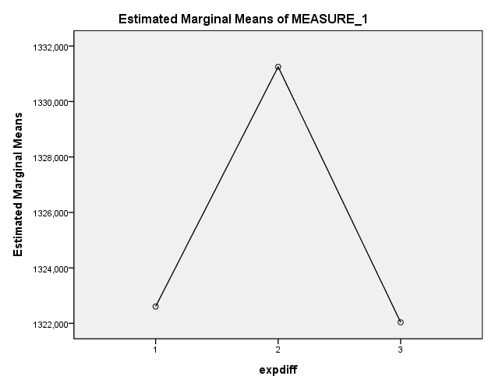

GLM EMG0_mean EMG1_mean EMG2_mean
/WSFACTOR=expdiff 3 Polynomial
/METHOD=SSTYPE(3)
/PLOT=PROFILE(expdiff)
/EMMEANS=TABLES(expdiff) COMPARE ADJ(BONFERRONI)
/CRITERIA=ALPHA(.05)
/WSDESIGN=expdiff.

General Linear Model
Within-Subjects Factors
Measure:MEASURE_1
expdiff | Dependent Variable
1 | EMG0_mean
2 | EMG1_mean
3 | EMG2_mean
Multivariate Tests^{b}
Effect |  |  |  | Value |  | F | Hypothesis df |  |  | Error df | Sig.
expdiff | Pillai's Trace |  |  | ,437 |  | 5,040ª | 2,000 |  |  | 13,000 | ,024
expdiff | Wilks' Lambda |  |  | ,563 |  | 5,040ª | 2,000 |  |  | 13,000 | ,024
expdiff | Hotelling's Trace |  |  | ,775 |  | 5,040ª | 2,000 |  |  | 13,000 | ,024
expdiff | Roy's Largest Root |  |  | ,775 |  | 5,040ª | 2,000 |  |  | 13,000 | ,024
a. Exact statistic
b. Design: Intercept
Within Subjects Design: expdiff

Tests of Within-Subjects Effects
Measure:MEASURE_1
Source |  |  |  |  | Type III Sum of Squares |  |  | df | Mean Square |  |  | F |  | Sig.
expdiff |  | Sphericity Assumed |  |  | 19,221 |  |  | 2 | 9,611 |  |  | 4,825 |  | ,016
 |  | Greenhouse-Geisser |  |  | 19,221 |  |  | 1,597 | 12,034 |  |  | 4,825 |  | ,024
 |  | Huynh-Feldt |  |  | 19,221 |  |  | 1,770 | 10,856 |  |  | 4,825 |  | ,020
 |  | Lower-bound |  |  | 19,221 |  |  | 1,000 | 19,221 |  |  | 4,825 |  | ,045
Error(expdiff) |  | Sphericity Assumed |  |  | 55,776 |  |  | 28 | 1,992
 |  | Greenhouse-Geisser |  |  | 55,776 |  |  | 22,362 | 2,494
 |  | Huynh-Feldt |  |  | 55,776 |  |  | 24,787 | 2,250
 |  | Lower-bound |  |  | 55,776 |  |  | 14,000 | 3,984

Tests of Within-Subjects Contrasts
Measure:MEASURE_1
Source | expdiff | Type III Sum of Squares | df | Mean Square | F | Sig.
expdiff | Linear | 16,505 | 1 | 16,505 | 5,731 | ,031
expdiff | Quadratic | 2,716 | 1 | 2,716 | 2,460 | ,139
Error(expdiff) | Linear | 40,319 | 14 | 2,880
Error(expdiff) | Quadratic | 15,457 | 14 | 1,104

Estimated Marginal Means
expdiff

Estimates
Measure:MEASURE_1
expdiff | Mean |  | Std. Error |  | 95% Confidence Interval
expdiff |  |  |  |  | Lower Bound |  | Upper Bound
1 | 4,806 |  | ,721 |  | 3,258 |  | 6,353
2 | 5,026 |  | ,866 |  | 3,169 |  | 6,884
3 | 6,289 |  | ,804 |  | 4,564 |  | 8,014
Pairwise Comparisons
Measure:MEASURE_1
(I) expdiff |  | (J) expdiff |  | Mean Difference (I-J) |  | Std. Error |  | Sig.ª | 95% Confidence Interval for Differenceª
 |  |  |  |  |  |  |  |  | Lower Bound |  | Upper Bound
1 |  | 2 |  | -,221 |  | ,509 |  | 1,000 | -1,605 |  | 1,164
 |  | 3 |  | -1,483 |  | ,620 |  | ,094 | -3,168 |  | ,201
2 |  | 1 |  | ,221 |  | ,509 |  | 1,000 | -1,164 |  | 1,605
 |  | 3 |  | -1,263* |  | ,391 |  | ,018 | -2,327 |  | -,199
3 |  | 1 |  | 1,483 |  | ,620 |  | ,094 | -,201 |  | 3,168
 |  | 2 |  | 1,263* |  | ,391 |  | ,018 | ,199 |  | 2,327
Based on estimated marginal means
a. Adjustment for multiple comparisons: Bonferroni.
*. The mean difference is significant at the ,05 level.

Profile Plots
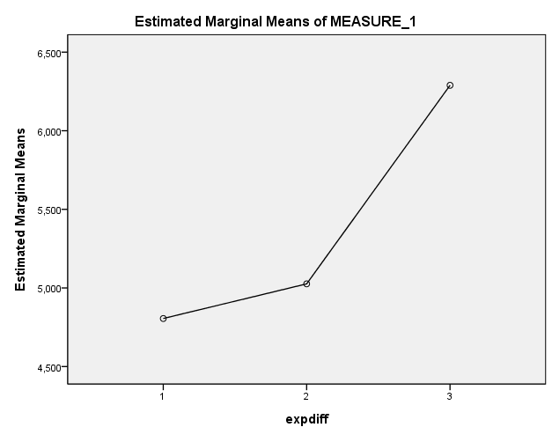

GLM GSR0_mean GSR1_mean GSR2_mean
/WSFACTOR=expdiff 3 Polynomial
/METHOD=SSTYPE(3)
/PLOT=PROFILE(expdiff)
/EMMEANS=TABLES(expdiff) COMPARE ADJ(BONFERRONI)
/CRITERIA=ALPHA(.05)
/WSDESIGN=expdiff.

General Linear Model
Within-Subjects Factors
Measure:MEASURE_1
expdiff | Dependent Variable
1 | GSR0_mean
2 | GSR1_mean
3 | GSR2_mean

Multivariate Tests^{b}
Effect |  | Value | F | Hypothesis df | Error df | Sig.
expdiff | Pillai's Trace | ,117 | 1,058ª | 2,000 | 16,000 | ,370
expdiff | Wilks' Lambda | ,883 | 1,058ª | 2,000 | 16,000 | ,370
expdiff | Hotelling's Trace | ,132 | 1,058ª | 2,000 | 16,000 | ,370
expdiff | Roy's Largest Root | ,132 | 1,058ª | 2,000 | 16,000 | ,370
a. Exact statistic
b. Design: Intercept
Within Subjects Design: expdiff

Tests of Within-Subjects Effects
Measure:MEASURE_1
Source |  | Type III Sum of Squares | df | Mean Square | F | Sig.
expdiff | Sphericity Assumed | ,012 | 2 | ,006 | ,703 | ,502
expdiff | Greenhouse-Geisser | ,012 | 1,035 | ,012 | ,703 | ,418
expdiff | Huynh-Feldt | ,012 | 1,041 | ,011 | ,703 | ,419
expdiff | Lower-bound | ,012 | 1,000 | ,012 | ,703 | ,413
Error(expdiff) | Sphericity Assumed | ,288 | 34 | ,008
Error(expdiff) | Greenhouse-Geisser | ,288 | 17,588 | ,016
Error(expdiff) | Huynh-Feldt | ,288 | 17,700 | ,016
Error(expdiff) | Lower-bound | ,288 | 17,000 | ,017

Tests of Within-Subjects Contrasts
Measure:MEASURE_1
Source | expdiff | Type III Sum of Squares | df | Mean Square | F | Sig.
expdiff | Linear | ,010 | 1 | ,010 | ,878 | ,362
expdiff | Quadratic | ,002 | 1 | ,002 | ,331 | ,572
Error(expdiff) | Linear | ,196 | 17 | ,012
Error(expdiff) | Quadratic | ,092 | 17 | ,005

Estimated Marginal Means
expdiff
Estimates
Measure:MEASURE_1
expdiff | Mean | Std. Error | 95% Confidence Interval
expdiff | Mean | Std. Error | Lower Bound | Upper Bound
1 | ,805 | ,036 | ,728 | ,882
2 | ,801 | ,039 | ,719 | ,883
3 | ,772 | ,056 | ,653 | ,890

Pairwise Comparisons
Measure:MEASURE_1
(I) expdiff | (J) expdiff | Mean Difference (I-J) | Std. Error | Sig.ª | 95% Confidence Interval for Differenceª
 |  |  |  |  | Lower Bound | Upper Bound
1 | 2 | ,005 | ,006 | 1,000 | -,012 | ,022
1 | 3 | ,034 | ,036 | 1,000 | -,062 | ,129
2 | 1 | -,005 | ,006 | 1,000 | -,022 | ,012
2 | 3 | ,029 | ,039 | 1,000 | -,074 | ,132
3 | 1 | -,034 | ,036 | 1,000 | -,129 | ,062
3 | 2 | -,029 | ,039 | 1,000 | -,132 | ,074
Based on estimated marginal means
a. Adjustment for multiple comparisons: Bonferroni.

Profile Plots
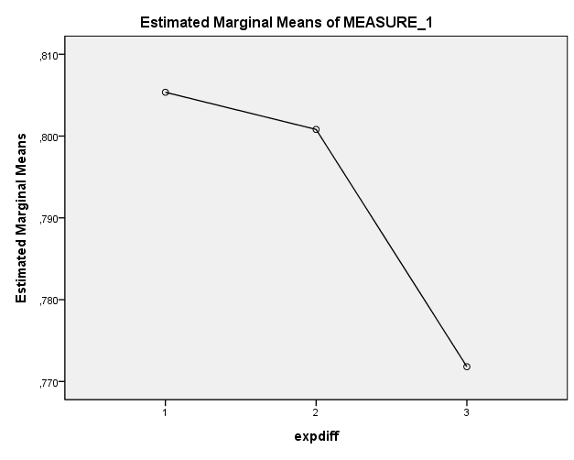

GLM Press0_sd Press1_sd Press2_sd
/WSFACTOR=expdiff 3 Polynomial
/METHOD=SSTYPE(3)
/PLOT=PROFILE(expdiff)
/EMMEANS=TABLES(expdiff) COMPARE ADJ(BONFERRONI)
/CRITERIA=ALPHA(.05)
/WSDESIGN=expdiff.

General Linear Model
Within-Subjects Factors
Measure:MEASURE_1
expdiff | Dependent Variable
1 | Press0_sd
2 | Press1_sd
3 | Press2_sd
Multivariate Tests^{b}
Effect |  |  | Value | F | Hypothesis df | Error df | Sig.
expdiff | Pillai's Trace |  | ,089 | ,780ª | 2,000 | 16,000 | ,475
expdiff | Wilks' Lambda |  | ,911 | ,780ª | 2,000 | 16,000 | ,475
expdiff | Hotelling's Trace |  | ,097 | ,780ª | 2,000 | 16,000 | ,475
expdiff | Roy's Largest Root |  | ,097 | ,780ª | 2,000 | 16,000 | ,475
a. Exact statistic
b. Design: Intercept
Within Subjects Design: expdiff

Tests of Within-Subjects Effects
Measure:MEASURE_1
Source |  | Type III Sum of Squares | df | Mean Square | F | Sig.
expdiff | Sphericity Assumed | 204,607 | 2 | 102,304 | ,432 | ,653
expdiff | Greenhouse-Geisser | 204,607 | 1,569 | 130,395 | ,432 | ,606
expdiff | Huynh-Feldt | 204,607 | 1,701 | 120,302 | ,432 | ,622
expdiff | Lower-bound | 204,607 | 1,000 | 204,607 | ,432 | ,520
Error(expdiff) | Sphericity Assumed | 8059,218 | 34 | 237,036
Error(expdiff) | Greenhouse-Geisser | 8059,218 | 26,675 | 302,123
Error(expdiff) | Huynh-Feldt | 8059,218 | 28,913 | 278,738
Error(expdiff) | Lower-bound | 8059,218 | 17,000 | 474,072

Tests of Within-Subjects Contrasts
Measure:MEASURE_1
Source | expdiff | Type III Sum of Squares | df | Mean Square | F | Sig.
expdiff | Linear | 57,474 | 1 | 57,474 | ,163 | ,691
expdiff | Quadratic | 147,133 | 1 | 147,133 | 1,203 | ,288
Error(expdiff) | Linear | 5979,543 | 17 | 351,738
Error(expdiff) | Quadratic | 2079,675 | 17 | 122,334

Estimated Marginal Means
expdiff
Estimates
Measure:MEASURE_1
expdiff | Mean | Std. Error | 95% Confidence Interval
expdiff | Mean | Std. Error | Lower Bound | Upper Bound
1 | 449,539 | 7,192 | 434,365 | 464,713
2 | 444,774 | 7,385 | 429,194 | 460,354
3 | 447,012 | 7,454 | 431,286 | 462,737

Pairwise Comparisons
Measure:MEASURE_1
(I) expdiff | (J) expdiff | Mean Difference (I-J) | Std. Error | Sig.ª | 95% Confidence Interval for Differenceª
 |  |  |  |  | Lower Bound | Upper Bound
1 | 2 | 4,765 | 3,922 | ,723 | -5,647 | 15,177
1 | 3 | 2,527 | 6,252 | 1,000 | -14,071 | 19,125
2 | 1 | -4,765 | 3,922 | ,723 | -15,177 | 5,647
2 | 3 | -2,238 | 4,955 | 1,000 | -15,393 | 10,917
3 | 1 | -2,527 | 6,252 | 1,000 | -19,125 | 14,071
3 | 2 | 2,238 | 4,955 | 1,000 | -10,917 | 15,393
Based on estimated marginal means
a. Adjustment for multiple comparisons: Bonferroni.

Profile Plots

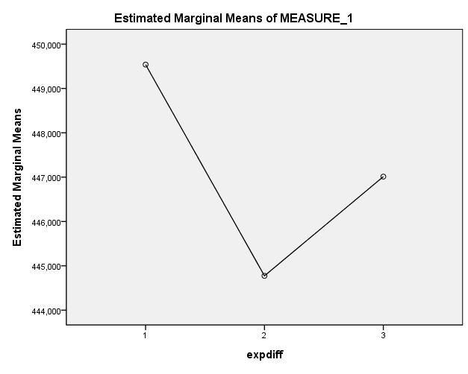

GLM EMG0_sd EMG1_sd EMG2_sd
/WSFACTOR=expdiff 3 Polynomial
/METHOD=SSTYPE(3)
/PLOT=PROFILE(expdiff)
/EMMEANS=TABLES(expdiff) COMPARE ADJ(BONFERRONI)
/CRITERIA=ALPHA(.05)
/WSDESIGN=expdiff.

General Linear Model
Within-Subjects Factors
Measure:MEASURE_1
expdiff | Dependent Variable
1 | EMG0_sd
2 | EMG1_sd
3 | EMG2_sd

Multivariate Tests^{b}
Effect |  | Value | F | Hypothesis df | Error df | Sig.
expdiff | Pillai's Trace | ,287 | 2,611ª | 2,000 | 13,000 | ,111
expdiff | Wilks' Lambda | ,713 | 2,611ª | 2,000 | 13,000 | ,111
expdiff | Hotelling's Trace | ,402 | 2,611ª | 2,000 | 13,000 | ,111
expdiff | Roy's Largest Root | ,402 | 2,611ª | 2,000 | 13,000 | ,111
a. Exact statistic
b. Design: Intercept
Within Subjects Design: expdiff

Tests of Within-Subjects Effects
Measure:MEASURE_1
Source |  | Type III Sum of Squares | df | Mean Square | F | Sig.
expdiff | Sphericity Assumed | 42,409 | 2 | 21,204 | 3,235 | ,054
expdiff | Greenhouse-Geisser | 42,409 | 1,871 | 22,671 | 3,235 | ,058
expdiff | Huynh-Feldt | 42,409 | 2,000 | 21,204 | 3,235 | ,054
expdiff | Lower-bound | 42,409 | 1,000 | 42,409 | 3,235 | ,094
Error(expdiff) | Sphericity Assumed | 183,553 | 28 | 6,555
Error(expdiff) | Greenhouse-Geisser | 183,553 | 26,188 | 7,009
Error(expdiff) | Huynh-Feldt | 183,553 | 28,000 | 6,555
Error(expdiff) | Lower-bound | 183,553 | 14,000 | 13,111

Tests of Within-Subjects Contrasts
Measure:MEASURE_1
Source | expdiff | Type III Sum of Squares | df | Mean Square | F | Sig.
expdiff | Linear | 26,519 | 1 | 26,519 | 3,308 | ,090
expdiff | Quadratic | 15,889 | 1 | 15,889 | 3,119 | ,099
Error(expdiff) | Linear | 112,240 | 14 | 8,017
Error(expdiff) | Quadratic | 71,313 | 14 | 5,094

Estimated Marginal Means
expdiff
Estimates
Measure:MEASURE_1
expdiff | Mean | Std. Error | 95% Confidence Interval
expdiff | Mean | Std. Error | Lower Bound | Upper Bound
1 | 3,419 | ,949 | 1,383 | 5,454
2 | 3,098 | ,705 | 1,585 | 4,611
3 | 5,299 | ,938 | 3,287 | 7,311

Pairwise Comparisons
Measure:MEASURE_1
(I) expdiff | (J) expdiff | Mean Difference (I-J) | Std. Error | Sig.ª | 95% Confidence Interval for Differenceª
 |  |  |  |  | Lower Bound | Upper Bound
1 | 2 | ,320 | ,819 | 1,000 | -1,906 | 2,547
1 | 3 | -1,880 | 1,034 | ,271 | -4,690 | ,929
2 | 1 | -,320 | ,819 | 1,000 | -2,547 | 1,906
2 | 3 | -2,201 | ,939 | ,103 | -4,753 | ,352
3 | 1 | 1,880 | 1,034 | ,271 | -,929 | 4,690
3 | 2 | 2,201 | ,939 | ,103 | -,352 | 4,753
Based on estimated marginal means
a. Adjustment for multiple comparisons: Bonferroni.

Profile Plots

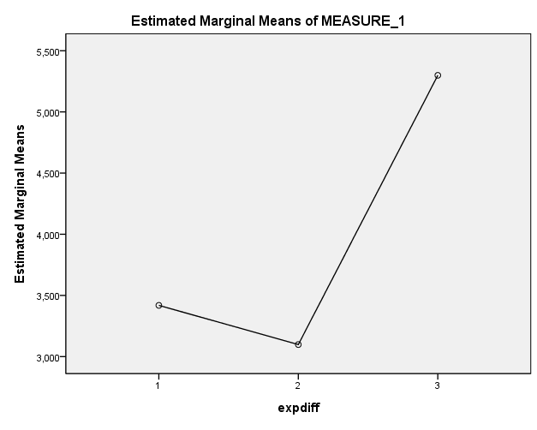

GLM GSR0_sd GSR1_sd GSR2_sd
/WSFACTOR=expdiff 3 Polynomial
/METHOD=SSTYPE(3)
/PLOT=PROFILE(expdiff)
/EMMEANS=TABLES(expdiff) COMPARE ADJ(BONFERRONI)
/CRITERIA=ALPHA(.05)
/WSDESIGN=expdiff.

General Linear Model
Within-Subjects Factors
Measure:MEASURE_1
expdiff | Dependent Variable
1 | GSR0_sd
2 | GSR1_sd
3 | GSR2_sd

Multivariate Tests^{b}
Effect |  |  | Value |  | F | Hypothesis df |  |  | Error df | Sig.
expdiff | Pillai's Trace |  | ,111 |  | ,995ª | 2,000 |  |  | 16,000 | ,391
expdiff | Wilks' Lambda |  | ,889 |  | ,995ª | 2,000 |  |  | 16,000 | ,391
expdiff | Hotelling's Trace |  | ,124 |  | ,995ª | 2,000 |  |  | 16,000 | ,391
expdiff | Roy's Largest Root |  | ,124 |  | ,995ª | 2,000 |  |  | 16,000 | ,391
a. Exact statistic
b. Design: Intercept
Within Subjects Design: expdiff

Tests of Within-Subjects Effects
Measure:MEASURE_1
Source |  |  |  | Type III Sum of Squares |  |  | df | Mean Square |  |  | F |  | Sig.
expdiff |  | Sphericity Assumed |  | ,001 |  |  | 2 | ,000 |  |  | 1,801 |  | ,181
 |  | Greenhouse-Geisser |  | ,001 |  |  | 1,087 | ,001 |  |  | 1,801 |  | ,197
 |  | Huynh-Feldt |  | ,001 |  |  | 1,104 | ,001 |  |  | 1,801 |  | ,197
 |  | Lower-bound |  | ,001 |  |  | 1,000 | ,001 |  |  | 1,801 |  | ,197
Error(expdiff) |  | Sphericity Assumed |  | ,007 |  |  | 34 | ,000
 |  | Greenhouse-Geisser |  | ,007 |  |  | 18,481 | ,000
 |  | Huynh-Feldt |  | ,007 |  |  | 18,769 | ,000
 |  | Lower-bound |  | ,007 |  |  | 17,000 | ,000

Tests of Within-Subjects Contrasts
Measure:MEASURE_1
Source | expdiff | Type III Sum of Squares | df | Mean Square | F | Sig.
expdiff | Linear | 2,610E-5 | 1 | 2,610E-5 | ,588 | ,454
expdiff | Quadratic | ,001 | 1 | ,001 | 1,939 | ,182
Error(expdiff) | Linear | ,001 | 17 | 4,442E-5
Error(expdiff) | Quadratic | ,007 | 17 | ,000

Estimated Marginal Means
expdiff
Estimates
Measure:MEASURE_1
expdiff | Mean | Std. Error | 95% Confidence Interval
expdiff | Mean | Std. Error | Lower Bound | Upper Bound
1 | ,026 | ,003 | ,020 | ,033
2 | ,033 | ,007 | ,019 | ,048
3 | ,025 | ,002 | ,020 | ,029

Pairwise Comparisons
Measure:MEASURE_1
(I) expdiff | (J) expdiff | Mean Difference (I-J) | Std. Error | Sig.ª | 95% Confidence Interval for Differenceª
 |  |  |  |  | Lower Bound | Upper Bound
1 | 2 | -,007 | ,005 | ,505 | -,020 | ,006
1 | 3 | ,002 | ,002 | 1,000 | -,004 | ,008
2 | 1 | ,007 | ,005 | ,505 | -,006 | ,020
2 | 3 | ,009 | ,007 | ,597 | -,009 | ,026
3 | 1 | -,002 | ,002 | 1,000 | -,008 | ,004
3 | 2 | -,009 | ,007 | ,597 | -,026 | ,009
Based on estimated marginal means
a. Adjustment for multiple comparisons: Bonferroni.

Profile Plots
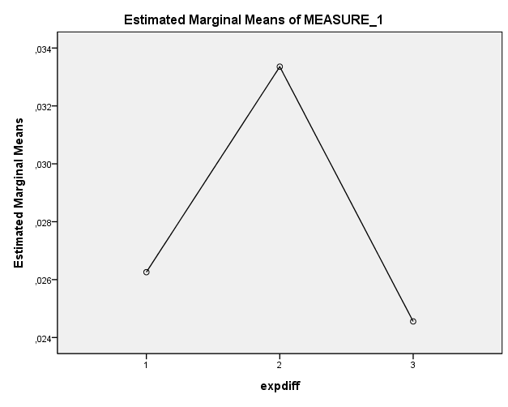

This was copied from a software student (under the name of Dr_Asik) and can be found at http://drasik.blogspot.com/2008/12/xna-pac-man.html.

