

Laboratory Instructions

Prescription Number(s): ECEN303

Laboratory Number: 1

Laboratory Title: Electronics Survival Guide

Name: __

Student number: __

# 1.1 Aim

This lab contains a summary of the important things that you need to know for the start of ECEN303: Analogue Electronics. You may have seen most of the content before, although it’s OK if some of it has slipped your mind since last year. Aim to complete the exercises that follow within the first week of the course, and keep these lab notes as a handy reference for the rest of the semester.

# 1.2 Setup

Before you begin building circuits, take a moment to setup your workspace. Set the power supply on your bench to provide two dependent rails and connect these to a breadboard. Also connect a 1 *µ*F tantalum capacitor between each rail and ground, in order to reduce the likelihood of HF interference and/or oscillation in your active circuits. Take care to connect the capacitors the right way round, as they are polarised (shorter leg is negative).

Connect probes to the oscilloscope and set them to 10× mode using the slider switch on each probe. Also change the probe multiplication setting on the oscilloscope, by selecting *CH X Menu* → *Probe* (*second softkey from the bottom*) → *Attenuation* 10*x*. On the

function generator, set the impedance mode of each output to High Z by selecting *OutputMenu* → *Load Impedance* → *High Z* using the oscilloscope soft keys. Finally, connect a pair of banana↔alligator cables to the bench multimeter, to aid resistance measurements later in the lab.

# 1.3 Voltage Dividers

Construct the circuit shown in Fig. 1.1 on a breadboard and measure the voltage at node *vX*, recording the result on Fig. 1.1.

*v*2 = 11V

*R*2 = 4*.*7kΩ

*vX*

*R*1 = 1kΩ

*v*1 = 0V

Figure 1.1: Voltage divider circuit.

Now replace *R*2 with another resistor so that *vX* = 1V. Show your calculations and record the new value of *R*2 in the box below. Use a multimeter to confirm your values.

|  |
| --- |
| (calculation) ± (uncertainty) (units) |

*R*2

• Hence, derive an equation for *vX* in terms of *v*1, *v*2, *R*1 and *R*2.

|  |
| --- |
| (calculation) ± (uncertainty) (units) |

Voltage divider equation:

# 1.4 Non-inverting Amplifier

Construct the circuit shown in Fig. 1.2 on a breadboard. Power the op-amp with ±15 V rails and connect a 1 Vpp, 1 kHz ac signal from the signal generator to *vI*. Be sure to include 1 *µ*F decoupling capacitors between the power supply rails and ground. Using an oscilloscope, measure the voltages at *vO*, *vXN* and *vXP* . Record your measurements on Fig. 1.2.

*R*

1

=1

kΩ

*R*

2

=10

kΩ

*v*

*O*

*v*

*I*

*v*

*XP*

*v*

*XN*

Figure 1.2: Non-inverting amplifier circuit.

What is the voltage difference between *vXP* and *vXN*, and how does this compare in size to *vI* and *vO*?

* Hence, explain the term *virtual short* in the context of a non-inverting amplifier. Note that when either *vXN* or *vXP* are connected to ground we say that the other input is a *virtual ground*.

Use the voltage divider equation you derived earlier, together with your knowledge of the relationship between *vXP* and *vXN*, to calculate the gain of the non-inverting amplifier,.

Make sure your calculation agrees with the measurements of *vO* and *vI* that you took earlier.

|  |
| --- |
| (calculation) ± (uncertainty) (units) |

*A*non−inv

* In summary, derive an equation for the voltage gain, *A*non−inv, of a non-inverting amplifier in terms of *R*1 and *R*2.

|  |
| --- |
| (calculation) ± (uncertainty) (units) |

Gain equation for a

non-inverting amplifier:

# 1.5 Voltage Follower

As a special case of a non-inverting amplifier, we can make *R*1 = ∞ and *R*2 = 0, to give the circuit shown in Fig. 1.3. In this case the gain is given by

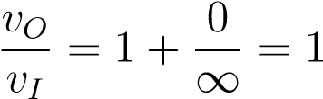 (1.1)

That is, the circuit has a voltage gain of one, so the output is equal to the input. Note that to improve stability, it is often a good idea to make *R*2 a small resistor, say ∼ 50Ω.

*v*

*O*

*v*

*I*

Figure 1.3: Voltage follower circuit.

Although an amplifier with unity gain may seem superfluous at first, its true benefit is shown when we examine its input and output impedances. Connect a 5 Vdc signal to the *vI* input on the voltage follower via an 820kΩ resistor. Using an oscilloscope, carefully measure the mean (i.e. dc) voltages on either side of the resistor, *vS* and *vI*:

|  |
| --- |
| (measurement) ± (uncertainty) (units) |

*vS*

|  |
| --- |
| (measurement) ± (uncertainty) (units) |

*vI*

Also measure the exact impedance of the 820kΩ resistor, *R*820kΩ, using a multimeter.

|  |
| --- |
| (measurement) ± (uncertainty) (units) |

*R*820kΩ

Knowing two voltages and a resistance, use the voltage divider equation to find the unknown input impedance of the voltage follower, *Z*in:

|  |
| --- |
| (calculation) ± (uncertainty) (units) |

*Z*in

Remove the 820kΩ resistor from the circuit and connect a 100mVdc signal directly to *vI*. Measure the no-load output voltage of the voltage follower, *vO,*NL:

|  |
| --- |
| (measurement) ± (uncertainty) (units) |

*vO,*NL

Now connect a 10Ω resistor between *vO* and ground and remeasure *vO*:

|  |
| --- |
| (measurement) ± (uncertainty) (units) |

*vO,*10Ω

Finally, measure the exact impedance of the 10Ω resistor:

|  |
| --- |
| (measurement) ± (uncertainty) (units) |

*R*10Ω

• Knowing two voltages and a resistance, use the voltage divider equation to find the unknown output impedance of the voltage follower, *Z*out:

|  |
| --- |
| (calculation) ± (uncertainty) (units) |

*Z*out

How does *Zin* compare to *Zout* for the voltage follower? Are these values consistent with what we would expect for an ideal load (∞Ω) and an ideal source (0Ω)? Hence, give an example of an application where a voltage follower would be useful.

# 1.6 Inverting Amplifier

Construct the circuit shown in Fig. 1.4 on a breadboard. Use the same power supply and ac input arrangements that you used for the non-inverting amplifier.

*R*

1

=1

kΩ

*R*

2

=10

kΩ

*v*

*O*

*v*

*I*

*v*

*XN*

*v*

*XP*

Figure 1.4: Inverting amplifier circuit.

Using two oscilloscope probes to measure voltages on either side of a resistor, find the currents flowing through *R*1 and *R*2, i.e. *i*1 and *i*2. Note these currents on Fig. 1.4. Hence, calculate the current flowing into the op-amp’s inverting input, *iN* = *i*1 − *i*2:

|  |
| --- |
| (calculation) ± (uncertainty) (units) |

*iN*

How does *iN* compare to *i*1 and *i*2? What does this tell us about the inputs of an op-amp?

Based on this result calculate the voltage gain for this circuit, , using Kirchoff’s current law at node *vXN*.

|  |
| --- |
| (calculation) ± (uncertainty) (units) |

*A*inv

Secure in the knowledge that *vXN* is a virtual ground, use the voltage divider equation from the previous section to recalculate *A*inv.

|  |
| --- |
| (calculation) ± (uncertainty) (units) |

*A*inv

Finally, compare your two calculated results to your measurements for *vI* and *vO*. Do they all agree? If not, have you noted the phase of each measurement?

• In summary, what is the equation for the voltage gain, *A*inv, of an inverting amplifier?

|  |
| --- |
| (calculation) ± (uncertainty) (units) |

Gain equation for an inverting amplifier:

# 1.7 Impedance

Modify your inverting amplifier circuit by adding a resistor, *R*3, between *vXN* and *vO* so that the gain of your amplifier is reduced to ∼−3×. Record the changes to your circuit on Fig. 1.5 and show your calculations, including the new gain, below.

*R*

1

=1

kΩ

*R*

2

=10

kΩ

*v*

*O*

*v*

*I*

*v*

*XN*

*v*

*XP*

Figure 1.5: Inverting amplifier with reduced gain.

Remove *R*2 and *R*3 from your circuit and replace them with a 10 nF capacitor, *C*1, as shown in Fig. 1.6. Choose the value of *R*1 such that the gain of your amplifier is roughly −10× for an input frequency of 1 kHz.

*R*

1

*v*

*O*

*v*

*I*

*v*

*XN*

*v*

*XP*

*C*

1

=10

nF

Figure 1.6: Integrator circuit.

Record your calculations and the value of *R*1 below, and confirm that your calculations are correct by measuring *vI* and *vO* with the oscilloscope.

In particular, measure the phase difference between *vI* and *vO*.

|  |
| --- |
| (measurement) ± (uncertainty) (units) |

*φvI*−*vO*

Does *vO* lead or lag *vI*?

Now add a second capacitor, *C*2, between *vXN* and *vO* to reduce the gain to ∼−7× at 1 kHz. Record the changes to your circuit on Fig. 1.7 and show your calculations, including the new gain, below. Again, confirm your calculations by taking measurements with the oscilloscope.

*R*

1

*v*

*O*

*v*

*I*

*v*

*XN*

*v*

*XP*

*C*

1

=10

nF

Figure 1.7: Integrator with reduced gain.

In summary, complete Table 1.1 based on your experiments with resistors and capacitors. Use background knowledge, your ECEN203 notes, or Google to complete the inductors column.

|  |  |  |  |
| --- | --- | --- | --- |
|  | Resistors | Capacitors | Inductors |
| Ohm’s Law | *v* = *iR* | *i* = *C* dd*vt* | *v* = *L*dd*ti* |
| Impedance  (Fourier notation) | *ZR* = | *ZC* = | *ZL* = |
| Impedance  (Laplace notation) | *ZR* = | *ZC* = | *ZL* = |
| Parallel components | *R*1*//R*2 = | *C*1*//C*2 = | *L*1*//L*2 = |

Table 1.1: Impedance for ideal resistors, capacitors and inductors.

# 1.8 Integrator

So far, we have only looked at the performance of the integrators in Figs. 1.6 and 1.7 at a single frequency of 1 kHz. Based on the entries in Table 1.1, what do you expect to happen to the gain of the integrator at higher frequencies?

Measure the gain and phase response of your integrator over a handful of frequencies, and record the results in Fig. 1.8. Note that the behaviour of the integrator is uniform for all frequencies, i.e. the trends in gain and phase that you see at one frequency, say 10 krad/s, are equally valid at another frequency, say 100 rad/s.

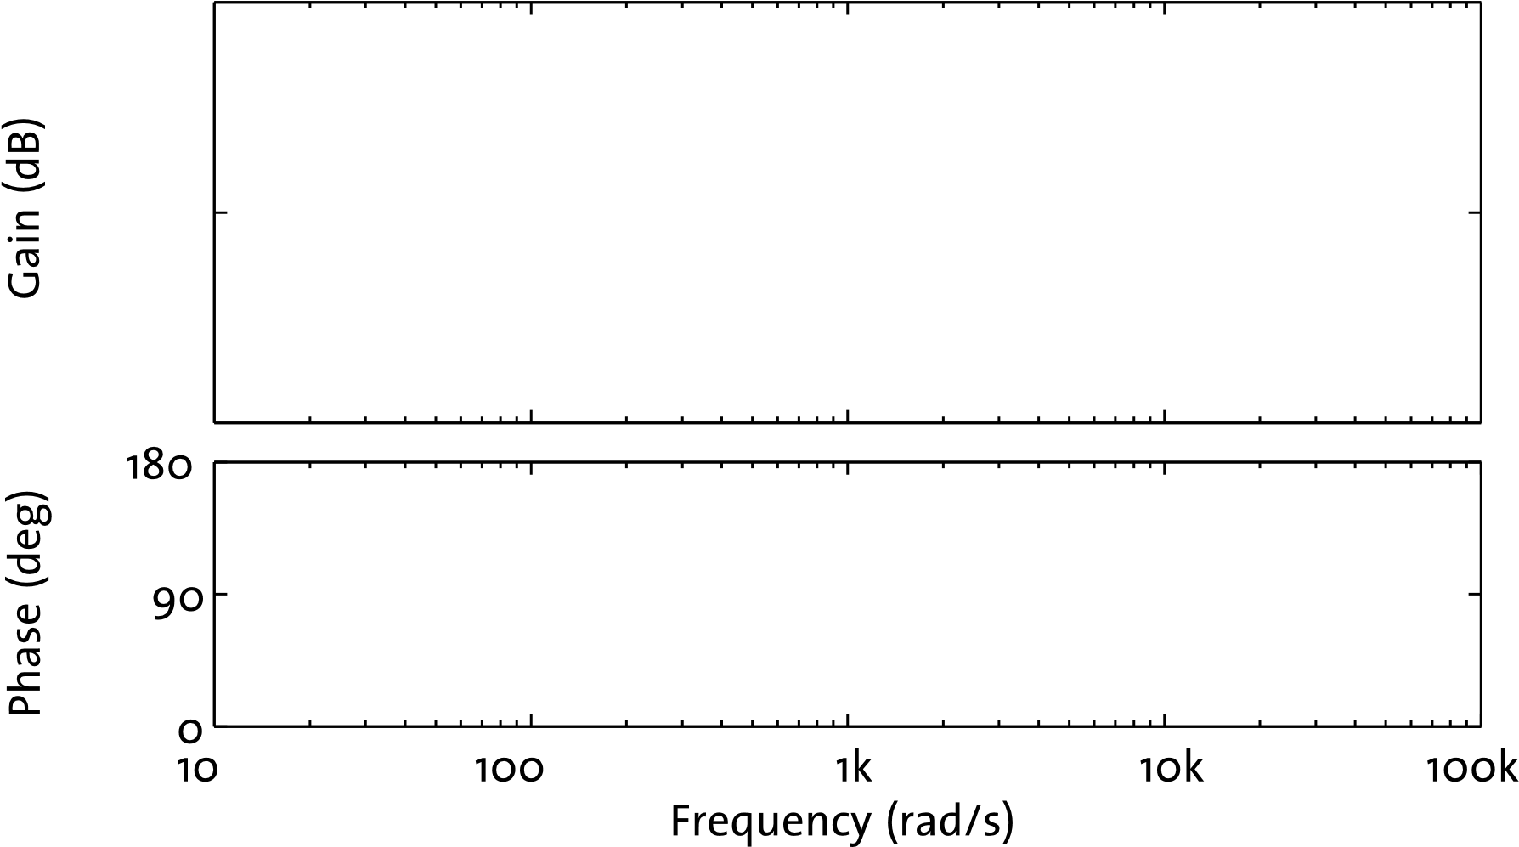

Figure 1.8: Gain and phase response for the integrator circuit shown in Fig. 1.7.

• Based on Fig. 1.8 and your earlier calculations, derive an expression for the transfer function of your integrator circuit,, in terms of *R*, *C*, and *s*, the Laplacian variable. Note that you can use either a voltage-divider analysis, which relies on the voltage at the op-amp’s inputs being equal, or a current node analysis, which relies on no current flowing into the op-amp’s inputs.

|  |
| --- |
| (calculation) ± (uncertainty) (units) |

Integrator transfer function:

# 1.9 First Order Low Pass Filter

Construct the circuit shown in Fig. 1.9 on a breadboard, using

|  |  |  |
| --- | --- | --- |
| *R*1 | = 1kΩ | (1.2) |
| *R*2 | = 10kΩ | (1.3) |
| *C* | = 10nF | (1.4) |

Note that this circuit is very similar to the integrator shown in Fig. 1.6, with the addition of a resistor, *R*2, in parallel with the capacitor, *C*. In fact, it can be thought of as a *leaky integrator*, because charge leaks off the capacitor through *R*2.

*R*

1

*R*

2

*v*

*O*

*v*

*I*

*C*

Figure 1.9: First order active low pass filter circuit.

Measure the gain and frequency response of your circuit and record the results on Fig. 1.10.

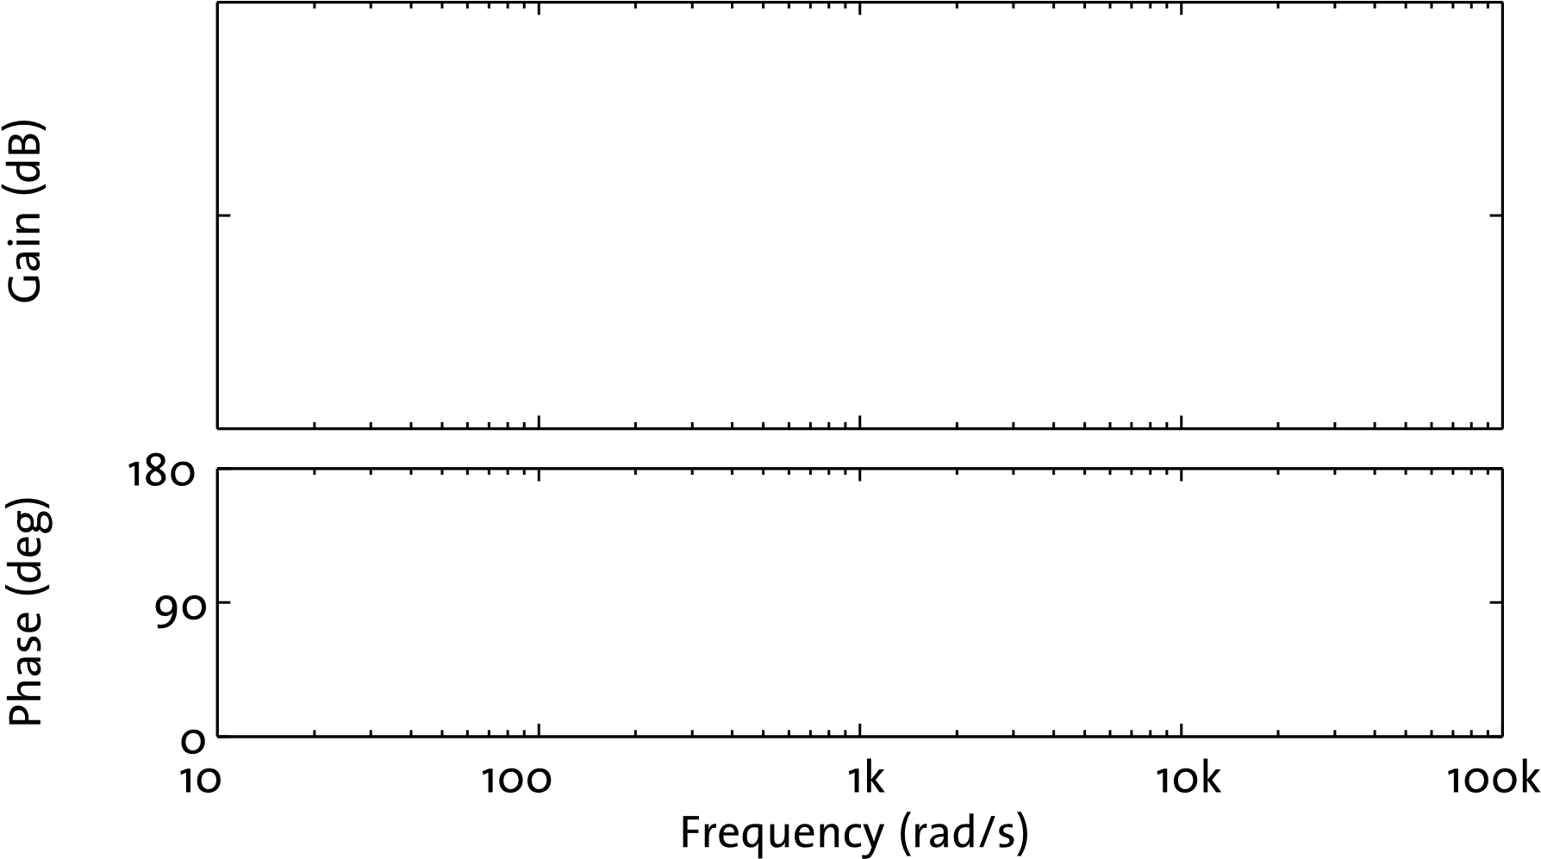

Figure 1.10: Gain and phase response for the low pass filter circuit shown in Fig. 1.9.

Based on your plotted results, what are the pass-band gain and cut-off frequency1 for this low pass filter circuit?

|  |
| --- |
| (measurement) ± (uncertainty) (units) |

*ALPF*

|  |
| --- |
| (measurement) ± (uncertainty) (units) |

*fL*

• Using the fact that *vXN* = *vXP* = 0V, derive the frequency response of the low pass filter circuit, , by treating *R*1, *R*2, and *C* as a voltage divider network.

Check that the equation you derive is consistent with your measured values for gain and cut-off frequency.

# 1.10 Differentiator

• Calculate the transfer function of the differentiator circuit shown in Fig. 1.11 by equating the currents *iC* and *iR* that flow through node *vN*. As before, use *R* = 100kΩ and *C* = 10nF.

1Cut-off frequency: the frequency at which the voltage gain is 3dB less than the pass-bound gain. −3dB = v02 √v0 =0*.*707v0.

=

2 2

*R*

*v*

*O*

*v*

*I*

*v*

*N*

*i*

*R*

*i*

C

*C*

Figure 1.11: Differentiator circuit.

|  |
| --- |
| (calculation) ± (uncertainty) (units) |

Differentiator transfer function:

Note the similarities between this transfer function and the integrator transfer function found in Section 1.8.

Now draw the gain and phase response that you expect for the differentiator on Fig. 1.12.

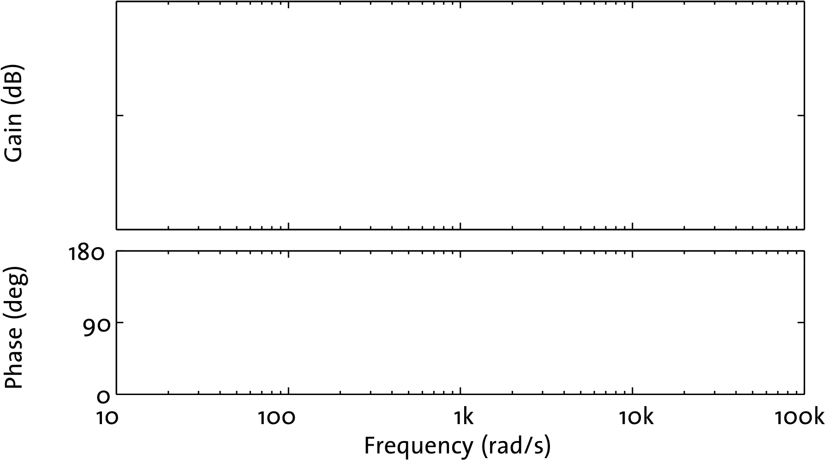

Figure 1.12: Gain and phase response for the differentiator circuit shown in Fig. 1.11.

Once you have made your prediction, build the differentiator circuit on your breadboard and measure its gain and phase response at a handful of different frequencies using the function generator and oscilloscope. Plot the results over your predictions in Fig. 1.12.

Note that your results may not be as expected, since this differentiator circuit typically suffers from noise and stability problems. A quick and dirty solution to the stability issue is to add a resistor in parallel with the capacitor, to give a high pass filter similar to the low pass filter shown in Fig. 1.9.

# 1.11 Summing and Difference Amplifiers

One amplifier configuration that you may not have seen before is the summing amplifier, shown in Fig. 1.13.

*v*

2

*v*

*O*

*R*

2

*R*

f

*R*

1

*v*

1

Figure 1.13: Two-input summing amplifier circuit.

Using either a sum-of-currents or virtual ground approach, derive an expression for *vO* in terms of *v*1, *v*2, *R*1, *R*2 and *Rf*:

|  |
| --- |
| (calculation) ± (uncertainty) (units) |

*vO,*summing amp

* Hence, explain how the summing amplifier works.

Note that we can easily extend the amplifier to contain an arbitrary number of inputs.

Similar to the summing amp but slightly more complicated is the difference amplifier, shown in Fig. 1.14.

*R*

1

*R*

2

*v*

*O*

*v*

1

*R*

4

*R*

3

*v*

2

Figure 1.14: Difference amplifier circuit.

Assuming *R*3 = *R*1 and *R*4 = *R*2, derive an expression for *vO* in terms of *v*1 and *v*2.

|  |
| --- |
| (calculation) ± (uncertainty) (units) |

*vO,*difference amp

* Using an LM324 quad op-amp chip, build the summing amplifier shown in Fig. 1.13 on your breadboard, choosing resistor values to give each input unity gain. Connect a 1 Vpp, 1 kHz sine wave signal to the *v*1 input and connect a 10 kHz, 200 mVpp square wave signal to the *v*2 input. The sine wave represents a signal we are trying to measure and the smaller square wave represents unwanted noise. Use the oscilloscope to view both input signals and the output signal; thus confirm that your summing amplifier circuit is working.
* Configure one of the free op-amps on the LM324 chip as an inverting amplifier with unity gain and connect the output of the summing amplifier to the input of the inverter, as shown in Fig. 1.15. Confirm that the circuit is behaving as expected by examining the inverter’s input and output waveforms on the oscilloscope.

Summing Amp Inverter Difference Amp

*v*

2

*R*

2

*R*

f

*R*

1

*v*

1

*R*

3

*R*

4

*R*

5

*R*

6

*v*

*O*

*R*

8

*R*

7

*v*

4

*v*

3

Figure 1.15: Summing and difference amplifier circuit.

* Finally, build a difference amplifier on your breadboard, again configured with unity gain (*R*5 = *R*6 = *R*7 = *R*8). Connect the output of the inverter to the *v*3 input of the difference amplifier, and connect the *v*4 input to the same square wave ‘noise’ signal that is connected to the summing amplifier’s *v*2 input, as shown in Fig. 1.15.
* Capture the output of the summing amplifier, the output of the inverter, and the output of the difference amplifier on the oscilloscope at the same time. Note that you will probably need to use averaging to remove unwanted HF noise (real noise, not square wave ‘noise’) from the output of the difference amplifier. Save a screenshot to a USB drive or CF card and print it out to stick into Fig. 1.16.

Figure 1.16: Noisy waveform from summing amplifier, inverted noisy waveform, and cleaned waveform from difference amplifier.

END OF LAB