**EEEN313 and ECEN405 Assignment 1**

**Total marks: 115 (Contribution: 15%)**

Below are the problems for this assignment. Do your calculation as needed and then put your final answers as well any discussion or plots in the spaces required.

Submit this document with a filename:

ECEN405_Assmt_2021_”your surname”-“your initial” on the Wiki submission system no later than 13 August by 11.59 pm.

You are welcome to discuss and find best ways to solve the problem/s. Please make sure you DON’T copy-paste the solution.

**Name: ……………………………………………………………………………………………..**

**Student Number:……………………………………………………………………………….**

**Q1.** The voltage and current for a device are periodic functions with T= 100ms is described as the following. Determine (a) the instantaneous power (b) average power and (c) energy absorbed by the device in one time period.



Answer (15)

**Q2.** Induction cooking based on power electronics is estimated to be 80% efficient compared to 55% for conventional electrical cooking. If the average home consumes 2kW-hrs of daily using conventional electric heating and one million households switch to induction cooking, calculate the annual savings in electricity usage.

Answer (15)

**Q3.** Find Real, Reactive and Apparent power for following load configuration.

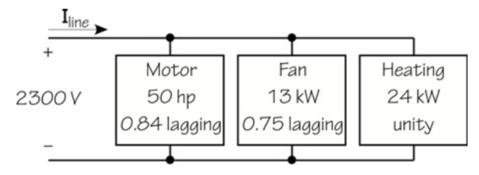

Answer: (15)

**Q4.** A 4,160-V, 50-Hz, 3∅ system supplies a 720-kW load at 0.82 lagging power factor through lines with a line impedance of 1.5 + j3.6 Ω/∅. (∅ is often written for “phase.”) Find the line current, the percent efficiency, the percent voltage regulation, and the generator power factor, and generator voltage.

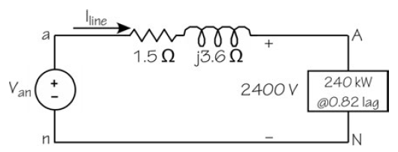

Answer: (20)

**Q5.** The circuit of the figure on slide 13 (Energy Recovery) of your ‘power computations2’ notes on energy recovery has Vcc = 90V, L=200mH, R=20Ω, t1=10ms, and T=100ms. Determine (a) the peak current and peak energy storage in the inductor, (b) the average power absorbed by the resistor and (c) the peak and average power supplied by the source.

Answer: (15)

**Q6.** For the following circuit, find P, Q and the power factor.

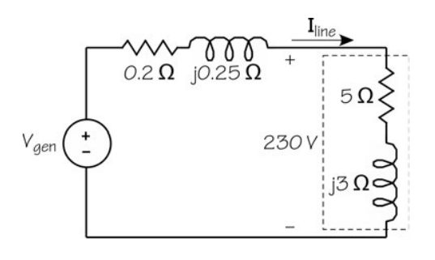

Answer: (15)

**Q7**: In your own words, write the relationship between Apparent, Real and Reactive Powers. How is Power Factor related to them? Describe how would you provide a solution if your house has a Power Factor of 0.3 to improve it to 0.9?

Answer: (20)