**EEEN313 and ECEN405 Assignment 2**

**Total marks: 150 (Contribution: 20%)**

**Due date: 15 Oct 2359 on Wiki.**

**Note: Please note that 10% (15 Marks) of the mark will be allocated to professionalism of the report including neatly written, well laid, and highlighting the answer so that we don’t have to scavenge for answers when marking.**

**Failing to write the steps towards achieving a solution will cost you 10% (15 Marks).**

Below are the problems for this assignment. Do your calculation as needed and then put your final answers as well any discussion or plots in the spaces required.

Submit this document with a filename:

ECEN405_Assmt_2021_”your surname”-“your initial” on the Wiki submission system no later than 1 October by 11.59 pm.

You are welcome to discuss with others and find best ways to solve the problem/s. Please make sure you DON’T copy-paste the solution.

**Name: Daniel Eisen**

**Student Number: 300447549**

**Q1.** In a single-phase diode rectifier bridge, Is = 10A(rms), Is1 = 8A(rms), and DPF = 0.85. Calculate Idistortion, %**THD**, and PF.

Answer (10)

**Q2.** Calculate the percentage **harmonic distortion** of individual component and total THD for an output signal having a fundamental amplitude of 5 V, second harmonic amplitude of 0.5V and a third and fourth harmonic components of 0.3 and 0.2.

Answer (15)

**Q3.** A **magnetic core** has the following properties: The core Area Am is 0.931 cm2, the magnetic path length is 3.76 cm and the relative permeability of the material µr is 5000.

i. Calculate the Reluctance of the core.

ii. Calculate the reluctance of an air gap of length 1mm is introduced in the core.

iii. A coil with 25 turns is wound on the core with an air gap introduced in ii. Calculate the inductance of the coil.

iv. If the flux density in the core of (iii) is not to exceed 0.2T, what is the maximum current that can be allowed to flow through the inductor coil?

v. At the maximum current calculated in (iv), calculate the energy stored in the magnetic core and the air gap. Compare the two.

Answer: (30)

**Q4.** A current of 50 mA is applied to the coil of example in **EM** lecture slide 17 (replicated below). Find the total flux in the core, the flux density B, and the magnetic field intensity H.

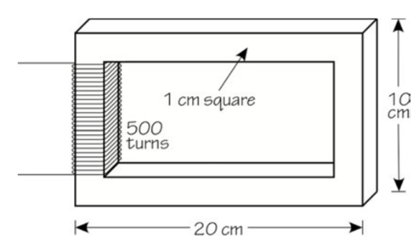

Answer: (10)

**Q5.** For a similar **motor** discussed in an example in the lecture notes, the rated efficiency was 91.7%. Catalog data shows voltage is 230/460 V, current is 25/12.5 A and power factor is 82%, full-load speed is 1765 rpm. Check (write your procedure) the efficiency is correct with the given data. How much will it cost to run the motor at full load for 16 hours per day, five days a week, and 50 weeks a year? Assume the plant has a contracted rate of 12 cents per kwh.

Answer: (10)

**Q6.** A 10-hp, 3-phase, 50-Hz **motor** has a full-load speed of 1,165 rpm. It is rated at 230/460 volts, 34.0/17.0 amperes full load, 71% power factor. Rotational losses are estimated to be 175 W. Find the following:

1. Number of poles and slip.
2. Torque output
3. Power input and efficiency.
4. Power lost in the rotor and stator.

Answer: (20)

**Q7**: For the above motor, specify the capacitance per phase (in kVARs) needed to improve the power factor to 92%. Then find the magnitude of the line current with the added capacitance.

Answer: (15)

**Q8**: In a single phase 50Hz **power factor correction** circuit, Vs = 240V (rms), Vd = 500V and the output power is 600W. Calculate iL(t), d(t) and the average current id through the output diode. Calculate the second harmonic peak voltage in the capacitor if C = 690µF.

Answer: (15)

**Q9**: In a 2-pole, three-phase **PMAC motor drive**, the torque constant kT, phase and the  
voltage constant kE, 1-phase are 0.5 in MKS units. The synchronous inductance is  
20mH (neglect the winding resistance). This motor is supplying a torque of 3 Nm at  
a speed of 3,000 rpm in a balanced sinusoidal steady state. Calculate the per-phase  
voltage across the power-processing unit as it supplies controlled currents to this  
motor.

Answer: (25)