**CHAPTER 2: VARIABLES AND DATA TYPES**

## **2-1. Simple Message: Store a message in a variable, and then print that**

## **message.**

# CODE

message="I am Eisha and I am doing Task3"

print(message)

# SCREENSHOT OF OUTPUT

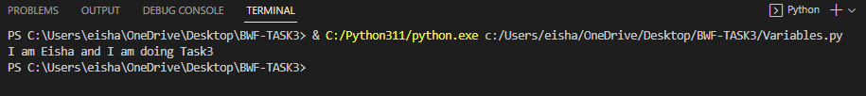

## **2-2. Simple Messages: Store a message in a variable, and print that message.Then change the value of your variable to a new message, and print the new message.**

# CODE

message="I am Eisha and I am doing Task3"

print(message)

message="I forgot to mention my full name. SO my name is Eisha Fatima and I am doing Task 3"

print(message)

# SCREENSHOT OF OUTPUT

## **2-3. Personal Message: Store a person’s name in a variable, and print a message to that person. Your message should be simple, such as, “Hello Eric,would you like to learn some Python today?”**

# CODE

name="Eisha"

print(f'Hello {name}, hope you are enjoying learning python!')

# SCREENSHOT



## **2-4. Name Cases: Store a person’s name in a variable, and then print that per-**

## **son’s name in lowercase, uppercase, and titlecase.**

# CODE

name="Eisha"

print(f'Lowercase={name.lower()}\nUppercase={name.upper()}\nTitlecase={name.title()}')

# SCREENSHOT

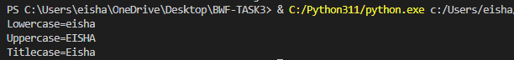

## **2-5. Famous Quote: Find a quote from a famous person you admire. Print the quote and the name of its author. Your output should look something like the**

## **following, including the quotation marks:**

## **Albert Einstein once said, “A person who never made a**

## **mistake never tried anything new.”**

# CODE

print(f'Hazrat Ali(A.S) said,"Be like the flower that gives its fragrance even to the hand that crushes it"')

# SCREENSHOT OF OUTPUT



## **2-6. Famous Quote 2: Repeat Exercise 2-5, but this time store the famous per-**

## **son’s name in a variable called famous_person. Then compose your message**

## **and store it in a new variable called message. Print your message.**

# CODE

famous_person="Hazrat Ali(A.S)"

message=f'{famous_person} said,"Be like the flower that gives its fragrance even to the hand that crushes it"'

print(message)

# SCREENSHOT OF OUTPUT



## **2-7. Stripping Names: Store a person’s name, and include some whitespace**

## **characters at the beginning and end of the name. Make sure you use each**

## **character combination, "\t" and "\n", at least once.**

# CODE

name="\tEisha\t\n\t\tFatima\t"

print(f"Original string:{name}")

print(f'Using lstrip={name.lstrip()}')

print(f'Using rstrip={name.rstrip()}')

print(f'Using strip={name.strip()}')

# SCREENSHOT OF OUTPUT

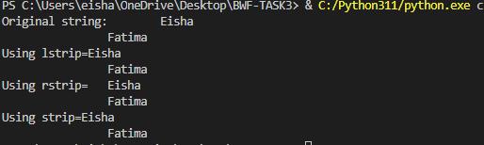

## **2-8. Number Eight: Write addition, subtraction, multiplication, and division operations that each result in the number 8. Be sure to enclose your operations in print statements to see the results. You should create four lines that look**

## **like this:**

## **print(5 + 3)**

## **Your output should simply be four lines with the number 8 appearing once on each line.**

# CODE

print(f'Using Addition:{4+4}')

print(f'Using Multiplication:{4*2}')

print(f'Using Subtraction:{8-4}')

print(f'Using Division:{16/2}')

# SCREENSHOT OF OUTPUT

## **2-9. Favorite Number: Store your favorite number in a variable. Then, using**

## **that variable, create a message that reveals your favorite number. Print that**

## **message.**

# CODE

fav_num=8

message=f'My favourite number is:{fav_num}'

print(message)

# SCREENSHOT OF OUTPUT



## **2-10. Adding Comments: Choose two of the programs you’ve written, and add at least one comment to each. If you don’t have anything specific to write because your programs are too simple at this point, just add your name and the current date at the top of each program file. Then write one sentence**

## **describing what the program does.**

# CODE

# A program that outputs number 8

print(f'Using Addition:{4+4}')

print(f'Using Multiplication:{4*2}')

print(f'Using Subtraction:{8-4}')

print(f'Using Division:{16/2}')