TASK 1
TOPIC 1:
Starting with Git
- Git Configuration:
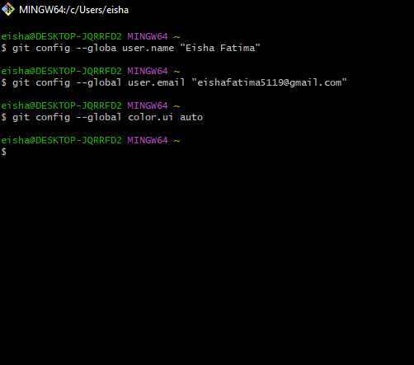

Initializing Git Repo(Local):
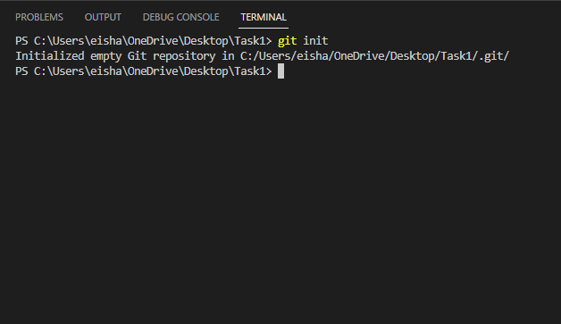

Creating a gitignore file which will contain the files that we want to ignore in our commits.
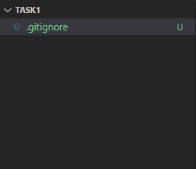
Now creating a random file to show the procedure of ignoring a file.
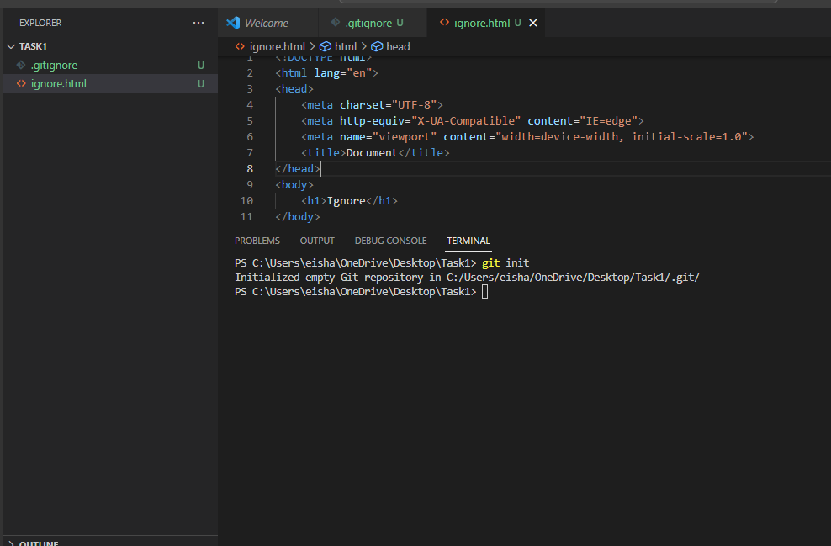
Now we declare the path of ignore.html in the gitignore file to ignore that file.
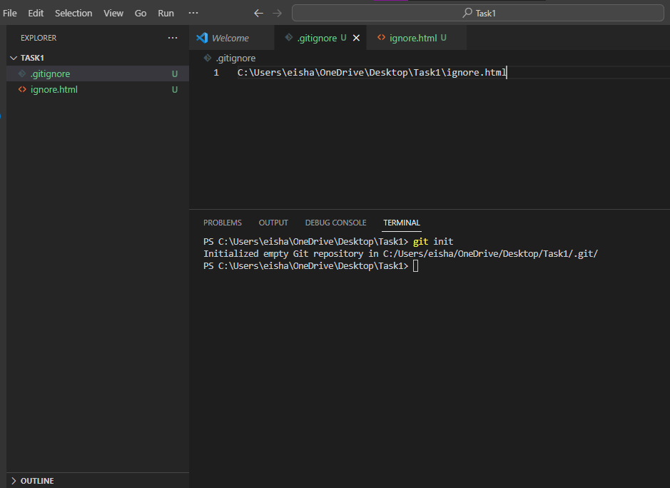
Now the git initialization is complete.
Next, I will perform the repository cloning:
I have cloned a repo with the name Task1 from my github using http clone link.
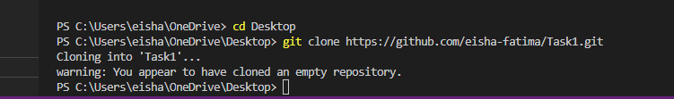

CHECKING GIT STATUS:
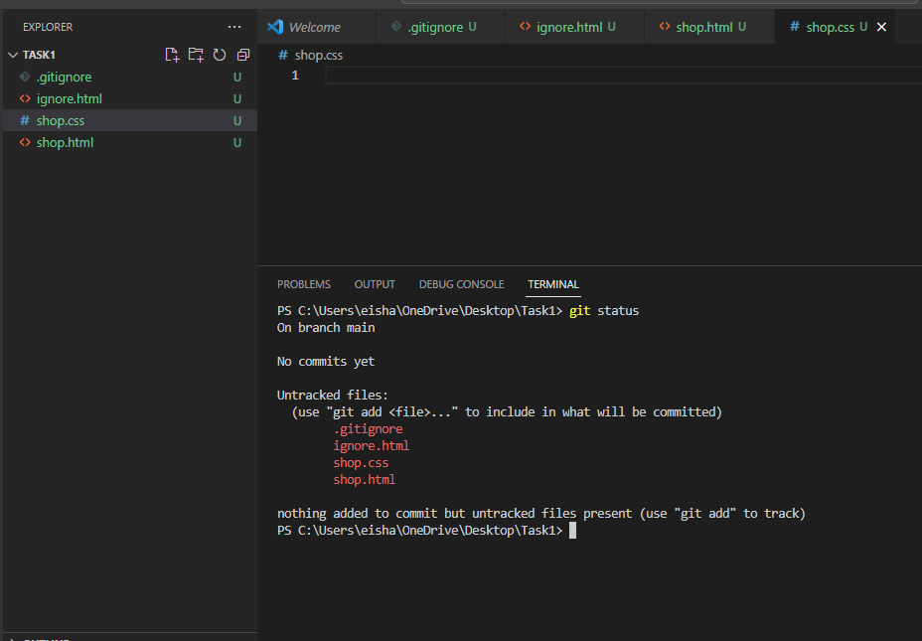

Now adding the files using the git add command to make it possible to commit the files. This is called staging the files for commit.
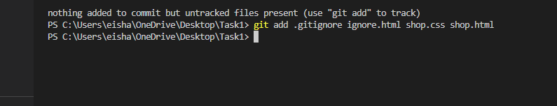
Now Checking status again:
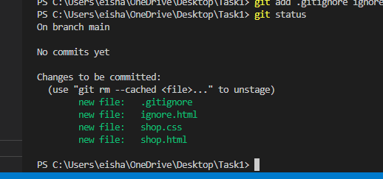
Now green files are ready for commit.

Commit Command:
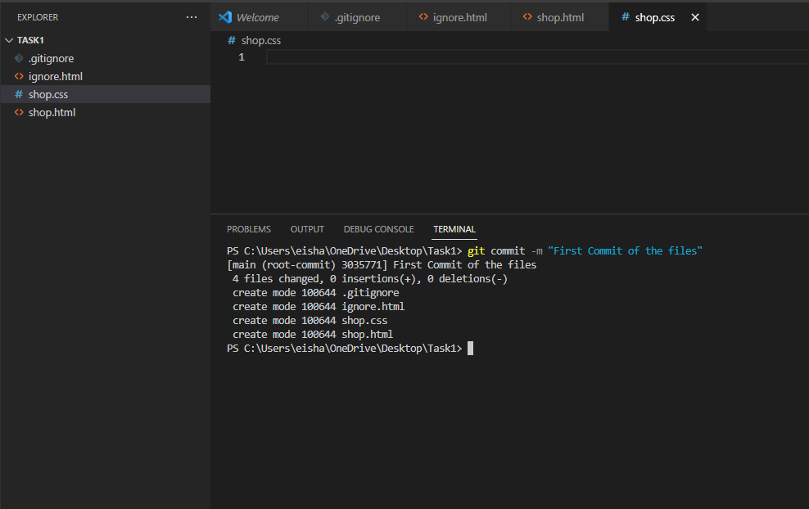
Now to check the history of the commits we can use the git log command:

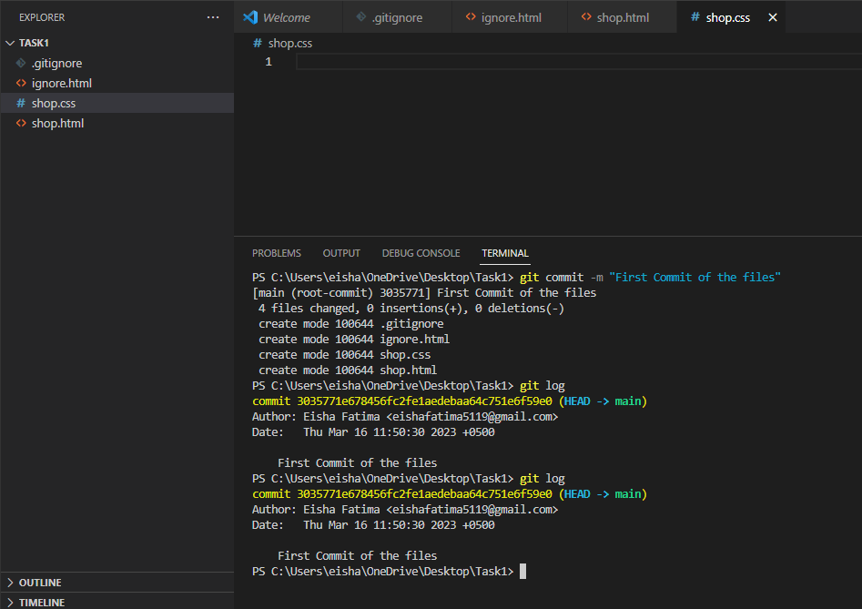

BRANCHING & MERGING:
The default branch is main or master. Now using git branch command we can make new branches to work on separately.
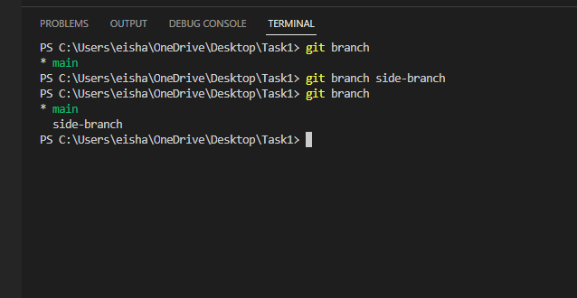
Here we have two branches now. One is main and other is side-branch.
We are on the main branch with color green.
Switching Branch:
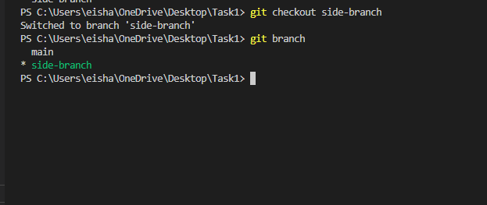
Switched to side-branch.
Now, we are in the side branch whatever changes or work we do now in the repo will be in the side-branch and not the main branch.
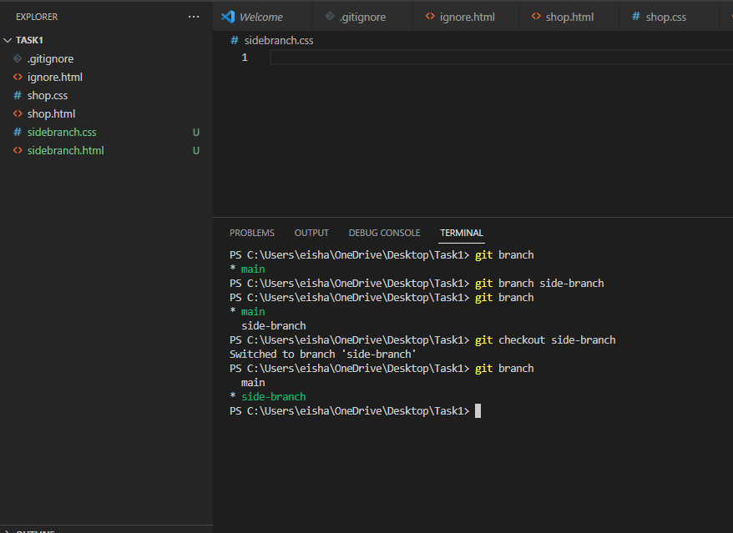
Created two files sidebranch.css and sidebranch.html in the side-branch.
COMMITING IN THE side-branch:
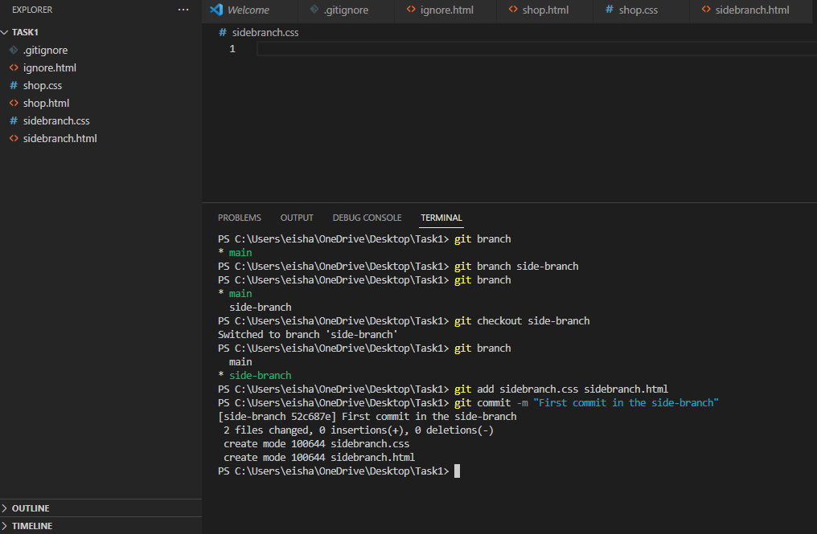

MAIN BRANCH:
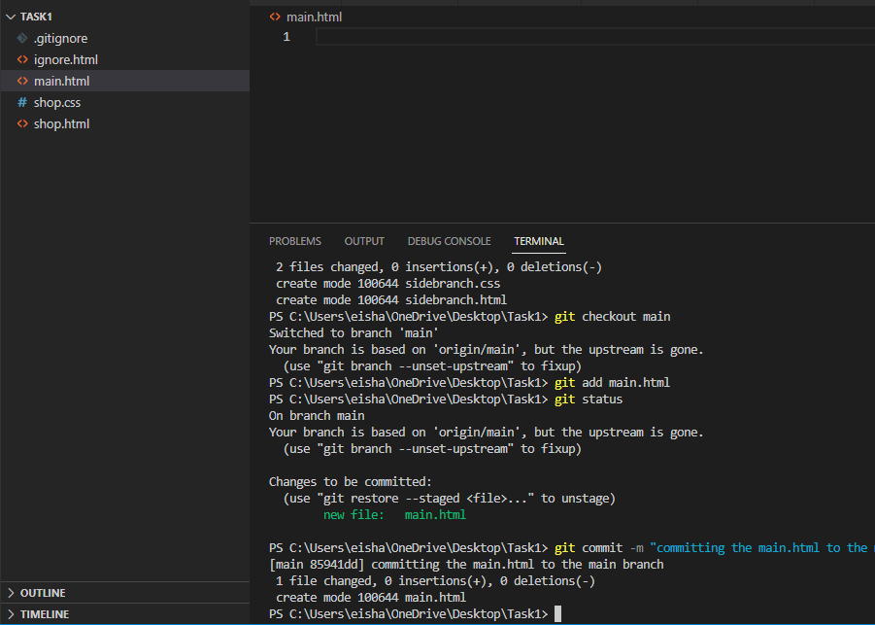
SIDE-BRANCH:
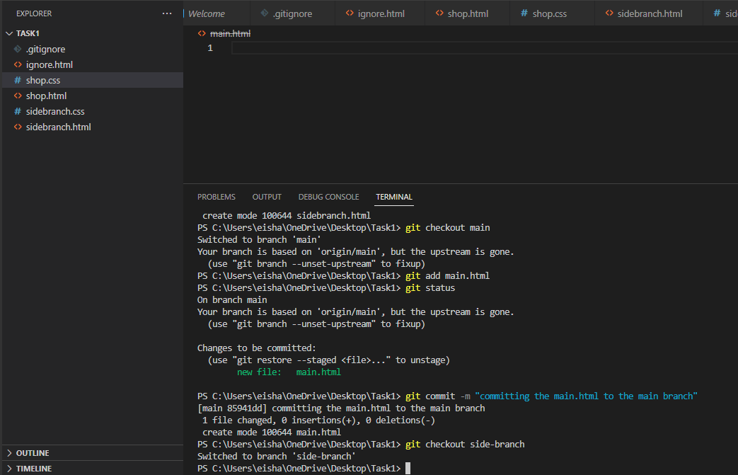

Merging the Branches:
Using git merge command as shown below.
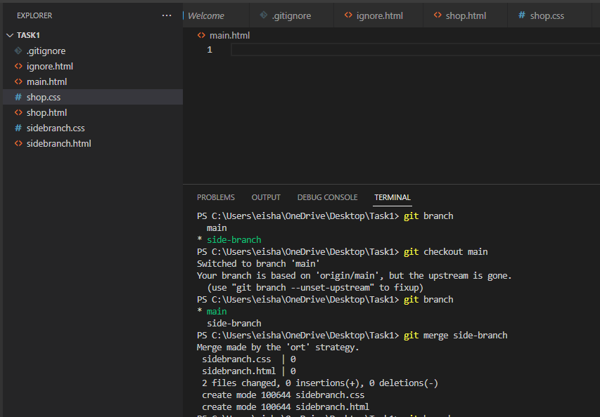
Now both branches have been merged. You can see the side-branch files in the main branch which you could not previously.

