

**Familiarization to lab equipment and Packet tracer software, and Construct network cable.**

lab#1

Eisha Baig | 200901015 | 19/2/2023

BSCS-01 (SECTION B)

TASK # 1

**Objective:**

Learn and design networking cable (Ethernet cable) in different style.

**Equipment:**

Crimping Tool.

RJ 45 Connector.

Cutter.

Networking Cable.

**WORKING:**

We have implemented a crossover Ethernet cable in the lab, and to configure the crossover, we built the T-568A sequence on one side and the T-568B sequence on the other. The color sequence used for the T-568A and T-568B configurations are different, but by using a crossover cable, we can connect two devices directly to each other without the need for a switch or hub.:

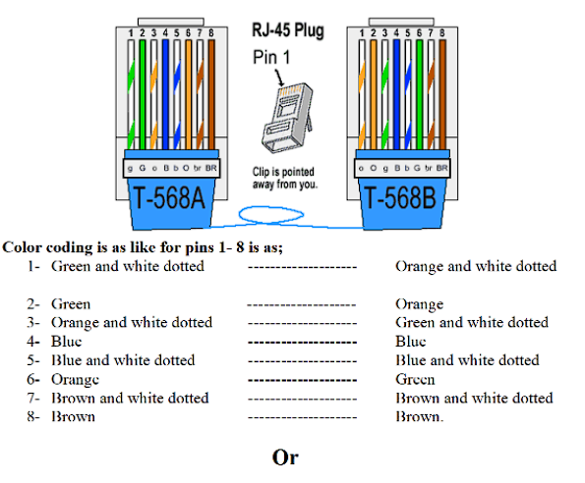

The first step was to remove the upper covering of the cable and then after-words we had to separate the stripped color wire and solid colored wire and straighten then up to arrange them according to the color code and after that we had to plug in the wires using the Rj45 connector. And then finally we had to punch the connector in the end using the crimping tool.

Task # 2

**Difference between Straight-Through and Crossover Ethernet Cable**:

Straight through is used in communication between two different devices while cross over is used in same devices level.

For Switch to router, Switch to PC or server, Hub to PC or server, and

For Switch to switch, Switch to hub, Hub to hub, Router to router, Router Ethernet port to PC NIC, PC to PC etc.

* A straight-through Ethernet cable has the same wiring sequence on both ends, typically using the T568B wiring on both ends. It is used to connect different types of devices, such as a computer to a router or a switch.
* A crossover Ethernet cable has different wiring sequences on each end. one end uses the T568A, and the other end uses the T568B. It is used to connect two devices of the same type, such as two computers or two switches.

The T568B standard is most commonly used and effective for several reasons one of them is:

It is the most widely used standard for Ethernet cabling, making it easier to find compatible components and support.