CN-ASSIGNMENT#1

|  |  |  |  |
| --- | --- | --- | --- |
| **NAME** | **:** |  | **EISHA BAIG** |
| **ROLL NO** | **:** | **200901015** | |
| **SECTION** | **:** |  | **B** |
| **DEPARTMENT** | **:** | **BSCS-01(B)** | |

We have created a static blog page website using Node.js, Express.js, CSS, and HTML:

1. Create a new node_server: run the command **npm init** to create a new project. And include Express.js as a dependency.
2. Set up Express.js server: Create a new file called **index.js** and add the following code:
3. const express = require('express'); const app = express(); app.use(express.static('public')); app.listen(3000, () => { console.log('Server listening on port 3000'); });

This code sets up a basic Express.js server that serves static files from a **public** folder and listens for requests on port 3000.

1. Set up folder structure: we have created a new folder named as **public** and have added the following subfolders: **css**, **js**, and **img**. Then we have created an **index.html** in the **public** folder.

Test server: Run **node index.js** in terminal to start Express.js server. After opening the web browser we are going to type in localhost:3000.

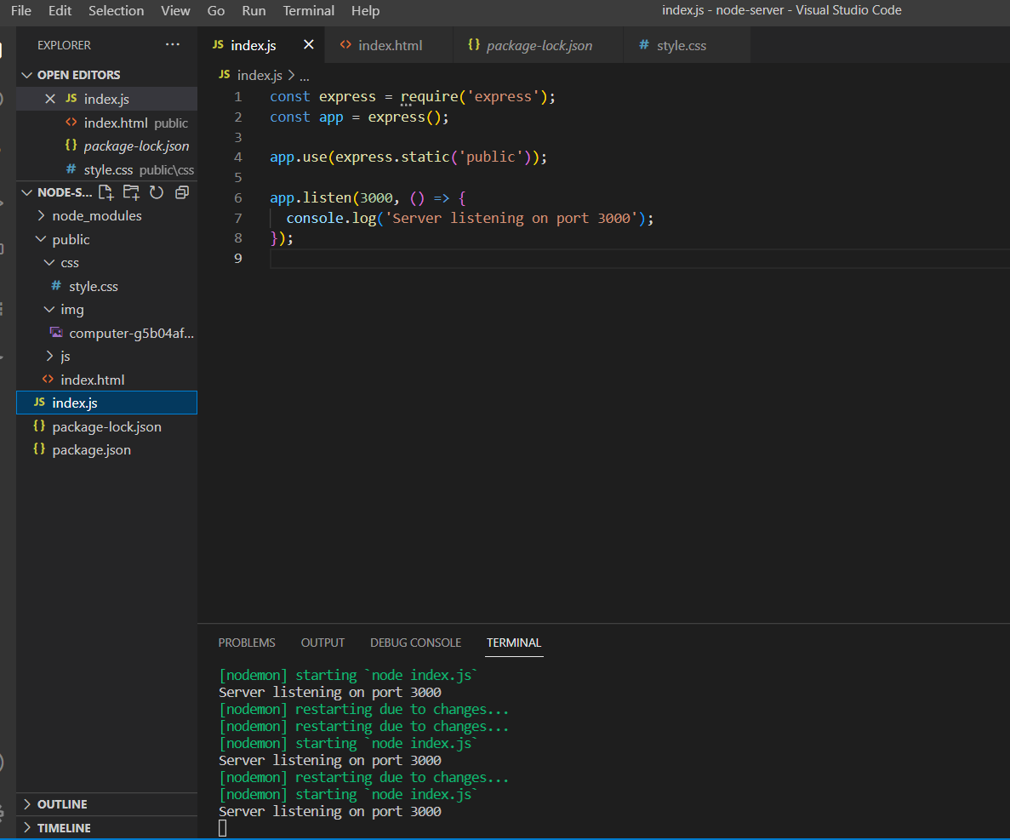

Following are the control panel buttons displayed that performs the functionality of dark mode and text only mode and battery-optimized mode.

Results after clicking on the dark-mode:

Results after clicking on text-only mode:

## Hosting web-Application using Apache http server:

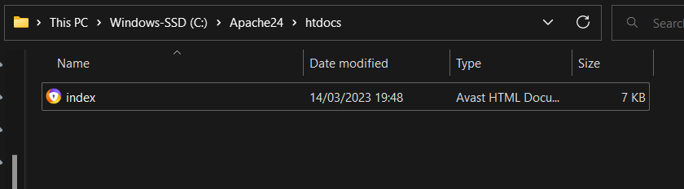

We will use this url address in-order to view our page



## Responsiveness of the web-application:





## Comparing loading times of both server:

APACHE HTTP SERVER:

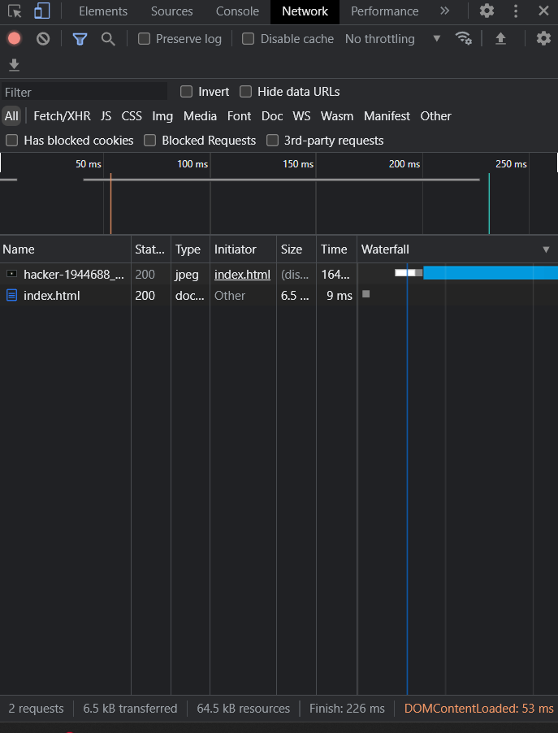



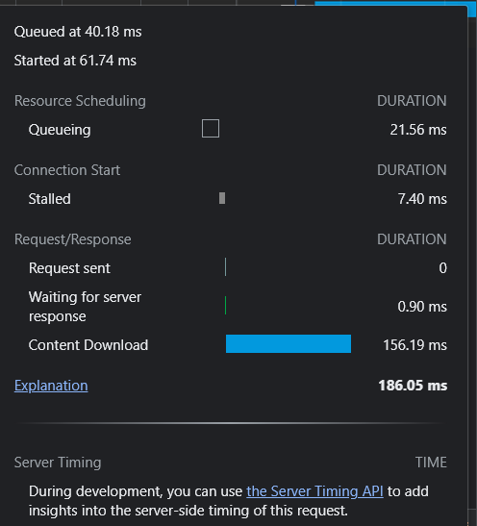

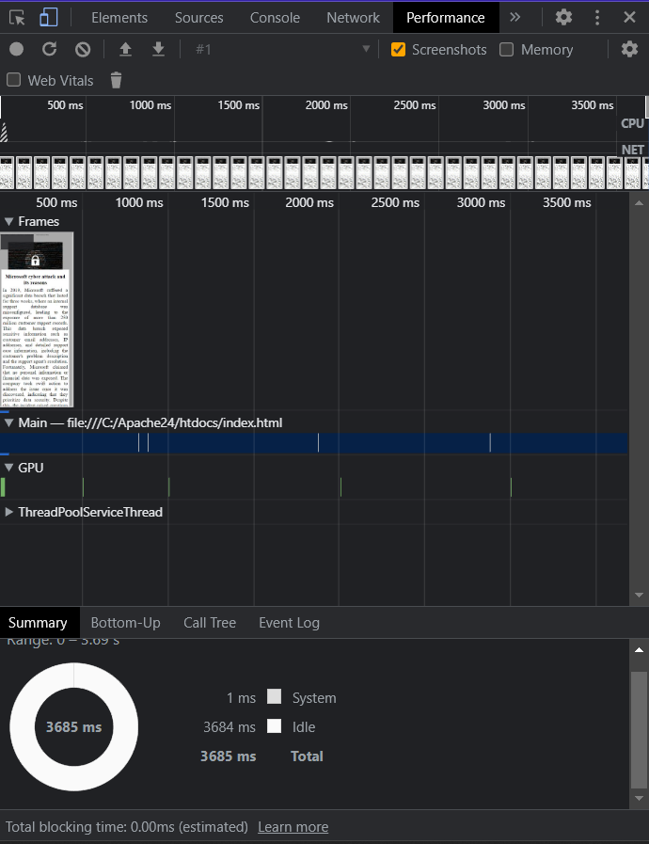

EXPRESS JS/NODEJS:

