|  |  |  |  |
| --- | --- | --- | --- |
| **DATE OF EXPERIMENT** | **:** | **7/03/23** | |
|  |  |  | |
| **Lab Number** | **:** | **03** | |
|  |  |  | |
|  |  |  | |
| **NAME** | **:** |  | **EISHA BAIG**  **___________________** |
| **ROLL NO** | **:** | **_____________200901015______** | |

Task#1:

1. Choose the PCs and router you need based on your requirements.
2. Connect the PCs and router together using a crossover cable.
3. Assign IP addresses to the PCs and router. Such that, PC-0 gets 192.168.16.1, the router gets 192.168.16.2, and PC-1 gets 10.10.10.1.
4. Then we will configure the gateway address on PC-0 and PC-1 to be the IP address of the router (192.168.16.2 in this case).
5. Test the network connectivity by trying to ping the other PC from each PC.

Output:

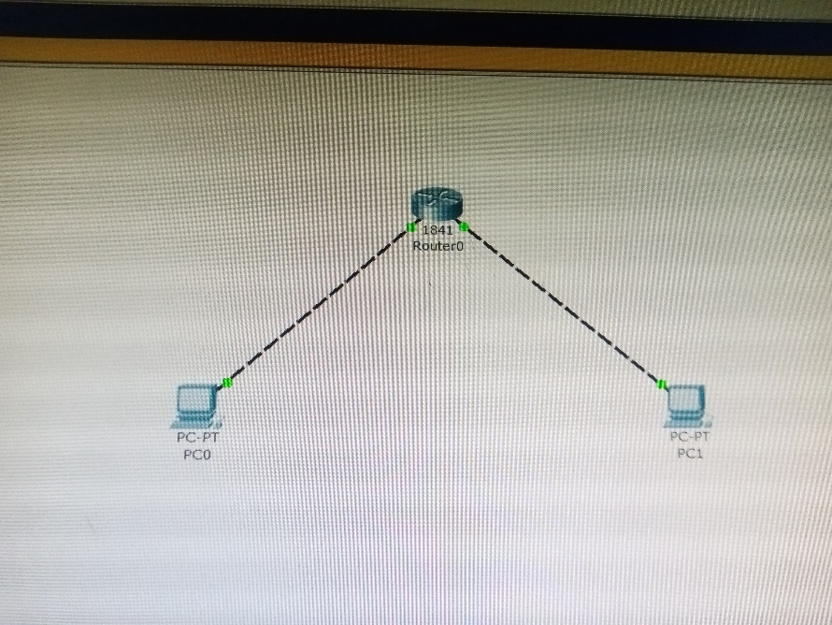

Task#2:

1. Choose the PCs and router and switches you need based on your requirements.
2. Connect the PCs and router and the switches together using a straight-over cable.
3. Assign IP addresses to the PCs and router. Such that, PC-0 gets 192.168.16.1, the router gets 192.168.16.2, and PC-1 gets 10.10.10.1 and then we will connect the switches with the router.
4. Then we will configure the gateway address on PC-0 and PC-1 to be the IP address of the router (192.168.16.2 in this case).
5. Test the network connectivity by trying to ping the other PC from each PC.

Output:

