Eisha Baig

200901015 (BSCS-01)(B)

compiler_construction

Assignment# 3

TASK#1:

In this assignment you are required to parse an xml file (provided in attachment) file using python or any language of your preference.

The data to be extracted from file includes:

1.Book_Id

2.Author_Name

3.Title

4.Genre

5.Price

6.Publish_date

7.Description

We have used (module) xml for parsing the document which contains four sub-packages:

Dom, parsers, sax, etree, we have used the etree(ElementTree library) and we have given it an alias name ET.

Then we will pass the compiler.xml file as a parameter to ET.parse. After this we will use getroot() method in order to fetch the root of the xml file which is <catalog>.

Then we have used tag , attrib, text in order to find various elements.

In order to print the attrib and text of a specific book id we have used if else condition on it, and user id is taken as an input from the user the atrrib and text of the book would be printed on the basis of that user input.

TASK#1:

After extracting the above information from the tags, you have to create an excel file to record the data in the following table format.

In order to create an xml file we will use xlsxwriter module for this, then we will use workbook() method which takes one-argument as a filename then the workbook object is used to add new worksheet. We use this work object to write data via the write() method. After this we will create a variable my_list which will store the data.

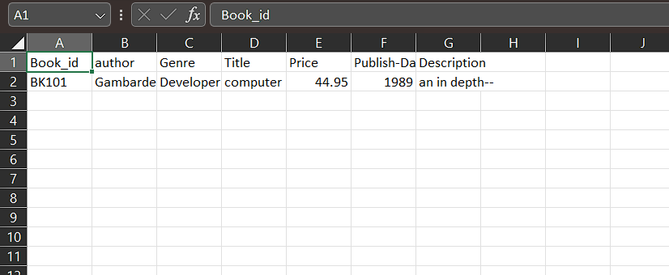

GITHUB_LINK:

https://github.com/eisha01/parsing_xml-file-and-creating-excel-sheet.git