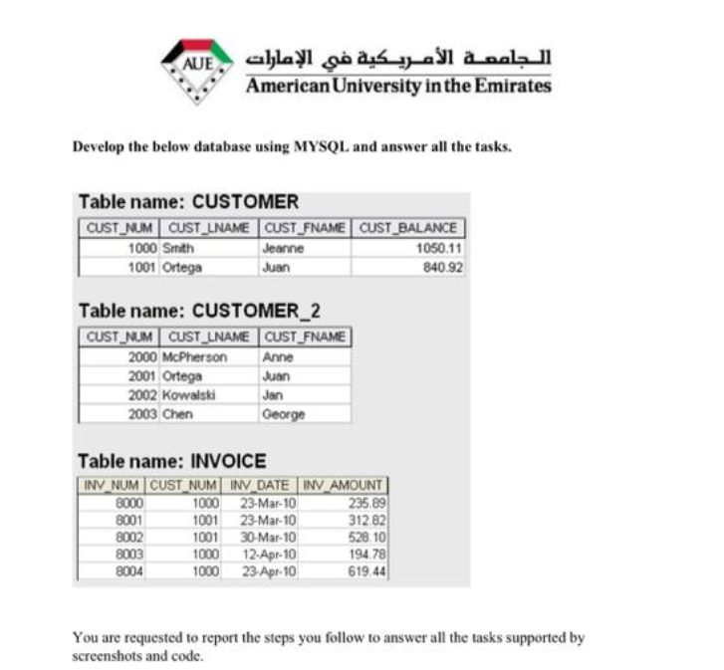



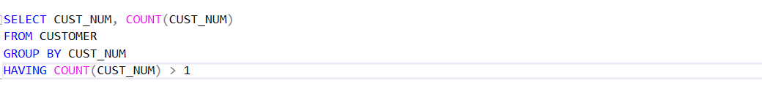

# OUTPUTS:

FOR FINDING THE AVG:

FOR THE COUNT()

FOR ALTER TABLE:

FOR FINDING THE DUPLICATE VALUES:

FOR JOINING TABLES:

