**Homepage for non-members:**



**Member Login Window:**

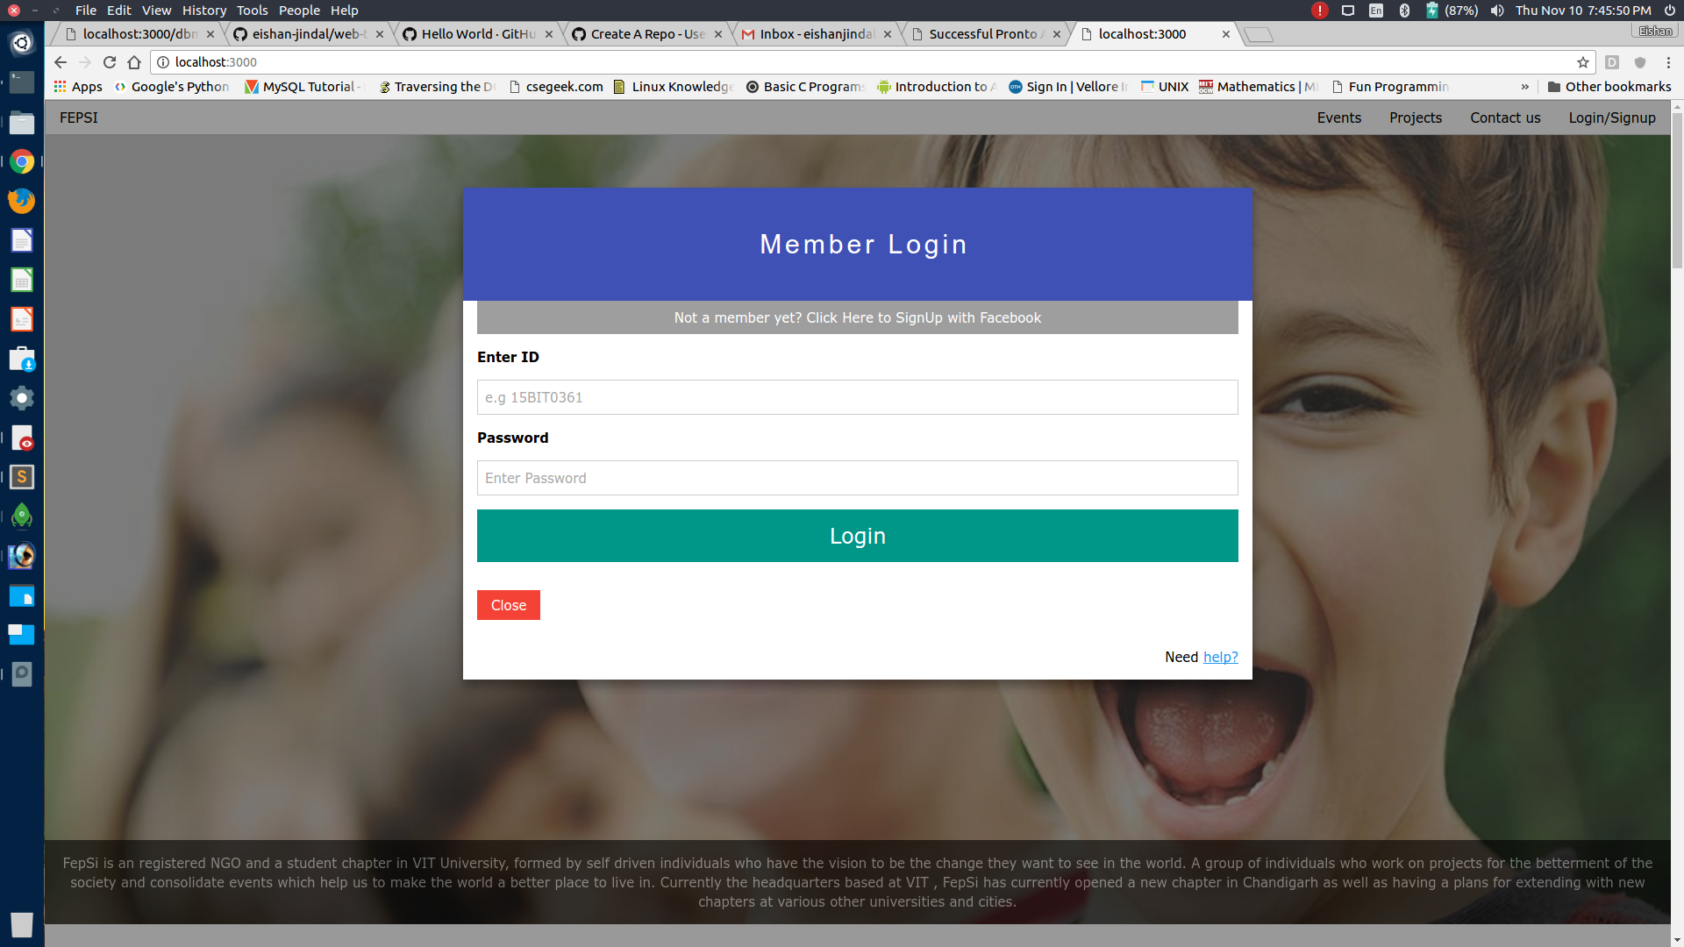

**Events Registration Window:**

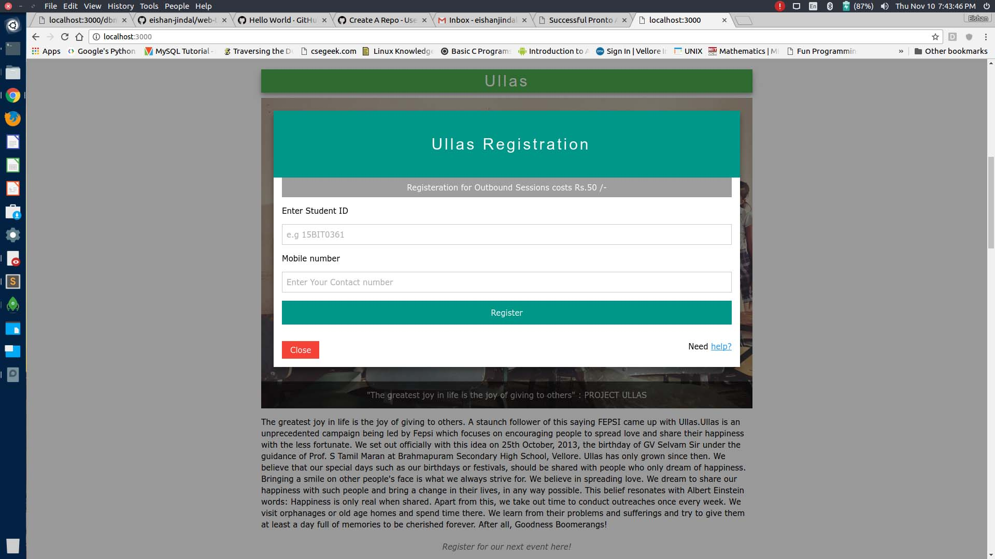

**Member Homepage:**

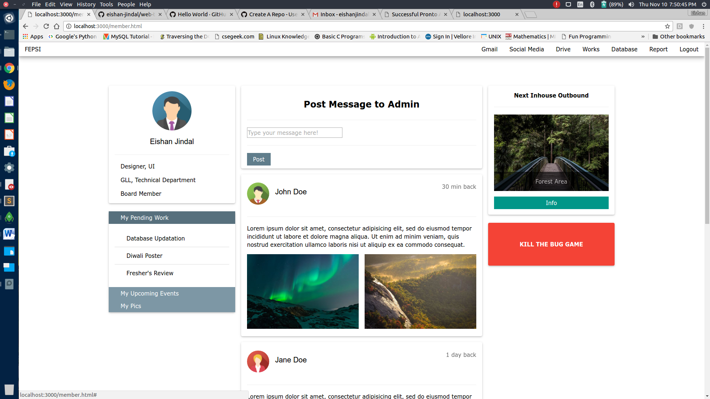

**New Member Addition form:**

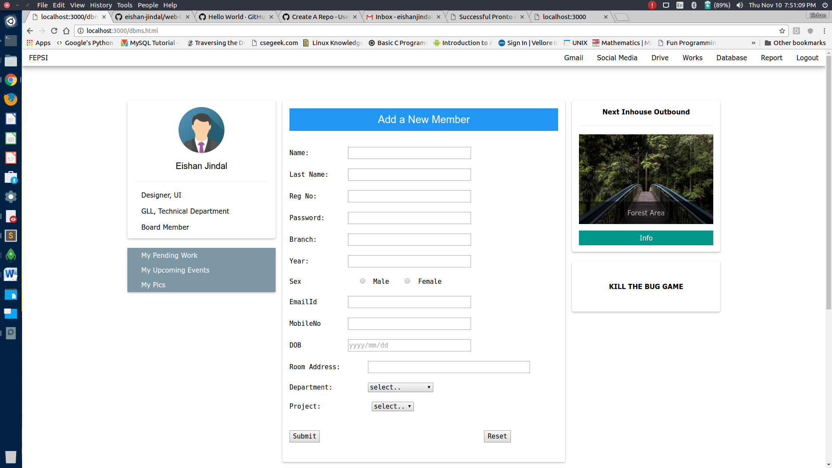

**Database queries:**

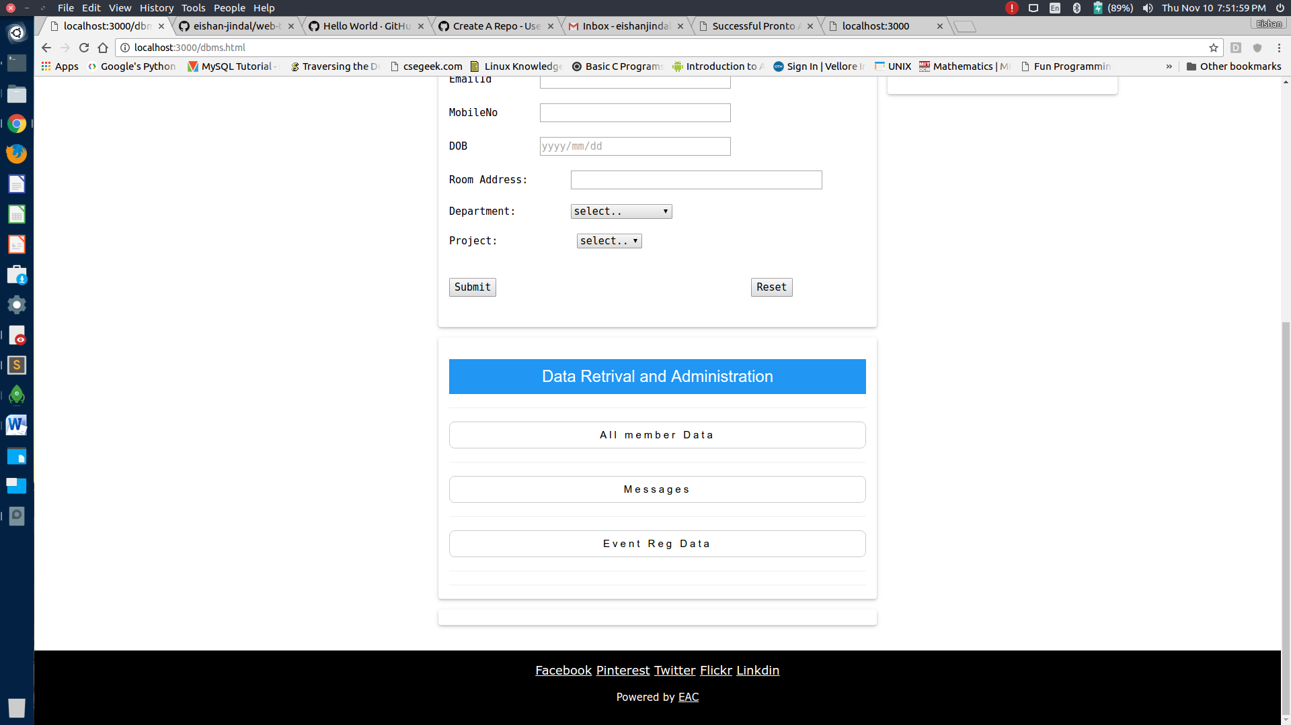

**MongoDB:**

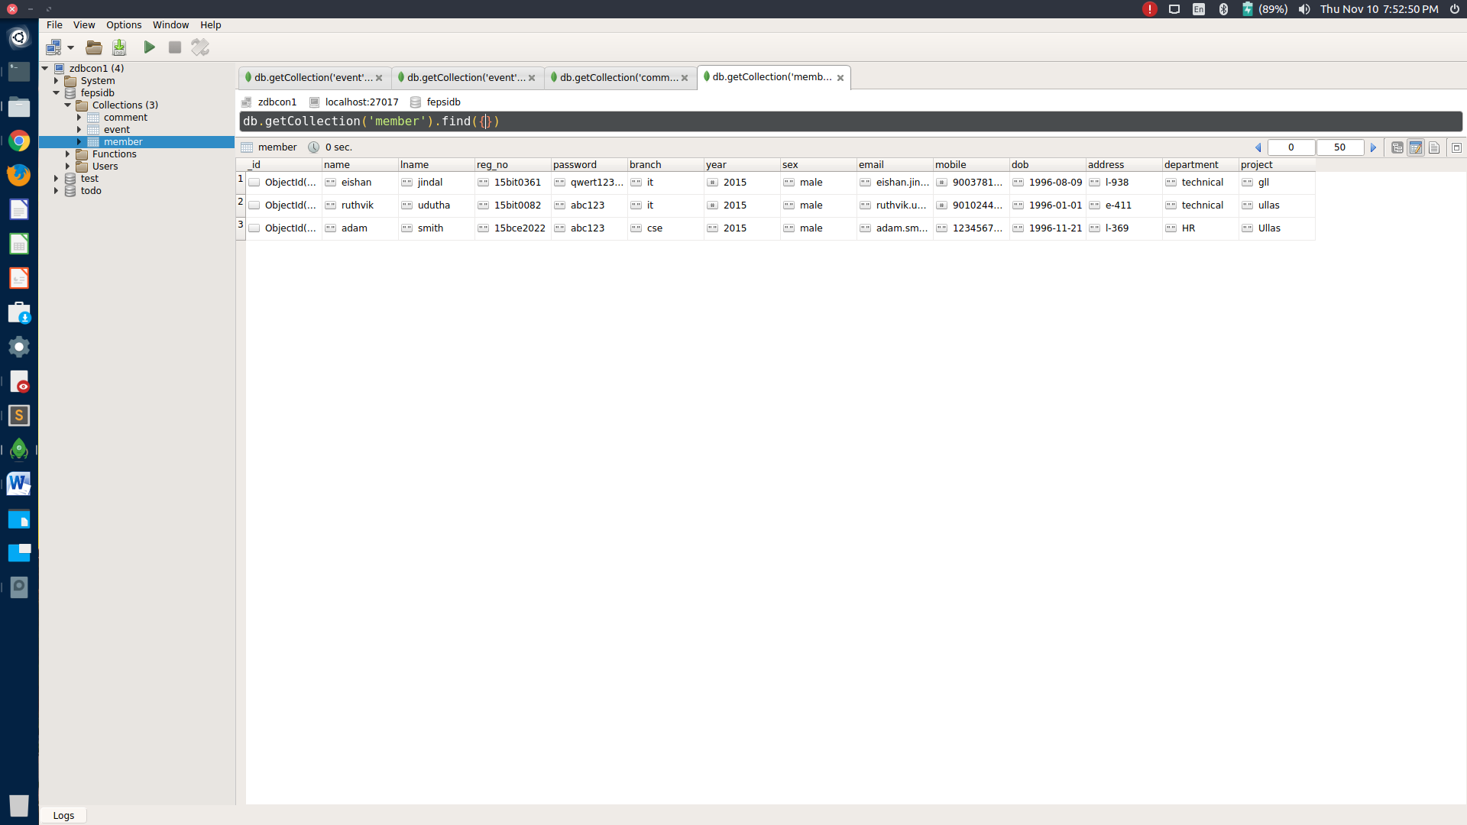

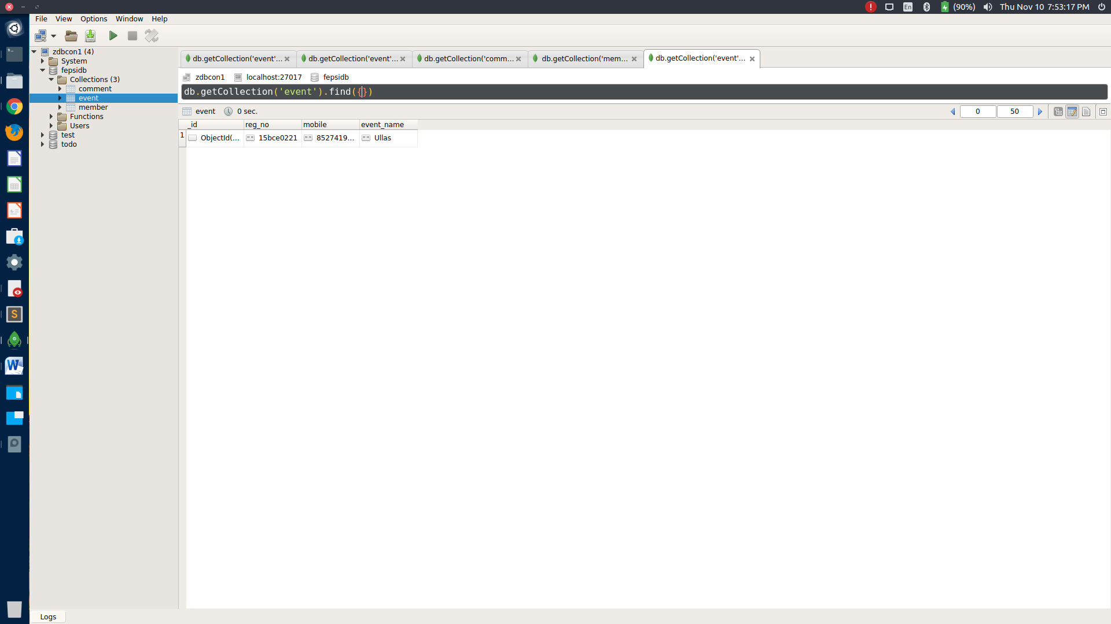

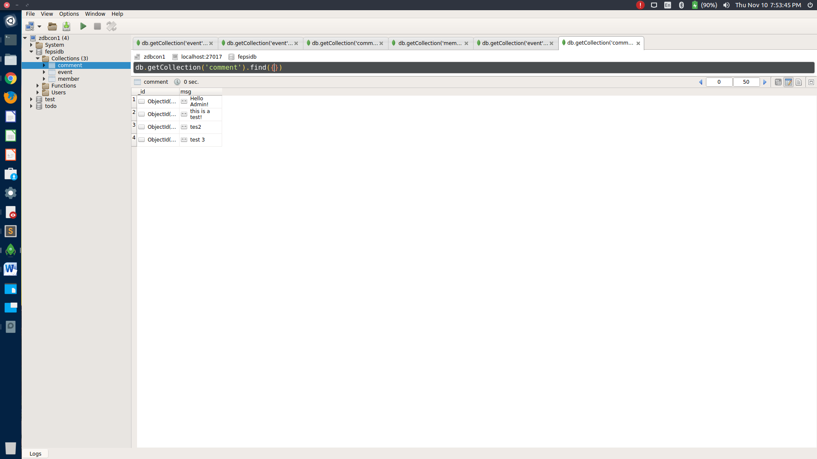

**//WRITE ALL CODE IN SIZE 11pt or less**

**//Donot INCLUDE NODE_MODULES FOLDER CONTENTS**

**//WRITE DOWN PROJECT DIRECTORY STRUCTURE**