2.0 ANALYSIS
2.1 Al-Ikhsan background of establishment and development
Al-Ikhsan began as a small retail business in Malaysia with the main objectives of providing affordable sports good to the public. At the early stage, the business focused on supplying basic sportswear and equipment at lower prices compared to international brands. This positioning allowed the company to attract students, athletes, and budget-conscious customers. Over time, Al-Ikhsan expanded significantly and became one of the largest sports retail chains in Malaysia. The company now operates multiple outlets nationwide, especially in shopping malls and urban commercial areas where customer traffic is high. Its growth can be attributed to its consistent pricing strategy, strong demand for sports-related products, and continuous expansion into new locations. The brand also strengthened its identity by offering a wide range of products that cater to both casual users and serious sports enthusiasts, making it a familiar name in Malaysia’s sports retail industry.
2.2 Challenges faced by Al-Ikhsan
During its operations, Al-Ikhsan faces several key challenges that affect its business performance and daily operations.
1. Maintaining sales performance
One of the main challenges is maintaining consistent sales throughout the year. Although Al-Ikhsan has a strong customer base, sales performance can fluctuate depending on seasons, promotions, and market competition. For example, sales may increase significantly during festive seasons, school holidays, or promotional campaigns, but drop during off-peak periods. In addition, the presence of strong competitors, especially international sports brands and online marketplaces, makes it more difficult to sustain stable revenue. Customers today have more options and can easily compare prices online, which increases pressure on the company to continuously offer attractive pricing and promotions. Therefore, maintaining steady sales requires continuous marketing efforts, competitive pricing strategies, and strong brand visibility.
2. Managing people and customer service
Another significant challenge is managing people, particularly in terms of customer service quality. As a retail business with multiple outlets, ensuring consistent service standards across all branches can be difficult. Staff are required to handle different types of customers, each with varying expectations and behaviors. Some customers require detailed assistance in selecting products, while others expect fast and efficient service. This creates pressure on employees to maintain professionalism, patience, and product knowledge always. In addition, staff turnover and training can also affect service quality. New employees may require time to adapt, which can temporarily impact on customer experience. Therefore, continuous training and proper staff management are essential to ensure that all customers receive a positive and consistent shopping experience across all outlets.
2.3 Al-Ikhsan future strategies and recommendations
To improve competitiveness and strengthen market position, several strategies have been identified based on current business needs.
1. Attracting school-age customers
One of the key strategies is to focus on attracting customers from school age groups. This is because Al-Ikhsan Cawangan is surrounded by many high school and middle-aged students. This segment is very important because they represent long-term customers who may continue purchasing sports products as they grow older. To attract this group, the company can offer more affordable and trendy sports products that suit students’ needs, such as school sports shoes, jerseys, and basic sportwear. Creating products that are both budget-friendly and stylish can help increase interest among younger customers.
2. Providing vouchers for schools
Another effective strategy is to collaborate directly with schools by providing vouchers or special discounts. These vouchers can be distributed during school sports events, physical education programs, or school tournaments. This approach helps to increase brand exposure among students and encourages them to visit Al-Ikhsan stores. It also builds a positive relationship between the brand and educational institutions, which can lead to long-tern customer loyalty.

Figure 1: Al-Ikhsan school promotion
3. Strengthening the official website of Al-Ikhsan
Improving and strengthening the official website is also an important strategy. A more user-friendly and responsive website can enhance the online shopping experience for customers. Features such as easy navigation, accurate product descriptions, real-time stock availability, and secure payment systems can increase customer satisfaction. In addition, improving website performance can help the company compete more effectively with other e-commerce platforms.
4. Participating in local events
The company can also increase its visibility by participating in local events such as community sports days, school tournaments, and public sporting activities. By being physically present at these events, Al-Ikhsan can directly engage with potential customers and promote its products. This strategy also helps strengthen brand awareness at the community level and builds a more personal connection with customers.
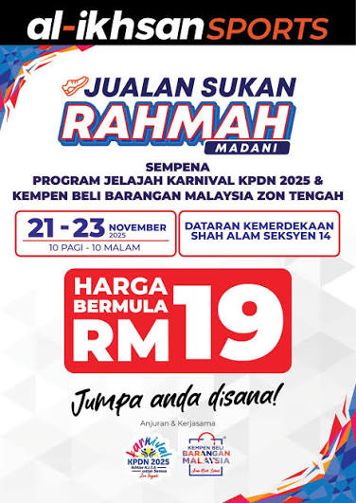
Figure 2: Collaboration between Al-Ikhsan & KPDN

2.4Al-Ikhsan most popular customer choices
Based on customer purchasing patterns, one of the most popular product categories is women’s footwear. This includes sports shoes, casual sneakers, and lifestyle footwear designed specifically for female customers.
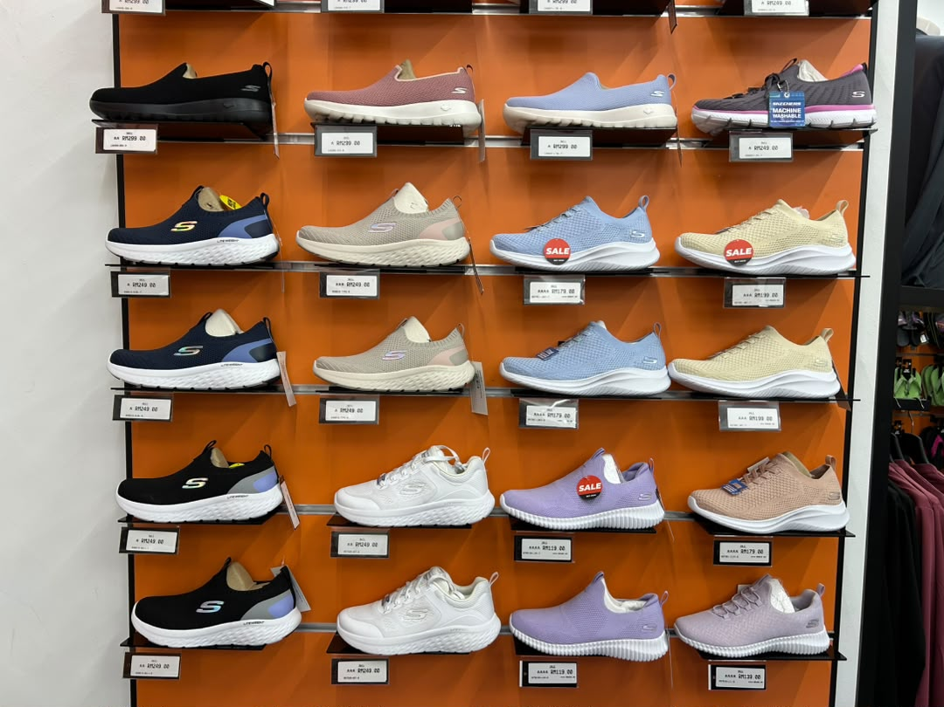
Figure 3: Women sport shoes at Al-Ikhsan

2.5 Al-Ikhsan most effective marketing strategies
1. Social media engagement strategy
The most effective marketing strategy used by Al-Ikhsan is social media engagement. This includes activities such as reposting customer content, responding to comments, and boosting posts to increase visibility. Reposting customer content helps build trust and authenticity, as it shows real users engaging with the brand’s products. Responding to comments improves customer interaction and creates a more active online presence, making customers feel valued and heard. In addition, boosting posts through paid promotions allows the company to reach a wider and more targeted audience, especially potential customers who are interested in sports-related products.

Suggested Improvements for Al-Ikhsan
1. Integrated real-time inventory system
A centralized inventory system should be developed to connect all branches in real time. This system would ensure that stock levels are updated instantly across all outlets. It would also help staff manage inventory more efficiently and reduce errors related to stock availability. Customers would benefit from accurate product availability information before visiting stores.
2. Mobile application for Al-Ikhsan
A dedicated mobile application would significantly improve customer experience. The app could allow users to browse products, check stock availability based on location, and make online purchases. It could also include features such as click-and-collect services, where customers order online and pick-up items in-store. Push notifications can be used to inform customers about promotions and new arrivals.
3. Customer loyalty system
A digital loyalty system can help improve customer retention. By awarding points for every purchase, customers are encouraged to return for future transactions. These points can later be redeemed for discounts or vouchers. A tier-based system such as Bronze, Silver, and Gold can also be introduced to reward frequent buyers with exclusive benefits.
4. AI-Based recommendation system
An advanced system using artificial intelligence can be implemented to analyze customer behavior and purchase history. Based on this data, the system can recommend relevant or complementary products. For instance, customers who purchase running shoes may be recommended sports socks or athletic apparel. This improves cross-selling opportunities and enhances user experience.
5. Digital marketing analytics dashboard
A centralized dashboard for management can be developed to track business performance. This system would provide insights such as sales performance by branch, most popular products, customer buying trends, and overall revenue analysis. With this data, management can make more informed and strategic business decisios.

